
Geothermal/Ground Source Heat Pumps
Fact Sheet SWP-120

What are geothermal heat pumps?
Geothermal heat pumps, also known as ground source heat pumps, are a relatively efficient renewable energy technology. Geothermal heat pumps are used for space heating and cooling, as well as water heating. The greatest advantage is that it works by concentrating naturally existing heat, rather than producing heat through combustion of fossil fuels. For cooling, the reverse process occurs.

Types of geothermal heat pumps?
Ground source heat pumps are categorized as having either closed or open loops. The three types of closed loop system installations include: horizontal, vertical, and pond/lake. The fourth type of ground source heat pump is the open-loop system. To determine which option is the best, you must look at the climate, soil conditions, available land, and local installation costs at your site. All of these types of systems can be used for residential and commercial building applications. Read on for more detailed descriptions of the types of closed and open loop systems.

Closed-Loop System- Horizontal
Horizontal ground source heat pump installation is generally most cost-effective for residential installations, particularly for new construction where sufficient land is available. It requires trenches at least four feet deep. The most common layouts either use two pipes, one buried at six feet, and the other at four feet, or two pipes placed side-by-side at five feet in the ground in a two-foot wide trench. The method of looping pipe allows more pipe in a shorter trench, which cuts down on installation costs and makes horizontal installation possible in areas it would not be with conventional horizontal applications.
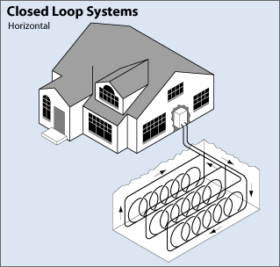

Closed-Loop System- Vertical
Vertical systems are often used for large commercial buildings and schools because the land area required for horizontal loops would be prohibitive. Vertical loops are also used where the soil is too shallow for trenching, and they minimize the disturbance to existing landscaping. For a vertical system, holes (approximately four inches in diameter) are drilled about 20 feet apart and 100 to 400 feet deep. Into these holes go two pipes that are connected at the bottom with a U-bend to form a loop. The vertical loops relate to horizontal pipe (i.e., manifold), placed in trenches, and connected to the heat pump in the building.
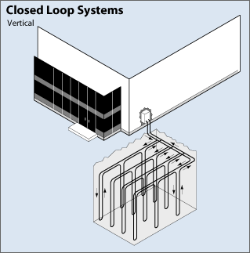

Closed-Loop System- Pond/Lake
If your site has an adequate water body, this may be the lowest cost option. A supply line pipe is run underground from the building to the water and coiled into circles at least eight feet under the surface to prevent freezing. The coils should only be placed in a water source that meets minimum volume, depth, and quality criteria.
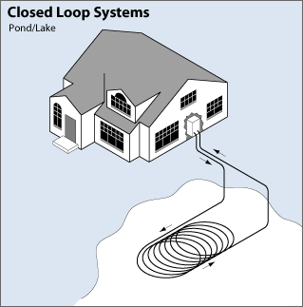

Open-Loop System
An open loop system uses a well or surface water body such as a pond or lake as the heat exchange fluid that circulates directly through the ground source heat pump system. Once the water has circulated through the system, it returns to the ground through the well, a recharge well. Discharge to the surface may be considered but triggers additional permitting considerations. The open-loop surface water option is only practical where there is an adequate supply of relatively clean water, and all regulations regarding a surface or groundwater discharge are met.

If an open-loop system is installed where the building or home is served by a public water system, the installation should be inspected to ensure compliance with the utility’s back flow prevention ordinance, if any.
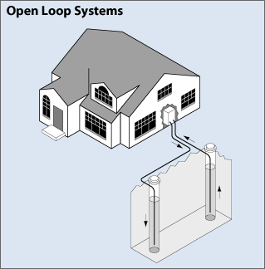

Permitting Information?
The three permitting agencies include: The Environmental Protection Agency (EPA), Montana Department of Natural Resources and Conservation (DNRC), and the Montana Department of Environmental Quality (DEQ).

The EPA only regulates open loop ground source heat pumps. As the applicant, you must submit information on your proposed open loop ground source heat pump by completing the “Shallow Waste Disposal System/Well Inventory Request Form” located at:
https://www.epa.gov/sites/production/files/2017-03/documents/class_v_inventory_form.pdf

Single family residential homes are excluded from this requirement. Completed copies of the form should be sent to:
Omar Sierra-Lopez
sierra-lopez.omar@epa.gov
EPA Region 8
1595 Wynkoop Street
8P-W-GW
Denver, Colorado 80202-1129
Phone: (800) 227-8917 x312-7045 or 303-312-7045

If it is determined that your proposed heat pump system does not need an EPA permit, the system will be “rule authorized” and there are no further actions that you must take.

The Montana DNRC requires a Water Right Permit for groundwater use (originating after June 30, 1973) over 35 gallons per minute (gpm) or 10 acre-feet per year, or any surface water appropriation. A Groundwater Certificate is required for developed groundwater use (originating after June 30, 1973) under 35 gpm, not to exceed 10 acre-feet per year.

The DNRC also requires extraction and return wells be built to well construction standards and that well logs be properly recorded.

The DEQ requires a Montana Ground Water Pollution Control System permit if the water used for a ground source heat pump is altered (e.g. if additives are added to the water) and discharged back into the aquifer. If the water is not altered no permit is necessary. Temperature changes typically do no trigger a permit requirement. If the water is to be discharged to the ground surface, a Montana Pollutant Discharge Elimination System (MPDES) permit may be required. Contact the Permitting and Compliance Division at (406) 444-5546 to discuss a specific project or for additional information.

Resources: Where can you get help?
For local assistance, check your phone directory for the following telephone numbers:
- Local DNRC office
- County Environmental Health Department or Sanitarian’s Office under County Government listings.
- Heating and Cooling in the yellow pages.
DEQ can provide information about state and federal requirements for geothermal energy development. Contact DEQ’s Geothermal Energy Program at (406) 444-0281 if you would like additional information about geothermal heat systems. You can also access DEQ’s Geothermal Energy Internet site at: https://deq.mt.gov/energy/Programs/renewable

Contact the DNRC for well construction standards and well log requirements (406)444-6643.

Montana State University Extension Service has publications on geothermal heat pumps and other topics available by calling (406) 994-3171 or on the Internet at https://guides.lib.montana.edu/extensionservicepubs

Contact EPA in Denver to learn about federal regulations pertaining to geothermal heating by calling (303) 312-6312 or 1- 800-227-8917 or visit EPA on the Internet at https://www.epa.gov/uic/underground-injection-control-epa-region-8-co-mt-nd-sd-ut-and-wy

References:
Montana DEQ Geothermal Energy Program, March 2008, Georgia Brensdal personal communication.

International Ground Source Heat Pump Association (IGSHPA), April 2008, retrieved from the World Wide Web: https://igshpa.org/ .

U.S. Department of Energy, December 5, 2006, Energy Efficiency and Renewable Energy Geothermal Technologies Program – Geopowering the West. Retrieved from the World Wide Web https://www.energy.gov/eere/geothermal/geothermal-energy-us-department-energy

