
Large capacity septic system operation and maintenance
Fact Sheet SWP-104

Basic information on proper operation and maintenance of residential scale septic systems is available through various sources in the state (see Resources near the end of this publication). For some commercial establishments, the sources and characteristics of wastewater may be quite similar to those of residential wastewater. For other businesses and institutions, however, wastewater may be very different: for example, it may contain harsh industrial-strength cleaners or high concentrations of oils, or it may derive from processes (e.g., small-scale manufacturing) that introduce chemicals and other substances not found in residential wastewater. Accordingly, many large capacity septic system owners face a couple of special considerations in operating and maintaining their systems. If improperly used or operated, septic systems can be a significant source of ground water contamination that can lead to waterborne disease outbreaks and other adverse health effects. This fact sheet is provided to address some of those considerations and to help owners of large capacity septic systems protect their source of drinking water.

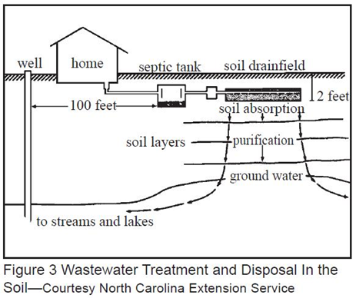

Large capacity septic systems fall under the EPA designation of "Class V Injection Wells" and are regulated by Underground Injection Control (UIC) programs set up by the EPA. In broad terms, this means commercial systems are subject to more stringent oversight than residential systems--out of heightened concern for contamination of groundwater by various types of Class V wells and shallow disposal systems. Of particular concern are systems receiving wastewater from industries and automotive service stations.

A Word About Access
Routine septic tank maintenance cannot occur if reasonable tank access is not provided. Moreover, emergency repairs in the winter can be totally stalled when septic tank access is blocked by frozen soils. If your tank is completely buried, consider asking your pumping contractor what he recommends for improved access.

Tank Pumping Frequency
As with residential systems, regular, scheduled pumping of the septic tank is arguably the most essential element of large capacity septic system maintenance. The key difference lies in the frequency of pumping: commercial septic tanks typically require (much) more frequent pumping than their residential counterparts. There are several reasons for this:
- Faster rate of wastewater flow, resulting in greater likelihood of solids carry-over to drainfield
- Greater strength of wastewater (higher "organic load," that is, higher concentrations of solids and fats, oils and grease), resulting in faster accumulation of solids in septic tank
- Presence of higher strength cleaners and other chemicals not normally found in household wastewater, potentially resulting in harm to bacteria that breakdown wastewater in the septic tank
- Varied and changeable group of system users (employees and customers), resulting in somewhat lessened ability to control/enforce good maintenance practices (as compared to household)

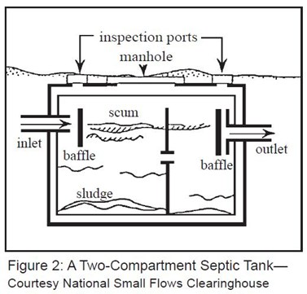

How frequently you will need to have your tank pumped depends on a number of factors, including:
- Type and size of your establishment
- Size of your septic tank
- Volume and rate of wastewater flows
- Amount of organic matter (e.g., waste solids, food scraps, fats/oils/grease) in your establishment's wastewater

The first two factors are essentially fixed. If, however, your septic tank is undersized, you may need to replace it with a larger tank to improve the quality of wastewater treatment. The second two factors can be significantly influenced by your operational practices.

Here are some things you can do to avoid overstressing your septic system over the long term and using pumping (which will always be necessary, whatever your maintenance habits) as a substitute for good operational basics:
- In restrooms: make sure plumbing fixtures don't leak; install automatic shut-off faucets,
- In kitchens: divert kitchen wastewater to grease trap; scrape plates into the garbage, not the sink; install drain covers and sink baskets/strainers to prevent solids (food scraps, fats, oils and grease) from entering your system; avoid use of garbage disposal; use water-saving dishwasher cycle; use mild detergents, not harsh industrial cleaners; use paper towels rather than rags to mop up grease from counters, grills, etc.
- In laundry facilities: avoid use of harsh detergents; space out laundry over the course of the week rather than doing establishment's washing all at once.

An inspection of your septic system by a licensed septic inspector (which should be an annual event) can help you determine the pumping frequency your tank requires. You should schedule pumping with a licensed pumper based on your required frequency (e.g., every three months, twice a year). This same pumper can also pump out your grease trap and/or clean your effluent filter. Note, however, that grease traps will almost always require more frequent pumping than your septic tank to function effectively.

Fats, Oils, and Grease
The most serious problem that plagues large capacity septic systems is the carry-over of fats, oils and grease (sometimes referred to as FOG) into the drainfield (leachfield). When carry-over occurs, these materials reduce the absorption capacity of the drainfield and can lead to system overflows (i.e., breakout), at which point, depending on the extent of damage, the drainfield will need to be repaired, extended or even replaced.

The drainfield of a well-designed and maintained system can handle small amounts of FOG, such as natural body oils carried over from a household's shower water. However, drainfields or alternative treatment systems cannot accommodate significant concentrations of FOG, such as that produced by restaurants, bakeries, cafeterias and camps (and even households that are heavy garbage disposal users and regularly pour cooking grease down their drains).

For this reason, many counties and states require the use of grease traps (also called grease interceptors) by restaurants and similar commercial establishments. Grease traps are holding tanks; modified septic tanks that receive kitchen wastewater prior to the passage of that wastewater to the main septic tank. In the grease trap, wastewater is slowed and allowed to cool somewhat, giving fats, oils and grease a chance to settle out before the effluent passes to the septic tank, where further settling occurs. Grease traps generally range in size from one to three times the average daily flow that will be discharged into it. As with the main septic tank, proper sizing of the grease trap is critical to its ability to fulfill its function.

Effluent Filters
Effluent filters are typically installed on the outlet tee of the septic tank in order to inhibit suspended solids from entering the drainfield. Solids that get into the drainfield can clog the drainfield and lead to drainfield failure. Effluent filters are common on newer septic tanks but often are not found on older tanks.

The popularity of effluent filters is increasing since they can significantly increase drainfield longevity. Septic tank pumpers may advise owners to consider installing an effluent filter.

The servicing of effluent filters is relatively simple. The filter should be removed from its basket and rinsed down while being held over the tank opening. Care should be taken not to spray the filter growth onto surfaces that might be contacted by the unprotected person. In addition, the person servicing the filter should protect himself or herself from back spray. Servicing of the filter can be performed by a licensed septic pumper familiar with the cleaning precautions and procedures.

Operation and Maintenance
Good operation and maintenance practices enable the grease trap and septic tank to work effectively in reducing grease and oil. Some rules of thumb for restaurants and other establishments include:
- Scrape food scraps and congealed fats into the garbage
- Use drain covers and sink baskets and strainers to prevent solids from entering the flow of wastewater
- Eliminate the use of a garbage disposal
- Avoid pouring cooking oil and grease down the drain
- Do not rely on septic system additives that claim to reduce oils and grease. Although these additives do indeed dissolve oils and grease, this only increases the likelihood that these materials will be carried over to the drainfield rather than remaining in the grease trap and septic tank where they can be slowly broken down and pumped out at regular intervals.

Perhaps above all else, the key to the grease trap's effectiveness is regular, frequent pumping. Depending on the size of the grease trap and the strength and flow of wastewater at a given commercial establishment, required pumping frequency may range from twice per month to once every three or six months. A proper pumping does not just remove the liquid in the grease trap but scours the grease trap and the associated lines to eliminate caked-on substances and oily residue. Pumping should be done by a licensed solid waste hauler who will dispose of grease and oils properly (e.g., in designated landfill areas).

Resources: Where can you get help?
For local assistance, check your phone directory for the following telephone numbers:
County Environmental Health Department or Sanitarian’s Office under County Government listings.
Septic tanks and Systems Cleaning and pump-and-haul contractors in the yellow pages.

DEQ can provide information about state and federal requirements for:

- Safe alternatives for industrial chemicals
- Hazardous waste technical assistance
- Pollution prevention and planning
- Drinking water protection planning Underground injection control
- Shallow disposal systems
- Air and water quality compliance assistance
- Discharge permits
- Septic or other waste disposal systems
- Underground storage tanks
- Solid waste management and disposal

Call DEQ at (406) 444-5546 for assistance. You can also visit DEQ’s website at https://deq.mt.gov/ If you would like more information on drinking water protection, please contact DEQ’s Source Water Protection Program – Eric Sivers at 406-444-4806.

Montana State University Extension Service has several publications on septic systems and other topics available (406) 994-3171 or on their website at http://guides.lib.montana.edu/extensionservicepubs

Contact EPA Region 8 in Denver to learn about federal regulations pertaining to large capacity septic systems by calling (303) 312-6133 or visit EPA’s website at https://www.epa.gov/septic .

The bottom line for large capacity septic systems is:
- Have a knowledgeable septic professional determine how frequently your tank and grease trap requires pumping,
- Set a maintenance schedule based on that and stick to it!

References:
Montana State University Extension Service. Septic System Records and Maintenance Guidelines. 2003.

Septic System History and Records

Map the location of your building and septic system components below

Date constructed: __________________ permit number: _________________

Installation contractor name: _________________________________________

Address: _______________________________ phone: ____________________

Tank size (gallons): ____________________

Drainfield description:

Maintenance History
Date | Service description | Notes

