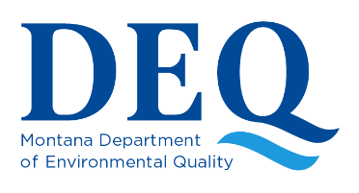
Septic Tank & Drainfield Operation & Maintenance
Fact Sheet SWP-103

This fact sheet explains how septic systems work, how they should be laid out, how to know when to pump the tank, and why septic systems fail.

Households not served by public sewers usually depend on a septic system to dispose of wastewater. There are many different types of septic systems designed to fit a wide range of soil and site conditions. These include mound systems, sand filter systems, and pressure distribution systems. This fact sheet should help you understand the operation and maintenance of a conventional gravity-flow septic system.

A conventional septic system consists of two main parts: the septic tank and the drainfield (also referred to as a leach field, absorption bed, or absorption field). At the head of the drainfield a distribution box or a manifold distributes wastewater to several absorption trenches. Some authorities require that newly installed drainfields include a designated replacement area. Should the existing septic system need an addition, repair, or replacement, the replacement area can then be used.
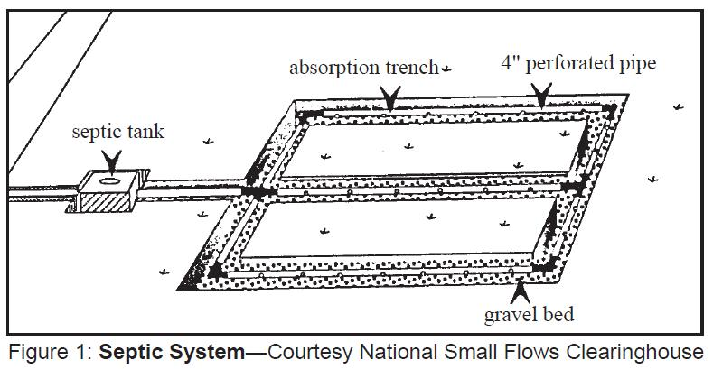

How the system works

The Septic Tank
A septic tank is an underground watertight container, typically about 9 feet long, 4-5 feet wide and 5 feet tall, that is connected to the home's sewer line. While typically designed with a 1,000-gallon liquid capacity, the size of the tank is determined by the number of bedrooms in the home. (Septic tanks come under the legal supervision of counties in Montana.) Septic tanks may be rectangular or cylindrical and may be made of concrete, fiberglass or polyethylene.

Raw wastewater from the bathroom, kitchen and laundry room flows into the tank, where the solids separate from the liquid. Light solids, such as soap suds and fat, float to the top and form a scum layer. This layer remains on top and gradually thickens until the tank is cleaned. The liquid waste goes into the drainfield, while the heavier solids settle to the bottom of the tank where they are gradually decomposed by bacteria. But some non-decomposed solids remain, forming a sludge layer that eventually must be pumped out.

Septic tanks may have one or two compartments. Two-compartment tanks do a better job of settling solids and are required in some areas for new installations. Tees or baffles at the tank's inlet pipe slow the incoming wastes and reduce disturbance of the settled sludge. A tee or baffle at the outlet keeps the solids or scum in the tank. All tanks should have accessible covers for checking the condition of the baffles and for pumping both compartments.
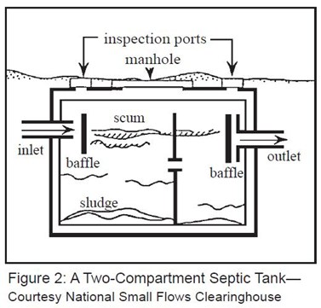

The Drainfield
Further treatment of wastewater occurs in the soil beneath the drainfield. The drainfield consists of long underground perforated pipes or tiles connected to the septic tank. The network of pipes is laid in gravel-filled trenches (2-3 feet wide), or beds (over 3 feet wide) in the soil. Liquid waste or effluent flows out of the tank and is evenly distributed into the soil through the piping system. The soil below the drainfield provides the final treatment of the septic tank effluent. After the effluent has passed into the soil, most of it percolates downward and outward, eventually entering the groundwater. A small percentage is taken up by plants through their roots or evaporates from the soil.

The soil filters the effluent as it passes through the pore spaces. Chemical and biological processes treat the effluent before it reaches groundwater, or a restrictive layer, such as hardpan, bedrock, or clay soils. These processes work best where the soil is somewhat dry and permeable and contains plenty of oxygen. The size and type of drainfield depends on the estimated daily wastewater flow and soil conditions.

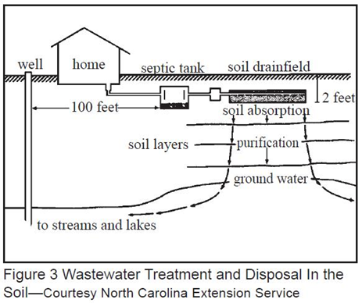

Tips for using your septic system
A septic system cannot treat wastewater if the tank is not used and maintained properly. Here are a few tips for installing and using your septic system:
- For future maintenance and to avoid deep root planting and other damaging activities in the drainfield area, make an accurate diagram showing the location of your tank, drainfield and replacement area.
- Keep a record of pumping, inspection, and other maintenance. Include name, address and phone numbers for installers and pumpers.
- To simplify tank access for inspection and maintenance, install a watertight concrete riser over the septic tank.
- The area over the drainfield should be left undisturbed, with only a mowed grass cover. Roots from nearby trees or shrubs may clog and damage your drain lines.
- Keep automobiles and heavy equipment off the drainfield.
- Do not plan any building additions, pools, driveways, or other construction work near the septic tank, drainfield or the replacement drainfield area.
- Do not put too much water into the septic system.

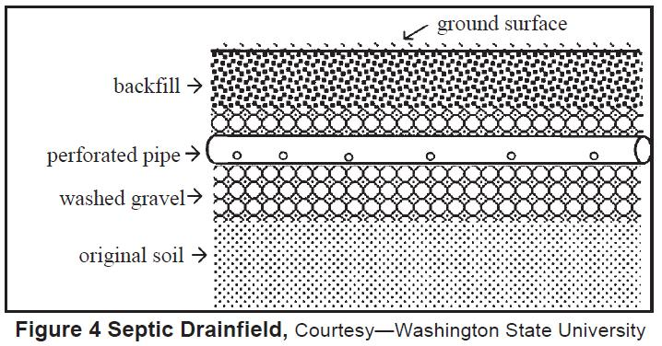

Water overload occurs when the drainfield is flooded with more water than it can effectively absorb, reducing the ability of the system to drain wastes and filter sewage before it reaches groundwater. It also increases the risk that effluent will pool on the ground surface and run off into surface water or down nearby water well casings. Typical indoor water use is about 50 gallons per day for each person in the family. Water-saving devices such as low-flow shower heads, faucet aerators, toilet dams or low-flow toilets can greatly reduce water flow into the system. Strategies such as taking short showers, spreading out laundry loads over the week and never allowing rainwater from downspouts to enter the septic system will also help.
- Do not flush non-biodegradable materials such as plastics, disposable diapers, sanitary napkins and applicators; they rapidly fill up the tank and will clog the system.
- Restrict the use of your kitchen garbage disposal; it increases the amount of solids in the tank, making them slower to decompose.
- Do not pour grease or cooking oils down the sink drain because they solidify and clog the drainfield.
- Do not allow paints, motor oil, pesticides, fertilizers or disinfectants to get into your septic system. They can pass directly through the septic system and contaminate groundwater. These chemicals can also kill the microorganisms which decompose wastes and can damage the soil in the drainfield.
- Do not use caustic drain openers for a clogged drain. Instead use boiling water or a drain snake to free up clogs. Clean your toilet, sinks, shower and tubs with a mild detergent or baking soda rather than the stronger and potentially system-damaging commercial bathroom cleansers.
- If you have a water softener, the size of the drainfield must be increased to accommodate the additional flow. The salt recharge solution should not be allowed to enter the system if the predominant soils in the drainfield are very fine textured, and drainage is very slow. In these situations, sodium in the softener recharge solution may change soil structure in the drainfield and plug the system.

How will I know when to pump the tank?
Pumping frequency depends on three variables: the size of your tank, the number of people in the household, and the volume of solids in your wastewater. If you are unsure about when to have the tank pumped, observe the yearly rate of solids accumulation in the septic tank (see MSU Extension https://waterquality.montana.edu/well-ed/care-maintenance/index.html
The solids should be pumped out of the septic tank by a licensed septic contractor. Most county health departments recommend that the accumulated solids in the bottom of the septic tank be pumped out every three to five years, although if the tank is large and the household is small a tank can function longer without requiring pumping (see Table 1).
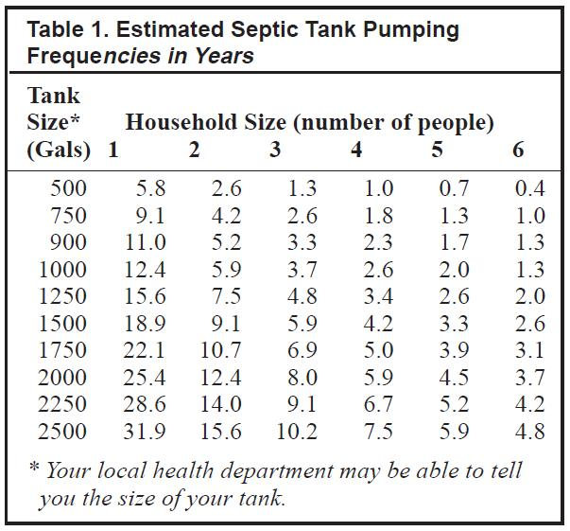

What is septic system failure?
A septic system should effectively accept liquid wastes from your house and prevent biological and nutrient contaminants from getting into your well or nearby lakes and streams. Anytime these things do not happen, the system is failing.

For example, when waste backs up in your backyard, the system has obviously failed. If significant amounts of biological or nutrient contaminants reach your well or surface waters, the system is also failing, even though it may appear to be working just fine.

Why septic systems fail?
Most septic systems are designed to have a lifetime of 20 to 30 years, under the best conditions. However, many septic systems will fail before this time. Eventually, the soil around the absorption field becomes clogged with organic material, making the system unusable. Many other factors can cause the system to fail well before the end of its "design" lifetime. Pipes blocked by roots, soils saturated by storm water, crushed tile, improper location, poor original design, or poor installation can all lead to major problems.

But by far the most common reason for early failure is improper maintenance by homeowners. When a system is poorly maintained and not pumped out on a regular basis, sludge (solid material) builds up inside the septic tank, then flows into the absorption field, clogging it beyond repair.

How to know if your system is failing
These symptoms tell you that you have a serious problem:
- Sewage backup in your drains or toilets. This is often a black liquid with a disagreeable odor.
- Slow flushing of your toilets. Many of the drains in your house will drain much slower than usual, despite the use of plungers or drain cleaning products.
- Surface flow of wastewater. Sometimes you will notice liquid seeping along the surface of the ground near your septic system. It may or may not have much of an odor associated with it.
- Lush green grass over the absorption field, even during dry weather. Often, this indicates that an excessive amount of liquid from your system is moving up through the soil, instead of downward as it should. While some upward movement of liquid from the absorption field is good, too much could indicate major problems.
- The presence of nitrate or bacteria in your drinking water well. This indicates that liquid from the system may be flowing into the well through the ground or over the surface. Water tests available from your local health department will indicate if you have this problem.
- Buildup of aquatic weeds or algae in lakes or ponds adjacent to your home. This may indicate that nutrient-rich septic system waste is leaching into the surface water. This may lead to both inconvenience and possible health problems.
- Unpleasant odors around your house. Often, an improperly vented plumbing system or a failing septic system causes a buildup of disagreeable odors around the house.

Could an additive help my system?
A number of products are marketed with the pledge that they can keep septic systems operating smoothly, correct system upsets, or do away with the need to pump the tank periodically. These are either chemical additives (strong acids or alkalis, or organic solvents) or biological additives (cultures of harmless bacteria or yeast, plus waste-digesting enzymes).

Although some manufacturers of additives have test data showing how their products perform, there has been almost no independent testing of these products in full-sized septic systems. The existing information does not show improved long-term performance in systems where additives have been used. If a system is not being misused by the homeowner, these products are unlikely to pose a benefit. The amount of material added with each dose of product is very small compared to the biological material already present and working in the tank.

Occasionally a system suffers an upset, when the septic tank bacteria are harmed or destroyed. This can happen if the home is vacant for a long period and the tank receives no fresh wastewater, or if strong cleaning agents are flushed down the drain. After a few days of normal use, the biological system in the tank will re-establish itself. In this situation the biological additives may help speed the recovery of the septic tank.

Every septic tank needs to be pumped periodically, because all wastewater contains inert matter that cannot be degraded in the tank. No additive can do away with this need.

Could an additive harm my system?
The biological additives are unlikely to be harmful. The chemical additives could definitely harm your system. These products have the potential to sterilize your system temporarily. The resulting passage of raw sewage into the drainfield will hasten its failure. The acid and alkali products can corrode the plumbing and the tank. The organic solvents pass through the system unchanged. They can then infiltrate into the groundwater, creating a chemical plume that endangers nearby wells.
  - For information on evaluating a septic system when selling or purchasing property, inspecting solids levels in a septic tank and septic system troubleshooting, see MSU Extension https://waterquality.montana.edu/well-ed/care-maintenance/index.html

Required design features are set forth in DEQ Circular 4 (December 2023)," Montana Standards for Subsurface Wastewater Treatment Systems," published by the Water Quality Division, Montana Department of Environmental Quality.

References:
Adapted from Montana State University Extension Service MONTGUIDE MT199401 HR 10/2002
Septic Tank and Drainfield Operation and Maintenance, by Michael P. Vogel, Ed.D., and Gretchen L. Rupp, P.E.

