Standard Operating Procedures for Lagoon Operators Personal Protective Equipment (PPE)

Personal Protective Equipment (PPE) is necessary for lagoon operators to be safe working around wastewater. Safety precautions may include wearing disposable gloves, eye protection, foot protection, respiratory protection, hand washing, and cleaning tools after completing the work.

HAND PROTECTION 29 CFR 1910.138
Employers shall select and require employees to use appropriate hand protection when employees' hands are exposed to hazards such as those from skin absorption of harmful substances; severe cuts or lacerations; severe abrasions; punctures; chemical burns; thermal burns; and harmful temperature extremes."
Disposable gloves come in many different types for different jobs. Probably the most used type of glove by operators is nitrile. Nitrile gloves come in different thicknesses. The thinner the glove, the easier it is to tear, but the cost is less. Most of the operators that use disposable nitrile gloves opt for a glove that is about 6 to 8 mm. They can be purchased through several vendors, USA Blue Book or from an auto part store, etc. If necessary, you can use two layers of nitrile gloves or put leather gloves over the nitrile glove to prevent the tearing of the nitrile glove. Nitrile gloves are not abrasion resistant. Anytime there is an opportunity for wastewater to touch your hands, you should wear some type of had protection. Whether that is completing maintenance, working with laboratory equipment, or collecting samples. Always wash your hands after dealing with wastewater, whether you are wearing gloves or not. Use hand sanitizer if water is not available.

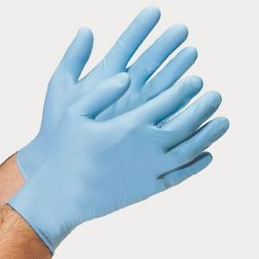
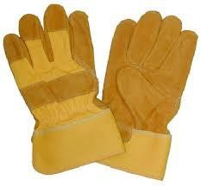

EYE AND FACE PROTECTION 29 CFR 1910.133

"The employer shall ensure that each affected employee uses appropriate eye or face protection when exposed to eye or face hazards from flying particles, molten metal, liquid chemicals, acids or caustic liquids, chemical gases or vapors, or potentially injurious light radiation."
Safety glasses are probably the most used option for instances requiring eye protection. Other types of eye protection include, but are not limited to, face shields or goggles.
Safety glasses are the easiest to use and are the most comfortable of the three. They can be sunglasses or clear lens. Many prescription glasses can be made as safety glasses. If there is an opportunity for wastewater or a chemical to splash your eyes, you should have some sort of eye protection also, if you are doing maintenance, grinding, cutting, or similar work, you need to protect your eyes from flying objects. Many facilities require operators to wear safety glasses whenever they are onsite.
Safety Glasses: these protective eyeglasses have safety frames constructed of metal or plastic and impact-resistant lenses.
Goggles: these provide tight-fitting eye protection that completely covers the eyes, eye sockets, and the facial area immediately surrounding the eye— pro from impact, dust, and splashes.
Face Shields: these transparent sheets of plastic extend from the eyebrows to below the chin and across the entire width of the head. They protect against nuisance dust and potential splashes or sprays of hazardous liquids, but will not provide adequate protection against impact hazards.
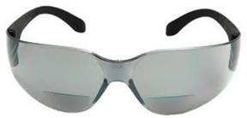
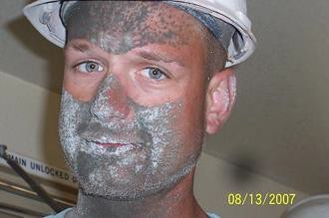

FOOT PROTECTION29 CFR 1910.136
"The employer shall ensure that each affected employee uses protective footwear when working in areas where there is a danger of foot injuries due to falling or rolling objects, or objects piercing the sole, and where such employee's feet are exposed to electrical hazards."
There are different types of foot protection depending on what is needed: Rubber boots if you are going to be in water; insulated boots if you are going to be in cold weather most of the time; and footwear with special gripping sloes for slippery conditions. Of the many types of footwear, probably the most common are steel-toed boots. This may not

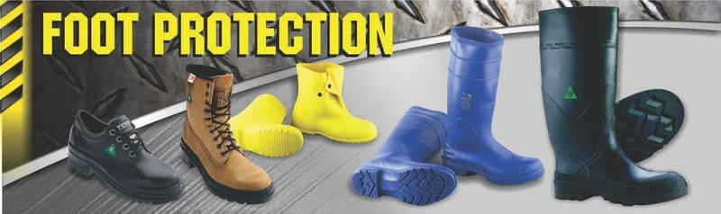
work for you, so there are a few other options available. The operator may opt to wear toe covers. These slip over your regular shoes to protect the arch and toes. They have elastic around the bottom and a strap that goes behind the heel of your shoe. They are clumsy and can be difficult to wear but will provide the required protection. The better option is to wear a shoe or boot with the protection built into the foot covering. The protection can be either steel or a composite. Steel is usually cheaper, but composite is lighter and warmer. Steel in cold temperatures will make your toes cold. The above protection can be purchased in an insulated boot (Muck brand), tennis shoes, dress shoes, cowboy boots, and regular work boots. Always wear the correct type of footwear necessary to protect your feet. Do not wear the boots/shoes that you wear at work at home. You do not want to bring home anything that can make your family sick.

RESPIRATORY PROTECTION29 CFR 1910.134
"Respiratory Protection is required for all employees that:
- work in situations where the level of oxygen is insufficient, or potentially insufficient, or
- are potentially exposed to harmful levels of hazardous gases or vapors, or
- are exposed to other potential respiratory hazards, such as dust, mists, fumes, sprays, and other airborne particles."
There are different types of respiratory protection. Examples of respiratory protection are listed below:
Air-Purifying Respirators (APR)
  - Not approved for use in oxygen-deficient atmospheres
  - Allow contaminant breakthrough, therefore, need adequate warning properties

  - Approved for atmospheres containing specific chemicals up to designated concentrations
  - If leaks develop, wearer draws in contaminated air
  - Types of APR:
    - Filtering Face Piece (N95) (dust mask)
    - Half-Face Air-Purifying Respirator (HF-APR)
    - Full-Face Air-Purifying Respirator (FF-APR)
    - Powered Air-Purifying Respirator (PAPR)
    - Canister Type Respirator (CTR) Atmosphere Supplying Respirators (ASR) Supplied Air Respirators (SAR)
  - Only positive pressure SAR's with escape Self Contained Breathing Apparatus (SCBA's) are recommended for IDLH atmospheres
  - All SAR couplings must be incompatible with the outlets of other gas systems used on-site to prevent the worker from connecting to an inappropriate compressed gas source
  - Airlines should be no longer than 300 feet
  - The use of air compressors as the air source is limited by the questionable quality of the ambient air.
Self-Contained Breathing Apparatus (SCBA)
  - Only positive pressure SCBA's are recommended for IDLH atmospheres
Abrasive Blasting (Loose-Fitting) Respirators (ABR) Escape-Only Self-Contained Breathing Apparatus (ESCBA)
Determine that the proper respirators are being used to:
  - Limit exposure to potential contaminants
  - Protect against the specific hazard levels in work areas
  - Coincide with the amount of oxygen in the workplace Determine that the respirators are being used properly by:

  - Ensuring certified grade D breathing air for Self-Contained Breathing Apparatus's and Atmosphere Supplying Respirator’s requirements
  - Ensuring employees are medically certified and fit-tested
  - Conducting a medical evaluation
    - The employer shall provide a medical evaluation to determine the employee's ability to wear a respirator before the employee is fit tested or required to use the respirator in the workplace.
  - Conducting a respirator fit test
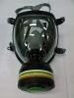
    - Before an employee uses a respirator, whenever a different facepiece is used, and at least annually thereafter, the employee must be fit tested with the same make, model, style, and size of respirator that will be used.
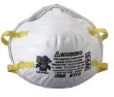
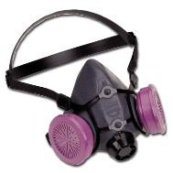
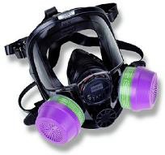

SAFETY DATA SHEETS (SDS)
Safety Data Sheets are required for all chemicals on-site and have a legally required format the Safety Data Sheets must adhere to. The format requires the following:
  - Identification
  - Hazard(s) identification
  - Composition/information on ingredients
  - First-aid measures
  - Firefighting measures
  - Accidental release measures
  - Handling and storage
  - Exposure controls/personal protection
  - Physical and chemical properties
  - Stability and reactivity

  - Toxicological information
  - Ecological information
  - Disposal considerations
  - Transport information
  - Regulatory information
  - Other information
The SDS provides the operator with the information to protect themselves from injury.

HEARING PROTECTION1926.52(a)

Protection against the effects of noise exposure shall be provided when the sound levels exceed those shown in Table D-2 of this section when measured on the A-scale of a standard sound level meter at slow response.
There are different types of hearing protection available, earmuffs, and earplugs. The operator needs to be aware of loud noises when working around machinery, especially blowers. Many lagoon systems have old blowers that are extremely loud and can damage hearing. The operator has the option of either turning off the loud equipment or wearing some sort of hearing protection. Earplugs have the best noise reduction rating (NRR) and either need to be specially made, or there are disposable earplugs. Earmuffs are easier to use but need to be stored, so they are clean when the operator needs to wear them. Hanging them on a peg next to the blower is probably not a good idea as they may collect dirt and duct on the pads, and insects can build nests inside the earmuffs.
Earmuffs: 20-27 NRR Earplugs: 26-35 NRR
NRR = "Noise Reduction Rating" = how much noise in decibels the device will reduce for the wearer.
OSHA’s PEL = 90 dBA (8 hr TWA) Action Level = 85 dBA (8-Hour TWA)



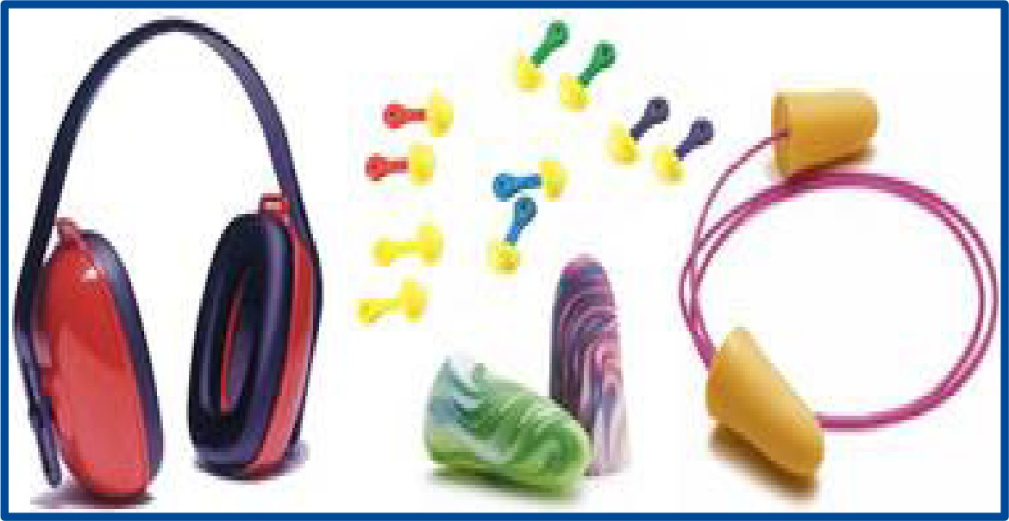

Some Common Decibel Levels

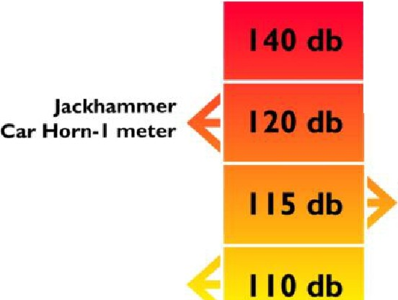
Hearing Threshold of Pain
130 db

� Gunshot, Fireworks
..,,. Airplane takeoff - 25 Meters

iPod at Peak Volume
Baby Crying

Chainsaw Airport

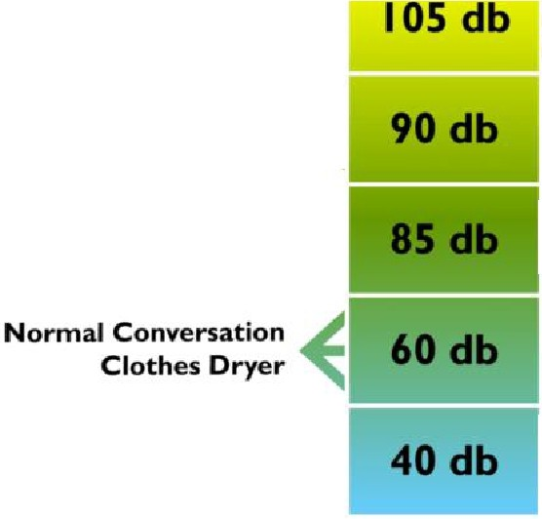
Rock Concert Helicopter

Hair Dryer ,L.
Lawnmower �

� Busy City Traffic
7' Vacuum Cleaner

�Raindrop 7'Quiet Room

Noise Exposure Levels
Noise-induced hearing damage is related to the duration and volume of exposure. Government research suggests the
safe exposure limit is 85 decibels for 8 hours a day.

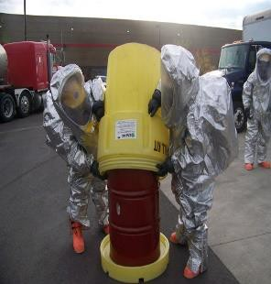

CHEMICAL PROTECTIVE CLOTHING
- Level A
  - Highest respiratory, skin, and eye protection
  - SCBA or SAR
  - Fully encapsulating, chemical resistant suit
- Level B
  - Highest respiratory and less skin protection than level A
  - SCBA or SAR,
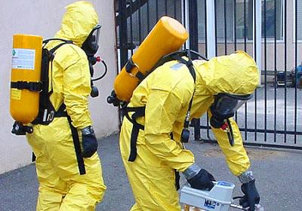
    - Chemical resistant clothing one- or two-piece chemical splash suit

- Level C
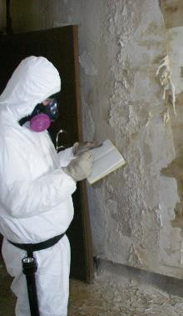
  - Same skin protection as Level B and lower respiratory protection
  - Full-face or half-face, air-purifying, canister-equipped respirator
  - Chemical resistant clothing

- Level D
  - No respiratory protection
  - Minimal skin protection (regular clothing)
  - Safety boots or shoes
  - Other items as needed

OTHER PPE ITEMS
Change clothes before work and after your shift is done. It is a smart thing to have two lockers at work—one for street clothes and one for work clothes. Change into the clothes you are going to wear during the work shift and after showering change into the street clothes. Two lockers will keep your clothes from contaminating the other set.
Some facilities have uniforms for the operators. This keeps your clothes separate. If uniforms are not furnished, have several sets of clothes you wear just for work and keep them separate from the regular clothes you wear around the family.

HARD HAT
Hard hats are necessary for construction areas. Some facilities require a hard hat or bump caps to be worn by all personnel who are out in the plant working. For normal activities in the facility, wearing a hard hat is up to the management of the facility.

COVERALLS
Coveralls fall under Level D in chemical protective clothing. Many operators wear coveralls to prevent their clothes from becoming damaged or stained. The coveralls also protect from splashing. The coveralls can be left at the facility and washed there. This prevents bringing home any disease from work.

RAIN SUIT
Rain suits are not just for the rain. If you are going to do a job where it is wet and dirty, then a rain suit might just be the answer. Another option is just wearing a part of a rain suit such as the bottoms or top to keep you clean and dry. Keeping sewage off your body will help you stay healthy.

