REQUIREMENTS FOR SUBMITTING NONCOMPLIANCE REPORTING FORMS
The following directions are to assist the operator in locating the Noncompliance Reporting Form (NCR) and Sanitary Sewer Overflow (SSO) Event Form.
MPDES DISCHARGE PERMIT NONCOMPLIANCE REPORTING
Noncompliance reporting is required when a permittee identifies a condition(s) that is not in compliance with their discharge permit, or when a permittee determines they will not be able to comply with a condition(s) of their permit. Examples of noncompliance include but are not limited to: any noncompliance that may endanger health or the environment, a discharge of pollutants from the construction project site to state waters, failure of installed Best Management Practices (BMPs) and failure to conduct inspections.
SANITARY SEWER OVERFLOW EVENT REPORTING
SSOs are discharges of wastewater (including that combined with rainfall induced infiltration/inflow) from a separate sanitary sewer prior to treatment at the wastewater treatment plant. SSOs typically release untreated sewage into basements or out of manholes and onto city streets, playgrounds, and into streams. SSOs can be attributed to the sanitary sewer collection system being improperly designed, operated and/or maintained. SSOs are a threat to public health and the environment.

TIMELINES TO REPORT NONCOMPLIANCE
The permittee is required to adhere to the following oral and written reporting timelines.
24-Hour Notification

The permittee must provide an oral report to the Compliance, Training and Technical Assistance Section (CTTA) within 24 hours of first identifying the noncompliance. The permittee may contact a Compliance Inspector directly, the CTTA Section Supervisor (406) 444-0917, the Water Protection Bureau (406) 444-5546, or the Water Quality Division at (406) 444-6697. If the noncompliance occurs on a weekend, the permittee may leave a voice mail message at any of the above telephone numbers.
Written Report

A written report must be submitted to the CTTA within five days of the discovery

of noncompliance. The Noncompliance Reporting Form (NCR) or Sanitary Sewer Overflow (SSO) Event Form must be completed and mailed to the address below or uploaded to the FACTS (https://deq.mt.gov/Public/FACTS) database within five days of the 24-hour oral report. The form can be found under permitting titled ‘Noncompliance Reporting Forms’ at: https://deq.mt.gov/Water/Resources/forms#
The mailing address for the DEQ is as follows:
Montana Department of Environmental Quality, Water Protection Bureau c/o (Compliance Inspector)
P.O. Box 200901
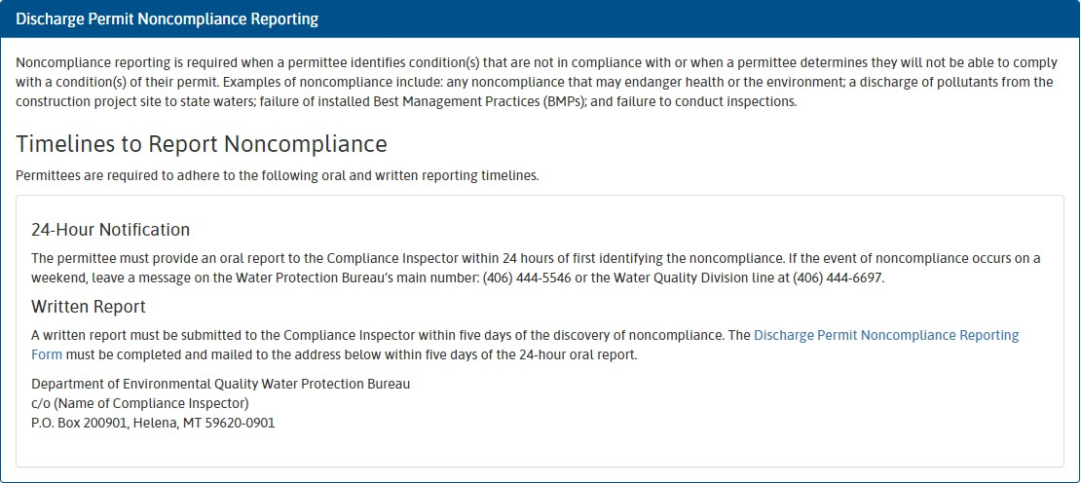
Helena, MT 59620-0901

