Draft Standard Operating Procedures for Lock-Out Tag-Out (LO/TO)

(29 CFR 1910.147)
This standard covers the servicing and maintenance of machines and equipment in which the energization, or startup of the machines or equipment, causes a release of stored energy that could harm employees. This standard establishes minimum performance requirements for the control of such hazardous energy.

- Each piece of equipment that has the potential to injure the operator with the release of stored energy, either electrical or hydraulic, must be locked out and tagged
- There is a way to lock out almost everything in a wastewater treatment plant (WWTP)
  - Valves can be chained in place
  - Covers are available to go over handwheels that can be locked
  - Electrical panels can be locked
  - Individual breakers can be covered and padlocked
  - Starter units have a location available to insert a lock or hasp through to prevent power from being turned on
- Each person working on the piece of equipment should place their lock on the unit
- A multiple lockout hasp is used when there will be more than one person working on a piece of equipment. This item allows multiple locks to be attached to a single unit. Each person working on the unit should have their lock and tag attached to the multiple lockout hasp
- Do not cut off someone else's lock. You have to find the person whose lock is still on the unit and have them remove it

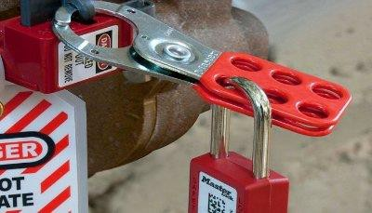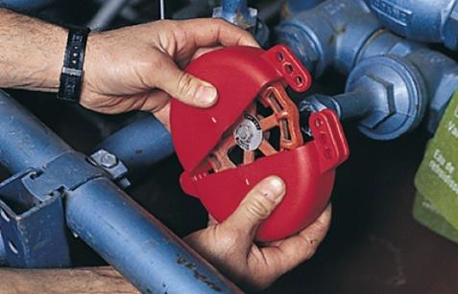
Multiple Lockout Hasp Cover to Lockout a Handwheel

- The tag that is attached to the lock to indicated who locked out the equipment should contain the following information:
  - Name of the person who is locking out the piece of equipment
  - The date that the equipment is locked out
  - The tags are usually labeled
    - “Danger”
    - “Do Not Operate”
    - “Equipment is Locked Out”
- When all work is completed on the equipment, the lock/s and tag/s can be removed and the equipment can be placed back into service
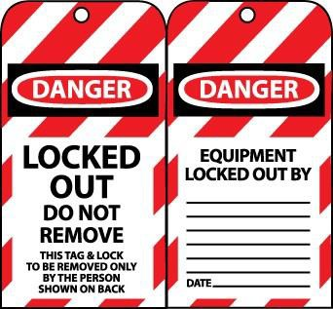
PROCEDURE TO FOLLOW WHEN LOCKING OUT EQUIPMENT
- Have tag, lock, and locking device at the site
- Make sure the equipment is turned off
- Complete the tag with your name and the date
- Use the lockout device to make the equipment inoperable

- Attach tag and lock to the lockout device
- Perform work on the equipment
- Remove the tag and lock from the lockout device
- Check unit for proper operation
- If the equipment is working properly, put the unit back into service
- Return tag, lock, and locking device to the proper storage location

