Sample Preparation and Collection
Selecting a Laboratory, Ordering Sampling Bottles, Sample Collection and Sample Shipping

Before proceeding with the steps outlined in this guidance document, your school should have completed the plumbing history and inventory forms. A sampling plan is also required and is created using the plumbing inventory. Once those tasks are completed and submitted to DEQ, your school can move forward to the sampling tasks.

STEP 1: Selecting and Coordinating with a Laboratory

Schools are required to have the water samples analyzed by a laboratory (lab) that is certified by the State of Montana to analyze for lead. A list of certified labs can be found on DEQ’s Lead Reduction in Schools Drinking Water Program webpage at: https://deq.mt.gov/water/programs/dw

When selecting a lab, consider the location. If the lab is close, you may be able to pick up sample containers and drop off your samples directly at the lab. Some labs may offer courier services. If you are not within a short drive of a lab, you will have to receive and send your samples through a shipping service (FedEx, UPS, etc).

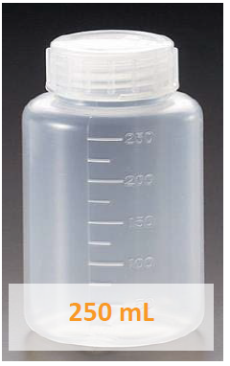
When contacting the lab, please let them know the following:
- The school is collecting samples as part of the Lead in School Drinking Water Program.
- A 250 milliliter (ml) unpreserved sample container is needed for each sample
- The number of samples the school plans on collecting and make to ask for a few extra containers.
- Whether the school is public or private. (only public schools are eligible for the sample reimbursement grant program).
- Ask about either courier service or the lab’s shipping procedures.
- The school name and school PWS ID number. The PWS number is assigned to schools by DEQ once the school setup documentation is submitted and will have a format of MT-OPI####. If you don’t have a school PWS ID, please contact DEQ. If a school is a standalone public water system, do not use your PWS ID. DEQ will assigned a separate school PWS ID.
- The date you are planning on sampling. Try to give the lab at least a one-week notice before you need the sample containers.

STEP 2: Preparing to Sample

The next step is to prepare to collect the samples. It’s important to be organized and will make sampling a lot easier and faster. Make sure to complete the following steps:
- Once you have received the sample containers from the laboratory, make sure that you have what you ordered.
- Review the school’s sampling plan. The sampling plan was created during the school setup step.
- Print out a Lead in School Chain of Custody (COC) form from the DEQ webpage at: https://deq.mt.gov/water/programs/dw
- Fill out the top portion of the COC using the “How to fill out COC” guidance document located on the DEQ webpage.
- Fill out the labels on the sample containers. It’s easier to fill out the labels before you fill them with water. Labels may differ depending on the lab selected, but they all should have at least a section for sample ID, date, and time. You can write in the time after you collect the sample. Fine tip Sharpies usually work the best. Be careful using gel pens as they have tendency of bleeding if the label gets wet.
- Determine when you are going to sample. Samples should be collected after a 6-18 hour stagnation time. Typically that would be in the morning before school starts.
- Samples do not have to be sampled all in one day. Samples can be collected over multiple days or weeks. Once a sample has been collected, you will have 10 days to get it to the lab.
- Try to avoid sampling after or during extended breaks (i.e. summer break). If you decide to sample during those breaks, make sure the water is being used on a routine basis before the sampling.

STEP 3: Sample Collection
Now you’re ready to sample! It’s important that the water samples be collected properly. Please read the following sampling procedures carefully.
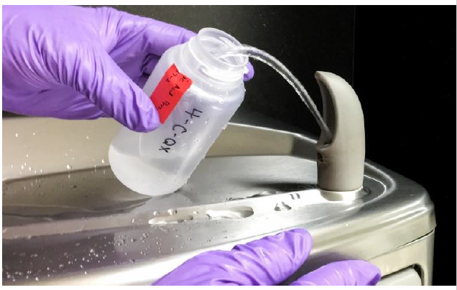
- Sample the water fixtures that are the furthest away from where the water line enters your school first, if possible. Then work your way back.
- Samples must be first draw samples, meaning your capturing the water coming from the fixture as it is first opened.
- The sample containers must be 250 ml to collect samples.
- Fixtures must not be used for a minimum of 6 hours to a maximum of 18 hours prior to sample collection. Because of this requirement, the best time to collect samples is early in the morning. This requirement is necessary to mimic the water that may be consumed on a typical morning by children. Lead concentrations in water are potentially the highest at this time.
- Do not touch the inside of the cap or bottle with your fingers.
- Place the opened sample container beneath the fixture and gently open the cold water tap. Do not sample from the hot water tap. Fill the container to the fill line, or to the top depending on the container.
- Place the cap back on the container and tighten. Place the sample container back in the laboratory-provided kit.
- Write the time the sample was collected on the container label and on the Chain of Custody form. Double check the sample ID to make sure it is correct.
STEP 4: Getting the Samples to the Laboratory
- Once you have collected the samples, the next step is getting them to the lab for analysis. Follow the lab’s instructions for how to pack and transport the samples. The lab likely gave you the sample containers in a cooler. If instructions were not in the cooler, contact your lab for guidance.
- Depending on where your lab is located, samples can either be directly delivered to the lab or they have to be shipped.
- Make sure a signed copy of the COC form is placed in the cooler with the samples. Place the COC form in a ziplock bag to prevent it from getting wet.
- If you are shipping the samples, the cooler will have to be sealed using packing tape (using duct tape is not recommended).
- Samples do not have to be packed in ice.

