Guide for Submitting Online Payments
If you need to pay permit fees online, send a hard copy application or need to adjust the payment fee, you may follow these instructions to pay the fee using a credit card or debit card to satisfy the payment.

The Asbestos Control Program has a separate online application system with the ability to submit the fee at the same time, that should be used for your next permitting requests. Please visit https://deq.mt.gov/cleanupandrec/programs/asbestos

*Be sure to send a receipt to the program to complete the submittal requirements and start the NESHAP required 10-working day review. *

Step One
1. Go to Department of Environmental Quality website http://deq.mt.gov.

Step Two

Step Three

1. On the left-hand side of the page, find the “PAY A BILL” tab.
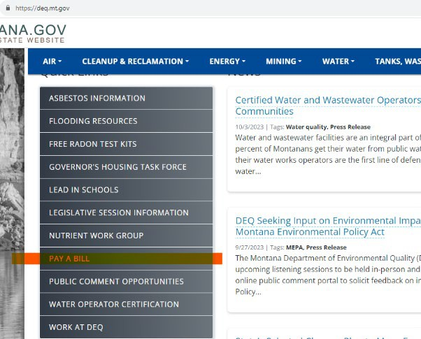

- Select “Credit/Debit Card” for Payment Type then “Add item.”

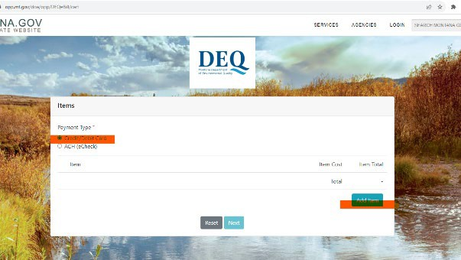

Step Four

Step Five

  - Scroll to the bottom of the “Add an Item” list and select “Number Invoice Starts With is Not Listed.”
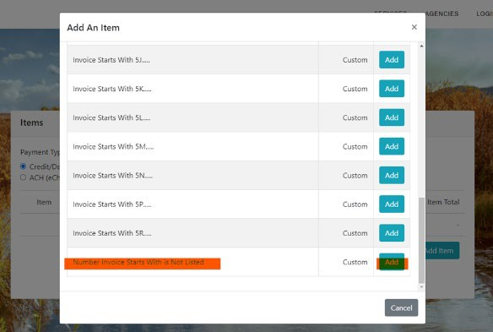

- Enter the dollar amount under “Item Cost”.
- Under “Invoice #” enter “Asbestos Control Program”
- Under “Customer Number” enter the projects name used on the application
- Under “Business / Customer Name” enter the name that submitted the application or company name.
- Select “Next”

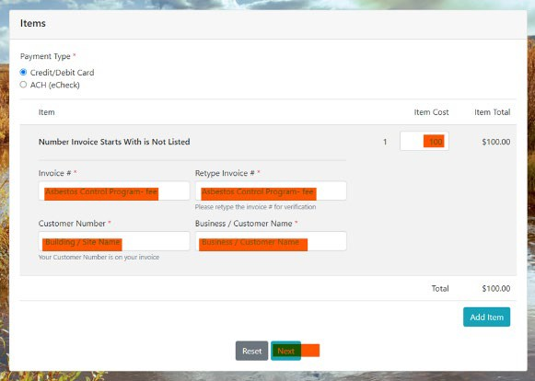

Step Six
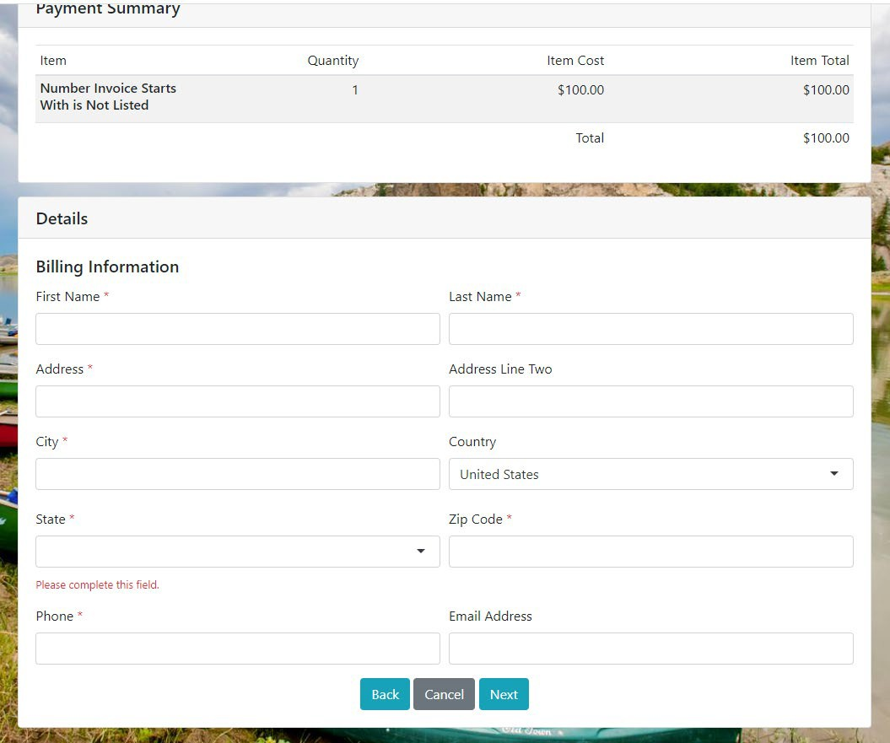
  - Enter billing information.

Step Seven
- Enter Credit / Debit Card information.
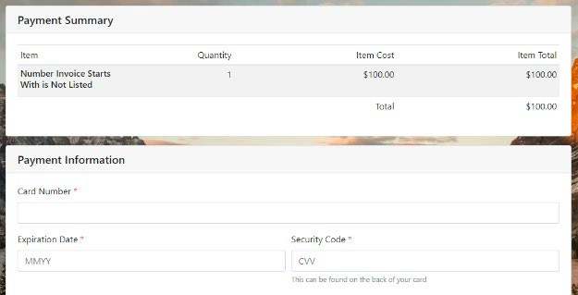
- Select “Next” when complete.
Step Eight
  - Once payment is submitted send the program a copy or screen shot of the electronic receipt to deqacponline@mt.gov.

Should you have any questions, comments, or concerns please feel free to contact the program at 406-444-5300 or deqacponline@mt.gov.

Thank you,

