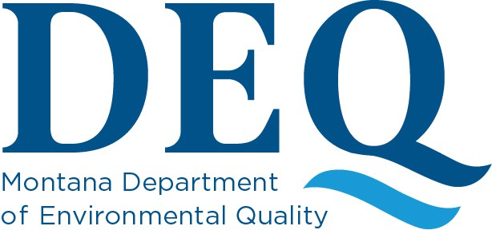

Emergency Notification and Ordered Demolition Resource
The Asbestos Control Program (ACP) is providing this document to assist owners and operators in determining the difference between an Emergency Notification and an Ordered Demolition.

Emergency Notification

- An emergency renovation operation means “a renovation operation that was not planned but results from a sudden, unexpected event that, if not immediately attended to, presents a safety or public health hazard, is necessary to protect equipment from damage, or is necessary to avoid imposing an unreasonable financial burden. This term includes operations necessitated by nonroutine failures of equipment.”
- The owner or operator of the facility shall immediately notify DEQ by submitting a completed Emergency Notification form to the program.
- Once the Emergency Notification is submitted to DEQ, the cleanup effort may begin immediately.
- The owner or operator must submit a completed application for an Asbestos Project Permit within five working days after the initial Emergency Notification.
- If structural members of the facility must be impacted during the renovation activities, a Demolition Notification is due at the same time the Asbestos Project Permit is submitted.

Ordered Demolition

- A demolition means “the wrecking or taking out of any load-supporting structural member of a facility together with any related handling operations or the intentional burning of any facility.”
- A state or local governing agency may issue an Ordered Demolition on official letterhead to have a structure demolished immediately because it is structurally unsound and in danger of imminent collapse. The owner or operator must submit a Demolition Notification form along with the Order issued by the government agency.
- If a facility is demolished before regulated asbestos-containing material (RACM) (identified or assumed) can be removed, an Asbestos Project Permit is required along with the Demolition Notification. An immediate start date is then allowed.
Please contact ACP with any questions at 406-444-5300 or deqacponline@mt.gov

Supplemental Definitions:
Asbestos-containing waste materials means “mill tailings or any waste that contains commercial asbestos and is generated by a source subject to the provisions of this subpart. This term includes filters from control devices, friable asbestos waste material, and bags or other similar packaging contaminated with commercial asbestos. As applied to demolition and renovation operations, this term also includes regulated asbestos-containing material waste and materials contaminated with asbestos including disposable equipment and clothing.”

An Asbestos Project Permit application must be submitted to DEQ by contractors when doing any renovation project that involves more than 10 square feet, 3 linear feet, or 3 cubic feet of asbestos-containing material. The permit application and corresponding fees must be submitted to DEQ 10 working days prior to any asbestos related activities. DEQ will then issue a Project Permit to the contractor.

A Demolition Notice is submitted to DEQ by contractors for any demolition activity that will impact a load-supporting member of a facility (e.g., wall). The notice and corresponding fee must be submitted to DEQ 10 working days prior to starting demolition activities. DEQ will then issue a Demolition Acknowledgement to the contractor.
A facility means “any institutional, commercial, public, industrial, or residential structure, installation, or building (including any structure, installation, or building containing condominiums or individual dwelling units operated as a residential cooperative but excluding residential buildings having four or fewer dwelling units); any ship; and any active or inactive waste disposal site. For purposes of this definition, any building, structure, or installation that contains a loft used as a dwelling is not considered a residential structure, installation, or building. Any structure, installation or building that was previously subject to this definition is not excluded, regardless of its current use or function.”

Regulated asbestos-containing material (RACM) means “friable asbestos material, Category I nonfriable ACM that has become friable, Category I nonfriable ACM that will be or has been subjected to sanding, grinding, cutting, or abrading, or Category II nonfriable ACM that has a high probability of becoming or has become crumbled, pulverized, or reduced to powder by the forces expected to act on the material in the course of demolition or renovation operations regulated by this definition.”

A renovation means “altering a facility or one or more facility components in any way, including the stripping or removal of RACM from a facility component. Operations in which load-supporting structural members are wrecked or taken out are demolitions.”

Please contact ACP with any questions at 406-444-5300 or deqacponline@mt.gov

