
SAFE NEEDLE DISPOSAL
The safe disposal of needles, syringes, and lancets – also called “sharps” is critical to prevent risks to the public, sanitation and sewage treatment workers, janitors, housekeepers, and children from improper disposal. Instead of placing sharps directly in the trash, consider any one of these disposal methods:

DROP BOX OR SUPERVISED COLLECTION SITES
Some communities offer collection sites that accept used needles.
Check with your pharmacist or health care provider for availability in your area.

AT-HOME NEEDLE DESTRUCTION DEVICES

MAIL BACK PROGRAMS
Used sharps are placed in special containers and are then mailed to a collection site for proper disposal. You pay for this service, and the price often depends upon the size of the container that you pick. When contacting a mail-back service company, be sure to ask them if their service is approved by the U.S. Postal Service or similar parcel/postal services, e.g., UPS, FedEx, etc...
For a list of mail-back service companies, contact Safe Needle Disposal at 1-800-643-1643, Monday through Friday, 9am-5pm EST, or visit their website at: www.safeneedledisposal.org

SYRINGE EXCHANGE PROGRAMS

Several manufacturers offer products for sale that allows you to destroy used needles at home. These devices sever, burn, or melt the needle – making it safe for disposal. Prices vary depending on the product. Ask your pharmacist or search the internet using the keywords “sharps disposal devices”.

For a list of mail-back service companies, contact Safe Needle Disposal at 1-800-643-1643, Monday through Friday, 9am-5pm EST, or visit their website at: www.safeneedledisposal.org

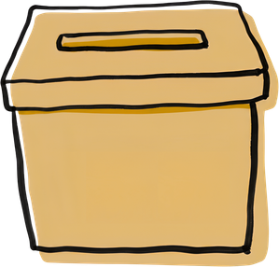
OTHER RECOMMENDATIONS
Questions? Contact the DEQ Solid Waste Program at 406-444-5300
If none of the above options are available in your area, you may put the used sharps into an empty, puncture- and leak-proof container with a tight lid, like a liquid laundry detergent or bleach container.
- Don’t use a clear container, and mark or label the container with the word “SHARPS”.
- Don’t fill the container too full - this may increase pressure on the lid.
- Add some household bleach to the container to disinfect the needles
- Seal the container with a tight-fitting lid and secure it with heavy-duty tape, such as duct tape, to make sure it won’t come off.
- You may put the secured container into your regular garbage for transport to the local solid-waste landfill. However, the Department recommends you notify your local garbage hauler that you have sharps for disposal to determine if there are any additional handling requirements.

