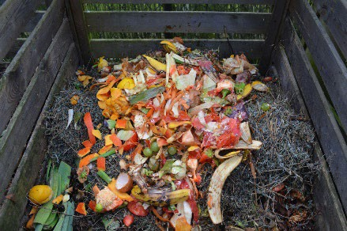
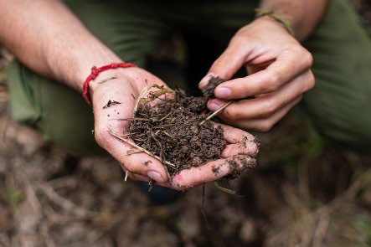


COMPOSTING IN MONTANA

The following is an overview of the importance of composting and the practical steps Montanans can take to start composting in their household. Composting is an integral part of creating a greener and less wasteful Montana. Food waste is incredibly prevalent, and it is using precious landﬁll space. Composting is a practical and accessible solution for Montanans to take a personal stand against unnecessary waste. Start composting today!

Why Compost?
According to a Gallup study, the average amount of food waste per American household is 3 pounds per week. Additionally, according to the EPA roughly 40 million tons of food waste is sent to the landﬁlls each year. Composting is an eﬃcient and fruitful way to dispose of those old vegetables and food scraps in an environmentally protective manner. Starting to compost may seem like a daunting task, but it does not have to be! Keep reading to understand some composting basics and understand how to make composting work for wherever you currently reside.

How Does Composting Work?
Composting, put simply, is product that results from the decomposition of organic matter. The process of composting is aerobic, meaning that it uses oxygen to break down its components. Four main elements are necessary for composting to be eﬀective: carbon, nitrogen, oxygen, and water. The carbon comes from “browns” which refers to carbon rich inputs such as paper or cardboard. Nitrogen comes from “greens” which refers to nitrogen rich inputs such as food waste. The generally recommended ratio of browns to greens is 70% browns (carbon rich inputs) to 30% greens (nitrogen rich inputs). With your compost think about layering the browns and greens to get a good distribution for more eﬀective decomposition. Oxygen can be added to the pile through “turning” the pile, bringing the outer, drier material inward and the inner, warmer material outward. Finally, an eﬀective compost pile should have a moisture content of 40-60%.

What Should You Compost?
- Fruits and vegetables
- Eggshells
- Paper towels, napkins, shredded brown bags and non-glossy cardboard
- Natural fabric
- Coﬀee grounds, coﬀee ﬁlters, tea leaves/bags (no staples)

- Plant stalks, twigs, and dry leaves
- Citrus fruits


What Should You Not Compost?
- Animal products like meat, ﬁsh, cheese and bones
- Fats, oils, and grease
- Pet waste and cat litter
- Dryer lint
- Produce stickers
These are general guidelines for doing your own composting indoors. If you are paying for a composting bucket from a commercial composter, check their guidelines for what you can put in your compost bucket. If you are unsure about putting something in your compost, do some research ﬁrst!

Composting In an Apartment?
If you think that composting is not an option for you because you live in an apartment, you are wrong! Let’s break down (ha!) how you can start composting in your apartment.

The easiest way to start composting in your apartment would be through a commercial service (see composting companies in Montana listed below). However, if you are unable to pay for that service or are not within the service area for a company, or you simply want to try home composting yourself then see the diﬀerent options below.

A popular method of indoor composting is called “vermicomposting” which utilizes worms to decompose the waste and create a nutrient rich compost. You can either buy a kit to get started or create your own vermicompost.
Check out the EPA’s guidance for more information on creating your own vermicompost: https://www.epa.gov/recycle/how-create-and-maintain-indoor-worm-composting-bin.

You are also able to create or buy your own compost bin (minus the worms) although ensuring adequate decomposition may be a little trickier.

Check out this resource for building your own indoor composting container: https://www.bhg.com/how-to-make-diy-indoor-compost-bin-11700866.
The ﬁnished compost can be mixed into the soil for your plants or the soil of the herb garden in your window. You can even give it to a friend to use in their garden.

Composting In a Yard or Garden?
If you live in a home with a yard or garden, then you have more options for composting as it is more feasible to compost outdoors, and you can compost larger amounts.

Again, if it is right for you, check out options for home composting containers through a local composting service in Montana. They have multiple sizes of containers and often oﬀer drop-oﬀ or curbside services.

There are countless options for purchasing a backyard composting container. You can also build your own. The EPA has created guidance for how to compost in your backyard: https://www.epa.gov/recycle/composting-home#backcom.
The ﬁnished compost can be used in your yard and garden to help improve soil health and structure. Plus, you are doing the right thing by the environment and Montana!

Some Composting Options In Montana
- Dirt Rich Composting
Columbia Falls, MT
Services: Residential, commercial pick-up in Columbia Falls, Whiteﬁsh and Bigfork. Drop-oﬀ in Columbia Falls Website: dirtrichcompost.com
Phone: (406) 212-7535
- Soil Cycle
Missoula, MT
Services: Residential and Commercial pick-up in Missoula, Drop-oﬀ location in Missoula Website: soilcyclemissoula.com
Phone: (406) 518-1253
- Garden City Compost
Missoula, MT
Services: Drop-oﬀ locations in Missoula
Website: www.ci.missoula.mt.us/2089/Garden-City-Compost Phone: (406) 552-6619
- 406 Compost
Clancy, MT
Services: Residential and Commercial pick-up in the greater Helena area Website: 406compost.com
Phone: (406) 449-6008
- Better Roots Composting
East Helena, MT
Services: Residential, commercial pick-up in Helena, East Helena, Birdseye and Montana City. Drop-oﬀ in East Helena.
Website: betterrootscomposting.com Phone: (406) 603-0114
- Happy Trash Can Curbside Composting
Bozeman, MT
Services: Residential, commercial pick-up in Bozeman, Belgrade and Livingston. Drop-oﬀ in Bozeman. Website: happytrashcan.net
Phone: (406) 570-0896
- YES Compost
Belgrade, MT
Services: Residential, commercial pick-up in Bozeman, Belgrade and Big Sky. Drop-oﬀ in Belgrade Website: yescompost.com
Phone: (406) 219-7011
- Swift Buckets
Billings, MT
Services: Residential and Commercial pick-up in Billings and Laurel Website: swiftmicrogreens.com
Phone: (406) 794-9370
- Country Compost
Havre, MT
Services: Residential and commercial pick-up in Havre Website: https://www.countrycompostllc.com/ Phone: (406) 262-0902

