
Lithium-ion
Battery FAQs

This Frequently Asked Questions (FAQs) guidance is designed to provide information on the best practice for properly handling and disposing of lithium-ion batteries.

This document is intended as general guidance for lithium-ion battery waste generated by households, not businesses, and is not meant to modify or replace applicable laws and rules governing lithium-ion battery management, which undergo periodic revisions. In the event of a conflict between this guidance and applicable laws and rules, the applicable laws and rules govern. This guidance may not cover all situations, and DEQ retains the right to allow for reasonable, situational flexibility based on an analysis of site-specific circumstances. This guidance may be revised at any time.
For more information on this FAQ, please contact Dusti Johnson (406-444-6499) or Megan Wingard (406-444-2835), DEQ’s Materials Management Specialists from the Waste Management and Remediation Bureau.
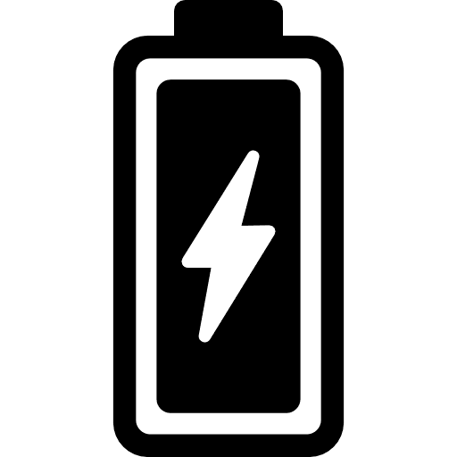

FAQs

How do I know what type of battery I have?
- How can I tell if a product contains a lithium-ion battery?
- Why are lithium-ion batteries dangerous?

How should I properly store my batteries?

My battery is damaged, what should I do?

How should I properly dispose of lithium-ion batteries?

Where can I take my lithium-ion batteries for disposal?

How are lithium-ion batteries recycled?

What can I do with my EV battery?

Q: How do I know what type of battery I have?
A: Household batteries are typically lumped into 2 different categories: non-rechargeable (single use) batteries and rechargeable batteries. Non-rechargeable batteries are typically alkaline batteries and come in a variety of different sizes including AA, AAA, D-Cell, C-Cell, 9 volt, and 6-volt. Alkaline batteries should be recycled, when possible, but can be safely discarded in the trash in small quantities. Some non-rechargeable batteries are being replaced by Lithium Primary batteries which are usually labeled with the word “Lithium” and are not rechargeable. Rechargeable household batteries include nickel-cadmium (Ni-Cd), nickel metal hydride (Ni-Mh), and lithium ion (Li) batteries. Check labels as lithium-ion batteries may be marked as “Rechargeable”, “Lithium-ion”, “Li-ION”, and “LiPo” (lithium polymer). Button and coin cell batteries begin with (LIR###).
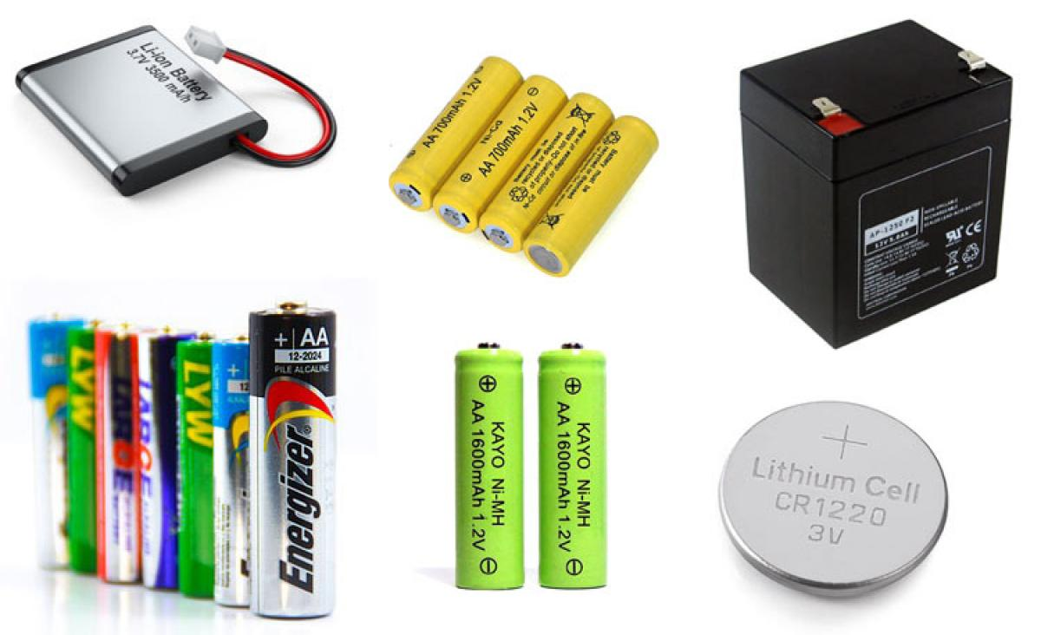
Source: https://components101.com/articles/different-types-of-batteries-and-their-uses

Q: How can I tell if a product contains a lithium-ion battery?
A: Determining whether a product contains a lithium-ion battery can be tricky. Lithium-ion batteries are in a shocking amount of products such as toothebrushes, children’s toys, and e-cigarettes. Many people do not realize that these products contain lithium-ion batteries and unkowingly improperly dispose of these items in the garbage. Items that contain lithium-ion batteries are required to have proper warning labelling. Every lithium-ion battery is designated with a United Nations (UN) number for shipping. A UN number is a four-digit number that identifies hazardous materials and articles. Check the product sticker for information regarding the battery including what type, voltage, and UN number.

Q: Why are lithium-ion batteries dangerous?
A: While lithium-ion batteries may present a more desirable alternative to non-rechargeable batteries as they are more easily recycled and able to be reused, they present unique safety challenges. Because lithium-ion batteries store a significant amount of energy in a small space, when that energy is released in an uncontrolled manner it causes overheating which in turn, can cause internal battery components to become flammable and release toxic gases. The uncontrollable release of energy is referred to as “thermal runaway” which is a violent chain reaction of exothermic chemical reactions that causes an uncontrolled increase in the system’s temperature which can lead to fires or explosions. Thermal runaway can be caused by mechanical damage, external heat, short circuit, or overcharging.

Not only do these lithium-ion batteries pose a real danger inside households, they also are a dangerous and costly for waste management facilities. Lithium-ion batteries and battery containing products that are improperly thrown in the trash or placed in the recycling bin can become damaged or crushed during processing. This damage or crushing can result in fires or explosions at solid waste facilities and recycling centers that is both costly and puts workers safety in jeopardy.

To prevent safety hazards in households or landfills, please properly handle, store, and dispose of your lithium-ion batteries.

Q: How should I properly store my batteries?
A: There are several measures you can take to ensure that lithium-ion batteries are stored safely within your home.
- Do not store batteries where the terminals are in contact with each other or where the terminals can come into contact with metal objects.
- Store batteries away from direct sunlight, heat sources, and water.
- Ideal temperature for storage is between 35-90 degrees Fahrenheit. Avoid extreme heat or cold when storing batteries.
- Stop charging once the battery is fully charged.
- Try to charge large lithium-ion batteries such as E-bikes, E-scooters, and electric vehicles outdoors and out of direct sunlight, if possible.
- Do not use device/battery if it shows signs of being damaged (unusual odor, excessive heat, or swelling).
- Use the charger provided with the device or a third-party charger designed specifically for the device as incompatible chargers can overcharge or undercharge the battery.

Q: My battery is damaged, what should I do?
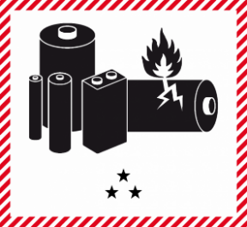
A: If your battery is swollen, corroded, leaking, or has a strange
odor, the battery is likely damaged and requires special handling to
ensure safety. Do not use batteries that show any signs of damage.
Store the damaged battery in a safe location until you are able to
properly dispose of it. The damaged battery should be stored in a
watertight container that is filled with a fire suppressant material such
as sand or kitty litter.

Corroded, Swollen, and Burned Batteries Examples:
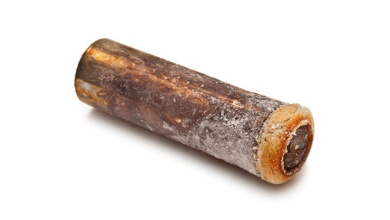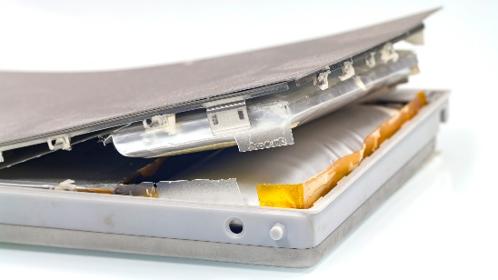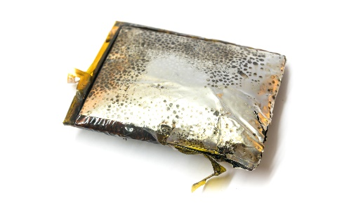
Call2Recycle Canada | Safety -DDR Battery Disposal

If the battery catches on fire or you believe that you have an imminent risk of fire, you need to remove yourself from proximity to the battery and call 911.

Q: How should I properly dispose of my lithium-ion batteries?
A: Lithium-ion batteries should NOT be disposed of in the trash or your household recycling. They can cause fires or even explosions if they are not handled and disposed of correctly. Place each battery or battery containing device in a separate plastic bag and tape the terminals before transport and disposal. Do NOT attempt to remove lithium-ion batteries from devices if it is not easily removable. Attempting removal can damage the battery and may lead to fires or explosion.

Q: Where can I take my lithium-ion batteries for disposal?
A: There are several different options to take your lithium-ion batteries for recycling:
- Target, Best Buy, Staples, Lowe’s, Sears and Home Depot are all part of the Rechargeable Battery Recycling Corporation. These retailers accept all rechargeable batteries and cell phones for recycling.
- Batteries Plus accepts both non-rechargeable and rechargeable batteries for recycling.
- Check with your local transfer station or landfill to see if they accept rechargeable batteries for recycling or if they have somewhere you should take them.
Additionally, there are several mail-in programs that collect batteries for recycling:
- The 'Big Green Box' Program allows you to purchase postage-paid boxes to collect both alkaline batteries, rechargeable batteries and other items for recycling. (https://www.cirbasolutions.com/big-green-box-to-werecycle-battery-box/)
- Easypak Recycling Made Easy: Mail-in recycling with EasyPak prepaid recycling containers. EasyPak lets users recycle fluorescent lamps, CFLs, ballasts, batteries and electronic waste while keeping track of their progress online.
(https://tcrwusa.com/)
- Call2Recycle offers a mail-in recycling program for batteries. You can order several different sizes of boxes to suit your specific needs.
(https://www.call2recycle.org/store/)

Websites you can use to find the nearest drop-off location for batteries:
- https://www.call2recycle.org/
- https://earth911.com/

Q: How are lithium-ion batteries recycled?
A: Lithium-ion batteries contain critical materials that are necessary to produce new batteries. Recycling reduces the need to use raw materials for production of batteries. Recycling also ensures that the batteries do not end up in the landfills, which wreaks havoc on their operations. In the recycling process the batteries are first disassembled, and then crushed under liquid to prevent fugitive emissions and reduce reactions. Then, the metal is separated and sent off for purification.
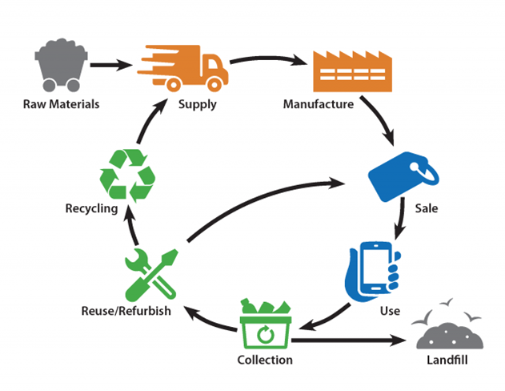
Source: https://www.epa.gov/recycle/used-lithium-ion-batteries

Q: What can I do with my electric vehicle (EV) battery?
A: The purchase and use of EV and hybrid vehicles has been on the rise in recent years. The batteries in EVs pose numerous challenges when it comes to their disposal. EV lithium-ion battery packs can weigh over 1,000 pounds and improper storage or handling of these vehicles can pose serious risks to personal safety due to the potential for fires or explosions. Due to these challenges, Montana counties are not currently accepting EVs for disposal at junk vehicle yards. EV manufacturers have established take-back programs for end-of-life EV. Please contact the manufacturer of your EV or hybrid vehicle for information and process specifics regarding take-back programs.
For more information regarding EV options and the Junk Vehicle program, please contact Brady Christensen (406-444-3048).

