

Lithium-ion Battery:
Best Management Practices

This Best Management Practices is designed to provide information on the best practice for properly handling and disposing of lithium-ion batteries for commercial entities (not households).

This document is intended as general guidance for lithium-ion battery waste generated or collected by businesses, not households, and is not meant to modify or replace applicable laws and rules governing lithium-ion battery management, which undergo periodic revisions. In the event of a conflict between this guidance and applicable laws and rules, the applicable laws and rules govern. This guidance may not cover all situations, and DEQ retains the right to allow for reasonable, situational flexibility based on an analysis of site-specific circumstances. This guidance may be revised at any time.
For more information on this FAQ, please contact Megan Wingard (406-444-2835) or Dusti Johnson (406-444-6499), DEQ’s Materials Management Specialists from the Waste Management and Remediation Bureau.

Outline:

Applicable Regulations

Acceptance Procedures
- Proper Storage
- Transportation
- Safety Precautions

Applicable Regulations:
Currently, lithium-ion batteries, despite technically being hazardous waste as they are both ignitable and reactive, are regulated as “Universal Waste” requirements outlined in 40 Code of Federal Regulations (CFR) 273 as incorporated by reference in the Administrative Rules of Montana (ARM) 17.53.1301. To be subject to the Universal Waste regulations, rather than the stricter Hazardous Waste regulations, the wastes must be destined for recycling.
The EPA’s Universal Waste regulations were established to help streamline regulations of hazardous wastes to:
- Promote the collection and recycling of specific hazardous wastes.
- Relieve some of the regulatory burden for those who collect and transport these wastes.
- Encourage development of programs to reduce the amount of these wastes entering landfills.
As outlined on the DEQ’s Hazardous Waste page (see: https://deq.mt.gov/twr/Programs/hazmat), requirements differ depending on whether you accumulate less or more than 5,000 kg total Universal Wastes on site at one time.

UW Generator & Small Quantity Handler of UW (SQHUW)
- Never accumulates more than 5,000 kilograms (11,000 pounds) of UW.
- May not dispose of UW.
- May not intentionally dilute or treat UW.
- Must manage UW to prevent releases.
- Must immediately contain any releases of UW. If releases are hazardous waste, must manage as hazardous waste.
- May, within strict limits, crush spent lamps.
- Must mark containers to identify specific type of UW.
- May not hold UW for longer than one year unless necessary to facilitate proper recovery.
- Must demonstrate length of time any UW is in accumulation.
- Must inform employees regarding proper handling of UW and emergency procedures.
- May ship only to other UW Handlers, UW Destination Facilities, or foreign destination.
- Must comply with U.S. DOT shipping requirements.

Large Quantity Handler of UW (LQHUW)
- Exceeds 5,000 kilograms (11,000 pounds) of UW in accumulation.
- May not dispose of UW.
- May not intentionally dilute or treat UW.
- May, within strict limits, crush spent lamps.
- Must notify MT DEQ of activities.
- Must manage UW to prevent releases.
- Must immediately contain any releases of UW. If releases are hazardous waste, must manage as hazardous waste.
- Must mark containers to identify specific type of UW.
- May not hold UW for longer than one year unless necessary to facilitate proper recovery.
- Must demonstrate length of time any UW is in accumulation.
- Must ensure employees are thoroughly familiar with proper UW handling and emergency procedures.
- May ship UW only to other UW Handlers, UW Destination Facility, or foreign destination.
- Must comply with U.S. DOT shipping requirements.
- Must maintain, for at least three years, records of each shipment of UW received at or shipped from facility.

Acceptance Procedures:
Facilities that accept or produce used lithium-ion batteries most likely also interact with other types of batteries as well, such as alkaline or non-rechargeable lithium batteries. If accepting batteries from the public, it is crucial that there is proper signage signifying which batteries go where. Additionally, employees should be instructed on how to properly identify and sort the different types of batteries, so as not to contaminate the waste stream for recycling.

Lithium-ion batteries are found in a multitude of items, from toothbrushes to laptops. It is critical to determine whether only loose lithium-ion batteries are accepted or if products with imbedded lithium-ion batteries are also acceptable. When filling up drums, large products with embedded lithium-ion batteries may cause some space constraint issues.

Currently, a major problem are e-cigarettes/vapes. These devices contain lithium-ion batteries and oftentimes, nicotine. Nicotine is regulated as an acute hazardous waste. Generating more than 2.2 pounds of an acute hazardous waste in any calendar month or accumulating more than 2.2 pounds of an acute hazardous waste at any time would designate your facility as a large quantity generator (40 CFR 262.13 as incorporated by reference in ARM 17.53.601).

If a damaged batteries are brought to the collection point, proper procedures must be in place. When the damage involves a breach in an individual cell casing, it would likely be considered a household hazardous waste rather than universal waste. Damage is likely to have occurred if your battery looks swollen, corroded, or is leaking. If your facility is intent on accepting damaged batteries, these batteries would count towards the total hazardous waste generated in a calendar month. Therefore, if the facility surpasses 220 pounds of hazardous waste accumulation in a calendar month, they would no longer be considered a Very Small Quantity Generator (VSQG) of hazardous waste.

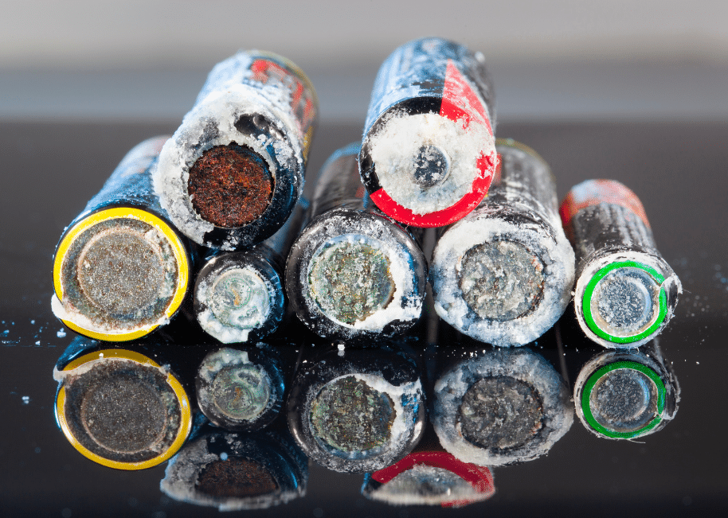
Source: https://sunlypower.com/do-lithium-batteries-leak/
Call2Recycle, Battey Recyclers of America, Cirba Solutions etc., are major resources for battery collection and recycling and have options to help generators with managing damaged, defective, or recalled (DDR) batteries. These options often include individual containers that provide containment for the damaged batteries. If your facility accepts damaged batteries, proper precautions and protocol must be followed as damaged batteries pose a more significant risk for fires and possibly explosions. Additionally, facilities would need to be mindful of the applicable hazardous waste generator requirements that damaged batteries would fall under.

When starting a battery collection area, some best management practices include:

- Making the collection area easily identifiable with clear instructions regarding which type of batteries/products are accepted.
- Clearly labeling what type of battery should be placed in which container.
- Ensuring collection containers are out of direct sunlight and have protection from the elements so as not to pose a safety hazard.
- When possible, preventing the terminals of batteries coming in contact with each other as that can damage the batteries.

Proper Storage:
To comply with Universal Waste rules the storage area of lithium-ion batteries must comply with several requirements:
- Label each drum in which the batteries are contained with the words “Universal Waste – Battery(ies)”, or “Waste Battery(ies)”, or “Used Battery(ies)”.
- Clearly demonstrate the length of time that the universal waste has been accumulated on each drum.
- Drums are not allowed to be stored on site for longer than 1 year from the accumulation start date.
While not required by Universal Waste rules, there are several storage considerations that can help protect worker safety and functionality of the facility. This includes ensuring that:

- The collection area for the batteries is covered as to protect from water contamination or direct sunlight.
- The batteries are covered when stored after collection.
- The batteries are stored in a such a way where the risk of fire is averted either through covering the batteries with fire suppressant, taping the terminals of the batteries, or ensuring the terminals do not come into direct contact with each other.

See the Safety Precautions section for more information on safe storage of batteries.

Transportation:
As Universal Waste, lithium-ion batteries transporters and facilities must comply with their own set of transporter and destination facility rules as detailed below:
UW Transporter:
- May not dispose of UW.
- May not intentionally dilute or treat UW.
- Must comply with U.S. DOT shipping requirements.
- May not hold shipment at any single transfer site for more than ten days.
- Must immediately contain any releases. If releases are hazardous waste, must manage as hazardous waste.
- May transport UW only to UW Handler, UW Destination Facility, or foreign destination.
UW Destination Facility:
- Must comply with requirements for Hazardous Waste Treatment, Storage or Disposal Facilities.
- May ship UW only to other UW Handlers, UW Destination Facilities, or foreign facilities.
- Must maintain, for at least three years, records for each shipment of UW received.

Safety Precautions:
The EPA recommends that beyond following the Universal Waste standards for storage and DOT’s transportation standards for lithium batteries, handlers of end-of-life lithium batteries take additional precautions to protect against the chance of thermal runaway and fire. These include:
- Ensuring safety training is provided for all employees removing, disassembling, or handling the batteries.
- Potentially isolating the terminals of the batteries with non-conductive tape, plastic bags, or other separation techniques to prevent thermal runaway.
- Attempting to prevent damaging the batteries through careful handling and storage.
- Storing batteries in climate-controlled spaces (e.g., out of direct sunlight, extreme cold or heat) with good ventilation.
- Storing batteries in a separate building away from other flammable materials and occupied spaces when possible.
- Storing batteries that have been identified as damaged, defective, or recalled separately from non-DDR batteries in appropriate containers.
- Installing advanced fire detection and suppression equipment.
- Conducting frequent visual and thermal inspections of batteries.
- Having ongoing communications with local fire marshals and first responders about materials and processes happening on site.
- Maintaining a plan for how to respond and evacuate in case of an emergency.
Maintaining awareness of the inherent dangers involved in the collection, handling, and storage of lithium-ion batteries is key. Ensure employees are aware of the risks and are properly trained and equipped to deal with potential safety issues that might arise during routine work.

