DETERMINING DEPTH TO GROUNDWATER WORKSHEET
DRYLAND APPLICATION

Applications require a conclusive and appropriate basis for estimating groundwater levels to determine that Dryland operations would not affect water. Filling out this worksheet allows DEQ Opencut to conduct a meaningful review of the application. The Operator understands that additional information regarding groundwater may be required.

This worksheet provides options to Applicants regarding methods to verify that Dryland operations would not intersect or affect water, as required by ARM 17.24.227(1), ARM 17.24.228, §82-4-432(1)(c) & 82-4-432(14), MCA.

This form includes automated calculations that require Microsoft Word 2010 or newer. As data is entered into this form, auto calculate fields will auto populate (tab out of each field to ensure they auto calculate). Auto calculate fields contain red text. If an auto calculate field is blank, either: a) the required information was not entered, or b) the blank field does not pertain to this application.

The estimated depths to groundwater are considered preliminary and will be reviewed by DEQ Opencut. Ensure supporting documentation used for estimated groundwater levels is complete, accurate and conclusive. Opencut reserves the right to refute information included in this form if it is not accurately documented.

Site Specific Information

- Operator Name:

- Site Name:

- Opencut Number (if previously permitted):

Mining scenarios

The below mining scenarios, if applicable, can be used to verify that Dryland operations would not intersect or affect water and would remain a minimum of 3-feet above the seasonal high water table. The 3-foot separation is required to ensure seasonal fluctuations of the water table level do not negate the abilty to conduct Dryland operations at this site. Two or more years of groundwater monitoring data could reduce the 3-foot requirement.

- Mining a Hill or Knob
Conducting opencut operations without mining deeper than the approximate elevation of adjacent undisturbed ground (i.e. base elevation). Mining would be conducted as shown in the picture below and would not occur below the base elevation of the hill/knob.
A Soil Test Pit has been dug a minimum of 3 feet deep at the lowest elevation of the site (base elevation).
Test Pit Latitude: Test Pit Longitude: -
Photo(s) of the test pit with scale, meeting the Soil Guideline requirements, are attached below.
Note: The bottom of the test pit elevation can be substituted for the seasonal high to verify that this Dryland operation would not intersect/affect water.

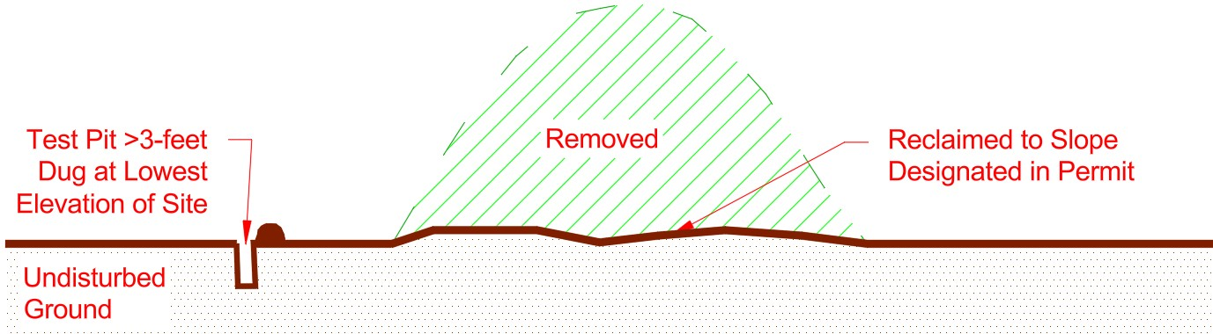
  - Additional information, if applicable:



- Excavating into a Hillside and Not Mining Below Existing Grade
Conducting opencut operations without mining deeper than the approximate elevation of adjacent undisturbed ground (i.e. base elevation). Mining would be conducted as shown in the picture below and would not occur below the base elevation of the hillside.
A soil test pit has been dug a minimum of 3 feet deep at the lowest elevation of the site (base elevation).
Test Pit Latitude: Test Pit Longitude: -
Photo(s) of the test pit with scale, meeting the soil guideline requirements, are attached below.
Note: The bottom of the test pit elevation can be substituted for the seasonal high to verify that this Dryland operation would not intersect water.

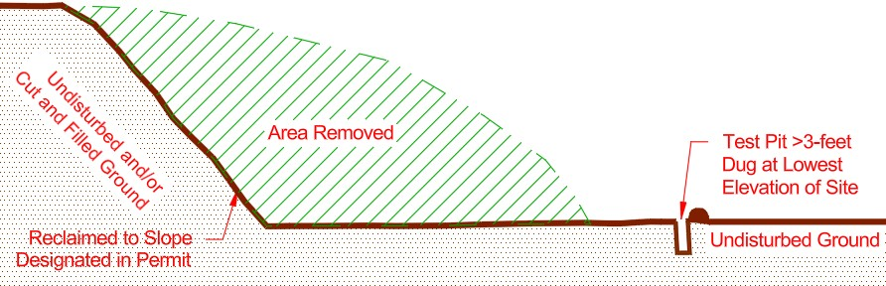
- Additional information, if applicable:

- Existing Site where Mining will not be Deeper than Lowest Elevation of Existing Pit Floor
Opencut activities have already occurred at the site and multiple years of publicly available aerial photography show that the site is and has been dry. Further opencut activities will not mine deeper than the current mining depth, so water would not be intersected. Current aerial photos can be viewed on the Montana DEQ Opencut Mining Web Mapping Application found here: https://gis.mtdeq.us/portal/apps/webappviewer/index.html?id=7b60084bc4c444a19c9a7a0867e7635a

A soil test pit has been dug a minimum of 3 feet deep at the lowest elevation of the site (base elevation).
Test Pit Latitude: Test Pit Longitude: -
Photo(s) of the test pit with scale, meeting the soil guideline requirements, are attached below.
Note: The bottom of the test pit elevation can be substituted for the seasonal high to verify that this Dryland operation would not intersect water.

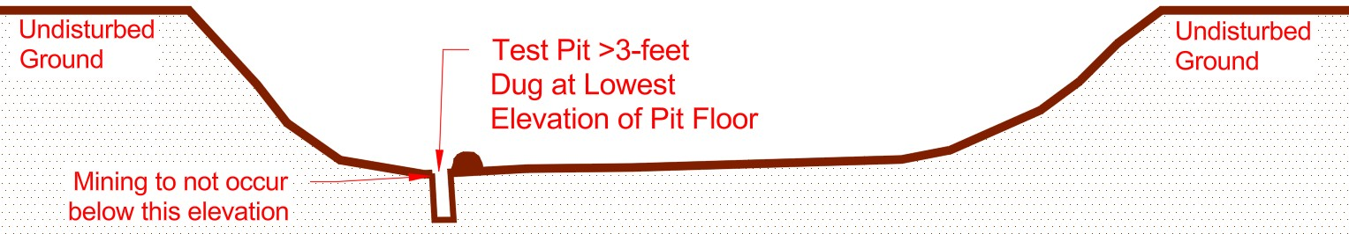
- Additional information, if applicable:

- Mining a Bluff/Plateau/Terrace with 3 feet or greater of Vertical Separation from Surface Water
Opencut operations would mine a bluff/plateau/terrace near a surface water. Mining depth would stop a minimum of 3-feet above the nearby surface water’s high water mark to ensure the site does not intersect water.

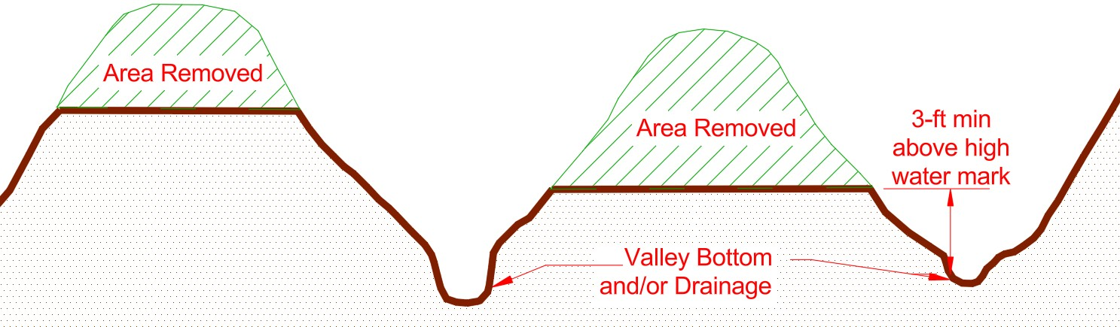
- Additional information, if applicable (i.e. such as actual vertical separation, etc

- Conducting Opencut Operations on the Ridges Located between the Drainages
The ridges would be excavated/mined to a depth no deeper than the mining depth stated in section C1 of the Dryland application. Mining depth would stop a minimum of 3-feet above the nearby/adjacent drainages to prevent intersecting water.

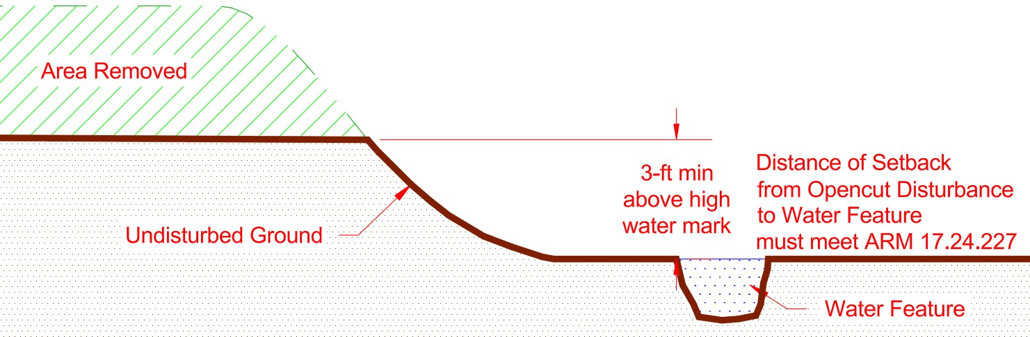
- Additional information, if applicable:

- Onsite & nearby tools & data to determining seasonal High water level
The below options allow for additional methods to determine the seasonal high water elevation to verify that the Dryland operation would not intersect water. These methods can be used with the above options or when the above options do not apply.

Undisturbed Ground Elevation at Maximum Mining Depth at Lowest Elevation of Site
Lowest Location at Site: ft Where Mining will Occur (from top of ground to
bottom of pit)
ft (If depth does not match the mining depth in
application, explain fully in #1 below)
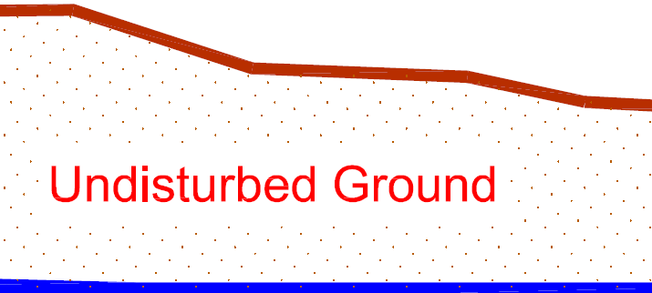
Estimated Elevation of Seasonal High Groundwater
at Lowest Elevation of the Site: ft


- If mining to the depth stated above would not occur throughout the entire site, explain in detail any variations in mining depth across the site:

- Use this worksheet to provide data supporting the ‘Estimated Elevation of Seasonal High Groundwater at Lowest Elevation of Site’ stated above by choosing the appropriate option in section “B” below.

Choose the method(s) below (minimum of one method must be chosen) that were used to determine seasonal high-water levels for this site:

- Elevation of Nearby Surface Water: The elevation of nearby surface water may provide supporting evidence of groundwater elevation if those features are created from groundwater. This method works best for nearby water features such as prairie potholes containing surface water or water features that were created by Opencut operations. This method is not applicable for streams, creeks or rivers.

This method requires accurate data that establishes the elevation of surface water in existing nearby applicable surface water, as well as the lowest elevation within the proposed permit boundary. It is recommended that the elevation data be obtained by surveying the identified features/locations, although other forms of obtaining elevation information may be acceptable if adequate documentation is provided. (i.e. UAV Flights, Topographic Maps, etc.)

Surface water feature(s) used to determine groundwater levels must be identified and labeled with their elevation on the Area Map and Site Map (if applicable). If this option is chosen for a Dryland site, submit a map that shows the proposed permit boundary in relation to the water feature. Ensure elevations are shown on the map.

Provide the following information:
- Ground elevation from lowest undisturbed ground location within proposed permit boundary where mining will occur = feet.

- Mining elevation below the lowest undisturbed ground location where mining would occur, measured from lowest undisturbed ground location = 0 feet

- Elevation of nearest applicable (most representative/closest) surface water feature (i.e. prairie potholes, wetlands, ponds, etc.) Water Elevation = feet
    - Date Surveyed (if applicable):
    - Water Feature (name, type):
    - Location of water feature from Permit boundary (distance/direction in feet):

- Is the elevation of the lowest proposed mining depth ( 0 feet) lower in elevation or within three feet of the Groundwater Elevation of nearby surface water feature ( 0 feet)?
0 feet - 0 feet = 0 feet

- Additional information that would help explain water levels and mining at this site (if applicable):

- Well Logs & GWIC Well Data: Information can be used for applicable existing wells within 1,000 feet of the permit boundary. If no applicable wells are located within a minimum of 1,000 feet of the permit boundary, it is recommended to choose a different scenario within this worksheet. Wells used should be at the same approximate elevation as the mine site, unless a valid and detailed explanation is provided that explains how the chosen wells verify groundwater depth for this site (i.e. mining a knob/hill, etc.).

In most cases, the wells that are located closest to the site and at the same approximate elevation are the most representative.

Well logs can be accessed from the “Mapping DEQ’s Data” site located here: https://deq.mt.gov/mining/Programs/opencut (click on Mapping DEQ’s Data) tab. Wells displayed online are frequently not located in their actual location, so the operator must “ground truth” the actual well locations to ensure applicability of the well log. The actual location of each well used to support the groundwater depth estimates must be displayed on the Area Map or a separate well map (i.e. for a Dryland Application). Well logs referenced below must be submitted with this worksheet.

The Operator must use the closest and most applicable wells when determining seasonal high and low water depths. If available, up to three wells must be used to determine groundwater depth. Less wells can be used if three or more representative wells do not exist.

Well I.D. GWIC Static Water Ground Elev. Distance from Water
on Map # Level (ft) of Well Permit BNDRY (ft) Elevation
Well #1 0 feet
Well #2 0 feet
Well #3 0 feet

- Well #1: If 0 feet > - 3 feet, then mining would occur into or within 3 feet of groundwater and this Dryland Application cannot be used.

- Well #2: If 0 feet > - 3 feet, then mining would occur into or within 3 feet of groundwater and this Dryland Application cannot be used.

- Well #3: If 0 feet > - 3 feet, then mining would occur into or within 3 feet of groundwater and this Dryland Application cannot be used.

Dryland Permit Application:

If the static water level is within 3 feet of the mining depth, it is likely that water would be affected by this opencut operation and Standard application is required. Under 82-4-430, MCA, a Standard Opencut Mining Permit Application is required for ‘Opencut operation that affects surface water, including intermittent or perennial streams, groundwater, or water conveyance facilities.’ If the Operation could affect water, the Operator must submit a Standard Opencut Mining Permit Application.

If the static water level is greater than 3 feet from the mining depth, choose an appropriate post mining land use in section E2 of the Dryland Opencut Mining Permit Application. Include a copy of this document and all supporting documentation with the application.

- Additional information (if applicable):

- Groundwater Observation/Monitoring Wells: Groundwater observation/monitoring wells provide a viable method for determining the elevation of groundwater and for taking water samples. Refer to Appendix A – Groundwater Observation Well Installation and Measuring Procedures for the requirements to allow the use of this method of determining depth to groundwater. This method requires planning ahead and monitoring during the correct times of the year to obtain accurate and acceptable data indicating high and low water table. Ensure all data and measurements supporting the below information is provided with the application (i.e. Appendix A and other supporting data). Monitoring wells must be within the permit boundary, immediately adjacent to the permit boundary or as otherwise approved by the Department.
Water level measurements must be taken weekly, starting no later than May and ending after two consecutive weekly readings showing a decline in water level (usually late July/August).
Water level measurements with dates taken must be attached to this worksheet when submitted.
Provide the following information:

Monitoring Well #1:
- The measured seasonal high-water table level measurement (Distance from ground surface at well location to static water level - closest to ground surface, shallowest): feet.

- Estimated seasonal high water table level measurement ( 0 feet) minus (-) proposed maximum mining depth ( 0 feet) = ( 0 feet)
If this number ( 0 feet) < 3 feet, then mining would occur into or within 3 feet of groundwater and this Dryland Application cannot be used.

- Additional information:

Monitoring Well #2:
- The measured seasonal high-water table level measurement (Distance from ground surface at well location to static water level - closest to ground surface, shallowest): feet.

- Estimated seasonal high water table level measurement ( 0 feet) minus (-) proposed maximum mining depth ( 0 feet) = ( 0 feet)
Is this number ( 0 feet) < 3 feet, then mining would occur into or within 3 feet of groundwater and this Dryland Application cannot be used.

- Additional information:

Monitoring Well #3:
- The measured seasonal high-water table level measurement (Distance from ground surface at well location to static water level - closest to ground surface, shallowest): feet.

- Estimated seasonal high water table level measurement ( 0 feet) minus (-) proposed maximum mining depth ( 0 feet) = ( 0 feet)
Is this number ( 0 feet) < 3 feet, then mining would occur into or within 3 feet of groundwater and this Dryland Application cannot be used.

- Additional information:

If the static water level is < 3 feet of the mining depth, a Dryland Application cannot be used, and a Standard Application must be used. Per 82-4-430, MCA, a Standard Opencut Mining Permit Application is required for ‘Opencut operation that affects surface water, including intermittent or perennial streams, groundwater, or water conveyance facilities.’ If the Operation could affect water, the Operator must submit a Standard Opencut Mining Permit Application.

If the static water level is greater than >3 feet of the mining depth, choose an appropriate dryland postmining land use in Section E of the Dryland Opencut Mining Permit Application and include a copy of this document and all supporting documentation with the application.

- Test Hole Observation: Test pit information may be acceptable in support of groundwater level estimates, or may verify that groundwater is not within 3-feet of the proposed mining depth, if the following criteria are met and included in this worksheet to substantiate groundwater estimates:
- A minimum of 3 test pits must be dug (minimum of 3-feet below the proposed maximum depth of mining).
  - Test Pit 1 must be located in the lowest area of the site, where mining would occur.
  - Test Pit 2 must be located in the approximate center of the site or about the average elevation of the site, where mining would occur.
  - Test Pit 3 must be located in the approximate highest average elevation of the site, where mining would occur.
- The test pits must be dug to a depth of at least three feet below the proposed maximum mining depth. Rationale and justification for the selected groundwater test pit locations must be provided.
- A professional with experience in soils capable of identifying evidence of groundwater in soils must conduct a detailed analysis of each test pit, specifically looking for indications of water (i.e. redoximorphic features, mottling, gleying, water, etc.). The name and qualifications of the soils professional must be submitted to DEQ Opencut along with an explanation of methodologies used and data collected [ARM 17.24.222(2)].
- This method may not be applicable in “clean” gravel seams as it does not contain organic matter, clay, or soil, mottling, redoximorphic features and/or gleying may not display or be visible.
- The soil test pits must be shown on the site map for a Standard application. A soil test pit map must be provided for a Dryland site.
- Clear picture(s) of each test pit, meeting the requirements of the soil guideline must be provided.

- Name of Soils professional that analyzed Test Pits:

- Summary of qualifications of Soils professional that analyzed Test Pits:

- Test Pit 1 (Dug at Lowest Elevation of site where mining would occur):
    - Depth of Test Pit 1: feet
    - Surface elevation of where Test Pit 1 was dug: feet
    - Depth where water or evidence of water was found (leave blank if no water or evidence of water was found): feet
    - Surface elevation of bottom of Test Pit 1: 0 feet
    - Elevation of where water or evidence of water was found: 0 feet
    - Was water, mottling, redoximorphic features, gleying or other evidence of water found in the Test Pit 1? Yes No
    - Location of Test Pit 1:
      - Latitude of Soil Test Pit (WGS 84 decimal degrees):
      - Longitude of Soil Test Pit (WGS 84 decimal degrees):
    - Provide a summary explaining the features that verify the evidence of water or lack of water within the Soil Test Pit:
    - Picture(s) (with scale) of soil test pit 1:

- Test Pit 2 (Dug at approximate center of site or about average elevation of site, where mining will occur):
- Depth of Test Pit 2: feet
- Surface elevation of where Test Pit 2 was dug: feet
- Depth where water or evidence of water was found (leave blank if no water or evidence of water was found): feet
- Surface elevation of bottom of Test Pit 2: 0 feet
- Elevation of where water or evidence of water was found: 0 feet
- Was water, mottling, redoximorphic features, gleying or other evidence of water found in the Test Pit 2? Yes No
- Location of Test Pit 2:
      - Latitude of Soil Test Pit (WGS 84 decimal degrees):
      - Longitude of Soil Test Pit (WGS 84 decimal degrees):
- Provide a summary explaining the features that verify the evidence of water or lack of water within the Soil Test Pit:
- Picture(s) (with scale) of soil test pit 2:

- Test Pit 3 (Dug at approximate highest elevation of site, where mining would occur):
- Depth of Test Pit 3: feet
- Surface elevation of where Test Pit 3 was dug: feet
- Depth where water or evidence of water was found (leave blank if no water or evidence of water was found): feet
- Surface elevation of bottom of Test Pit 3: 0 feet
- Elevation of where water or evidence of water was found: 0 feet
- Was water, mottling, redoximorphic features, gleying or other evidence of water found in the Test Pit 3? Yes No
- Location of Test Pit 3:
      - Latitude of Soil Test Pit (WGS 84 decimal degrees):
      - Longitude of Soil Test Pit (WGS 84 decimal degrees):
- Provide a summary explaining the features that verify the evidence of water or lack of water within the Soil Test Pit:
- Picture(s) (with scale) of soil test pit 3:

- Additional information, if applicable:

APPENDIX A - GROUNDWATER OBSERVATION WELL
INSTALLATION AND MEASURING PROCEDURES

The Operator may be required to provide data identifying the existing water levels through the installation of observation wells and a consistent measurement of those wells in order to accurately determine the postmining land use(s). The observation well plan must be prepared by a competent professional for Opencut to review and include the information listed below. Field data must be accompanied by the names and addresses of the parties that collected and analyzed the data, and must include a description of the methodologies used to gather and analyze the data [ARM 17.24.222(2)].
The plan must include:
  - Observation Well Plan to determine actual seasonal high and low water levels within the proposed permit boundary.
  - Installation of a minimum of three (3) groundwater observation wells (unless otherwise approved by the Department) located to adequately represent flows across the site, with at least one of the groundwater observation wells located at the lowest elevation of the site. Refer to “Where to Install” and “Installation Process” sections below for more detailed information.
  - Measurement of groundwater for a sufficient period of time to determine a peak and a sustained decline in the groundwater level (usually April/May through August/September). Refer to the Observation Schedule below for further guidance.
  - A report summarizing observation results including a description of topography, a map showing well locations, well logs, a table summarizing groundwater data collected, and actual seasonal high and low groundwater levels based on the collected data. The report must include total precipitation for the previous year and snowpack equivalent compared to the 30-year historical average. The results must be submitted for analysis and review with the application and prior to permit approval.

Observation Schedule

Observation wells must be installed before the time when groundwater levels are highest. This is typically during spring runoff and/or during the irrigation period, but may also occur at some other time during the year.
Observation measurements must be made weekly or more frequently during the appropriate periods of suspected high groundwater.

For areas were groundwater levels are not controlled/affected by canals and ditches, monitoring should begin a minimum of two weeks prior to spring runoff. Monitoring should continue through the higher water and until three consecutive readings show a decline in water table levels from the peak high. Failure to meet these criteria would likely result in the Opencut Section rejecting the results.

For areas were groundwater levels are controlled/affected by canals and ditches, monitoring should begin a minimum of two weeks prior to the ditch/canal becoming active. Monitoring should continue until the ditch/canal is turned off and three consecutive readings show a decline in water table levels from the peak high. If monitoring shows that water levels are stable by August of the year monitored, the data may be acceptable for determining seasonal high. Failure to meet these criteria would likely result in the Opencut Section rejecting the results.

The applicant is encouraged to submit a Pre-Application Meeting Request to seek guidance on any groundwater observation well plan and installation prior to implementing the plan or submitting a permit application. The monitoring and measurements of the observation wells must be completed by a qualified site evaluator such as a soil scientist, professional engineer, hydrogeologist, or geologist who has experience and knowledge on how to properly take and record measurements from an observation well.

Surface water levels may be indicative of the groundwater levels that could peak several weeks
after spring runoff and the irrigation season.

Local conditions may indicate that there is more than one geologic horizon that can become seasonally saturated. Observation wells must be installed to the depth of mining and preferably three feet deeper than the proposed mining depth. The wells should be placed in, but not extended through, the horizon that is to be monitored.

The Opencut Section may refuse to accept seasonal high groundwater data when the total precipitation for the previous year, defined as May 1 of the previous year to April 30 of the current year, if April 1 snowpack equivalent, measured at the nearest officially recognized observation station, is more than 25 percent below the 30-year historical average. This is based upon the definition of drought conditions created by the National Drought Mitigation Center. The Opencut Section may consider soil morphology and data from nearby groundwater observation sites with similar soil, geology, and proximity to streams or irrigation ditches, if available, to determine seasonal high groundwater elevation during periods of drought.

Where to Install

The observation wells must be installed in locations representative of typical groundwater conditions at the site. At least one of the wells should be in low lying areas of the site and the wells should be spread out to represent conditions across the site. Larger sites or sites with highly variable conditions and/or topography may require the installation of additional wells. Opencut may require additional observation wells if the wells installed by the Operator are not installed properly and/or are not in locations considered representative of the site.

Installation Process

The following criteria must be met for installed observation wells:
- The observation wells must be installed vertically into a dug or drilled hole.
- A slotted water well pipe should be used that is wide enough in diameter to install a measuring device.
- The slotted water well pipe must be installed a minimum of three feet deeper than the proposed mining depth.
- Slotted pipe (PVC is the most common material) with slot sizes between 0.04 and 0.10 inches wide is suggested. Slots should be horizontal and spaced at intervals less than or equal to 0.5 inches. Refer to ARM 36.21.650 for additional information on casing perforations. Alternate well materials are acceptable if they meet the requirements of ARM 36.21.640 (DNRC well casing requirements).
- The pipe must be perforated from 1 foot below the ground surface to 3 feet below the proposed maximum mining depth.
- The casing must be unperforated 1 foot below the ground surface to the top of the observation well. The observation well must extend at least 2 feet above the ground surface.
- The top of the observation well must be sealed with a watertight cap.
- The area around the well must be backfilled with native material to 1 foot below the ground surface.
- The observation well must be sealed in such a manner that prevents surface runoff from running along the outside of the well casing. The well should be sealed from 1 foot below the ground surface to slightly above grade to allow for subsidence and to maintain a positive ground slope away from the well casing. The material used to seal the well can be either fine-grained material or bentonite.
- Each observation well should be flagged to facilitate locating the well and labeled with a well number, operator name, and site name.
- Submit screening and installation information on all installed monitoring wells.
- Ensure all wells used meet the above requirements.

Measuring Procedures

Lower a measuring tape or stick to the water level and measure the distance from the water level to the top of the pipe (refer to example on last page). Water levels should be measured to the nearest inch. A plunking device or electronic water sensor can also be used. Data should be submitted in a similar form to that of the example.

Measure the distance from the top of the pipe to the natural ground surface (B distance) (refer to example). Then measure the distance from the top of the pipe to the water level (A distance) (refer to example). Subtract B from A. This value equals the actual separation between the water table and the natural ground surface.

Decommissioning

If observation wells were installed deeper than 10 feet below the proposed mine depth, the operator may be required to follow the standards in ARM 36.21.810.

Definitions of Soil Features Indicating the Presence of Water:
Redoximorphic Features: Redoximorphic features are a specific subset of mottles. Soil scientists define redoximorphic features as those formed by the reduction, translocation and oxidation of iron and manganese compounds in the soil after water saturation and desaturation, respectively (Soil Science Society of America, 2001, Vepraskas, 2015).

Gleying: Gleying occurs in waterlogged, anaerobic conditions when iron compounds are reduced and either removed from the soil, or segregated out as mottles or concretions in the soil. Marshy wetlands often contain gleyed soils.

Mottling: Soil mottling is a contrasting or “blotchy” color pattern within the dominant soil color. It is formed when the seasonal high-water table rises into aerobic soils, changing the conditions in the soils from aerobic (oxygen rich) to anoxic (without oxygen).

LINKS ON IDENTIFYING THE PRESCENCE OF WATER IN SOIL:
- New England Soil Profiles showing Redoximorphic Features: http://nesoil.com/images/redox.htm

- Number and Color of soil mottles: https://www.isqaper-is.eu/soil-quality/visual-soil-assessment/219-number-and-colour-of-soil-mottles

- Redoximorphic Features for Identifying Aquic Conditions: https://content.ces.ncsu.edu/pdf/redoximorphic-features-for-ident/2017-09-08/TB-~%20reprint_web.pdf

- Video Section 5 4 Hydric Soil Indicators: https://www.youtube.com/watch?v=HdDSxj5IbSs

- Video Soil Core Samples with Evidence of Oxidation and Reduction: https://www.youtube.com/watch?v=O8vW2txVAy4

- Video Envirothon Skills: Soil Mottling: https://youtu.be/e9uY-g7C-fA

