**SOIL & OVERBURDEN QUANTITY & REPLACEMENT DEPTH CALCULATION WORKSHEET**

**DEQ Opencut Mining Section**

**Use:** This worksheet will assist in determining if the soil and overburden stockpiled on site is adequate for reclamation, and is consistent with existing or previous permit parameters, etc. Refer to the Soil Guideline for information on how to determine soil and overburden depths.

**Directions:** Check the appropriate scenario below and fill in the corresponding boxes. Blue text is a value inputted by the user. **Red** text are static values that cannot be altered and are auto calculated.

**About:**

**1:** Permit and/or Disturbed Area in Acres rounded to the nearest tenth. (i.e. 7.8) Value inputted by user.

**2:** Conversion factor used to convert acres to square feet. Value is static and cannot be altered.

**3:** Soil depth in inches, rounded to the nearest whole number. Value inputted by user.

**4:** Conversion factor used to convert inches to feet. Value is static and cannot be altered.

**5:** Conversion factor used to convert overall value to cubic feet to cubic yards. Value is static and cannot be altered.

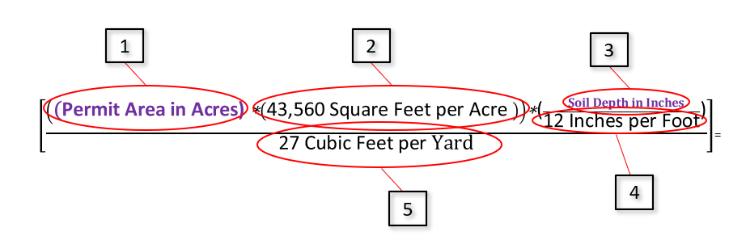

**Applicability:** Choose the scenario that best fits your site below.

* 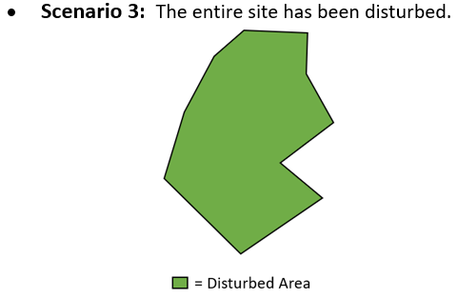**Scenario 1:** The site currently has no disturbance.

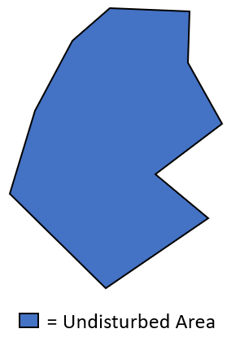

* **Scenario 2:** The site currently has some disturbance and some areas that have not been disturbed.

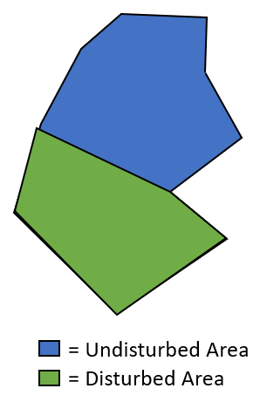

**Scenario 1:** The site has no disturbance. Soil and overburden remain naturally in place. Scenario 1 calculates the quantity of soil required to be stripped, stockpiled, and replaced for reclamation. This scenario may be most useful during the planning stages of preparing your permit. See graphic below.

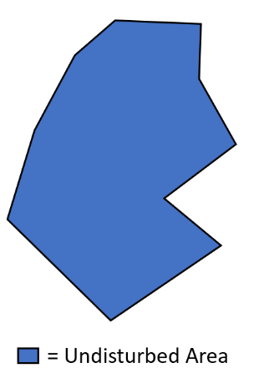

* Permit Area (Acres) =
* Soil Depth (Inches) =
* Overburden Depth (Inches) =

**Total Cubic Yards of Soil Available for Reclamation:**

$\left[\frac{\left(\left(\text{ =PermittedAcres \backslash \# "\#,\#\#0.0" }\text{ 0.0}\text{ Acres}\right)\text{*}\left(\text{43,560 Square Feet per Acre }\right)\right)\text{*(}\frac{\text{ =SoilDepth \backslash \# "\#,\#\#0" }\text{ 0}\text{ Inches of Soil}}{\text{12 Inches per Foot}}\text{)}}{\text{27 Cubic Feet per }\text{Yard}}\right]$ = **0**

**Cubic Yards of Soil**

**Total Cubic Yards of Overburden Available for Reclamation:**

**Cubic Yards of Overburden**

$\left[\frac{\left(\left(\text{ =PermittedAcres \backslash \# "\#,\#\#0.0" }\text{ 0.0}\text{ Acres}\right)\text{*}\left(\text{43,560} \text{Square Feet per Acre} \right)\right)\text{*}\text{(}\frac{ =OverburdenDepth \backslash \# "\#,\#\#0" 0 Inches of Overburden}{\text{12 Inches per Foot}}\text{)}}{\text{27 Cubic Feet per }\text{Yard}}\right]$**= 0**

**Scenario 2:** The site has disturbed and undisturbed areas. Scenario 2 helps the operator prove all soil and overburden required in the permit was saved or determine if a soil or overburden deficits exist. If a deficit exists, the Scenario 2 can help operators determine the quantity required to be imported (or otherwise found) for reclamation.   
NOTE: Private operators will need to bond for the deficit. See graphic below.

* 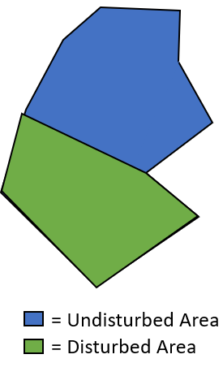Undisturbed Area (Acres) =
* Disturbed Area (Acres) =
* DEQ Approved Phase I Released Area (Acres) =
* Available Soil in Undisturbed Areas (Inches) =
* Available Overburden in Undisturbed Areas (Inches) =
* Originally Permitted Soil Depth (Inches) =
* Originally Permitted Overburden Depth (Inches)=

**Undisturbed Areas (Auto-Calculated from Values Entered Above)**

**Cubic Yards of Soil Available for Reclamation from Undisturbed Areas:**

**Cubic Yards of Salvageable Soil Available from Undisturbed Areas**

$\left[\frac{\left(\left(\text{ =UndisturbedAcres \backslash \# "\#,\#\#0.0" }\text{ 0.0}\text{ Acres}\right)*\left(43,560 Square Feet per Acre \right)\right)*(\frac{ =SoilUndisturbed \backslash \# "0" 0 Inches of Soil}{12 Inches per Foot})}{27 Cubic Feet per Yard}\right]$**= 0**

**Cubic Yards of Overburden Available for Reclamation from Undisturbed Areas:**

**Cubic Yards of**

**Salvageable**

**Overburden**

**Available from**

**Undisturbed Areas**

$\left[\frac{\left(\left(\text{ =UndisturbedAcres }\text{0}\text{ Acres}\right)*\left(43,560 Square Feet per Acre \right)\right)*(\frac{ =OBUndisturbed \backslash \# "0" 0 Inches of Overburden}{12 Inches per Foot})}{27 Cubic Feet per Yard}\right]$**= 0**

**Disturbed Areas (Auto-Calculated)**

**Cubic Yards of Soil Salvaged for Reclamation from Disturbed Areas:**

**Cubic Yards of Soil**

**that should have**

**been Salvaged**

**for Reclamation from Disturbed Areas permit**

$\left[\frac{\left(\left(\text{ =(DisturbedAcres-PhaseIRR) \backslash \# "\#,\#\#0.0" }\text{ 0.0}\text{ Acres}\right)*\left(43,560 Square Feet per Acre \right)\right)*(\frac{ =SoilDisturbed \backslash \# "0" 0 Inches of Soil}{12 Inches per Foot})}{27 Cubic Feet per Yard}\right]$**= 0**

**Cubic Yards of Overburden Salvaged for Reclamation from Disturbed Areas:**

**Cubic Yards of**

**Overburden that**

**should have been**

**Salvaged for**

**Reclamation from**

**Disturbed Areas permit**

$\left[\frac{\left(\left(\text{ =DisturbedAcres-PhaseIRR \backslash \# "\#,\#\#0.0" }\text{ 0.0}\text{ Acres}\right)*\left(43,560 Square Feet per Acre \right)\right)*(\frac{ =OBDisturbed 0 Inches of Overburden}{12 Inches per Foot})}{27 Cubic Feet per Yard}\right]$**= 0**

**Stockpiles at Site**-Input quantities of soil and overburden in their respective columns. Values will be auto calculated into the answer box below. If more than four stockpiles exist, combine multiple stockpiles so that all stockpiles onsite are represented below.

Soil Stockpile #1 (Cubic Yards) =       Overburden Stockpile #1 =

Soil Stockpile #2 (Cubic Yards) =       Overburden Stockpile #2 =

Soil Stockpile #3 (Cubic Yards) =       Overburden Stockpile #3 =

Soil Stockpile #4 (Cubic Yards) =       Overburden Stockpile #4 =

**Total Soil Stockpiled Onsite = 0 CY Total Overburden Stockpiled Onsite = 0 CY**

**Cubic Yards of Soil**

**Soil and Overburden Deficit Determination of Disturbed Areas (Auto-Calculated)**

**Soil Deficit Determination**

**0 CY** Total Soil Stockpiled Onsite -  **0 CY** Soil Permitted/Required to be Salvaged from Original Permit = **0**

* If this value is negative (-) the amount specified must be bonded for on the *Reclamation Bond Spreadsheet* under ‘Cost to Import, Purchase, and Place Soil’ (refer to Reclamation Bond Spreadsheet example below).

NOTE: Government operators would be required to describe how the deficit would be mitigated for final reclamation (i.e., importation of soil).

* If this value is 0 or a positive value, no action is required of the Operator.

**Overburden Deficit Determination**

**Cubic Yards of Overburden**

**0 CY** Total Overburden Stockpiled Onsite -  **0 CY** Overburden from Original Permit= **0**

* If this value is negative ( **0**) then the amount specified must be bonded for on the *Reclamation Bond Spreadsheet* in one of the blank lines. Ensure to enter the corresponding overburden deficit and market rate for overburden. See example below.

Note: The example below shows $10 for cost. This is just an example and the market rate may be substantially different.

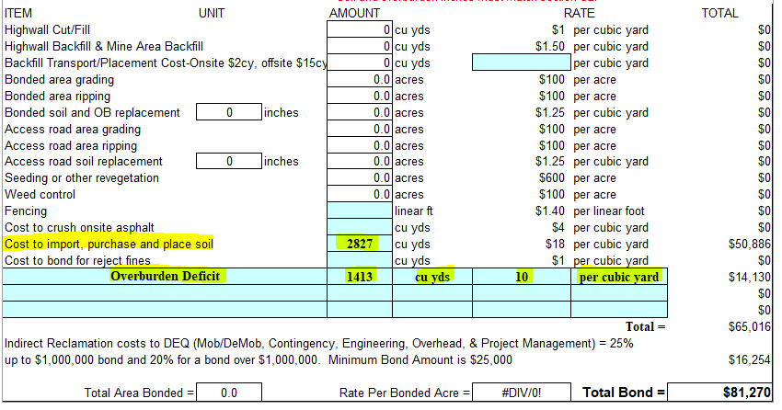

* If this value ( **0**) is 0 or a positive value, no action is required of the Operator.
* Note: It is important to calculate the on-site quantities accurately as Opencut may verify the above numbers using UAV technology. If Opencut finds deficits in stockpiled soil and overburden, the operator will be required to bond for that deficit and complete this worksheet.

**Soil and Overburden Budget - Uniform Replacement Depths Across the Site using Existing Soil and Overburden**

In special circumstances, if a soil deficit exists on site or if the original permitted soil and/or overburden depths were over inflated or inaccurate, the soil and/or overburden can be averaged across the site to a more realistic value. Normally, this is only applicable to sites permitted **prior to May 2009. Sites permitted AFTER 2009 would not be able to use this budget unless a valid reason is provided in the application and/or it is first approved by DEQ Opencut.** Just because the operator failed to save the permitted depths of soil/overburden for reclamation does not relieve the operator from being fully liable for the soil/overburden deficit.

Note: To use the Soil Budget Section, the Operator must have:

1. Soil Test Pits in undisturbed areas to verify soil depths

**Cubic Yards of Soil Available to Spread Across the Site**

**Soil Volume On Site**

**0 CY** Soil from Undisturbed Areas +  **0 CY** Soil from Soil Stockpiles =  **0**

**Inches of Soil to be Placed Across the Entire Site (Average)**

$\left[\frac{(\left( =(((UndisturbedAcres*43560)*(SoilUndisturbed/12))/27)+(Soil1+Soil2+Soil3+Soil4) \backslash \# "\#,\#\#0" 0 CY Total Soil from Entire Site\right)*27 Cubic Feet per cubic Yard)}{\left(43,560 Square Feet per Acre\right)*( =(DisturbedAcres-PhaseIRR)+UndisturbedAcres \backslash \# "\#,\#\#0.0" 0.0 Acres)}\right]$ = !Zero Divide **Feet of Soil**\*(12 inches)**=** !Zero Divide

**Cubic Yards of Overburden Available to Spread Across the Site**

**Overburden Volume On Site**

**0 CY** Overburden from Undisturbed Areas +  **0 CY** Overburden from Stockpiles=  **0**

$\left[\frac{(\left( =(((UndisturbedAcres*43560)*(OBUndisturbed/12))/27)+(Overburden1+Overburden2+Overburden3+Overburden4) \backslash \# "\#,\#\#0" 0 CY Total Overburden from Entire Site\right)*27 Cubic Feet Per cubic Yard)}{\left(43,560 Square Feet per Acre\right)*( =(DisturbedAcres-PhaseIRR)+UndisturbedAcres \backslash \# "\#,\#\#0.0" 0.0 Acres)}\right]$ = !Zero Divide **Feet of Overburden**\*(12 inches)= !Zero Divide

**Inches of Overburden to be Placed Across the Entire Site (Average)**

NOTE: If the above average is not sufficient to allow for vegetative growth and establishment, importation

of soil and overburden may be required. A minimum depth of at least 5-6 inches of soil/growth media is typically needed to support vegetative growth, but can be dependent on the proposed postmining land use, underlying substrate, amount and quality of available overburden, etc.

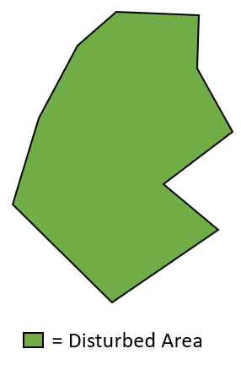**Scenario 3:** Entire site has been disturbed, no area of the site has soil and/or overburden in place. See graphic below.

* Disturbed Area (Acres) =
* DEQ Approved Phase I Released Area (Acres):
* Original Permitted Soil Depth (Inches) =
* Original Permitted Overburden Depth (Inches)=

**Original Soil and Original Overburden Calculations**

**Soil Calculation**

**Cubic Yards of Soil Salvaged for Reclamation from Entire Disturbed Site**

$\left[\frac{\left(\left( =DisturbedAcres2-PhaseIRR2 \backslash \# "\#,\#\#0.0" 0.0 Acres\right)*\left(43,560 Square Feet per Acre \right)\right)*(\frac{ =OGSoil \backslash \# "0" 0 Inches of Soil}{12 Inches per Foot})}{27 Cubic Feet per cubic Yard}\right]$**= 0**

**Overburden Calculation**

**Cubic Yards of Overburden Salvaged for Reclamation from Entire Disturbed Site**

$\left[\frac{\left(\left( =DisturbedAcres2-PhaseIRR2 \backslash \# "\#,\#\#0.0" 0.0 Acres\right)*\left(43,560 Square Feet per Acre \right)\right)*(\frac{ =OGOB \backslash \# "\#,\#\#0" 0 Inches of Soil}{12 Inches per Foot})}{27 Cubic Feet per cubic Yard}\right]$**= 0**

**Stockpiles at Site**-Input quantities of soil and overburden in their respective columns. Values will be auto calculated into the answer box below. If more than four stockpiles exist, combine multiple stockpiles so that all stockpiles onsite are represented below.

**Stockpiles at Site**

Soil Stockpile #1 (Cubic Yards) =       Overburden Stockpile #1 =

Soil Stockpile #2 (Cubic Yards) =       Overburden Stockpile #2 =

Soil Stockpile #3 (Cubic Yards) =       Overburden Stockpile #3 =

Soil Stockpile #4 (Cubic Yards) =       Overburden Stockpile #4 =

**Total Soil Stockpiled Onsite = 0 Cubic Yards Total Overburden Stockpiled Onsite = 0 Cubic Yards**

**Soil and Overburden Deficit Determination of Disturbed Areas**

**Soil Deficit Determination**

**Cubic Yards of Soil**

**0 CY** Total Soil Stockpiled On Site –  **0 CY** Soil from Original Permit =  **0**

* If this value is negative (-) then the amount specified must be bonded for on the *Reclamation Bond Spreadsheet* under ‘Cost to Import, Purchase, and Place Soil’ (refer to Reclamation Bond Spreadsheet example below).

NOTE: Government operators would be required to describe how the deficit would be mitigated for final reclamation (i.e. importation of soil).

* If this value ( **0**) is 0 or a positive value, adequate soil volumes exist on site for reclamation.

**Overburden Deficit Determination**

**Cubic Yards of Overburden**

**0 CY** Total Overburden Stockpiled on Site -  **0** **CY** Overburden From Original Permit=  **0**

* If this value is negative (-), then the amount specified must be bonded for on the *Reclamation Bond Spreadsheet* in one of the blank lines. Ensure to enter the corresponding overburden

deficit and market rate for overburden. See example below.



* If this value ( **0**) is 0 or a positive value, adequate overburden volumes exist on site for reclamation.

**Soil and Overburden Average Replacement Depth Across Site**

**Soil Average Replacement Depth Across Site**

**Inches of Soil per Acre**

$\left[\frac{ =SoilS1+SoilS2+SoilS3+SoilS4 \backslash \# "\#,\#\#0" 0 CY Total Soil Stockpiles On Site*27 Cubic Feet per Yard }{\left(43,560 Square Feet per Acre\right)*( =DisturbedAcres2-PhaseIRR2 \backslash \# "\#,\#\#0.0" 0.0 Acres)}\right]$ = !Zero DivideFeet * 12 inches per foot= !Zero Divide

**Overburden Average Replacement Depth Across Site**

**Inches of Overburden per Acre**

$\left[\frac{ =Ovbn1+Ovbn2+Ovbn3+Ovbn4 \backslash \# "\#,\#\#0" 0 CY Total Overburden Stockpiled on Site*27 Cubic Feet per Yard}{\left(43,560 Square Feet per Acre\right)*( =DisturbedAcres2-PhaseIRR2 \backslash \# "\#,\#\#0.0" 0.0 Acres)}\right]$ = **!Zero Divide** Feet *12 inches per foot= !Zero Divide

NOTE: If the above average is not sufficient to allow for vegetative growth and establishment, importation

of soil and overburden would be required. Normally a depth of 5-6 inches of soil is needed to support vegetative growth, but can be dependent on the proposed postmining land use, underlying substrate, amount and quality of available overburden, etc.