POND & WETLAND DESIGN WORKSHEET
Follow this worksheet to design a year-round pond, seasonal pond or wetland. Also refer to the below example Reclamation Map, Pond Plan View Contour Map, and cross-section drawings.

A - Site Specific Information:

- Operator Name:

- Site Name:

- Indicate whether ponds, wetlands, or both will remain as a result of Opencut Operations.
Ponds Only Wetlands Only Both Ponds and Wetlands

- Indicate the number of ponds to be constructed:
None 1 2 3 4 5 Other:
  - Indicate the maximum depth: feet

- Indicate the number of wetlands to be constructed:
None 1 2 3 4 5 Other:
  - Indicate the maximum depth: feet

B - Ponds & Wetlands
Consult the landowner about the mine site and pond design, the Opencut operations, and desired postmining designation of the pond. The pond design and construction should balance the needs and desires of the pond owner with the Opencut mine plan of operation. The prospective pond builder (the operator and landowner) are responsible for knowing the legal requirements for building a pond. Necessary state and federal permits will vary with specific site factors and individual circumstances. Consult the Department of Fish, Wildlife & Parks to learn what aquatic nuisance species are prohibited, how to prevent introduction, and what is essential to prevent the spread of troublesome invaders. Obtaining proper water rights for a new pond may be necessary under Montana law.
- Refer to the Department of Natural Resource and Conservation (DNRC) guideline “Opencut Mining: Do You Need a Water Right?” and consult the DNRC for operator or landowner requirements regarding water rights and ground water development for ponds. The DNRC Opencut Mining: Do You Need a Water Right? guideline is found here: https://deq.mt.gov/mining/assistance.

- In the Postmining Land Uses section of the Standard Opencut Mining Permit Application, designate all seasonal and year-round pondsand wetlands that apply. Many ponds have seasonal wetland areas or shallow inlets that act as functional wetlands. Constructed wetlands and ponds may qualify for technical assistance or mitigation grants (refer to suggested sources at the end of this worksheet). A well-designed pond or wetland may also increase the value and productivity of the mined property.

- Designate below a minimum of one long-axis cross-section and one short-axis cross-section drawing for each proposed pond or wetland. At least one cross-section with a slope of 5:1 or flatter must be used for most water features. Alternatively, create and submit additional cross-sections that represent the pond/wetland or submit a contour map of the finished pond. Identify locations of cross-sections on the Reclamation Map.

- 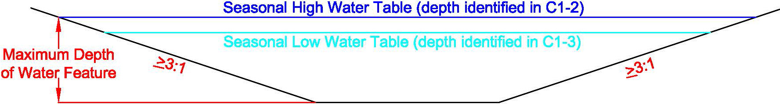
Additional Comments (if applicable):

- 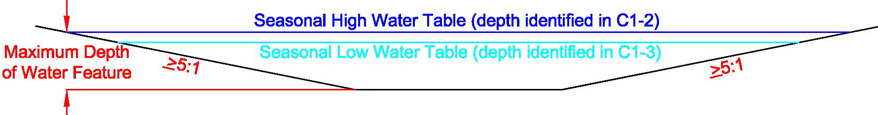
Additional Comments (if applicable):

- 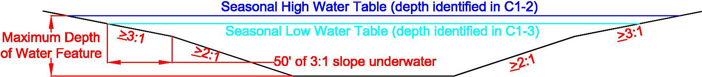
Additional Comments (if applicable):
- 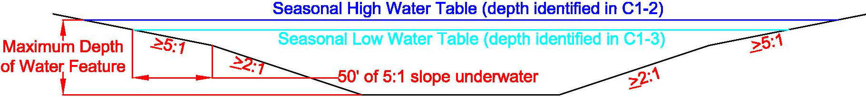
Additional Comments (if applicable):

- 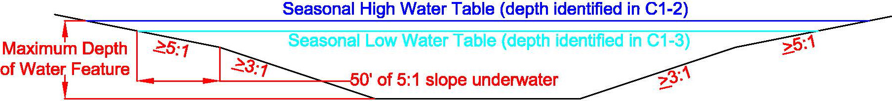
Additional Comments (if applicable):

- If additional cross-sections are needed to depict the pond/wetland, each cross section must contain the following:
    - Depths;
    - Slopes;
    - Physical features; and
    - Seasonal high and seasonal low water levels
Additional cross-sections are attached (check appropriate box on page 2 of the application).
Additional Comments (if applicable):

- Optional Alternative: Attach a labeled Contour Map showing the depth of each proposed pond or wetland with a contour interval appropriate for the pond/wetland depth.
The labeled Contour Map is attached (check appropriate box on page 2 of the application).
Additional Comments (if applicable):

- Ponds and wetlands must have several areas of 5:1 or flatter slopes along the shoreline, as well as leading into the pond for 50 feet under water before dropping off to a steeper slope. Depending on the pond or wetland type, 10 to 25 percent of the pond needs to be 5:1 or flatter slopes to provide access to the water feature. Indicate all slopes that would remain for final reclamation of the pond/wetland and show their location on the reclamation map. Check one or more box in each category to define the slopes for final reclamation of the pond/wetland feature:
  - Above High Water: 5:1 3:1 <3:1 (if <3:1 is checked complete 4d below)
  - Between High and Low Water: 5:1 3:1 <3:1 (if <3:1 is checked complete 4d below)
  - Below Low Water: 5:1 3:1 <3:1 (angle of repose)
  - Slopes <3:1 above the seasonal high and/or low water table require a slope stability study completed in accordance with ARM 17.24.219(1)(c)(vii).
The slope stability analysis is attached (check appropriate box on page 2 of the application).

- Check the physical features below that are included in the pond/wetland design. The features included in the design must meet the specific requirements described about each feature below.
Irregular Shoreline Inlets/Bays Islands Peninsulas Submerged habitat features
Boat Ramp Livestock Watering Ramp
Other:

- Ensure the Reclamation Map displays all information and meets the requirements of ARM 17.24.221(5).

C - SOIL REQUIREMENTS:
Operator understands that all soil taken from the pond or wetland area must be kept on-site for reclamation and cannot be removed or sold until the DEQ has determined the postmining land use has been met, thereby verifying the soil is not needed to reclaim the pond or wetland area, or other remaining areas. A Phase I or Phase II release must be submitted and approved prior to removing or selling soil. To obtain Phase I approval, a representative portion of the shoreline must also be reclaimed to Phase I or II standards.

D - WATER LEVELS
Accurately determine the site's existing or expected seasonal high and low water levels using the Determining Depth to Groundwater Worksheet found here: https://deq.mt.gov/mining/assistance (click on “Forms” tab). During Opencut operations, use this water level information and appropriate survey methods to establish correct pond feature elevations. In this worksheet, the term “normal water level” means the prevalent water table or surface water level during the year.

Use the below criteria as applicable for your water feature design:

E - ORIENTATION AND SHORELINES
If possible, orient the long axis of the mine pit (future pond) perpendicular to the prevailing wind. Build in a sinuous shoreline by mining the pit with an irregular shape. Make shorelines irregular with points, coves, inlets, peninsulas and bays located around 50% or more of the pond (see Figure 5). Inlets and peninsulas need to be 1 to 4 times longer than their width and located every 200 to 300 feet along the shore. Orientation perpendicular to the prevailing wind minimizes fetch (the distance wind blows over water), thus reducing wave action. Irregularly shaped shorelines increase edge habitat, provide various plant and animal habitats, and reduce wind and wave impacts on aquatic vegetation and shorelines.

F - SHORE PROTECTION, RESOILING AND REVEGETATION
Shorelines with excessive downwind erosive wave actions may need protection with riprap, cobbles, or pit run gravel placed from 2 feet above the seasonal high-water level to 2 feet below the seasonal low water level. Install berms, ditches, catchments, or erosion control products where runoff could carry sediment into the pond or erode shore slopes. Show areas of shoreline protection on the Reclamation Map.

All soil salvaged from the pond or wetland area must be kept on-site for reclamation and cannot be removed or sold until the DEQ has determined the postmining land use has been met, thereby verifying the soil is not needed to reclaim the pond or wetland area, or other remaining areas.

Hydric soil introduces aquatic plants and plant propagules to the pond, which facilitates plant and animal establishment and helps stabilize shorelines via vegetative growth. Salvage hydric soils that are present in existing wetlands, wet depressions or ditches within the permitted mine or facility area. Avoid obtaining soil from cattail or reed canary grass areas since these aggressive plants are undesirable. Stockpile hydric soil separately and keep wet. Place hydric soil along shorelines to enhance a vegetative wave action barrier. If an island or mainland shore shows excessive erosion before the permit is released, the DEQ will require stabilization of those areas. Replace soil above and below the seasonal low water table level during the driest season.

Seed upland areas at the first seasonal opportunity to minimize the time that replaced soil is exposed to erosion and invasive weeds. Use the DEQ wetland seed mix for the pond edges, transition zones, and submerged areas, or provide a custom seed mix that includes a minimum of 5 wetland species (e.g. obligate wetland and facultative wetland species). Islands must have soil replaced and be seeded or planted.

G - ISLANDS
Islands increase edge habitat by increasing shoreline length, provide nesting and loafing sites for wildlife, and add aesthetic appeal. Create islands by leaving natural material in place or by mounding and compacting materials (see Figure 1). Oversize rock piles can be used as loafing islands and can serve as riprap for islands in large ponds or wetlands that are subject to erosive wave action.
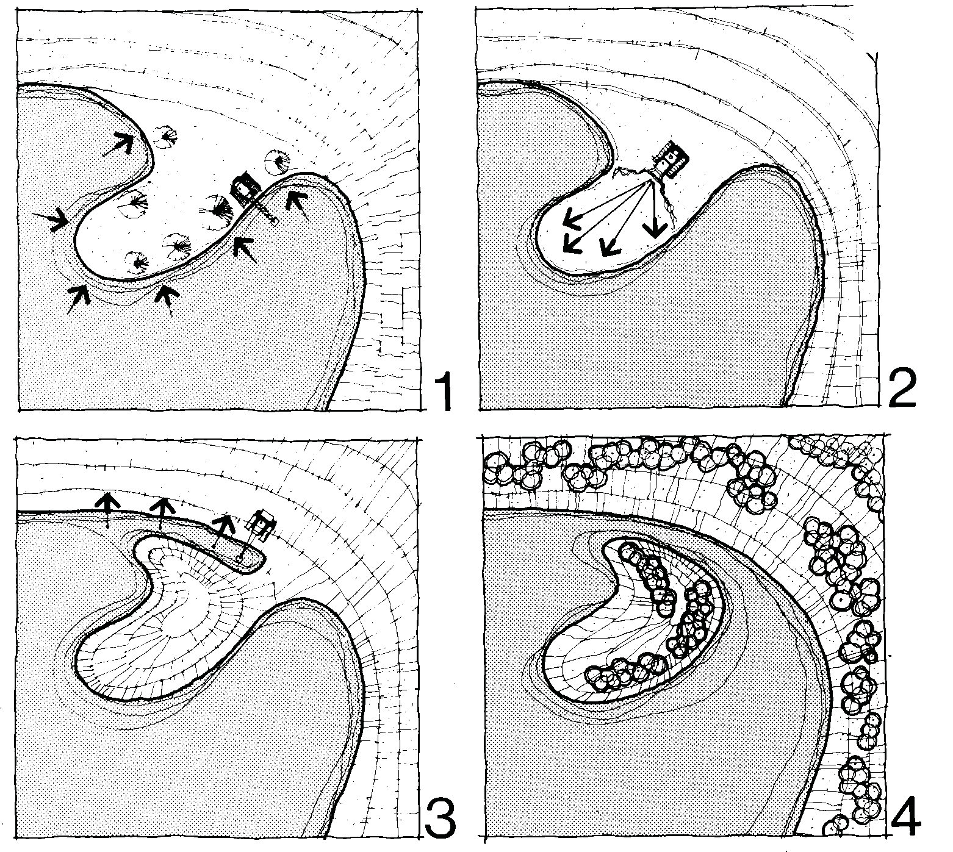
Figure 1. Island construction during active mining. (From Michalski [1987], Rehabilitation of Pits and Quarries for Fish and Wildlife, Ontario Ministry of Natural Resources.)

Location. If possible, locate islands in the upwind side of the pond or an area protected from the prevailing wind to minimize erosive wind and wave action. Maintain at least a 50-foot wide, 2-foot deep separation between islands and the mainland and keep islands at least 150 feet apart. Adequate distance between islands minimizes territorial strife among nesting birds. Adequate separation between islands and the mainland reduces terrestrial predators from reaching islands.
Size and Shape. Make islands ranging from 25-foot diameter circles to 50- by 200-foot rectangles at the seasonal high-water level. If possible, orient the long axis of islands parallel with the prevailing wind. Make the shorelines of large islands irregular. Islands oriented parallel with the prevailing wind are exposed to less wind and wave action. Linear islands with irregular shorelines provide better nesting opportunities. Horseshoe shaped islands with the mouth of the horseshoe in the lee of prevailing wind provide ideal shelter for waterfowl broods. The inner banks should be more gently sloped than the outer banks to increase the sheltering effect (see Figure 2).
Height and Shore Slope. Make islands with flat or rounded tops at least 3 feet above the seasonal high-water level. Grade the island flanks to 5:1 or flatter slopes that go at least 3.5 feet below normal water level. A 5:1 or flatter shore slope provides access for wildlife and reduces erosion. A water depth of at least 3.5 feet around an island controls emergent vegetation, which caters to the preference of nesting waterfowl for open shorelines and helps provide a separation between island and shoreline.

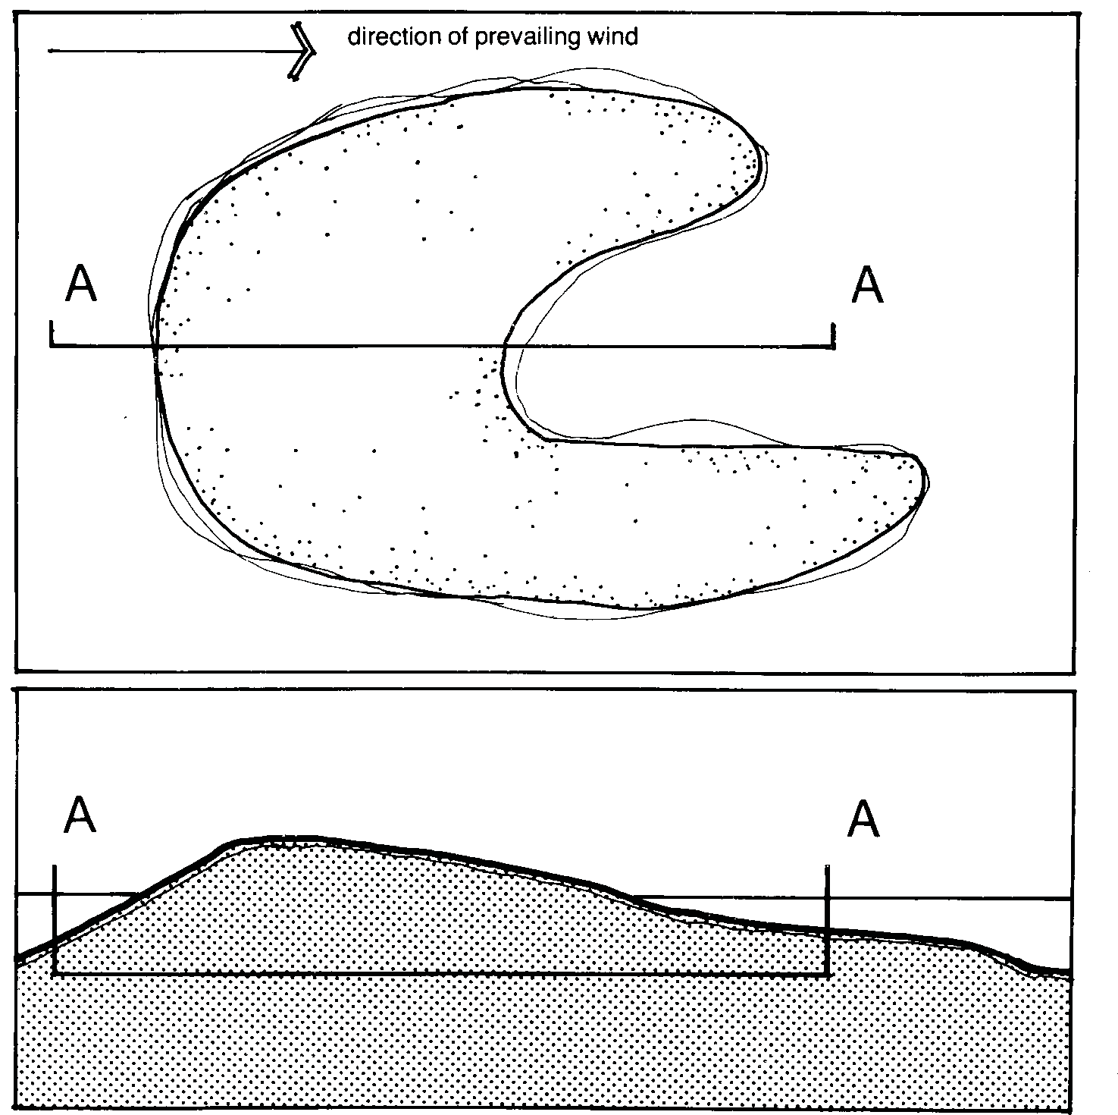
Figure 2. Horseshoe island construction. (From Michalski [1987], Rehabilitation of Pits and Quarries for Fish and Wildlife, Ontario Ministry of Natural Resources.)

H - FENCED BUFFER AND LIVESTOCK WATERING RAMP
Refer to the DNRC Opencut Mining: Do You Need a Water Right? guideline found at http://deq.mt.gov/Mining/opencut (I-1 under the Forms tab) water right may be required from DNRC for a livestock watering ramp. Unrestricted livestock will overgraze a pond site, trample the shore and pond bed, muddy and enrich the water, and shorten the life of a pond. Fencing will help vegetation establish and prevent livestock-related problems. Healthy vegetation filters out sediment and contaminants and provides cover for wildlife. A watering ramp provides livestock access to water. A 10-foot-wide ramp will service about 60 cows. Remove shade and other livestock attractants from around the ramp to keep livestock from loafing in or near the area.

If livestock use the area, establish a buffer around the pond by constructing a wildlife-friendly, durable fence at least 50-feet back from the seasonal high-water level. If livestock need access to water, construct one or more watering ramps as follows:
- Grade a minimum 10-foot wide, 5:1 ramp extending from 15 feet upslope of the seasonal high-water level to 5 feet downslope of the seasonal low water level. Skip to item 4 if the ramp foundation consists of natural gravel deposit.
- Install an appropriate geotextile or geogrid over the entire ramp area.
- Cover the geotextile or geogrid with minimum 12 inches of pit run or graded gravel.
- Install a fence that runs around the end and up the sides of the ramp to a gap in the perimeter fence. Keep the fence just inside the graveled ramp area so livestock remain on firm footing.
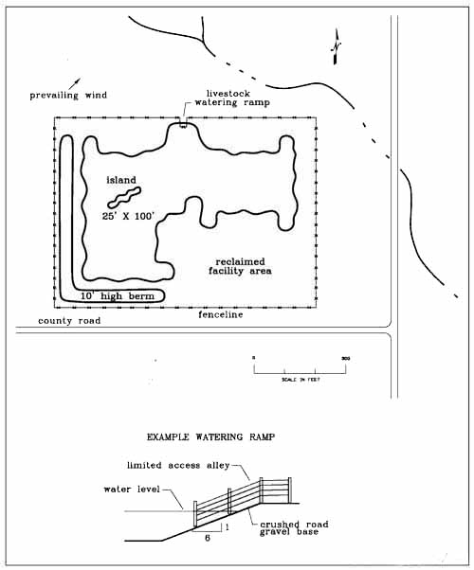
Figure 3. Example fenced buffer and livestock watering ramp.

I - WETLAND
The following criteria apply to the creation of a wetland. DEQ will consider site specific proposals for seasonal wetlands, which are wetlands that hold water through some of the summer but usually go dry by season’s end. In addition to the items discussed under All Ponds, follow these criteria for permanent or seasonal wetland ponds.

Size. One to five acres is optimal, although an area as small as 0.25 acre can be a functional wetland. Wetlands larger than five acres are acceptable. A group of small wetlands creates more diverse habitats, and is better for wildlife than one large wetland, as long as they are located at least 100 to 300 feet apart, or closer if tall vegetation screens the wetlands from one another.

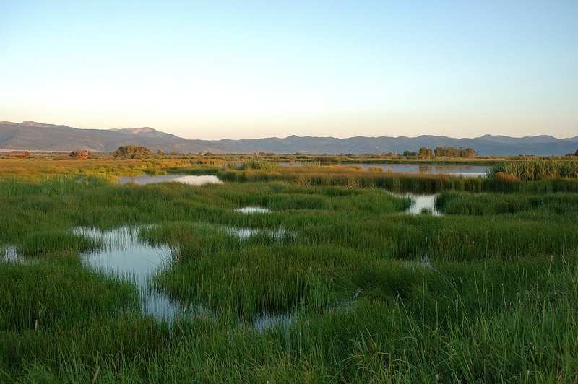
The “Hemi-Marsh” Principle

Figure 4. Hemi-Marsh. (From Katie Salsbury [2009], Guidelines for Designing Wildlife
Friendly Ponds. North Fork Native Plants).
Shore Slopes. Wetlands that have irregular shapes (no straight edges) provide more shoreline and increase habitat diversity. Shorelines need to be irregular with as many bays, inlets, and peninsulas as practical. Inlets and peninsulas need to be 1 to 4 times longer than their width. Placement of large woody debris and boulders will also increase availability of habitat to attract diverse wildlife. Grade the slopes to range from 10:1 to 5:1 along about 75 percent of the shoreline. Intersperse steep drop-off segments that are about 50-feet long and drop to a depth of at least 3.5 feet below normal water level along the other 25 percent of shoreline. A 5:1 shore slope provides good access for wildlife. Gradual slopes (10:1or flatter) on approximately half of the wetland shoreline are recommended to provide mudflats, emergent vegetation, feeding and hiding cover for wildlife, and to minimize soil erosion and slope slumping.
Depths. Create the following approximate wetland depths and coverage areas based on the normal water level:
- Shallows up to 3.5-feet deep over 35 percent or more of the area.
- Deep water areas a maximum of 10-feet deep (rooted aquatic vegetation can grow in water up to 6.5-feet deep).

If possible, locate the majority of shallows on the upwind side of the wetland. Vary water depths across the wetland by intermixing shallow and deep-water areas. Aquatic vegetation is better protected from wind and wave action in upwind shallows. Areas shallower than 3.5-feet deep support emergent vegetation that benefits certain wildlife and attracts dabbling ducks. Intermixing shallow and deep-water areas allows the formation of a mosaic of aquatic vegetation and open water, as shown in Figure 4 above.
Bed. Incorporating micro-topography into the bed encourages the development of greater diversity of wetland plants. In various places on at least 50 percent of the shallows bed, apply 6 to 36 inches of fine-textured substrate such as hydric or upland soil. Leave other areas of sandy, gravelly, and cobbly surfaces. Place boulders, rock piles, and tree trunks in shallows, leaving a portion of each above the normal water level. Place vegetative debris (from clearing activities) in the wetland to provide habitat for waterfowl and promote habitat for invertebrates. Fine-textured substrates support wetland plants and animals. Boulders, rock piles, and tree trunks in shallows provide resting sites for wildlife.

J - WILDLIFE POND
Ponds may be designed to have features that enhance wildlife habitat while also including features to optimize fish production and can simultaneously create wetlands next to the pond with diverse aquatic habitats. In addition to the items discussed under All Ponds, the following criteria include features that enhance pond habitat for wildlife.
Size. One to five acres is optimal. Ponds larger than 5 acres are acceptable.
Shore Slopes. Ponds that have irregular shapes (no straight edges) provide more shoreline and increase habitat diversity. Shorelines need to be sinuous with as many bays, inlets, and peninsulas as practical (Figure 5). Inlets and peninsulas need to be 1 to 4 times longer than their width. Placement of large woody debris and boulders will also increase availability of habitat to attract diverse wildlife. Grade to 3:1 or flatter slopes along about 50 percent of the shoreline. Grade to 5:1 or flatter slopes along about 25 percent of the shoreline for easy and safe access by wildlife and humans. Intersperse steep drop-off segments that are about 50-feet long and drop to a depth of at least 3.5 feet below normal water level along the other 25 percent of shoreline. Steep drop-offs keep portions of the shoreline free of emergent vegetation, which benefits certain wildlife and provides better recreational access. Plant vegetation that varies in both height and hydric needs. Ensure soil is retained onsite for placement onto shorelines to allow for vegetative growth.
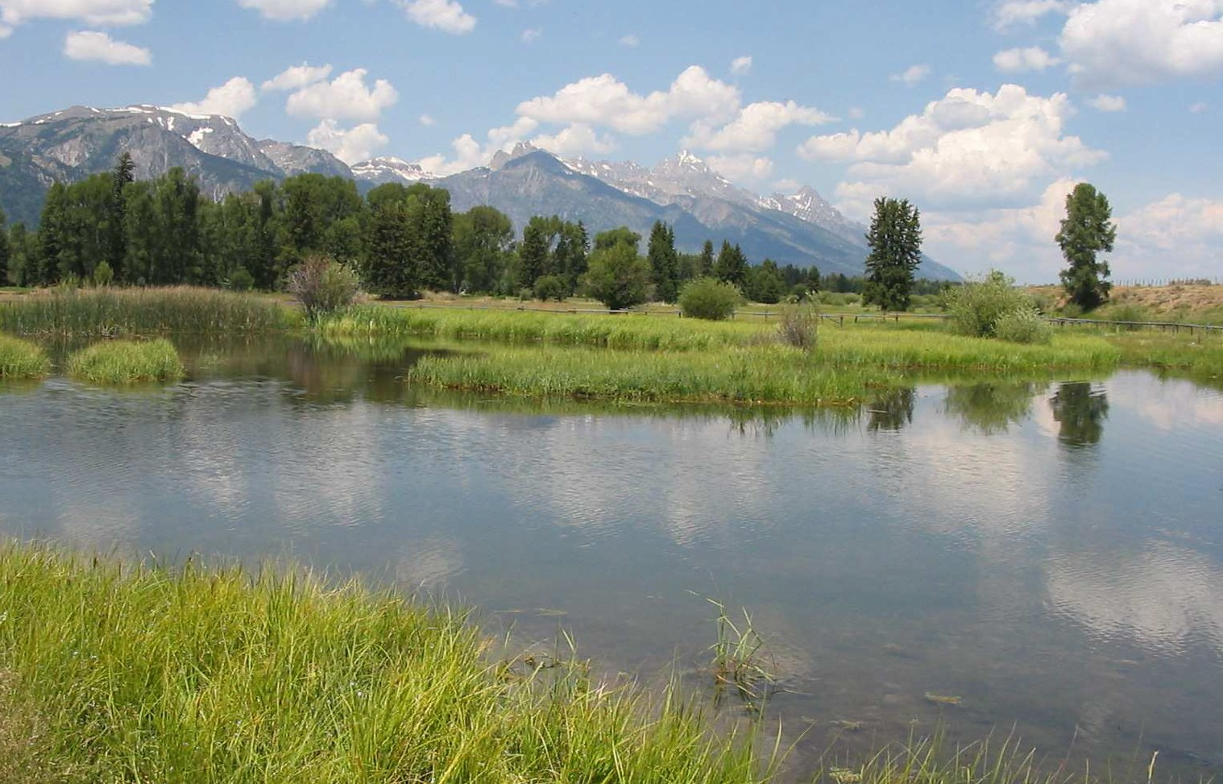
Multiple Bays
A Sinuous Shoreline
Figure 5. Bays and Shoreline. (From Katie Salsbury [2009], Guidelines for Designing Wildlife
Friendly Ponds. North Fork Native Plants).
Depths. Create the following approximate pond depths and coverage areas based on the normal water level:
- Shallows up to 3.5-feet deep over 25 percent of the area to allow emergent vegetation to grow and provide food and cover.
- Intermediate depth areas 8-feet deep over 50 percent of the area.
- Deep water areas of at least 15-feet deep over 25 percent of the area.
Wildlife primarily use shallow water while the steep drop-offs keep portions of the shoreline free of emergent vegetation, which benefits certain wildlife and provides better recreational access. Deep water prevents the growth of emergent vegetation and attracts diving ducks. Intermixing shallow and deep-water areas allows the formation of a mosaic of emergent vegetation and open water, which makes good wildlife habitat.
Bed. In various areas on at least 50 percent of the shallows bed, apply 6 inches of fine-textured substrate such as hydric or upland soil. Leave areas of sandy, gravelly, and cobbly surfaces. Place boulders, rock piles, and tree trunks in shallows, leaving a portion of each above the normal water level. Place these same items across intermediate depth and deep-water areas, anchoring tree trunks via partial burial in the pond bottom. Fine-textured substrates support wetland plants and animals. Rough intermediate depth and deep-water beds, and steep slopes between the various pond bed levels provide diverse habitat. Boulders, rock piles, and tree trunks in shallows provide resting sites for wildlife, and in intermediate depth and deep-water areas they provide better fish habitat.

K - FISH POND (Excerpted from A Guide to Building and Managing Private Fish Ponds in Montana. 2006.)
Across the mountainous western half of Montana, and in regions of eastern Montana where cold water springs are found, spectacular fishing can be provided in some very small trout ponds. Proper design and construction of a pond will dictate fishery quality. Fish stocking requires a Non-Commercial Private Fishpond License ($10 fee as of 2018) issued by MT Fish, Wildlife and Parks (FWP). The FWP permit will list specific fish species approved for the pond, and the pond builder may choose from these species. Aquatic nuisance species are a threat to ponds throughout Montana. Knowing what is prohibited, how to prevent introduction and dispersal, and where to find information is essential to prevent the spread of troublesome invaders.

Size. One to five acres is optimal. Ponds larger than 5 acres are acceptable, but smaller ponds are easier to manage and produce more pounds of fish per acre than large ponds. For ponds smaller than 1-acre, supplemental feeding of fish may be necessary.

Shore Slopes. The aquatic vegetation zones will occupy the first contour below water surface. These shallow water wetlands (Figure 6) should extend from the shoreline to a depth of about three feet and amount to anywhere from 10-25% of the pond surface area depending on the oxygen and nutrient qualities of the site. The shallow areas will quickly be colonized by fish food in the form of zooplankton, crustaceans, insects, and amphibians. Near- shore areas should have a gentle slope for safety for humans and animals.
Below the vegetation contour, the pond bottom should slope steeply down to a depth of at least ten feet to prevent growth of aquatic plants. The steep slope will also provide prime feeding area for fish. Terraces in the 6- to 8-foot contours are good places for piles of large rocks or woody debris that will provide cover.
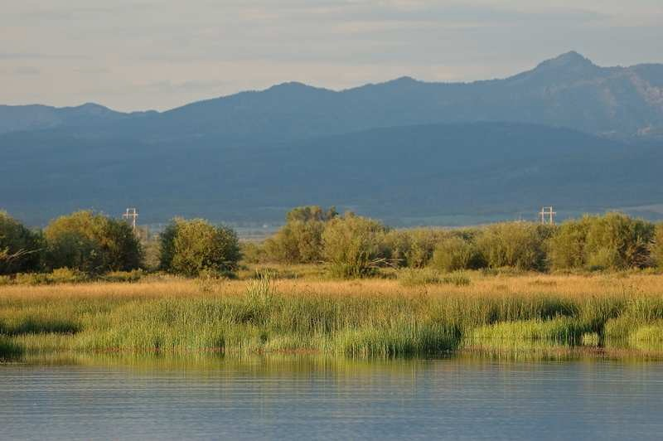
Vegetated Shallows
Figure 6. Shallow Aquatic Zone. (From Katie Salsbury [2009], Guidelines for Designing Wildlife
Friendly Ponds. North Fork Native Plants).

Depths. Shallows are needed for wetland habitat, fish forage production, fish reproduction, and aesthetics. Intermediate depth and deep-water areas maintain open water by discouraging the growth of aquatic vegetation. Deep water ensures that wintertime dissolved oxygen will be adequate to support fish populations and that there will be unfrozen areas within the pond.

The maximum depths that are necessary to prevent vegetation growth and the necessary depths to prevent anoxic conditions (winterkill) vary around the state. A pond 12 feet deep may need half its area at that depth, while one 15 feet deep may need only one-third its area at this depth to prevent anoxic conditions. Conditions in eastern Montana require a maximum depth of at least 10 feet to prevent vegetative growth. This variation in conditions around the state illustrates the importance of talking to a professional familiar with the area for design and construction of the pond. Aeration and recirculation are additional methods that may be needed to prevent anoxic conditions. These types of devices can be expensive and will add to the total cost of the pond maintenance.
Bed. In various areas on at least 50 percent of the shallows bed, apply 6 inches of fine-textured substrate such as hydric or upland soil. Leave areas of sandy, gravelly, and cobbly surfaces. Place boulders, rock piles, and tree trunks in shallows, leaving a portion of each above the normal water level. Place these same items across intermediate depth and deep-water areas, anchoring tree trunks via partial burial in the pond bottom. Fine-textured substrates support wetland plants and animals. Rough intermediate depth and deep-water beds, and steep slopes between the various pond bed levels provide better fish habitat. Boulders, rock piles, and tree trunks in shallows provide resting sites for wildlife, and in intermediate depth and deep-water areas they provide better fish habitat.

L - WATER SOURCE POND
In addition to the items discussed under All Ponds, follow these criteria for a water source pond.

Typically, a pond 1 acre or smaller may be designated as a water source pond for livestock, irrigation, firefighting reserve, or general use. Note that these uses would require a water right from DNRC. Grade at least one shore slope to 5:1 and the rest to 3:1. Build the pond so it is at least 3.5-feet deep at normal water level. A 5:1 slope provides good access for livestock, wildlife, and other uses. Water depths of at least 3.5 feet limit the growth of emergent vegetation, thus maintaining open water.

M - REFERENCES
Bender-Keigley, Janet. Montana Watercourse. 2008. A Landowners’ Guide to Montana Wetlands. www.mtwatercourse.org/publications

LeBeau, Michelle. Montana Watercourse. 2005. A Guidebook for Montana Ponds. Evaluates ponds and alternatives; contacts and references for technical details. www.mtwatercourse.org/publications

Michalski, M. F. P., D. R. Gregory, and A. J. Usher. 1987. Rehabilitation of pits and quarries for fish and wildlife. Ontario Ministry of Natural Resources, Land Management Branch. 59 pp.

Salsbury, Katie. 2009. Guidelines for Designing Wildlife Friendly Ponds. Tips and guidelines for ensuring pond functions for fish and wildlife. North Fork Native Plants. www.northforknativeplants.com/library

Schrank, Sally. MT FWP Fisheries Division. A Guide to Building and Managing Private Fish Ponds in Montana. 2006. Planning, legal requirements, design, stocking, and management of fish ponds. http://fwp.mt.gov/fishing/regulations/ponds.html

Soil Conservation Service. Ponds -- Planning, Design, Construction. U.S. Dept. of Agriculture, Ag. Handbook Number 590, Washington, 1997, 85 pages. Technical guide for planning and design of ponds.

N - PROGRAMS FOR TECHNICAL ASSISTANCE
Montana Wetlands Legacy Program; MT Fish, Wildlife & Parks (www.wetlandslegacy.org)
Wetland Mitigation Program; MT Dept. of Transportation (www.mdt.mt.gov)
Wetland Reserve and Wildlife Habitat Incentive Programs; Natural Resources Conservation Service (www.mt.nrcs.usda.gov/programs)

