For Office Use Only

Payor _________________________________Payment No. _______________ Payment Amt $_______________ Date ___________________

APPLICATION FOR STANDARD OPENCUT MINING PERMIT
This form is used to permit a new site, re-permit a site into the 2021 law and for amendment of existing permits where: a) water resources are affected, including surface water, intermittent or perennial streams, ground water, or water conveyance facilities, or b) where ten or more Occupied Dwelling Units are located within one-half mile of the permit boundary, MCA 82-4-432(1)(a) and (b).
Operator Name:
Site Name:
INSTRUCTIONS - How to submit a complete and accurate Plan & Application:
- Before completing this form, verify the most current version is being used and read the guidance information available on the Opencut Mining Section’s website at https://deq.mt.gov/mining/assistance.
- Fill in all blanks and provide a detailed answer for each question. Write “None” if that is the correct answer.
- This form includes automated calculations that require Microsoft Word 2010 or newer. As data is entered into this form, auto-calculate fields will auto-populate with red text. Tab out of each field to ensure they auto-calculate. If an auto-calculate field is blank, either: a) the required information was not entered, or b) the blank field does not pertain to your application.
- Opencut Mining Permits are “living” documents, meaning that whenever a permit is amended, the updated information replaces the outdated information. As a result, this form must be filled in completely for a Permit or an Amendment.
- The Department of Environmental Quality (DEQ) recommends completing this application form in electronic format. Doing so will make applying for a future amendment much easier. Operators should keep original electronic files and backups.
- Operator is required to submit all Required Support Documents, unless the exception box is appropriately checked. Operator is required to submit a copy of a previously approved support document with an amendment application. If permitted after 2010, the previously approved documents can be found on the Opencut website at https://deq.mt.gov/mining/assistance. (Click on the “Search Opencut Permits” tab.)
- Before submitting, check that all additional support documents have the same name or title shown in the “Support Documents” section. Include a Cover Letter with the application materials that lists the names of all “Other” support documents submitted.
- Sign and date the certification in Section G.
- Submit all required application materials as one package to the Opencut Mining Section electronically, through the link provided above, or by mail, addressed to: Montana Department of Environmental Quality, Opencut Mining Section, P.O. Box 200901, Helena, MT 59620-0901.

 | REQUIRED SUPPORT DOCUMENTS (unless exception applies & box is checked)
a | $1,500 Non-Refundable Fee for a Standard Permit or a Standard Amendment application if the application date is >10 years from the date of the last permit/amendment approval; or  $750 Non-Refundable Fee for a Standard Amendment application if the application date is < 10-years from the date of the last permit/amendment approval.  This application was submitted electronically and the check has been mailed.  (Make checks payable to Montana Department of Environmental Quality)  This application was submitted electronically and the payment was made electronically.  Exception: No Application Fee for Government entities
b | Consultation with DNRC on Sage Grouse (Compliance with Title 76, chapter 22, part 1)  Exception: Opencut site not located in Core, General Habitat, or Interconnectivity Sage Grouse Areas: https://sagegrouse.mt.gov  Exception: Amendment is not changing the existing permit boundary; therefore, no new sage grouse consultation is needed and Operator has submitted the existing sage grouse consultation.
c | Documentation of Consultation with State Historic Preservation Office (SHPO) MCA 82-4-432(2)(g)
d | Soil Photos Meeting Requirements of the Soil Guideline & MCA 82-4-432(14)(a)(vi)  Exception: Amendment or “Re-Permit” under HB599 is not adding acreage and site was permitted prior to 2016 rule change (If site was permitted after 2016, previously approved soil photos must be submitted).
e | Site Map MCA 82-4-403(12)(b)
f | Area Map MCA 82-4-403(12)(b)
g | Reclamation Map MCA 82-4-403(12)(b)
h | Location Map MCA 82-4-403(12)(b)
i | Boundary Coordinate Table or Proposed Permit Boundaries in format acceptable to the Department  Exception: Amendment is not changing the existing permitted boundaries and Opencut has a previous Permit Boundary submitted via BCT or other format acceptable to the Department (check with Opencut).
j | Weed Board Notification of Opencut Operation
k | Reclamation Bond Spreadsheet Exception: Government Operator MCA 82-4-433
l | Landowner Consultation MCA 82-4-432(2)(d)  Previously approved forms are acceptable for an Amendment not adding acreage, an asphalt or concrete plant, not changing the postmining land use, and not extending the reclamation date, as long as landowner has not changed. If the previously approved form cannot be found a new form is required.  Exception: Landowner is BLM or DNRC State Lands and the appropriate permit is attached.
m | Zoning Compliance MCA 82-4-432(2)(b)  Previously approved forms are acceptable for an Amendment not adding acreage, not changing the postmining land use, and not adding an asphalt or concrete plant. If the previously approved form cannot be found a new form is required.  Exception: Not required for applications mining bentonite, clay, scoria, peat, or soil only.
n | Operator Certification of Surface Landowners & Occupied Dwelling Units MCA 82-4-432(2)(f)  Exception: Not required for amendment adding less than 50% of the permitted acreage.
o | Determining Depth to Groundwater Worksheet MCA 82-4-432(1)(b)  Exception: Amendment not adding acreage or increasing mine depth  Exception: Not required if no water feature would remain for final reclamation, mining will not intercept groundwater, or mining would not occur within 5-feet of the high water table level (Opencut reserves the right to require this form if water could be encountered, or if Opencut disagrees with the high and low water table levels identified in Section C1 of this application).
p | Bond MCA 82-4-433  (Original Paper Bond must be Received by Opencut before permit can be issued.)  Exception: Government Operator exempt from bonding.  Exception: The submitted Reclamation Bond Spreadsheet does not require a higher bond.
 | ADDITIONAL SUPPORT DOCUMENTS* (as required)
q | Easement/Setback Documentation for Water Conveyance Facilities
r | Pond/Wetland Cross-Sections and/or Contour Map
s | Pond & Wetland Design Worksheet
t | Seed Mix Guideline
u | Slope Stability Analysis
v | Stream/Waterway Worksheet
w | Wash Plant Settling Pond Guideline
x | Other:
y | Other:
z | Other:
* Additional support documents must be clearly named or titled to be consistent with the names or titles above.

SECTION A – APPLICATION INFORMATION

A1. General Information MCA 82-4-403(6); MCA 82-4-432; MCA 82-4-434
            - Indicate which of the following is being requested (check one):
              - New Permit (includes expiry sites)
              - Convert Limited Opencut Operation to a Permit
              - Amendment of Existing Standard Permit
- Reason for Amendment (Required):
              - Amendment of Existing pre-2021 Permit (Permit obtained on 2019 form or earlier. Amendment is seeking change of reclamation date and/or postmining land use AND other parameters)
- Reclamation Date
- Postmining Land
- Other Reason for Amendment (Required):
Note: If ONLY changing the reclamation date or postmining land use, do not use this form. Use either the Application to Change Reclamation Date or Application to Change Postmining Land Use form).

            - Operator Name:

Site Name:

Final Reclamation Date auto-populated from Section E1-1: December 0

Operator Address:
City: State: Zip Code:
Office Phone # Cell # Operator/Business Email:

            - Site Contact Name: Site Contact Email: Cell #
Note: All official correspondence will be sent to the business email. The site contact name would be copied on emails.

            - requests that correspondence also be emailed to the consultant for this application (if not applicable proceed to #5).
Consultant Name: Consultant Email:

            - Landowner 1 Name:
Address:
City: State: Zip Code:
Phone #: Optional Additional Contact Information (e.g. email, other phone #):
If there is an additional landowner, provide contact information below; otherwise leave blank.
Landowner 2 Name:
Address:
City: State: Zip Code:
Phone #: Optional Additional Contact Information (e.g. email, other phone #):

Additional Landowners (if applicable, use the space provided and use same format as above):

            - County where the proposed site is located:

            - What type of materials will be mined from the permit area?
Bentonite Clay Gravel Peat Sand Scoria Soil
Mixtures including any of the above substances (i.e. borrow material)
Additional Information:

            - What processing equipment could be used in the permit area?
None Asphalt Plant (answer D5-1a) Concrete Plant (answer D5-1b) Conveyor
Crushing Equipment Pug Mill Screen Wash Plant (answer D5-1c)
Other:

            - Estimated quantity of mine material to be excavated and removed from the entire permit area:
cubic yards

            - Total Permit Acreage Breakdown (acreages must be entered to the nearest TENTH of an acre and must match the acreages of the boundary submitted to DEQ Opencut.)

 | Existing or New Permit Acres | Amendment Acres (if any) | Total Permitted Acres  Note: To ensure that the “Totals” display, use the Tab key after entering each acreage amount.
- Bonded Acres* |  |  | 0.0
- Non-Bonded Acres** |  |  | 0.0
- Bonded Access Road Acres*** |  |  | 0.0
Totals | 0.0 | 0.0 | 0.0
- *Although Government Operators do not “bond,” they would fill in this row to display entire permitted acreage.
- **Government Operators cannot have non-bonded acres and would not fill in this row.
- ***Complete only if Landowner Consultation form states an access road would be permitted.
Note: For amendments, if the acreage is increased by 50% or more, public notice is required with the possibility of a public meeting if the threshold requirements of MCA 82-4-432(9)(a) are met.

            - Private Operators Proposing to Permit Non-Bonded Area:
If Non-Bonded acreage is proposed, the Operator agrees not to disturb any Non-Bonded acreage for any opencut purpose until: a) the Operator submits a Request to Modify Bonded Acreage form with appropriate attachments and a reclamation bond, and b) DEQ Opencut provides written approval of the request.

A2. ADDITIONAL INFORMATION MCA 82-4-432(1); MCA 82-4-434(2)
- If applicable, provide additional application information not addressed above.
Answer:

SECTION B – PRE-MINE INFORMATION

Note: If a Pre-Application Meeting was conducted by DEQ Opencut, information from the Inspection Report can typically be used to complete portions of Section B.

B1. DIRECTIONS TO SITE
- Describe in detail how to get from the nearest town to the permit area. Provide directions that can be interpreted and followed by anyone viewing the Location Map for the site, both now and in the future (e.g. identify roads, mileposts, landmarks, and distances; include information on how to obtain keys or combinations for locks). Label the nearest town or public road intersection on the Location Map.
Answer:

B2. TOPOGRAPHY MCA 82-4-403(12)(b)
- Describe in detail the terrain in and within 1,000 feet of the permit area (e.g. hills, valleys, ridges, drainages, cliffs, and benches).
Answer:

B3. LAND USES MCA 82-4-403(12)(b)

Indicate current land uses within the permit area.
Cropland/Hayland Forest/Timberland Industrial/Commercial Oil/Gas
Opencut Operation Pasture/Rangeland Residential Other:

Indicate current land uses within 1,000 feet of the permit area.
Cropland/Hayland Forest/Timberland Industrial/Commercial Oil/Gas
Opencut Operation Pasture/Rangeland Residential Other:

B4. STRUCTURES, FACILITIES, & SURFACE DISTURBANCES
- Identify the manmade structures, facilities, or surface disturbances within the permit area.
None Construction Project Farming Fences Industrial/Commercial
Oil/Gas Structures or Pipelines Opencut Operation Overhead Power Lines or Facilities
Residential Roads Underground Utilities (e.g. electrical, fiber optic, water, sewer, phone, etc.)
Other:
Note: See additional requirements in Section D2 for utilities and infrastructure.

- Identify the manmade structures, facilities, or surface disturbances within 1,000 feet of the permit area.
None Construction Project Farming Fences Industrial/Commercial
Oil/Gas Structures or Pipelines Opencut Operation Overhead Power Lines or Facilities
Residential Railroad Roads Underground Utilities (e.g. electrical, fiber optic, water, sewer, phone, etc.)
Other:

B5. SURFACE WATER FEATURES
- Identify any surface water features within the permit area.
Note: This includes features that may contain water at any time, including seasonal ponds, drainages, runoff channels, ditches, floodways, etc.

None Drainage Irrigation Ditch/Canal Lake/Pond River– Name:
Spring Stream/Creek – name: Wetlands Other:

- Identify any surface water features within 1,000 feet of the permit area.
Note: This includes features that may contain water at any time, including seasonal ponds, drainages, runoff channels, ditches, floodways, etc.

None Drainage Irrigation Ditch/Canal Lake/Pond River– Name:
Spring Stream/Creek – name: Wetlands Other:

B6. VEGETATION
- Provide a list of the dominant grasses, forbs, shrubs and trees located within the permit area. If the species are not indicated in the check boxes below, check the “Other” box and list them.
Basin Wildrye Big Bluestem Bluebunch Wheatgrass Blue Grama Canada Wildrye
Cheatgrass Conifer Cottonwood Creeping Juniper Crested Wheatgrass Crop
Curlycup Gumweed Green Needlegrass Idaho Fescue Indian Ricegrass
Intermediate Wheatgrass Juniper Kentucky Bluegrass Needle & Thread Grass
Prairie Junegrass Prairie Sandreed Rough Fescue Rubber Rabbitbrush Sagebrush
Sedges/Rushes Sideoats Grama Slender Wheatgrass Smooth Brome Sweetclover
Thickspike Wheatgrass Willow Western Wheatgrass Other: _______________________

- Identify the Noxious Weeds present within the permit area.
If the species are not indicated in the check boxes below, check the “Other” box and list them.
None Canada Thistle Dalmatian Toadflax Field Bindweed Houndstongue Knapweed
Leafy Spurge Tansy Ragwort Whitetop Sulfur Cinquefoil Tamarisk (Salt Cedar)
Other:

B7. WILDLIFE MCA 82-4-402(2);MCA 82-4-403(14); MCA 82-4-434(2)
- Indicate the fish and wildlife species in and within 1,000 feet of the permit area.
Antelope Black Bear Coyotes Deer Elk Fish Fox Grizzly Bear Moose
Raptors Rodents Sage Grouse Song Birds Upland Birds Waterfowl Wolves
Other:

- Sage Grouse Consultation: If sage grouse was checked above and the proposed permit boundary is in core area, general habitat, or connectivity habitat, the area is regulated by the Montana Sage Grouse Habitat Conservation Program.
To determine whether this site is located in sage grouse habitat, click on the link below to visit the Montana Sage Grouse Habitat Conservation Program https://sagegrouse.mt.gov.
- The permit boundary is located:
Outside of Sage Grouse Habitat (If “Outside of Sage Grouse Habitat” or permitted prior to Sage Grouse Executive Order-12-2015, skip to B8)
Within Core Area Within General Habitat Within Connectivity Habitat
Additional Information:

B8. ADDITIONAL INFORMATION MCA 82-4-432(1)(a); MCA 82-4-434(2)
- If applicable, provide additional pre-mine site characteristics or circumstances not addressed above.
Answer:

SECTION C – SITE PREPARATION AND PLANNING

C1. WATER TABLE LEVELS MCA 82-4-432(1)(b)(i)
Unless the Exception box is checked on page 2, complete and attach the Determining Depth to Groundwater Worksheet found here: https://deq.mt.gov/mining/assistance (click on the “Forms” tab), check the appropriate box on page 2, and provide information below as determined by the Determining Depth to Groundwater Worksheet. Note: Seasonal high water levels may be influenced by irrigation and ditches and must be accounted for when determining groundwater elevations.
- The seasonal high water table is the highest level that water typically rises to each year.
- The seasonal low water table is the lowest level that water typically falls to each year.
- The maximum depth of mining is: feet below ground surface
- The seasonal high water table level is: feet below ground surface
- The seasonal low water table level is: feet below ground surface
- Water levels were determined by the following method(s):
Determining Depth to Groundwater Worksheet (check applicable box on page 2 and attach if required)
Other – Describe:
Seasonal high water table: 0.0 feet
Maximum depth of mining: 0.0 feet
Difference = 0.0 feet
- If the difference is >3 proceed to Section C2.
- If the difference is <0, a pond and/or wetland will be left for final reclamation. must include “pond” or “wetland” as a postmining land use in Section E2-1, as well as complete Section E3 & the Pond & Wetland Design Worksheet.
- If the difference is >0 and <3, soil could become saturated or ground water could occur in some portions of the pit. Therefore, explain how will maintain a minimum of 3 feet of separation between the seasonal high water table and the reclaimed ground surface (e.g. Operator will: backfill the site to maintain a minimum 3 feet of earthen material between water and the reclaimed ground surface; construct a permanent drainage mechanism; etc.):
would cease mining at or above the high water table and use on-site materials to backfill to ensure that a minimum of 3 feet of material is maintained above the seasonal high water table for final reclamation. No water feature would remain for final reclamation. Complete the Determining Depth to Groundwater Worksheet to verify the postmining land use would remain dry.
Other/Additional Information:

C2. SOIL AND OVERBURDEN MCA 82-4-403(12 & 15); MCA 82-4-431(1);MCA 82-4-434(2)(b)
- In the table below, provide soil and overburden thickness data obtained from test holes excavated within the proposed permit area (bonded and non-bonded areas). is required to provide no less than three test holes spaced representatively to describe proposed permit areas of less than nine acres, and one test hole per each three-acre area for proposed permit areas of nine acres or more, with a maximum of 20 representatively spaced test holes for proposed permit areas that exceed 60 acres, or as otherwise approved by DEQ Opencut.
  - For tips on proper identification of soil depths and taking photos that will be accepted by the Opencut Mining Section, refer to the Soil Guideline found at: https://deq.mt.gov/mining/assistance (click on the “Forms” tab).
  - Date test pits were dug:
Logged by:

Soil Test Hole I.D. on Map | Soil Thickness (inches) | Overburden Thickness (inches) | Total Depth of Test Hole (ft) | Water encountered  in Test Hole?  (ft) | Optional Info (e.g. soil and overburden type, texture, or structure, rock content, root description, etc.)
T1 |  |  |  | No  Yes-Depth to water =
T2 |  |  |  | No  Yes-Depth to water =
T3 |  |  |  | No  Yes-Depth to water =
T4 |  |  |  | No  Yes-Depth to water =
T5 |  |  |  | No  Yes-Depth to water =
T6 |  |  |  | No  Yes-Depth to water =
T7 |  |  |  | No  Yes-Depth to water =
T8 |  |  |  | No  Yes-Depth to water =
T9 |  |  |  | No  Yes-Depth to water =
T10 |  |  |  | No  Yes-Depth to water =
T11 |  |  |  | No  Yes-Depth to water =
T12 |  |  |  | No  Yes-Depth to water =
T13 |  |  |  | No  Yes-Depth to water =
T14 |  |  |  | No  Yes-Depth to water =
T15 |  |  |  | No  Yes-Depth to water =
T16 |  |  |  | No  Yes-Depth to water =
T17 |  |  |  | No  Yes-Depth to water =
T18 |  |  |  | No  Yes-Depth to water =
T19 |  |  |  | No  Yes-Depth to water =
T20 |  |  |  | No  Yes-Depth to water =

- If the minimum number of required test holes were not dug for this site, then explain in detail why not:

Note: This application may be found deficient if test holes do not meet the specifications described in C2-1 above, the Soil Guideline..

- In the table below, provide soil and overburden thicknesses to be stripped and salvaged for reclamation to the nearest inch.
If available, up to 24 inches of soil and overburden must be stripped, salvaged and replaced for reclamation. The soil to be stripped, salvaged and replaced for reclamation must include the top 24 inches of the soil profile.
Note: If overburden is a mine material or will be used as binder, an appropriate quantity must first be stripped and salvaged to satisfy the soil plus overburden replacement thickness requirement (24 inches cumulative).

Soil | Average Soil Thickness  to be Stripped, Salvaged, and Replaced for Reclamation (inches)
Permit Area Soil | 0
Permitted Access Road Soil | 0
Overburden | Average Overburden Thickness to be Stripped, Salvaged and Replaced for Reclamation (inches)
Permit Area Overburden | 0
Total Soil & Overburden thickness to be Replaced for Reclamation  (up to 24 inches required if available). | 0
Note: Depending on the additional surface area created from opencut mining, the actual soil depths replaced for reclamation may vary slightly from the amount noted above.

- Use this section to provide custom information pertaining to soil replacement (if applicable):

- If the average depth of soil at this site is 24 inches or less, skip to Section C3. If the average depth of soil at this site is greater than 24 inches, explain what will be done with the excess soil:
Soil in excess of 24 inches will be stripped, salvaged and replaced for final reclamation.
Soil in excess of 24 inches will not be saved for final reclamation, but will leave the site. understands they must strip, salvage and replace the top 24 inches of soil for final reclamation.
Other – Explain:

C3. EXISTING SITE CONDITIONS
- Is an existing disturbance located within the proposed permit boundary (e.g. permitted, unpermitted, historical, Limited Opencut Operation, etc.)? Yes No
If No, skip to Section C4. If Yes, Check the appropriate boxes below.
  - All soil and overburden was stripped and salvaged from the disturbed area and remains on site.
The location of the soil and overburden stockpiles must be identified on the Site Map.
Additional Description (if applicable):

  - Soil and overburden from the disturbed area has been lost and/or removed from the site.
The following quantity of soil cubic yards will be imported to the site to ensure the previously disturbed area is reclaimed to the productive postmining land use identified in this permit. Ensure the quantity stated in this section is added to the Reclamation Bond Spreadsheet’s line item Cost to Import, Purchase and Place Soil and that it is identical to the quantity identified here.
Additional Description (if applicable):

  - Soil from the area to be permitted would be used to reclaim the existing disturbance, and the soil idenitified in Section C2-3 has been averaged to account for reclamaton of both the existing disturbance and the undisturbed area.

- Will the disturbed area that is contained within the proposed permit boundary be used for further opencut operations or will it be reclaimed only? Reclaimed Only Used for further Opencut Operations
Additional Description (if applicable):

C4. ACCESS ROADS MCA 82-4-403(1)
- Access road(s) must meet the requirements of the Opencut Act and rules and be consistent with the Landowner Consultation form signed by the landowner.

C5. MAPPING MCA 82-4-403(12)(b)
- The Site, Area, Reclamation and Location Maps must meet the requirements of the Opencut Mining Act, associated rules, and Map Guideline. The Map Guideline can be found here: https://deq.mt.gov/mining/assistance (click on the “Forms” tab).

C6. MARKERS
- The site must be marked in accordance with the Opencut Mining Act and associated rules.

C7. ADDITIONAL INFORMATION MCA 82-4-432(1); MCA 82-4-434(1 & 2)
- If applicable, provide additional site preparation and planning information not addressed above.
Answer:

SECTION D –MINING & PROCESSING
D1. WATER MANAGEMENT & USE MCA 82-4-403(16); MCA 82-4-432(1); MCA 82-4-434(2)(d & l)
- Indicate the proposed use(s) of water:
Asphalt Plant Concrete Batch Plant Pug Milling Wash Plant Other:
  - Is the water source within 300 feet of the permit area? Yes No
If No, skip to Section D1-1b.
If Yes, identify the source of the water to be used and show its location on a map.
Irrigation Ditch Pit Pond Well Other:
  - Will water be stored on-site? Yes No
If No, skip to Section D1-1c.
If Yes, what will the water be stored in?
Detention/Retention Pond Lined Detention/Retention Pond Water Storage Tank
Other:

D2. SETBACKS, EASEMENTS, & PROHIBITED AREAS MCA 82-4-434(2)
- Will opencut operations be conducted within a waterway (e.g. intermittent or perennial stream, drainage, river, pond/lake, wetland or other surface water feature)? Yes No
If No, skip to Section D2-2.
If Yes, complete the Stream/Waterway Worksheet to guide through the requirements of the Opencut Mining Act. The Stream/Waterway Worksheet is found here https://deq.mt.gov/mining/assistance (click on the “Forms” tab).
Attach the Stream/Waterway Worksheet and required criteria to this application and check the appropriate box on page 2.

- Are there utilities, infrastructure, or easements within the proposed opencut boundary?
Note: Features outside the permit boundary that have easements that extend within the permit boundary would require documentation from the easement holder. These features may include transmission lines, pipelines, ditches, etc.
Yes No
If No, skip to Section D2-3.
If Yes, show the utilities, infrastructure or easements and/or required setbacks on the Site Map and/or Area Map, and complete “a” and “b” below:
- The width of required setbacks or easements within the proposed opencut boundary are as follows:
Water Conveyance Facility (Ditch, canal, waterline, etc.): Setback/Easement = ft.
Above Ground Utilities (e.g. power lines, poles, structures, etc.): Setback/Easement = ft.
Underground Utilities (e.g. gas, oil, fiber optic, etc.): Setback/Easement = ft.
Road: Setback/Easement = ft.
Other: Setback/Easement = ft.
Further Explanation (if applicable):

- must provide documentation from the dominant estate holding the easement (e.g. utility company, ditch rider, agency, private individual, etc.) describing its requirements. Check the appropriate box below and on page 2, and attach the documentation.
Easement holder has requirements for a setback or easement and documentation is attached. These may include: a) the required setback; b) crossing requirements; c) maximum ground slope allowed; and d) any other requirements for activities conducted under, over, or adjacent to the easement or the infrastructure it contains (e.g. inspections, safety, excavation, stockpiling, etc.).
Easement holder has no requirements for a setback or easement and documentation stating so is attached.

- Are there drainages, waterways, or other areas within the proposed permit boundary where opencut operations would require a setback or buffer or special reclamation to ensure a productive and stable postmining land use? Yes No
If No, skip to Section D2-4.
If Yes, check those that apply, provide the buffer/setback distance from the edge of the feature, and show its location on the Site Map:
  - Drainage: Setback from edge of defined channel = ft.
  - River: Setback from edge of defined channel = ft.
  - Intermittent or Perennial Stream: Setback from edge of defined channel = ft.
  - Pond/Lake: Setback from high water mark = ft.
  - Wetland: Setback from wetland = ft.
  - Other: Setback = ft.
Further Explanation (if applicable):

- If the site is located within a floodplain, will ensure they meet all floodplain requirements both during operations and at final reclamation.

D3. MINING DESCRIPTION MCA 82-4-434(2)
- Will processing equipment be stationary or move with the highwall as mining progresses across the site?
No Processing Equipment.
Mobile processing equipment checked in A1-9 and mine material stockpiles would remain in one general location throughout the life of the permit (location is identified on Site Map).
Mobile processing equipment checked in A1-9 and mine material stockpiles would move with mining activity (i.e. migrate with the highwall).
Further Explanation (if applicable):

- Opencut Operation Mining Direction:
  - Describe where opencut operations would begin at this site (e.g. north corner, west corner, southeast corner, existing disturbance, etc.):
Opencut activities will begin at:
  - Describe the direction that opencut operations would progress across the site over time (e.g. north to south, southeast to west then north, etc.):
Opencut activities will progress:

- If there are no non-bonded areas, skip to Section D3-4 below. If the permit boundary contains non-bonded areas:
  - Describe where opencut operations will begin in the proposed non-bonded area(s), once they are bonded (e.g. north corner, west corner, southeast corner, center, disturbance, etc.):
Answer:
  - Describe in which direction the opencut operation will progress in the proposed non-bonded area(s), once they are bonded (e.g. north to south, southeast to west then north, clockwise from center, etc.):
Answer:
Note: must submit a Request to Modify Bonded Acreage and obtain written approval from DEQ Opencut before any opencut activities (i.e. disturbance, stripping, mining, parking, etc.) can be conducted in any non-bonded area(s).

- Choose all scenarios below that best describe the method of mining across the entire site. If none of the scenarios depict how the site would be mined, complete “4j” below with a detailed explanation.

  - Mining a Terrace, Hill, or Plateau near the Edge of a Slope
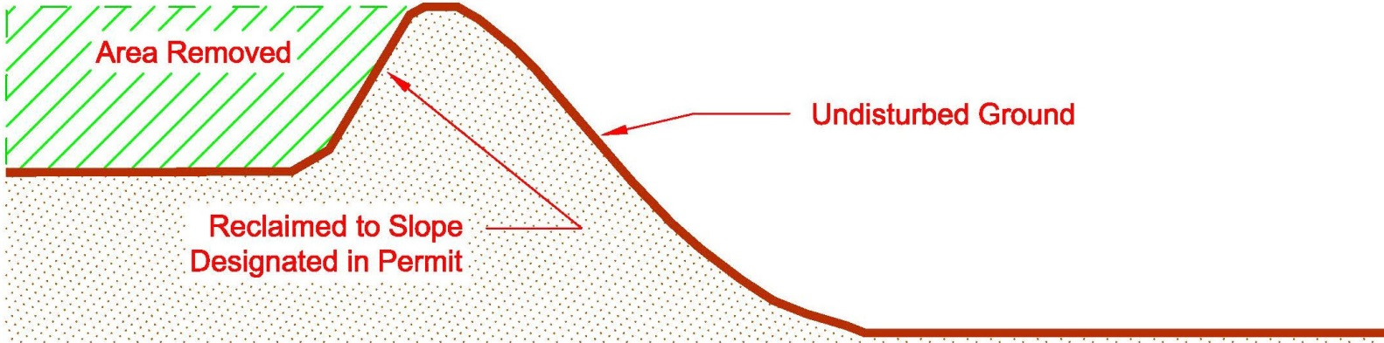
This mining method would be implemented at or near the following locations within the permitted boundary (check all that apply) All North South West East Northwest Northeast Southwest Southeast
Additional Information:

  - Mining a Terrace, Hill, or Plateau near the Edge of a Slope and near a Water Feature
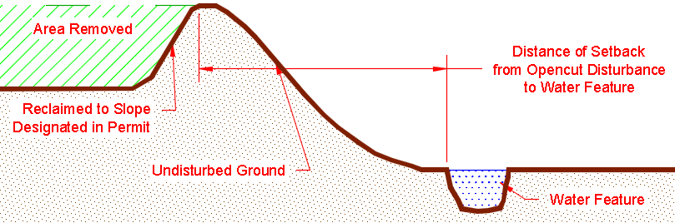
This mining method would be implemented at or near the following locations within the permitted boundary (check all that apply) All North South West East Northwest Northeast Southwest Southeast
Additional Information:

  - Mining a Terrace, Hill, or Plateau near the Edge of a Slope
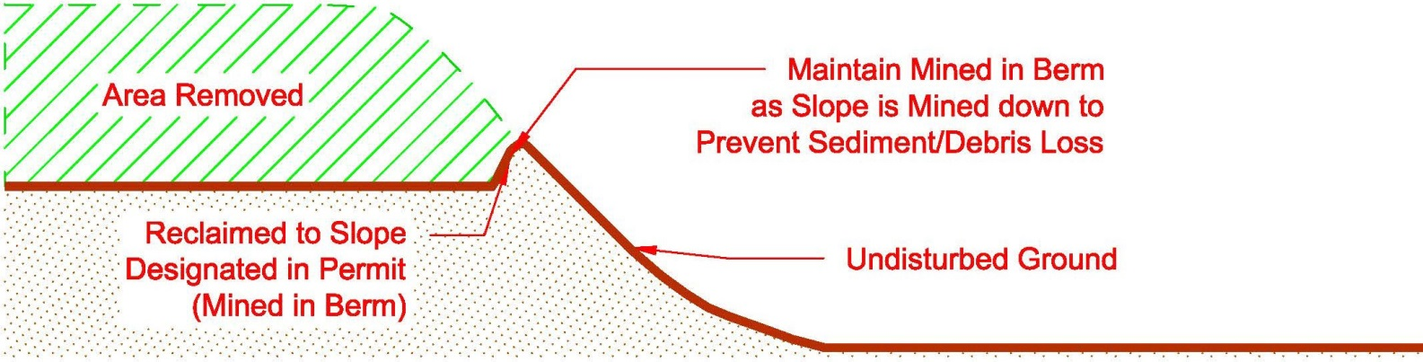
This mining method would be implemented at or near the following locations within the permitted boundary (check all that apply) All North South West East Northwest Northeast Southwest Southeast
Additional Information:

  - Mining a Terrace, Hill, or Plateau near the Edge of a Slope and near a Water Feature
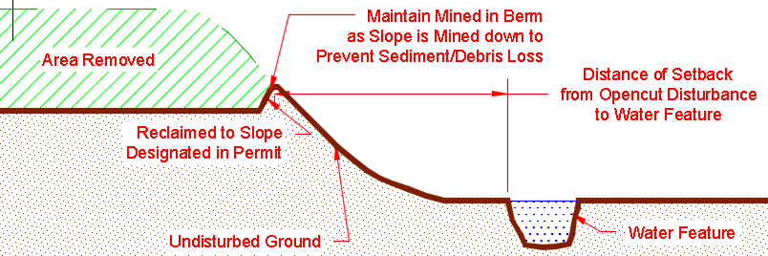
This mining method would be implemented at or near the following locations within the permitted boundary (check all that apply) All North South West East Northwest Northeast Southwest Southeast
Additional Information:

  - Mining a Terrace, Hill, or Plateau near the Edge of a Slope
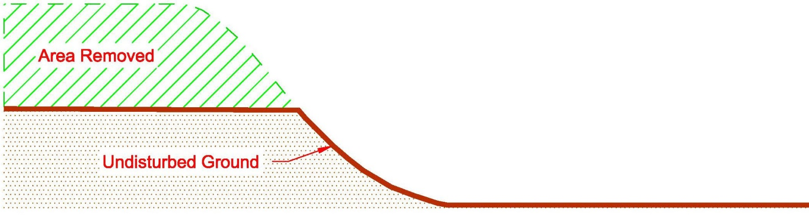
This mining method would be implemented at or near the following locations within the permitted boundary (check all that apply) All North South West East Northwest Northeast Southwest Southeast
Additional Information:

Note: This mining method requires to ensure that no sediment or debris erodes or is pushed down the slope. would implement, as necessary, erosion control measures at the edge of the slope or slightly downslope (within permit boundary) to prevent loss of sediment and debris.

  - Mining a Terrace, Hill, or Plateau near the Edge of a Slope and near a Water Feature
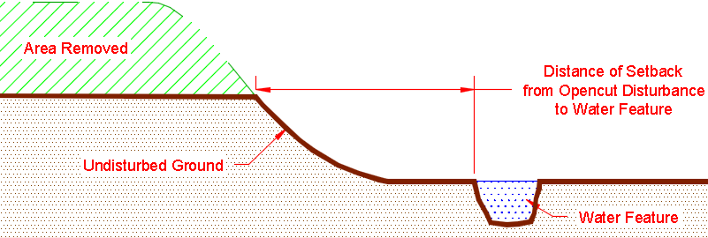
This mining method would be implemented at or near the following locations within the permitted boundary (check all that apply) All North South West East Northwest Northeast Southwest Southeast
Additional Information:

This mining method requires to ensure that no sediment or debris erodes or is pushed down the slope. would implement, as necessary, erosion control measures at the edge of the slope or slightly downslope (within permit boundary) to prevent loss of sediment and debris.

  - Mining a Relatively Flat Area to Create a Depression
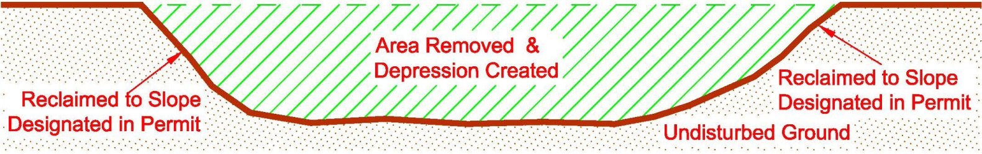
This mining method would be implemented at or near the following locations within the permitted boundary (check all that apply) All North South West East Northwest Northeast Southwest Southeast
Additional Information:

  - Mining a Hill or Knob and Reclaiming it to the Approximate Elevation of Adjacent Ground
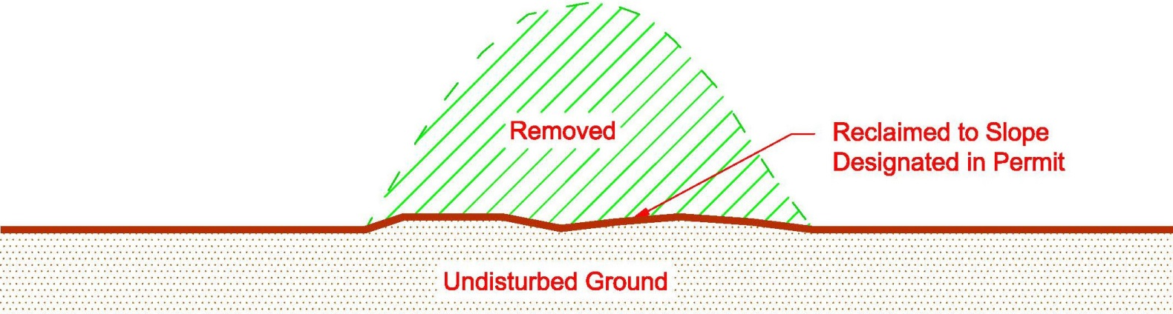
This mining method would be implemented at or near the following locations within the permitted boundary (check all that apply) All North South West East Northwest Northeast Southwest Southeast
Additional Information:

  - Excavating into a Hillside and Not Mining Below Existing Grade
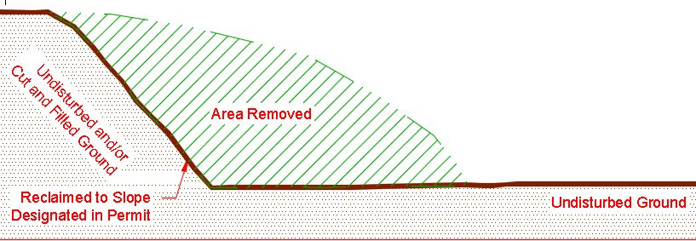
This mining method would be implemented at or near the following locations within the permitted boundary (check all that apply) All North South West East Northwest Northeast Southwest Southeast
Additional Information:

  - Other Scenario - Describe:

- Any slope steeper than 3:1 with a height of 5 feet or greater, present for any length of time, is considered to be a highwall. Will this site have highwalls? No Yes If Yes, skip to Section D-5b.
  - If No, explain in detail how this site will be mined without ever creating a highwall on-site. Note that mining without a highwall is not typical and is difficult to achieve.
Answer:
  - If Yes,
    - The maximum length of highwall on-site at any given time will be: linear feet. Note: This number must be used on the Reclamation Bond Spreadsheet.
    - The maximum height of highwall on-site at any given time will be: feet. Note: This number must be used on the Reclamation Bond Spreadsheet and will typically be consistent with the maximum depth of mining (see Section C1-1).
    - If the maximum height of highwall identified in D3-5 above is not identical to the maximum mine depth identified in C1-1 (i.e. ), explain in detail how the site will be mined:
  - Choose the highwall scenario below that best depicts how this site will be mined:
    - Cut & Fill Scenario (complete Highwall section on Reclamation Bond Spreadsheet)
  - understands that choosing this scenario requires that a buffer of unmined area be kept between the highwall and the permit/bonded boundary. Therefore, will maintain an adequate buffer to allow for cut-and-fill to be conducted.
  - Note: It is recommended that if the cut-and-fill scenario is to be used, the maximum advanced position of the highwall be clearly marked on the ground with durable markers to ensure enough material remains in place for slope reduction.

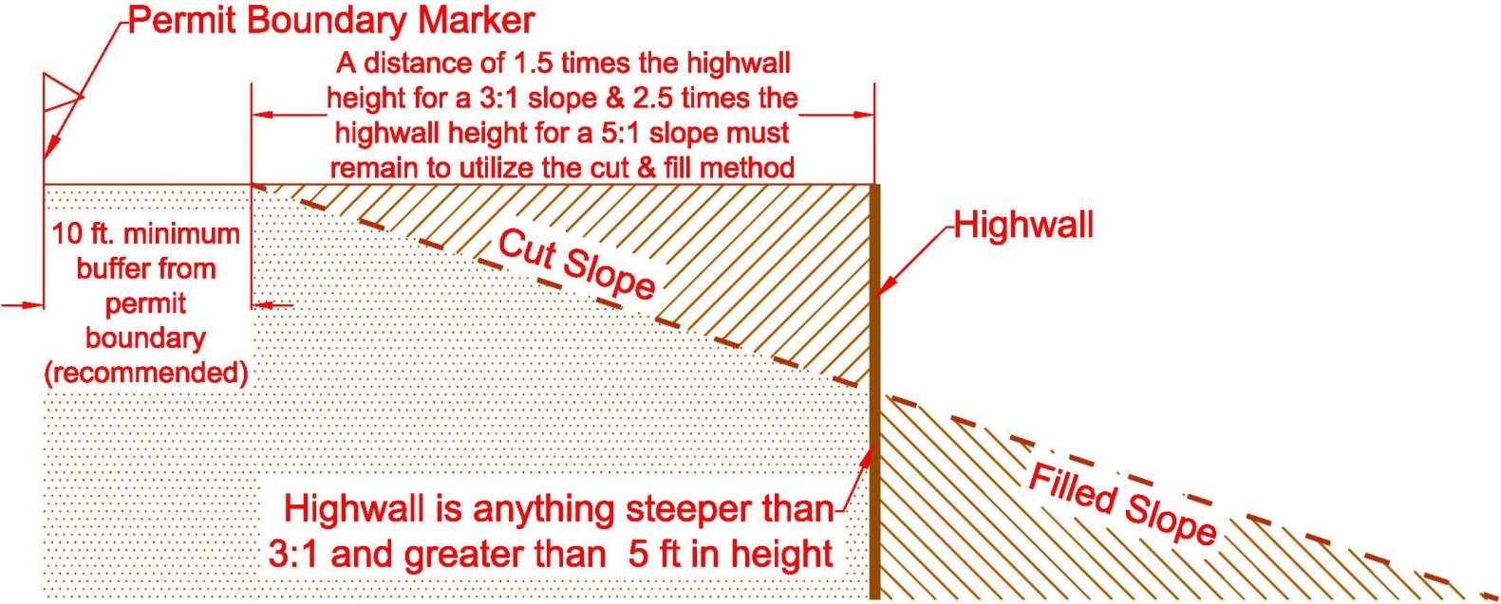

    - Backfill Scenario for areas where the Cut & Fill Method is not an Option (Complete Section D4 – Mine Material Backfill)
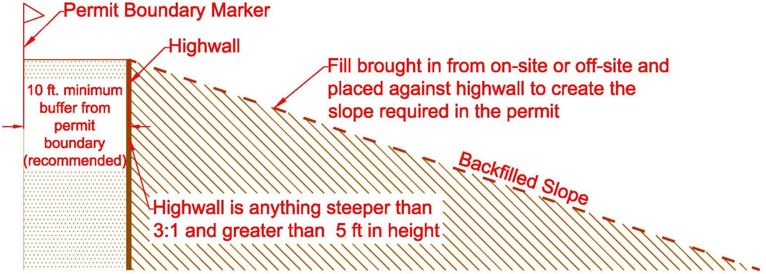

D4. MINE MATERIAL BACKFILL
- If “Backfill Scenario” was chosen in D3-5 or if any mine area backfill locations are planned (e.g. using material to raise the level of the pit floor to accomplish the reclamation plan), complete this section. If not, skip to Section D5.
Highwall Backfill* Mine Area Backfill**

Show the planned backfill location(s) on the Site Map or Reclamation Map and provide the following information:
- Describe where the backfill material will come from:
On-site – Describe:
Off-site – Describe:
- Material type(s) to be used as backfill (check all that apply):
Pit Run Gravel Oversize Rock Reject Fines Backhaul (Clean Fill Only)
Other:

*Highwall Backfill: must identify the linear feet, height, and slope of highwall to be backfilled on the Reclamation Bond Spreadsheet under “Highwall Backfill.” Additionally, must bond for transport/placement cost for the quantity of material to be placed against the highwall for backfill under the “Backfill Transport/Placement” cost line item ($2/cy for on-site generated backfill and $15/cy for off-site generated backfill).
**Mine Area Backfill: must identify the acreage, depth, and compaction percentage on the Reclamation Bond Spreadsheet under “Mine Area Backfill.” Additionally, must bond for transport/placement cost for the quantity of material to be placed on-site for backfill under the “Backfill Transport/Placement” cost line item ($2/cy for on-site generated backfill and $15/cy for off-site generated backfill).

D5. FACILITIES MCA 82-4-403(8 & 13); MCA 82-4-432; MCA 82-4-434
      - If an Asphalt Plant, Wash Plant, or Concrete Plant was checked in A1-1 or A1-8 above, complete this section. If not, skip to Section D5-2.
  - Asphalt Plant – If stationary, identify the specific or general location on the Site Map.
Must be checked in section A1-8 for a new permit and described in A1-1 for an Amendment.
Must remain in compliance with all sections of this plan.
- Where will the asphalt plant be set up?
Answer:
- A small amount of asphalt waste generated from daily startup and shutdown of the asphalt plant is expected; therefore, a maximum of 300 cubic yards of asphalt can be located onsite, near the asphalt plant. However, the asphalt waste must be removed when the asphalt plant is removed from the site, unless the site is permitted and bonded to store asphalt onsite.
- Describe additional restrictions or commitments on location of asphalt plant (placement away from water, residences, etc.)
Describe:

  - Concrete Plant - If stationary, identify the specific or general location on the Site Map.
Must be checked in section A1-8 for a new permit and described in A1-1 for an Amendment.
    - Where will the concrete plant be set up?
Answer:
    - Describe what will be done with wastewater created from the concrete plant.
will dispose of wastewater in an off-site location, greater than 300 feet from the permitted boundary, and in an area that would not impact surface or ground water.
will dispose of wastewater on-site or within 300 feet of the permitted boundary, and in an area that would not impact surface or ground water (location must be shown on Site Map).
Other - Describe:
    - Where will truck washouts occur?
will conduct truck washouts in an off-site location, located greater than 300 feet from the permitted boundary, and in an area that would not impact surface or ground water.
will conduct truck washouts on-site in or within 300 feet of the permitted boundary, and in an area that would not impact surface or ground water (location must be shown on Site Map).
Other - Describe:
    - Describe how and where return loads and excess or reject product will be handled or stored. If on-site or within 300 feet of the permitted boundary, show the location on the Site Map.
Concrete will be poured into casts to make products
Concrete will be poured on-site and buried under 3 feet of material suitable for sustaining the postmining land use.
Other:

  - Wash Plant - If stationary, identify the specific or general location on the Site Map.
Must be checked in section A1-8 for a new permit and described in A1-1 for an Amendment.
    - Where will the wash plant be set up?
Answer:
    - How many settling ponds will be used for the wash plant? 1 2 3 4
Other:
    - What will the approximate depth of the settling pond(s) be? Answer: feet
    - Will settling pond(s) be lined? No Yes
If Yes, type of liner:
    - Where will the wash plant obtain its water?
On-site well or well within 300 feet of permit boundary (Identify location on Site Map)
Surface water source within 300 feet of permit boundary (Identify location on Site Map)
Source located greater than 300 feet from permitted boundary
Other:
    - Will the water from the wash plant be recycled back into the wash plant? Yes No
If No, explain:
    - must show the location of the wash plant and any settling ponds or other wash plant features on the Site Map.
    - If attaches the Opencut Mining Section’s Wash Plant Settling Pond Guideline, check the appropriate box on page 2.

- Will salt or a salt mixed with product be stored on-site? Yes No
If No, skip to Section D6
If Yes, complete the following:
  - Show the proposed salt material stockpile(s) on the Site Map.
  - Indicate the maximum quantity of salt or salt product that would be stored on-site: cubic yards
  - Describe how salt materials would be stored on-site:
Storage Pad: Asphalt Pad Concrete Pad Other Impermeable Surface – Describe:
Cover: Enclosed Structure Roof Only Tarp Other Cover – Describe:
Other Storage Method:
Answer:

D6. ASPHALT & CONCRETE RECYCLING
- Asphalt Recycling – Typically, recycling involves accumulating materials containing asphalt, crushing these materials periodically, and stockpiling the resulting crushed asphalt product as is or blending it with other suitable materials. These recycled products are commonly used to surface roads, and operations permitted to operate an asphalt plant may also use these as feed into the plant.
Asphalt is considered to have the potential to impact water quality. As a result:
- An operation that imports materials containing asphalt must be permitted to store the debris awaiting recycling. Note: Imported debris may be a mixture of various materials (e.g. asphalt, concrete, soil, gravel, etc.). However, if the debris contains asphalt, it must be permitted as asphalt storage.
- Similarly, if a site permitted to operate an asphalt plant will stockpile asphalt produced on-site (e.g. excess or reject material), the operation must be permitted and bonded for asphalt storage.

  - Will asphalt or materials containing asphalt be stockpiled at the site? Yes No
If No, skip to Section D6-1b.
If Yes, must comply with the following requirements for stockpiled asphalt:
- The maximum amount of asphalt or material containing asphalt awaiting recycling that will be on-site at any time is cubic yards.
- This maximum value must be used in the Reclamation Bond Spreadsheet to calculate the cost to either recycle (i.e. crush) the asphalt, or dispose of it off-site in a lawful manner.
- Asphalt must be stored in the “asphalt stockpile area” shown on the Site Map.
- Imported asphalt must not be buried or otherwise disposed of on-site. During the final reclamation process, on-site asphalt stockpiles must be: a) removed from the site and disposed of in a lawful manner, or b) recycled into useful products which are removed from the site or used on-site to surface roads that are included in the approved postmining land use. Only on-site generated asphalt that has never left the site can be buried on-site as long as it is buried at least 25 feet above the ordinary high water table and under 3 feet of clean fill material suitable for sustaining the postmining vegetation.

  - Will on-site generated asphalt be buried on-site? Yes No
If No, skip to Section D6-2.
If Yes, item B of the Landowner Consultation Form must be checked “Yes.” What is the distance between the bottom of the proposed buried asphalt and the ordinary high water table?
Answer: feet. (Buried on-site generated asphalt must be located at least 25 feet above the ordinary high water table.)
Other:
    - Where will the required 3 feet of material suitable for sustaining postmining vegetation be obtained?
Answer: (Ensure that the additional fill is bonded for on the Reclamation Bond Spreadsheet)

- Concrete Recycling – Hardened concrete is not considered to have potential to impact water quality. As a result, concrete debris from construction or demolition projects may be imported to the site and stockpiled pending recycling or used as mine area backfill. Similarly, sites permitted to operate a concrete plant may stockpile excess or reject product that becomes hardened on-site.
  - Will hardened concrete be stored at the site? Yes No
If No, skip to Section D7.
If Yes, must comply with the following requirements for hardened concrete:
- When concrete is deposited at the site, any protruding metal must be cut off and collected. Any metal exposed during subsequent handling, transfer, crushing, or recycling must promptly be freed and collected. As a result, no protruding metal should be visible at any time. Salvaged metal must periodically be transported off-site for recycling or other lawful disposal.
- Concrete must be stored in the “concrete stockpile area” shown on the Site Map.
- Concrete present at the site during the final reclamation process must be a) removed from the site and disposed of in a lawful manner, b) recycled into useful products, or c) buried on-site under at least 3 feet of clean fill material suitable for sustaining the postmining vegetation.
Note: If asphalt is present in concrete stockpiles, the site must be permitted for asphalt recycling (refer to Section D7-1).

D7. REJECT FINES
- Reject fines are natural or crushed rock that is generally ¼ inch or smaller. Reject fines are usually created from screening product/material. Reject fines are typically pushed back into the pit to act as backfill before replacing the overburden and soil, or they are hauled off-site.
- Will reject fines be created at this site?
Yes No
If No, skip to Section D8.
If Yes, how will reject fines be handled at this site? Check all that apply:
        - Reject fines will be hauled off-site before accumulating to 10,000 cubic yards.
        - Reject fines will be periodically placed back into the mine area as operations progress through the life of the permit. Reject fines will not be allowed to accumulate to more than 10,000 cubic yards.
        - Reject fines will be stockpiled and used for reclamation at a later date.
          - The maximum quantity of fines to be stockpiled is cubic yards*
*Note: If more than 10,000 cubic yards of stockpiled reject fines will be located on-site, the entire stockpile must be bonded for on the Reclamation Bond Spreadsheet at a rate of $1.00 per cubic yard. Ensure the Reclamation Bond Spreadsheet is consistent with the quantity entered in this section.
        - Other:

D8. SOIL, OVERBURDEN, & MINE MATERIAL COMMITMENTS MCA 82-4-434(2)(b)
- will comply with the following requirements:
  - Prior to conducting any opencut operations, soil and overburden must be stripped separately to the average thicknesses identified in Section C2. (Note: Stripping soil may create low spots that collect water, necessitating the establishment of drainage ways, or the construction of raised roadbeds and work areas.)
  - must strip, stockpile, save and replace all soil (and overburden if sufficient soil is unavailable) to a minimum depth of 24 inches or to another depth approved in writing by DEQ Opencut and record the average thicknesses of soil to be replaced in Section C2.
  - All stripped soil and overburden must be: i) hauled directly to areas prepared for reclamation and re-soiling, or ii) promptly stockpiled and protected from erosion, comingling, contamination, compaction, and unnecessary disturbance. At the first seasonal opportunity, must shape and seed, with an approved perennial seed mix, any stockpile that will remain for 2 or more years.
  - Designate all soil and overburden stockpiles with signage that is legible, visible, and placed so that equipment operators and inspectors may readily identify the type of stockpile being worked for the life of the stockpile.
  - must not haul soil off-site, give it away, or sell it without written approval from DEQ Opencut.
  - Soil and overburden must be handled separately and will avoid mixing these materials, or handling them when wet or frozen. Overburden must be stockpiled only on areas where soil has been stripped to the required depth. Soil may be stockpiled on stripped or unstripped areas.
  - A minimum 10-foot wide buffer zone stripped of soil and needed overburden must be maintained along the crest (edge) of highwalls. This practice helps to ensure that soil will not be lost to mining. Highwalls are defined in D4-5.
  - Soil, overburden, and mine material stockpiles must be kept out of drainage bottoms and off of slopes steeper than 3:1. All excavated and/or processed mine material must be: i) removed from the site, ii) buried on-site, or iii) left for the landowner in accordance with the Landowner Consultation form and Section E7.
  - Burn pile residue, building demolition debris, metal, plastic, tires, and other wastes must be disposed of off-site and in a lawful manner, unless otherwise stated in the permit.
  - All clean fill (i.e. dirt, sand, fines, gravel, and oversize rock) that cannot, or will not, be buried during final reclamation must be removed from the permit area prior to bond or liability release request, with the exception of materials left for the landowner.

D9. ADDITIONAL IMPACTS MCA 82-4-434(2)(k)
- MCA 82-4-434(2)(k) requires that berms be constructed between the opencut operation and residences located within 300 feet of the permit boundary.

D10. ADDITIONAL COMMITMENTS MCA 82-4-434(2)(j); MCA 82-4-437
- understands that obtaining an Opencut Mining Permit does not relieve ’s obligation to comply with any other applicable federal, state, county, or local regulations, or ordinances and permits, licenses, and approvals for the operation. Obtaining an Opencut Mining Permit does not necessarily mean that an Operator can legally mine the site without first obtaining permits from other agencies MCA 82-4-434(2)(j).

- will comply with the following requirements:
- Key personnel and subcontractors involved in opencut operations must be informed of the requirements of this Plan and must be provided a copy of this Plan. In addition, they must be shown each boundary marker location and informed of the importance of the markers.
- Archaeological and historical values (i.e., “cultural resources”) on affected lands must be given legally required protection. MCA 82-4-434(2)(f).
- By March 1st of each year, must complete and return the Annual Production Report (APR) form that the Opencut Mining Section sends early in the year. must report the requested information regarding mining conducted during the preceding calendar year. In addition, must calculate the fee for the preceding year’s production (per cubic yard of material mined) and submit payment to DEQ along with the APR. Government operators are exempt from the APR fee, but are required to submit a completed APR form.

D11. ADDITIONAL INFORMATION MCA 82-4-432(1); MCA 82-4-434(2)
1. If applicable, provide additional water protection, mining, and processing information not addressed above.
Answer:

SECTION E – RECLAMATION PLAN

E1. RECLAMATION TIMEFRAME MCA 82-4-431(6 &7); MCA 82-4-434(2)(i); MCA 82-4-434(3 & 4)
- Reclamation must be:
- Completed in accordance with this Plan and as concurrent with the opencut operations as feasible.
- Final Reclamation Date is: Month December, Year
Note: If will not be able to achieve the postmining land use by this date, an amendment application must be submitted to extend the final reclamation date.

E2. POSTMINING LAND USES MCA 82-4-434(1) & (2)
        - The site will be reclaimed to the postmining land use(s) below. Show all postmining land uses on the Reclamation Map.
Permitted Access Road(s): Length Width
Internal Road(s): Length Width
Cropland/Farmland, Rangeland and/or Pasture (cropland requires 5:1 or flatter slopes for reclamation & Rangeland and/or Pasture require 3:1 slopes or flatter for final reclamation)
Year-round Pond
Seasonal Pond – Purpose: Wetland Seasonal Wetland
Berms Fences Landowner Equipment Storage Area
Landowner Material Stockpile Area (A shaped and seeded soil stockpile sufficient to reclaim the area beneath the material stockpile must remain within 100 feet of any remaining material stockpiles. Landowner material stockpiles must be consolidated into one area.)
Feedlot
Industrial/Commercial* Residential* Vegetative Screens Other:
*Residential and Industrial/Commercial land uses may require submittal of planning documents and approvals.
understands that all soil taken from residential or industrial/commercial areas must be kept on site for reclamation and cannot be removed or sold until DEQ Opencut has determined the postmining land use has been met, thereby verifying the soil is not needed to reclaim the area, or other remaining areas. This verification is achieved when submits a Phase I or Phase II release request, the site is inspected, and the release request is approved.
Note: If site plans change, must submit an amendment application to update the postmining land use(s).

- What facilities and structures will remain after reclamation of the site is completed?
None Concrete Structures Gravel or Paved Surface Area Office Scale
Other:

- Describe the purpose of leaving these facilities or structures intact.
Answer:

E3. PONDS AND WETLANDS MCA 82-4-434
- If Section E2 above does not designate a pond, seasonal pond, or wetland as a postmining land use, skip to Section E4; otherwise, proceed to E3-2 below.
- As a water feature would remain, complete the Pond and Wetland Design Worksheet, check the appropriate box on page 2, and include the worksheet with the application submittal. The Pond and Wetland Design Worksheet can be found here: https://deq.mt.gov/mining/assistance (click on the “Forms” tab).
- understands that all soil taken from the pond or wetland area must be kept on-site for reclamation and cannot be removed or sold until DEQ Opencut has determined the postmining land use has been met, thereby verifying the soil is not needed to reclaim the pond or wetland area, or other remaining areas. This verification is achieved when submits a Phase I or Phase II release request, the site is inspected, and the release request is approved.
- has consulted with DNRC and understands the requirements regarding water rights and ground water development related to reclaiming to the postmining land uses identified in E2-1. The DNRC water right flow chart can be accessed here: https://deq.mt.gov/mining/assistance.
Additional Information (if applicable):

E4. SITE CLEANUP, GRADING AND RECLAMATION
- must comply with the following requirements:
  - Leave reclaimed surfaces in a stable condition, graded to drain to low areas where applicable, and blended into the surrounding topography and drainageways. Note: Irregular contours are preferred for livestock and wildlife habitat; areas of unvarying slope should be minimized; and drainageways must be reclaimed similar to surrounding natural conditions.
  - Leave reclaimed surfaces with 5:1 or flatter slopes for hayland and cropland, and 3:1 or flatter slopes for other areas (DEQ Opencut may approve steeper slopes on a case by case basis).
  - Leave reclaimed surfaces at least 3 feet above the seasonal high water table level for dryland reclamation and at least 3 feet below the seasonal low water table level for pond reclamation (The DEQ may approve seasonal ponds for certain situations).
  - Retrieve and properly use, stockpile, or dispose of all refuse and spilled mine materials (e.g. chips, oversize, etc.) found in the permit area and along access roads as such materials will impair revegetation.

- Indicate the grade of the steepest slope that would remain after the site is reclaimed.
3:1 5:1 Other:
Note: This reclamation slope ratio must be used on the Reclamation Bond Spreadsheet.
If a slope of 3:1 or flatter was checked, skip to Section E4-3.
If the “Other” box above was checked and intends to have slopes steeper than 3:1, address the following:
must provide a slope stability study prepared by a professional engineer licensed in accordance with
Title 37, chapter 67, part 3, MCA, or a geologist with five years of post-graduate academic or professional work experience in the field of soil or rock mechanics, documenting that the slopes will remain stable.
Slope Stability Analysis Attached (check the appropriate box on page 2)
Further Description (if applicable):

- Will the site be graded to blend in with surrounding topography? Yes No
If No, explain in detail how the site will be graded:

- Would a water collection area remain for final reclamation?
Yes No
- If Yes, where will precipitation/stormwater/snow-melt, etc. concentrate or drain to in the reclaimed depression?
  - Seasonal or year-round wetland or pond (applicable postmining land use must be checked in Section E2).
  - Runoff collection area(s) in bottom of depression graded specifically to collect any runoff, thereby not impacting other areas of the site with ponding or pooling of water.
- Approximate location of water collection area(s) must be shown on the Reclamation Map
Water collection area is < ½ acre in size;
Water collection area is > ½ and < 1 acre in size – Explain why water collection area needs to be greater than ½ acre in size
  - Other - Describe:

- If No, describe where stormwater will concentrate or drain to, i.e. water will flow to the (check all that apply):
  - Water would infiltrate into the ground East North Northeast Northwest South
Southeast Southwest West
Further Description:
  - Water will flow off-site via:
Reclaimed drainages, swales, etc. within the permitted boundary Reclaimed slopes
Other - Describe:

Note: ARM 17.24.221(5) requires that the Reclamation Map contain arrows depicting the anticipated direction of water flow across the reclaimed site.

E5. SOIL AND OVERBURDEN SURFACE PREPARATION AND REPLACEMENT
- Compacted soil and overburden must be tilled to allow air and water movement, root penetration, and the subsurface drainage necessary for plant growth. Will alleviate compaction by deep-tilling or ripping all compacted surfaces to a depth of at least 12 inches before re-soiling? Yes No
Note: DEQ Opencut recommends the following:
- Ripping or deep tilling is not required for non-compactable materials such as sand and gravel.
- Ripper shanks should be spaced about equal to the ripping depth.
- Rip along contours where possible and when soil and overburden are dry enough to shatter.
- Protect ripped areas from re-compaction.
If No, explain in detail how overburden and soil compaction would be alleviated, or explain why relieving compaction would not be necessary:

- Indicate the methods to be used to relieve soil compaction and prepare the seedbed.
Chiseling Disking Harrowing Packing Other:

- will limit the presence of large rocks that are not characteristic of the soil prior to disturbance and may inhibit successful revegetation and agricultural production. Method(s) that will be used include:
Blading Off and Removal of Large Rocks Rock Picker Rolling Screening Hand Picking Other:

E6. REVEGETATION MCA 82-4-434(2)(h)
- must comply with the following requirements:
  - Establish vegetation capable of sustaining the designated postmining land use(s) and retards erosion.
  - Use certified weed-free seed and comply with local weed district requirements.
  - Seed during the late fall or early spring seeding season (unless otherwise approved) and seed along contours for drill seeding.
  - Ensure that areas seeded or planted to perennial species can be, and are, appropriately protected and managed from the time of seeding or planting through two growing seasons, or until site stabilization and revegetation are achieved, whichever is longer.
  - Revegetation success on non-cropland areas is achieved when vegetation capable of sustaining the designated postmining land use has been established. Revegetation success on cropland areas is achieved when a crop has been harvested from the entire area and the yield is comparable to those of crops grown on similar undisturbed sites under similar growing conditions.
  - Except for those postmining land uses that do not require vegetation, each surface area of the site that will be disturbed will be revegetated when its use for the opencut operation is no longer needed.
  - must attach the Opencut Mining Section’s Weed Board Notification of Opencut Operation form that has submitted to the weed board in the county or counties in which the proposed operation is located and check the appropriate box on page 1.

- The primary method of seeding will be: Drilling* Broadcasting**
*Sagebrush seed cannot be drill seeded and must be broadcast at the rates identified in the sagebrush seed mix. Grass and forb seeds in a sagebrush seed mix can be drill seeded.
**Broadcast seeding must be at double the rate used for drilling (i.e. 24 lbs/acre or more).

- DEQ Opencut’s Seed Mix Guideline is available on the Opencut Mining Section website at https://deq.mt.gov/mining/assistance (click on the “Forms” tab).
Will seed mixes described in the Seed Mix Guideline be used for final reclamation? Yes No
If No, complete the table below with a custom seed mix.
If Yes, check the appropriate box on page 2, attach a copy of the guideline, and indicate below which seed mix(es) would be used.
Native Grazing/Pasture Non-Native Grazing/Pasture
Native Rangeland (for moist/riparian regions)
Native Rangeland (for arid regions) Wetland Seed Mix (for pond edges or wetland areas)
OR
Cropland seed mix designated by Landowner at time of reclamation
OR
Recommended Seed Mixes for Sage Grouse Habitat
If the site is in general, core, or interconnectivity sage grouse habitat, must choose the appropriate seed mix below, unless the landowner has requested an alternate seed mix (refer to the Landowner Consultation form).
Northern Region Central & Southeastern Regions Southwestern and South Central Regions

In the table below, describe the seed mix species and rates of seeding (pure live seed per acre) that will be used:

SEED TYPE | SEED RATE
TOTAL SEEDING RATE | 0.0 pounds pure live seed/acre

Additional Seeding Information (if applicable):

- Indicate the measures to be used to manage and protect the site until reclamation vegetation is established.
Noxious Weed Control (mandatory) Fencing (include cost of fencing on the Reclamation Bond Spreadsheet)
No Grazing ( should secure written commitment from landowner)
Other:

- Indicate the method(s) or types of erosion control Best Management Practices (BMPs) that would be used at this site during reclamation to inhibit erosion and promote plant growth. must maintain the below checked erosion control BMP’s during reclamation to protect water quality and prevent sediment from leaving the site (as needed):
Equipment Tracking (orientated to trap moisture and break water flow) Erosion Control Blankets Mulch
Seeding/Harrowing Along Contour Slopes 5:1 or Flatter Straw Bales
Vegetated Buffer Strip Wattles Other:

E7. ADDITIONAL INFORMATION MCA 82-4-432(1); MCA 82-4-434(2)
1. If applicable, provide additional reclamation information not addressed above.
Answer:

SECTION F – RECLAMATION BOND CALCULATION MCA 82-4-433

Government Operators: Skip to Section G.

Non-Government Operators:
- Attach a proposed Reclamation Bond Spreadsheet and check the appropriate box on page 1.
- understands that DEQ Opencut may adjust the bond yearly.
- Provide additional information relevant to the Reclamation Bond Spreadsheet if applicable:

Proceed to Section G – Certification and ensure it is fully completed

SECTION G – CERTIFICATION MCA 82-4-432(1); MCA 82-4-431

The person signing below represents that (check one box):
I am an officer or an employee of and I am duly authorized to bind the Operator identified on page 1 of the Standard Opencut Mining Application as a corporation, limited partnership, limited liability company, or other corporate entity in good standing and authorized to do business in Montana, and in this capacity I acknowledge and certify that:
Or
I am the Operator identified on page 1 of the Standard Opencut Mining Application and I acknowledge and certify that:
- The attachments that follow my signature are incorporated into and enforceable as part of the Standard Opencut Mining Application;
- has the legal right to conduct opencut operations in the permit area described in the Standard Opencut Mining Application;
- consents to and acknowledges that DEQ and its representatives may access the site to inspect the permit area at any reasonable time, and that while DEQ attempts to provide reasonable notice of an inspection to when practicable under the circumstances, inspections may be conducted without prior notice as necessary to determine whether opencut operations are being conducted in compliance with the permit, Act, and rules. MCA 82-4-422(1)(d) and 425 & ARM 17-24-206(3).
- I have read and understand all the information, representations, terms, requirements, and conditions set forth in Standard Opencut Mining Application;
- The information, representations, and statements provided or acknowledged in the Standard Opencut Mining Application are, to the best of my knowledge and belief, true and correct; and,
- agrees to abide by and comply with the Opencut Mining Act, MCA 82-4-401 through 82-4-446, and ARMs 17.24.201 through 17.24.226, and all representations, terms, requirements, and conditions set forth in the Standard Opencut Mining Application and the Opencut Mining Permit approved by DEQ, and communicate the same to any contractor or supervisor who directs opencut operations under authority of the Opencut Mining Permit.
- will comply with applicable federal, state, county, or local regulations, ordinances and permits, licenses, and approvals for the operation. MCA 82-4-434(2)(j).
- understands that obtaining an Opencut Mining Permit does not relieve ’s obligation to comply with any other applicable federal, state, county, or local regulations, or ordinances and permits, licenses, and approvals for the operation. Obtaining an Opencut Mining Permit does not mean that an Operator can legally mine the site without first obtaining permits from other agencies. DEQ recommends contacting the DEQ Water Protection Bureau, at 406-444-5546, to determine if a water discharge permit is required and DEQ Air Quality Bureau, at 444-3490, to determine if an air quality permit is required for this opencut operation.

By:
 | Signature |  | Legibly print or type name
Title Date

