For Office Use Only

Payor _________________________________Payment No. _____________ Payment Amt $_____________________ Date ________________

OPENCUT MINING PLAN OF OPERATION AND APPLICATION
Operator Name:
Site Name:
INSTRUCTIONS - How to submit a complete and accurate Plan & Application:
- Before completing this form, verify you are using the most recent version and read the help information available on the Opencut Mining Section’s website at http://deq.mt.gov/Mining/opencut.
- Fill in all blanks and provide a detailed answer for each question. Write “None” if that is the correct answer.
- This form includes automated calculations that require Microsoft Word 2010 or newer. As data is entered into this form, auto calculate fields will auto populate (tab out of each field to ensure they auto calculate). Autocalculate fields contain red text. If an autocalculate field is blank, either: a) the required information was not entered, or b) the blank field does not pertain to your application.
- Opencut Mining Permits are “living” documents, meaning that whenever a permit is amended, the updated information replaces the outdated information. As a result, this form must be filled in completely for a Permit or an Amendment.
- The Department of Environmental Quality (DEQ) strongly recommends completing this application form in electronic format. Doing so will make applying for a future amendment much easier. Operators should keep the original electronic files and backup copies.
- Operator is required to submit all Required Support Documents, unless the exception box is appropriately checked. If the Existing Approved Form Attached box is checked, the Operator is required to submit a copy of the previously approved form with the amendment application. If permitted after 2010, the previously approved documents can be found on the Opencut website at http://deq.mt.gov/Mining/opencut (click on the “Search Opencut Permits” tab).
- Ensure all additional support documents submitted have the same name or title shown in the “Support Documents” section. Include a Cover Letter with the application materials that lists the names of all “Other” support documents submitted.
- Sign and date the certification in Section G.
- Submit all required application materials to the Opencut Mining Section in Helena as one package.

ID | SUPPORT DOCUMENTS
 | Required | REQUIRED SUPPORT DOCUMENTS
a |  | $1,500 Non-Refundable Fee for a Permit application or for an Amendment application if the  application date is >10 years from the date of the last permit/amendment approval; or  $750 Non-Refundable Fee for an Amendment application if the application date is < 10-years from  the date of the last permit/amendment approval.  Make checks payable to Montana Department of Environmental Quality  This application was submitted electronically and the check is in the mail.
b |  | Consultation with DNRC on Sage Grouse  Exception: Opencut site not located in Core, General Habitat, or Interconnectivity Sage Grouse Areas: https://sagegrouse.mt.gov  Exception: Amendment is not changing the existing permit boundary; therefore, no new sage grouse consultation is needed.
c |  | SHPO Consultation (no Class III required) or SHPO Concurrence Attached
d |  | Well Logs Exception: No Wells within 1,000 feet of permit area
e |  | Soil Photos Exception: Amendment with no new acreage being added.
f |  | Site Map
g |  | Area Map
h |  | Reclamation Map
i |  | Location Map
j |  | Boundary Coordinate Table  Exception: Amendment is not changing the existing permitted boundaries.
k |  | Weed Board Notification of Opencut Operation
l |  | Reclamation Bond Spreadsheet Exception: Government Operator
m |  | Landowner Consultation (ARM 17.24.206)  Existing approved forms are acceptable for an Amendment not adding acreage, an asphalt or concrete plant, not changing the postmining land use, and not extending the reclamation date.
n |  | Zoning Compliance (ARM 17.24.223)  Existing approved forms are acceptable for an Amendment not adding acreage, not changing the postmining land use, and not adding an asphalt or concrete plant.  Exception: Not required for applications mining bentonite, clay, scoria, peat, or soil only.
o |  | Surface Landowners List (MCA 82-4-432(2)(e) & (6)(b))  Exception: Not required for amendment adding less than 50% of the permitted acreage.
p |  | Fuel Guideline for Spill Prevention & Management Worksheet  Exception: Not required if no on-site fuel storage and/or no mobile fueling on-site.
q |  | Determining Depth to Groundwater Worksheet  Exception: Amendment not adding acreage or increasing mine depth  Exception: Not required if no water feature would remain for final reclamation and there is no  chance of a public meeting (Opencut reserves the right to require this form if water could be encountered, or if Opencut disagrees with the high and low water table levels identified in Section C1 of this application).
r |  | Bond (MCA 82-4-433)  (Original Paper Bond must be Received by Opencut before permit can be issued.)  Exception: Government Operator  Exception: The submitted Reclamation Bond Spreadsheet does not require a higher bond.
 | ADDITIONAL SUPPORT DOCUMENTS (as required)
 | Included
s |  | Additional Well Data
t |  | Dewatering Data and Analysis
u |  | Easement/Setback Documentation
v |  | Groundwater Monitoring Plan
w |  | Pond/Wetland Cross-Sections and/or Contour Map
x |  | Pond & Wetland Design Worksheet
y |  | Seed Mix Guideline
z |  | Slope Stability Analysis
aa |  | Stream/Waterway Worksheet
bb |  | Wash Plant Settling Pond Guideline
cc |  | Water Resources Assessment/Hydrogeologic Assessment
dd |  | Other:
ee |  | Other:
ff |  | Other:
gg |  | Other:
hh |  | Other:
ii |  | Other:
Additional support documents must be clearly named or titled to be consistent with the names or titles above.

SECTION A – APPLICATION INFORMATION

A1. General Information [MCA 82-4-432 & 82-4-403(6)] & [ARM 17.24.218]
            - Indicate which of the following is being requested (check one):
Permit Amendment Convert Limited Opencut Operation to a Permit
Reclamation Only (No further Opencut activities would occur, except reclamation): Complete Sections A1-1 through A1-8, A1-12, , A2, Section E, and provide a Reclamation Map and a Boundary Coordinate Table. The Department may also require the Operator to provide detailed site-specific conditions and reclamation plans, including but not limited to information for sections C2, C3 and D6.

For a Permit or to Convert Limited Opencut Operation to a Permit, skip to A1-3 and complete the remainder of this document. For an Amendment, proceed below:

            - For an Amendment:
- Update all the information in this document.
- The existing Opencut number is:
- Identify all the purposes of the amendment:
Change Reclamation Date
Change Postmining Land Use
Change Site Name – Former Site Name was: Note: If site name is changed, all forms must be revised accordingly (i.e. zoning, landowner, etc.)
Change Seed Mix
Change Mining Depth
Add Fuel Storage
Add Acreage
Add the following processing equipment:
None Asphalt Plant (answer D7-1a) Concrete Plant Overland Conveyor Crushing Equipment Pug Mill Screen Wash Plant Other:
Change the Hours of Operation
Change Landowner(s) – Previous Landowner’s Name:
Other:

            - Operator Name:

Site Name:

Final Reclamation Date auto-populated from Section E1-1: December 0

Operator Address:
City: State: Zip Code:
Office Phone # Cell # Operator/Business Email:

            - Site Contact Name: Site Contact Email: Cell #
Note: All official correspondence will be sent to the Business email. The site contact name would be copied on emails.

            - requests that correspondence also be emailed to the consultant for this application (if not applicable proceed to #6).
Consultant Name: Consultant Email:

            - Landowner 1 Name:
Address:
City: State: Zip Code:
Phone #: Optional Additional Contact Information (e.g. email, other phone #):
If there is an additional landowner, provide contact information below; otherwise leave blank.
Landowner 2 Name:
Address:
City: State: Zip Code:
Phone #: Optional Additional Contact Information (e.g. email, other phone #):

Additional Landowners (if applicable, use the space provided and use same format as above):

            - County where the proposed site is located:

            - Legal Description (Includes Permit Area, Access Roads, and Non-Bonded Areas):
Section(s) & Township North or South Range East or West
Section(s) & Township North or South Range East or West
Additional Sections, Township & Range (if applicable use same format as above):

            - What type of materials will be mined from the permit area?
Bentonite Clay Gravel Peat Sand Scoria Soil
Mixtures including any of the above substances (i.e. borrow material)
Additional Information:

            - What processing equipment could be used in the permit area?
None Asphalt Plant (answer D7-1a) Concrete Plant (answer D7-1b) Conveyor
Crushing Equipment Pug Mill Screen Wash Plant (answer D7-1c)
Other:

            - Estimated quantity of mine material to be excavated and removed from the entire permit area:
cubic yards

            - Total Permit Acreage Breakdown (acreages must be entered to the nearest TENTH of an acre, and must match the acreages created by the Boundary Coordinate Table).

 | Existing or New Permit Acres | Amendment Acres (if any) | Total Permitted Acres  Note: To ensure that the “Totals” display, use the Tab key after entering each acreage amount.
- Bonded Acres* |  |  | 0.0
- Non-Bonded Acres** |  |  | 0.0
- Bonded Access Road Acres*** |  |  | 0.0
Totals | 0.0 | 0.0 | 0.0
- *Although Government Operators do not “bond,” they would fill in this row to display entire permitted acreage.
- **Government Operators cannot have non-bonded acres and would not fill in this row.
- ***Complete only if Landowner Consultation form states an access road would be permitted.

            - Private Operators Proposing to Permit Non-Bonded Area:
If Non-Bonded acreage is proposed, the Operator agrees not to disturb any Non-Bonded acreage for any Opencut purpose until: a) the Operator submits a Request to Modify Bonded Acreage form with appropriate attachments and a reclamation bond, and b) the DEQ provides written approval of the request.

A2. ADDITIONAL INFORMATION [MCA 82-4-432(1) & 82-4-434(2)] & [ARM 17.24.222]
- If applicable, provide additional application information not addressed above.
Answer:

SECTION B – PRE-MINE INFORMATION

Note: If a Pre-Application Meeting was conducted by the DEQ, information from the Inspection Report can typically be used to complete portions of Section B.

B1. DIRECTIONS TO SITE [ARM 17.24.221(6)]
- Describe in detail how to get from the nearest town or public road intersection to the permit area. Provide directions that can be interpreted and followed by anyone viewing the Location Map for the site, both now and in the future (e.g. identify roads, mileposts, landmarks, and distances; include information on how to obtain keys or combinations for locks). Label the nearest town of public road intersection on the Location Map.
Answer:

B2. TOPOGRAPHY [MCA 82-4-403(11)(b)]
- Describe in detail the terrain in and within 1,000 feet of the permit area (e.g. hills, valleys, ridges, drainages, cliffs, and benches).
Answer:

B3. LAND USES [MCA 82-4-403(11)(b)]

Indicate current land uses within the permit area.
Cropland/Hayland Forest/Timberland Industrial/Commercial Oil/Gas
Opencut Operation Pasture/Rangeland Residential Other:

Indicate current land uses within 1,000 feet of the permit area.
Cropland/Hayland Forest/Timberland Industrial/Commercial Oil/Gas
Opencut Operation Pasture/Rangeland Residential Other:

B4. STRUCTURES, FACILITIES, & SURFACE DISTURBANCES [MCA 82-4-434(2)(n)] & [ARM 17.24.218(1)]
- Identify the manmade structures, facilities, or surface disturbances within the permit area.
None Construction Project Farming Fences Industrial/Commercial
Oil/Gas Structures or Pipelines Opencut Operation Overhead Power Lines or Facilities
Residential Roads Underground Utilities (e.g. electrical, fiber optic, water, sewer, phone, etc.)
Other:
Note: See additional requirements in Section D4 for utilities and infrastructure.

- Identify the manmade structures, facilities, or surface disturbances within 1,000 feet of the permit area.
None Construction Project Farming Fences Industrial/Commercial
Oil/Gas Structures or Pipelines Opencut Operation Overhead Power Lines or Facilities
Residential Railroad Roads Underground Utilities (e.g. electrical, fiber optic, water, sewer, phone, etc.)
Other:

B5. SURFACE WATER FEATURES [ARM 17.24.218(1) & 17.24.221]
- Identify any surface water features within the permit area.
Note: This includes features that may contain water at any time, including seasonal ponds, ephemeral drainages, runoff channels, ditches, floodways, etc. See Section D4 for additional Plan requirements for water features.

None Ephemeral Drainage Irrigation Ditch/Canal Lake/Pond River– Name:
Spring Stream/Creek – name: Wetlands Other:

- Identify any surface water features within 1,000 feet of the permit area.
Note: This includes features that may contain water at any time, including seasonal ponds, ephemeral drainages, runoff channels, ditches, floodways, etc.

None Ephemeral Drainage Irrigation Ditch/Canal Lake/Pond River– Name:
Spring Stream/Creek – name: Wetlands Other:

B6. VEGETATION [ARM 17.24.219(h) & 17.24.222]
- Provide a list of the dominant grasses, forbs, shrubs and trees located within the permit area. If the species are not indicated in the check boxes below, check the “Other” box and list them.
Basin Wildrye Big Bluestem Bluebunch Wheatgrass Blue Grama Canada Wildrye
Cheatgrass Conifer Cottonwood Creeping Juniper Crested Wheatgrass Crop
Curlycup Gumweed Green Needlegrass Idaho Fescue Indian Ricegrass
Intermediate Wheatgrass Juniper Kentucky Bluegrass Needle & Thread Grass
Prairie Junegrass Prarie Sandreed Rough Fescue Rubber Rabbitbrush Sagebrush
Sedges/Rushes Sideoats Grama Slender Wheatgrass Smooth Brome Sweetclover
Thickspike Wheatgrass Willow Western Wheatgrass Other: _______________________

- Identify the Noxious Weeds present within the permit area.
If the species are not indicated in the check boxes below, check the “Other” box and list them.
None Canada Thistle Dalmatian Toadflax Field Bindweed Houndstongue Knapweed
Leafy Spurge Tansy Ragwort Whitetop Sulfur Cinquefoil Tamarisk (Salt Cedar)
Other:

B7. WILDLIFE [MCA 82-4-402(2) & 82-4-403(13) & 82-4-434(2)] & [ARM 17.24.219 & 17.24.222]
- Indicate the fish and wildlife species in and within 1,000 feet of the permit area.
Antelope Black Bear Coyotes Deer Elk Fish Fox Grizzly Bear Moose
Raptors Rodents Sage Grouse Song Birds Upland Birds Waterfowl Wolves
Other:

- Sage Grouse Consultation - If sage grouse was checked above and the proposed permit boundary is in core area, general habitat, or connectivity habitat, the area is regulated by the Montana Sage Grouse Habitat Conservation Program.
To determine whether this site is located in sage grouse habitat, click on the below link to visit the Montana Sage Grouse Habitat Conservation Program https://sagegrouse.mt.gov.
- The permit boundary is located:
Outside of Sage Grouse Habitat (If “Outside of Sage Grouse Habitat” or permitted prior to Sage Grouse Executive order, skip to B8)
Within Core Area Within General Habitat Within Connectivity Habitat
Recommendations from the Sage Grouse Program must be addressed in the proper sections of this application (i.e. hours of operation, seed mix, etc.).
Additional Information:

B8. WELLS (water, oil, gas, etc.) [ARM 17.24.218(1)(g) & 17.24.221]
- In the table below, list the required information for wells in and within 1,000 feet of the permit area.
  - Information and well logs can be obtained from the Ground Water Information Center (GWIC) at http://mbmggwic.mtech.edu or by using the “Mapping DEQ’s Data” found at http://deq.mt.gov/Mining/opencut (click on the “Mapping DEQ’s Data” tab).
  - The DEQ recommends obtaining well information from the Montana Department of Natural Resources and Conservation (DNRC), and Board of Oil and Gas websites to determine the location of any oil and gas wells in the vicinity of the permit area.
  - Additional information may be available from landowners or by conducting field measurements.
  - Provide depths and static water levels in feet below the ground surface for all attached water wells.
  - Well locations must be reasonably accurate. In cases where well locations are unavailable or appear inaccurate, field confirmation may be required.
  - Locations of existing and proposed wells in and within 1,000 feet of the permit area must be shown and labeled on the Area Map or if more appropriate a separate Well Location Map.
  - Well logs in excess of 1,000 feet from the proposed permit boundary can be submitted and shown below if they provide relevant information. If provided, well locations must be shown on the appropriate map.
  - If there are no wells in and within 1,000 feet of the permit area, write “None” in the table below and skip to B8-3.

* Use these codes to fill in the “Use” Column below: D = Domestic, Ind = Industrial, I = Irrigation,
L = Lawn & Garden M = Monitoring, P = Public, S = Stock, O = Other

Well Information Table

Well I.D. on Map | GWIC ID# | Well Owner | Distance & Direction from Permit Boundary | Total Well Depth (feet) | Static Water Level (feet) | *Use | Comments
W1
W2
W3
W4
W5
W6
W7
W8
W9
W10
Note: If there are additional wells check the appropriate box on page 2 and attach the Opencut Mining Section’s Additional Well Data form. Start the form with “W11” under the “Well I.D. on Map” column. The form is found here: http://deq.mt.gov/Mining/opencut (click on the “Forms” tab).

- Attach the above identified Well Logs to this application and check the appropriate box on page 1.

- Are there Public Water Supply wells located within 100 feet of the permit area that are used for public water supply?
Yes No
If Yes, contact the DEQ Source Water Protection Program at 406-444-5546 to determine setbacks and restrictions and incorporate those into this application. Further Information (if applicable):

B9. ADDITIONAL INFORMATION [MCA 82-4-432(1) & 82-4-434(2)] & [ARM 17.24.222]
- If applicable, provide additional pre-mine site characteristics or circumstances not addressed above.
Answer:

SECTION C – SITE PREPARATION AND PLANNING

C1. WATER TABLE LEVELS [ARM 17.24.218(1)(g)]
Complete and attach the Determining Depth to Groundwater Worksheet found here: http://deq.mt.gov/Mining/opencut (click on the “Forms” tab), check the appropriate box on page 2, and provide information below as determined by the Determining Depth to Groundwater Worksheet. Note: Seasonal high water levels may be influenced by irrigation and ditches and must be accounted for when determining groundwater elevations.
- The seasonal high water table is the highest level that water typically rises to each year.
- The seasonal low water table is the lowest level that water typically falls to each year.
- The maximum depth of mining is: feet below ground surface
- The seasonal high water table level is: feet below ground surface
- The seasonal low water table level is: feet below ground surface
- Water levels were determined by the following method(s):
Determining Depth to Groundwater Worksheet (check box on page 2 and attach) Other:
Seasonal high water table: 0.0 feet
Maximum depth of mining: 0.0 feet
Difference = 0.0 feet
- If the difference is >3 proceed to Section C2.
- If the difference is <0, a pond and/or wetland will be left for final reclamation. must include “pond” or “wetland” as a postmining land use in Section E2-2, as well as complete Section E3 & the Pond & Wetland Design Worksheet.
- If the difference is >0 and <3, soil could become saturated or ground water could occur in some portions of the pit. Therefore, explain how will maintain a minimum of 3 feet of separation between the seasonal high water table and the reclaimed ground surface (e.g. The Operator will: backfill the site to maintain a minimum 3 feet of earthen material between water and the reclaimed ground surface; construct a permanent drainage mechanism; etc.):
would cease mining at or above the high water table and use on-site materials to backfill to ensure that a minimum of 3 feet of material is maintained above the seasonal high water table for final reclamation. No water feature would remain for final reclamation.
Other/Additional Information:

C2. SOIL AND OVERBURDEN [MCA 82-4-403(14) & 82-4-434(2)(c)] & [ARM 17.24.218(c-d) & 17.24.220(2)(b)]
- In the table below, provide soil and overburden thickness data obtained from test holes excavated within the proposed permit area (bonded and non-bonded areas). is required to provide no less than three test holes spaced representatively to describe proposed permit areas of less than nine acres, and one test hole per each three-acre area for proposed permit areas of nine acres or more, with a maximum of 20 representatively spaced test holes for proposed permit areas that exceed 60 acres, or as otherwise approved by the DEQ.
  - Clear, labeled photos showing the top three feet of the soil profile with a visible scale must be provided to the DEQ for each test hole. Soil photos must be labeled with the Soil Test Hole ID (see below table) and corresponding locations must be shown on the Site Map [ARM 17.24.221(3)]. Label the soil photos and Site Map with the proper Test Hole I.D. as provided in the table in Section C2-2 of the application (i.e. T1, T2, T3, etc.). Applications submitted with poor photos not meeting the soil guideline would be deemed incomplete.
  - Test holes must be of sufficient depth to measure the thicknesses of soil and overburden (minimum of 3 feet deep).
  - Exposures of the soil and overburden profile, such as a roadcut, may be used in lieu of a test hole, as long as 3 feet of the profile is exposed and clear photos are taken.
  - The soil is usually darker than overburden, may contain roots, and typically extends deeper than just the top few inches of rich organic matter. The number of roots and degree of darkening typically decrease with depth. Soil is the “growth media” that allows for successful revegetation. Soil in many areas is rocky, but that does not preclude the need to save it for use in reclamation.
  - For tips on proper identification of soil depths and taking photos that will be accepted by the Opencut Mining Section, refer to the Soil Guideline found at: http://deq.mt.gov/Mining/opencut (click on the “Forms” tab)
  - NRCS soil data can be used as a reference but does not replace onsite soil data.

- Date test pits were dug:
Logged by:

Soil Test Hole I.D. on Map | Soil Thickness (inches) | Overburden Thickness (inches) | Total Depth of Test Hole (ft) | Water encountered  in Test Hole?  (ft) | Optional Info (e.g. soil and overburden type, texture, or structure, rock content, root description, etc.)
T1 |  |  |  | No  Yes-Depth to water =
T2 |  |  |  | No  Yes-Depth to water =
T3 |  |  |  | No  Yes-Depth to water =
T4 |  |  |  | No  Yes-Depth to water =
T5 |  |  |  | No  Yes-Depth to water =
T6 |  |  |  | No  Yes-Depth to water =
T7 |  |  |  | No  Yes-Depth to water =
T8 |  |  |  | No  Yes-Depth to water =
T9 |  |  |  | No  Yes-Depth to water =
T10 |  |  |  | No  Yes-Depth to water =
T11 |  |  |  | No  Yes-Depth to water =
T12 |  |  |  | No  Yes-Depth to water =
T13 |  |  |  | No  Yes-Depth to water =
T14 |  |  |  | No  Yes-Depth to water =
T15 |  |  |  | No  Yes-Depth to water =
T16 |  |  |  | No  Yes-Depth to water =
T17 |  |  |  | No  Yes-Depth to water =
T18 |  |  |  | No  Yes-Depth to water =
T19 |  |  |  | No  Yes-Depth to water =
T20 |  |  |  | No  Yes-Depth to water =

- If the minimum number of required test holes were not dug for this site, then explain in detail why not:

Note: This application may be found deficient if test holes do not meet the specifications described in C2-1 above, the Soil Guideline, and ARM 17.24.218(1)(c).

- In the table below, provide soil and overburden thicknesses to be stripped and salvaged for reclamation to the nearest inch.
If available, up to 24 inches of soil and overburden must be stripped, salvaged and replaced for reclamation. The soil to be stripped, salvaged and replaced for reclamation must include the top 24 inches of the soil profile.
Note: If overburden is a mine material or will be used as binder, an appropriate quantity must first be stripped and salvaged to satisfy the soil plus overburden replacement thickness requirement (24 inches cumulative).

Soil | Average Soil Thickness  to be Stripped, Salvaged, Replaced for Reclamation (inches)
Permit Area Soil | 0
Permitted Access Road Soil | 0
Overburden | Average Overburden Thickness to be Stripped, Salvaged and Replaced for Reclamation (inches)
Permit Area Overburden | 0
Total Soil & Overburden thickness to be Replaced for Reclamation  (up to 24 inches required if available). | 0
Note: Depending on the additional surface area created from Opencut mining, the actual soil depths replaced for reclamation may vary slightly from the amount noted above.

- Use this section to provide custom information pertaining to soil replacement (if applicable):

- If the average depth of soil at this site is 24 inches or less, skip to C3. If the average depth of soil at this site is greater than 24 inches, explain what will be done with the excess soil:
Soil in excess of 24 inches will be stripped, salvaged and replaced for final reclamation.
Soil in excess of 24 inches will not be saved for final reclamation, but will leave the site. understands they must strip, salvage and replace the top 24 inches of soil for final reclamation.
Other: Explain

C3. EXISTING SITE CONDITIONS [ARM 17.24.221(3)]
- Is an existing disturbance located within the proposed permit boundary (e.g. permitted, unpermitted, historical, Limited Opencut Operation, etc.)? Yes No
If No, skip to C4. If Yes, Check the appropriate boxes below.
  - All soil and overburden was stripped and salvaged from the disturbed area and remains on site.
The location of the soil and overburden stockpiles must be identified on the Site Map.
Additional Description (if applicable):

  - Soil and overburden from the disturbed area has been lost and/or removed from the site.
The following quantity of soil cubic yards will be imported to the site to ensure the previously disturbed area is reclaimed to the productive postmining land use identified in this permit. Ensure the quantity stated in this section is added to the Reclamation Bond Spreadsheet’s line item Cost to Import, Purchase and Place Soil and that it is identical to the quantity identified here.
Additional Description (if applicable):

  - Soil from the area to be permitted would be used to reclaim the existing disturbance, and the soil idenitified in section C2-4 has been averaged to account for reclamaton of both the existing disturbance and the undisturbed area.

  - Will the disturbed area that is contained within the proposed permit boundary be used for further Opencut operations or will it be reclaimed only? Reclaimed Only Used for further Opencut Operations
Additional Description (if applicable):

C4. ACCESS ROADS [MCA 82-4-403(1) & 82-4-431(2)(c)] & [ARM 17.24. 202(1); 17.24.206(2); 17.24.218(1); 17.24.219(1)(e); & 17.24.221]
- Access road(s) must meet the requirements of the Opencut Act and rules and be consistent with the Landowner Consultation form signed by the landowner.

C5. HOURS OF OPERATION [MCA 82-4-434](2)(m)] & [ARM 17.24.218(1)(f)]
- The DEQ may impose reasonable limits on hours of operation to reduce adverse impacts on residential and Sage Grouse areas. must propose hours of operation by checking box “a”, “b” or “c” below (thereby adopting the hours stated), or by checking box “d” and providing the required information.
- DEQ will assess the site conditions and may restrict the hours of operation on a case by case basis. If residential areas are within ½ mile of the proposed Opencut operation (with the potential exception of the landowner’s residence), DEQ may require Option “a.” Alternatively, the operator could obtain a signed letter from each residence stating alternative proposed hours of operation are acceptable.
Note: Equipment start-up and warmup is part of operations and can only occur within the below designated hours of operation. Equipment startup can occur for maintenance.

- Permitted hours and activities are as follows:
- Monday-Friday 7 am to 7 pm - Activities: All permitted activities allowed
- Saturday 8 am to 5 pm - Activities: Maintenance only
Temporary Extended Hours: The above restricted hours of operation apply unless adjacent property owners and residents are notified of temporary extended hours for public works projects. Temporary extended hours are 24 hours a day, 7 days a week, Monday through Saturday. Extended hours must not exceed 30 consecutive working days, with no more than 30 days of extended hours in any six-month period. At least 30 days must elapse between periods of extended hours.
Prior to commencing temporary extended hours, must:
- Notify in writing the adjacent property owners and residents within ½-mile of the permit area;
- Notify in writing the County Commissioners;
- Publish notice of the extended days and hours of operation in the local newspaper at least seven days prior to commencing operations within the extended hours; and
- Keep and maintain a complete and accurate record of the hours operated. shall submit the record to the department within two work days after receipt of a request from the department.

- Permitted hours and activities are as follows:
- Monday–Friday: 7:00 am-7:00 pm - Activities: All permitted activities allowed.

- Site is located in Sage Grouse Core, General Habitat, or Interconnectivity area, and the permitted hours of operation are restricted to those stipulated in the attached Montana Sage Grouse Habitat Conservation Program’s letter. Check the box for this section and “d” below and enter the required Sage Grouse hours.

- Permitted hours and activities are as follows:
- Mon–Fri: am- pm Activities: All Activities Crushing Hauling Loading
Maintenance Mining Other:
- Saturday: am- pm Activities: All Activities Crushing Hauling Loading
Maintenance Mining Other:
- Sunday: am- pm Activities: All Activities Crushing Hauling Loading
Maintenance Mining Other:

Additional information:

C6. MAPPING [MCA 82-4-403(11)(b)] & [ARM 17.24.221]
- The Site, Area, Reclamation and Location Maps must meet the requirements of the Opencut Mining Act, associated rules, and Map Guideline. The Map Guideline can be found here: http://deq.mt.gov/Mining/opencut (click on the “Forms” tab).

C7. MARKERS [ARM 17.24.218(1)(a)]
- The site must be marked in accordance with the Opencut Mining Act and associated rules.

C8. ADDITIONAL INFORMATION [MCA 82-4-432(1) & 82-4-434(2)] & [ARM 17.24.222]
- If applicable, provide additional site preparation and planning information not addressed above.
Answer:

SECTION D – WATER PROTECTION, MINING & PROCESSING

D1. WATER PROTECTION [MCA 82-4-434(2)(l)] & [ARM 17.24.218(1)]
- must:
  - Protect on-site and off-site surface water and ground water from adverse changes in quality and quantity that could be caused by Opencut operations.
  - Prevent, minimize, or mitigate adverse impacts to on-site and off-site surface and ground water systems and structures that could be caused by Opencut operations.
  - Properly establish, use, and reclaim hydrologic structures and systems used for Opencut operations.
  - Keep waste and stationary equipment above the seasonal high-water level of surface and ground water and dispose of all petroleum, solvent, and chemical wastes in compliance with applicable state laws and rules.
  - has reviewed and will comply with the current DEQ Spill Management and Reporting Policy document found on the DEQ’s Enforcement website.

- has consulted DEQ Water Protection Bureau (WPB) and will obtain all required Montana Pollutant Discharge Elimination System (MPDES) permits including but not limited to:
- Authorization under the Stormwater Industrial General Permit (a.k.a. Stormwater Industrial (SWI) or Multi-Sector General Permit (MSGP), and/or
- Authorization under the Sand and Gravel General Permit (required for pit dewatering or process water discharges off-site into a state water).

All BMPs would be installed, maintained, and operated in accordance with the MSGP issued by the Water Protection Bureau and/or other requirements of the Water Protection Bureau to prevent the discharge of pollutants to a state water.
  - Determine if a Storm Water Permit or Sand and Gravel General Permit is required for your Opencut operation by reviewing the “Water Protection Bureau Permitting Guide: Sand and Gravel Operations” located at this link http://deq.mt.gov/Mining/opencut (click on the “Forms” tab), and by contacting the Montana Department of Environmental Quality’s Water Protection Bureau at (406) 444-5546.
Date WPB was Contacted for the proposed Site:
Indicate which of the below permits may be required from the Montana Department of Environmental Quality’s Water Protection Bureau:
None Storm Water Permit Sand and Gravel General Permit Other:

D2. FUEL DISPENSING & FUEL STORAGE [MCA 82-4-434(2)] & [ARM 17.24.218(1)(i)]
      - agrees to manage fuel as follows:
    - Routinely inspect and maintain fuel tanks, guard posts, secondary containment, fittings, piping, hoses, filters, and dispensers to prevent leaks and spills. The Department recommends using the Aboveground Storage Tanks Self-Inspection Checklist available from the Petroleum Tank Release Compensation Board at: http://deq.mt.gov/Portals/112/DEQAdmin/PET/Documents/Forms/StorageTankChecklist.pdf.
    - Retrieve, handle, and dispose of spilled fuel and contaminated materials and soil in a lawful manner.
    - Report a fuel spill of any quantity that reaches state waters or is greater than 25 gallons to the Montana Spill Hotline (406-324-4777). Note: “State waters” as defined in 75-5-103, MCA is defined as follows:
“State waters" means a body of water, irrigation system, or drainage system, either surface or underground.

      - Will there be stationary fuel storage on-site, mobile fueling on-site, or any type of on-site fueling? Yes No
If No, skip to Section D3.
Note: In accordance with ARM 17.24.218(1)(i), off-site fuel storage and fueling must be conducted in accordance with current codes adopted by the state fire marshal.
If Yes, must fill out and attach the Fuel Guideline for Spill Prevention & Management Worksheet and check the appropriate box on page 1.

      - Additional Information (if applicable):

D3. WATER MANAGEMENT & USE [MCA 82-4-434(2)(l)] & [ARM 17.24.218(1)(g, h & i) & [ARM 17.24.219(1)(b)]
- Indicate the proposed use(s) of water:
Asphalt Plant Concrete Batch Plant Dust Control (e.g. roads, crusher, etc.) Pug Milling
Wash Plant Other:
  - Is the water source within 300 feet of the permit area? Yes No
If No, skip to D3-1b.
If Yes, identify the source of the water to be used and show its location on a map.
Irrigation Ditch Pit Pond Well Other:
  - Will water be stored on-site? Yes No
If No, skip to D3-1c.
If Yes, what will the water be stored in?
Detention/Retention Pond Lined Detention/Retention Pond Water Storage Tank
Other:
  - has consulted with DNRC and understands the requirements regarding water rights and ground water development related to this Opencut operation. has or will obtain the appropriate and applicable water rights to conduct the activities identified in D3-1.
  - must take all necessary precautions and measures to protect the water rights of other parties.
Agrees: Additional Information (if applicable):

- Will dewatering be conducted at this site? Yes No
If No, skip to Section D4.
If Yes, ensure the appropriate boxes in Section D1-2 above are checked indicating the permit required from the DEQ Water Protection Bureau. Show the location of all pertinent features related to dewatering on the Site Map and provide the following information.
a. Describe how the site will be dewatered:
Surface water flow from site via a ditch, drainage channel, etc.
Pumping from: Pond Pit Wells Other:
Other:
  - Where will the water be discharged?
Pond Pit Ditch Creek River Ground Surface Wells Wetland
Other:
  - Additional Information (if applicable):

D4. SETBACKS, EASEMENTS, & PROHIBITED AREAS [MCA 82-4-434(2)] & [ARM 17.24.218(1)(h-k) & 17.24.221]
- The Opencut Act states that the DEQ cannot accept a plan of operation unless the plan provides that surface water and ground water will be given appropriate protection, consistent with state law, from deterioration of water quality and quantity that may arise as a result of the Opencut operation [MCA 82-4-434 (2)(l)].
Will Opencut operations be conducted within a waterway (e.g. ephemeral drainage, river, stream/creek, pond/lake, wetland or other surface water feature)? Yes No
If No, skip to D4-2.
If Yes, complete the Stream/Waterway Worksheet to guide through the requirements of the Opencut Mining Act. The Stream/Waterway Worksheet is found here http://deq.mt.gov/Mining/opencut (click on the “Forms” tab).
Attach the Stream/Waterway Worksheet and required criteria to this application and check the appropriate box on page 2.

- Are there utilities, infrastructure, improvements, or easements within the proposed Opencut boundary?
Note: Features outside the permit boundary that have easements that extend within the permit boundary would require documentation. These features may include transmission lines, pipelines, ditches, etc.
Yes No
If No, skip to D4-3.
If Yes, show the utilities, infrastructure, improvements or easements and/or required setbacks on the Site Map and/or Area Map, and complete “a” and “b” below:
- The width of required setbacks or easements within or adjacent to the proposed Opencut boundary are as follows:
Ditch: Setback/Easement = ft.
Above Ground Utilities (e.g. power lines, poles, structures, etc.): Setback/Easement = ft.
Underground Utilities (e.g. gas, oil, fiber optic, etc.): Setback/Easement = ft.
Road: Setback/Easement = ft.
Other: Setback/Easement = ft.
Further Explanation (if applicable):

- must provide documentation from the dominant estate holding the easement (e.g. utility company, ditch rider, agency, private individual, etc.) describing its requirements. Check the appropriate box below and on page 2, and attach the documentation.
Easement holder has requirements for a setback or easement and documentation is attached. These may include: a) the required setback; b) crossing requirements; c) maximum ground slope allowed; and d) any other requirements for activities conducted under, over, or adjacent to the easement or the infrastructure it contains (e.g. inspections, safety, excavation, stockpiling, etc.).
Easement holder has no requirements for a setback or easement and documentation is attached.

- Are there drainages, waterways, or other areas within or adjacent to the proposed permit boundary where Opencut operations would be prohibited, and from which a setback or buffer would be required [ARM 17.24.218(1)(h & j)]? Yes No
If No, skip to D5.
If Yes, check those that apply, provide the buffer/setback distance from the edge of the feature, and show its location on the Site Map:
  - Ephemeral Drainage: Setback from edge of defined channel = ft.
  - River: Setback from edge of defined channel = ft.
  - Stream/Creek: Setback from edge of defined channel = ft.
  - Pond/Lake: Setback from high water mark = ft.
  - Wetland: Setback from wetland = ft.
  - Other: Setback = ft.
Further Explanation (if applicable):

- Is the site or a portion of the site located within the floodplain or floodway? Click the following link to view the FEMA Flood Map Service: https://msc.fema.gov/portal/home.
Yes No
If No, skip to D5-1.
If Yes, provide a letter, permit, or other document from the local county floodplain administrator stating whether there are requirements, restrictions, etc., for this site and update this application as necessary to be consistent with any requirements.

D5. MINING DESCRIPTION [MCA 82-4-434(2)] & [ARM 17.24.218(1)]
- Is the site expected to be worked continuously or intermittently?
Worked continuously (i.e. year round)
Worked intermittently (i.e. on occasion when material is needed)
Additional information (if needed):

- Will any of the processing equipment identified in Section A1-10 be moved on-site and off-site as needed, or is it expected to remain on-site during the life of the permit?
No Processing Equipment Remain on-site Move on-site and off-site as needed
Additional Information:

- Will processing equipment be stationary or move with the highwall as mining progresses across the site?
No Processing Equipment.
Mobile processing equipment checked in A1-10 and mine material stockpiles would remain in one general location throughout the life of the permit (location is identified on Site Map).
Mobile processing equipment checked in A1-10 and mine material stockpiles would move with mining activity (i.e. migrate with the highwall).
Further Explanation (if applicable):
Other:

- Typically, the following excavating or hauling equipment is used on-site:
Backhoe, Dozer, Dump/Haul Truck, Excavator, Loader, Scraper and Skidsteer.
If applicable, identify any other equipment that may be used on-site:
Drag Line Dredge - Type: Other:

- Opencut Operation Mining Direction:
  - Describe where Opencut operations would begin at this site (e.g. north corner, west corner, southeast corner, existing disturbance, etc.):
Opencut activities will begin at:
  - Describe the direction that Opencut operations would progress across the site over time (e.g. north to south, southeast to west then north, etc.):
Opencut activities will progress:

- If there are no non-bonded areas, skip to Section D5-7 below. If the permit boundary contains non-bonded areas:
  - Describe where Opencut operations will begin in the proposed non-bonded area(s), once they are bonded (e.g. north corner, west corner, southeast corner, center, disturbance, etc.):
Answer:
  - Describe in which direction the Opencut operation will progress in the proposed non-bonded area(s), once they are bonded (e.g. north to south, southeast to west then north, clockwise from center, etc.):
Answer:
Note: must submit a Request to Modify Bonded Acreage and obtain written approval from the DEQ before any Opencut activities (i.e. disturbance, stripping, mining, parking, etc.) can be conducted in any non-bonded area(s).

- Choose all scenarios below that best describe the method of mining across the entire site. If none of the scenarios depict how the site would be mined, complete “7j” below with a detailed explanation.

  - Mining a Terrace, Hill, or Plateau near the Edge of a Slope
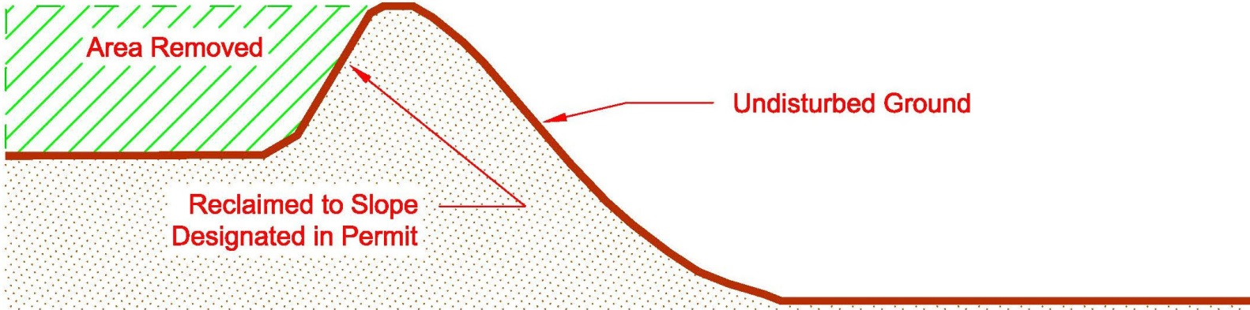

This mining method would be implemented at or near the following locations within the permitted boundary (check all that apply) All North South West East Northwest Northeast Southwest Southeast
Additional Information:

  - Mining a Terrace, Hill, or Plateau near the Edge of a Slope and near a Water Feature
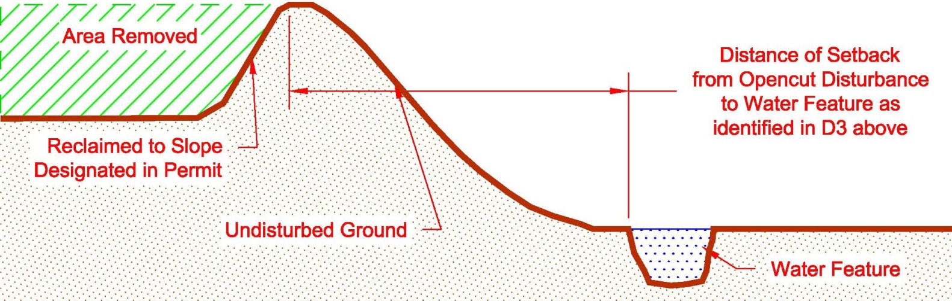

This mining method would be implemented at or near the following locations within the permitted boundary (check all that apply) All North South West East Northwest Northeast Southwest Southeast
Additional Information:

  - Mining a Terrace, Hill, or Plateau near the Edge of a Slope
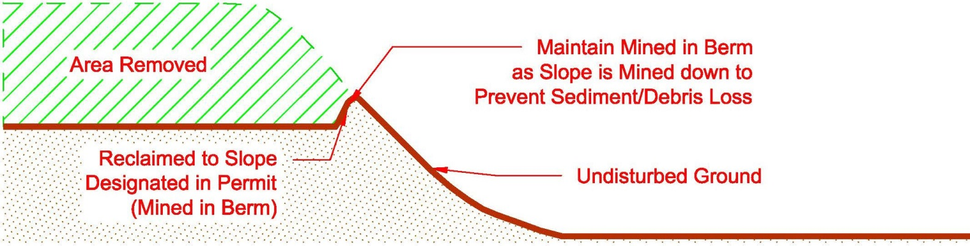

This mining method would be implemented at or near the following locations within the permitted boundary (check all that apply) All North South West East Northwest Northeast Southwest Southeast
Additional Information:

  - Mining a Terrace, Hill, or Plateau near the Edge of a Slope and near a Water Feature
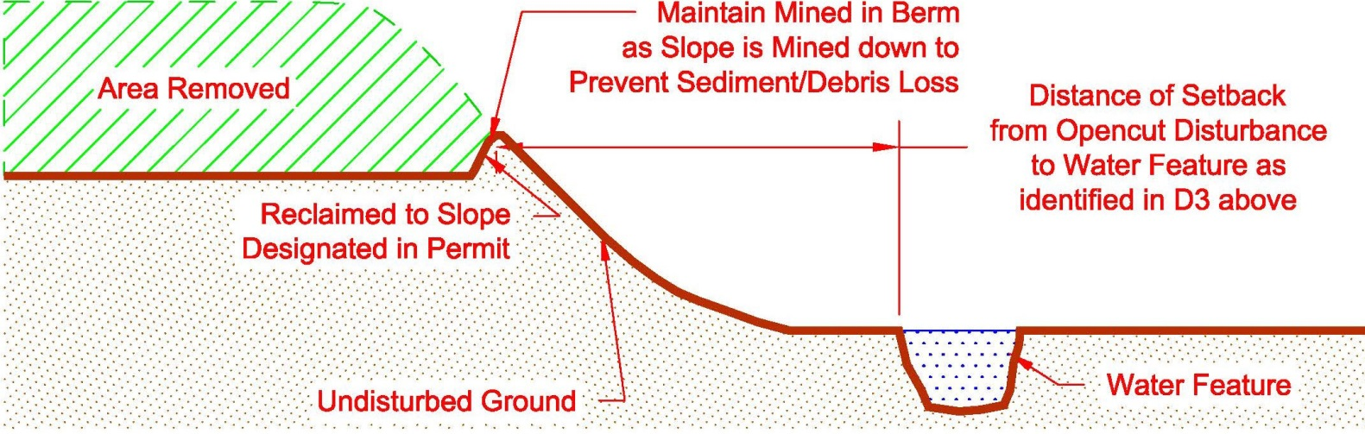
This mining method would be implemented at or near the following locations within the permitted boundary (check all that apply) All North South West East Northwest Northeast Southwest Southeast
Additional Information:

  - Mining a Terrace, Hill, or Plateau near the Edge of a Slope
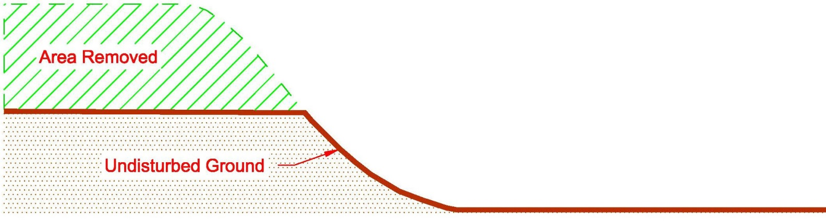
This mining method would be implemented at or near the following locations within the permitted boundary (check all that apply) All North South West East Northwest Northeast Southwest Southeast
Additional Information:

    - This mining method requires to ensure that no sediment or debris erodes or is pushed down the slope. would implement, as necessary, erosion control measures at the edge of the slope or slightly downslope (within permit boundary) to prevent loss of sediment and debris.

  - Mining a Terrace, Hill, or Plateau near the Edge of a Slope and near a Water Feature
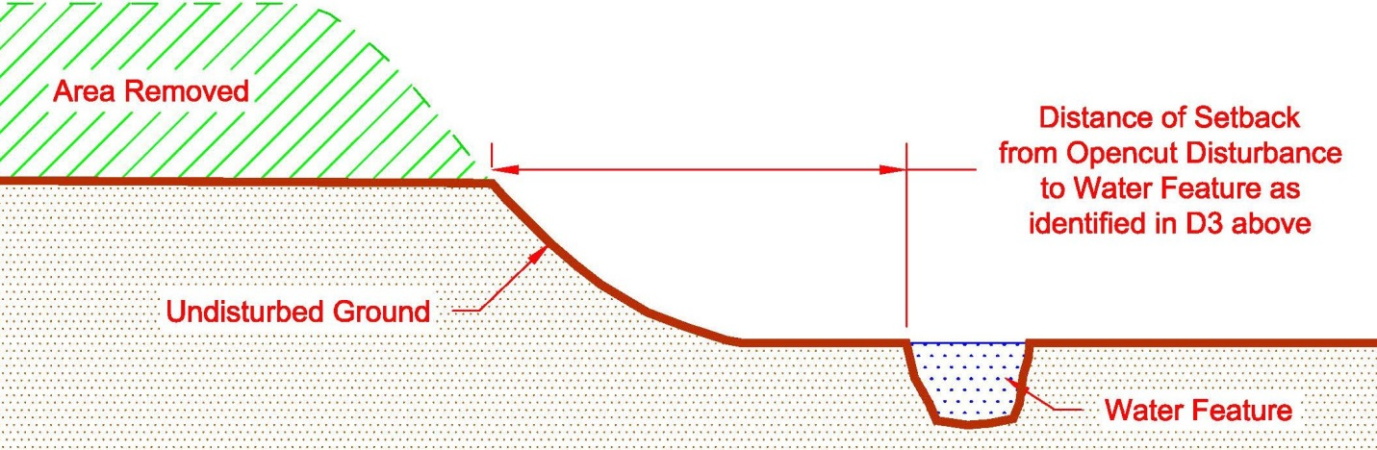
This mining method would be implemented at or near the following locations within the permitted boundary (check all that apply) All North South West East Northwest Northeast Southwest Southeast
Additional Information:

This mining method requires to ensure that no sediment or debris erodes or is pushed down the slope. would implement, as necessary, erosion control measures at the edge of the slope or slightly downslope (within permit boundary) to prevent loss of sediment and debris.

  - Mining a Relatively Flat Area to Create a Depression
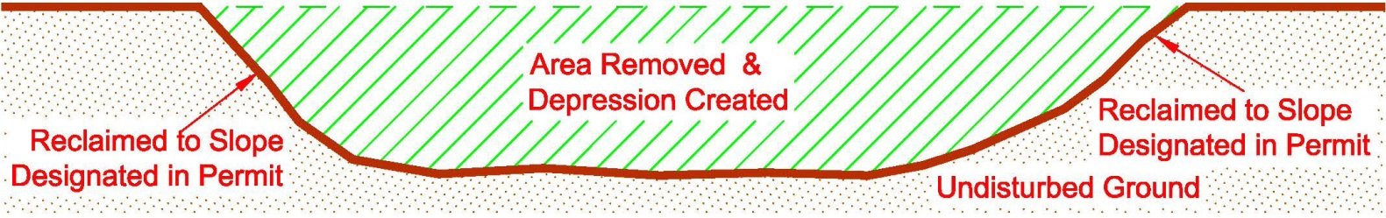
This mining method would be implemented at or near the following locations within the permitted boundary (check all that apply) All North South West East Northwest Northeast Southwest Southeast
Additional Information:

  - Mining a Hill or Knob and Reclaiming it to the Approximate Elevation of Adjacent Ground
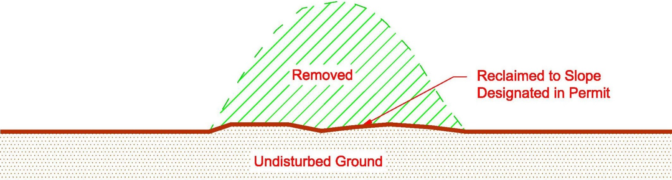
This mining method would be implemented at or near the following locations within the permitted boundary (check all that apply) All North South West East Northwest Northeast Southwest Southeast
Additional Information:

  - Excavating into a Hillside and Not Mining Below Existing Grade
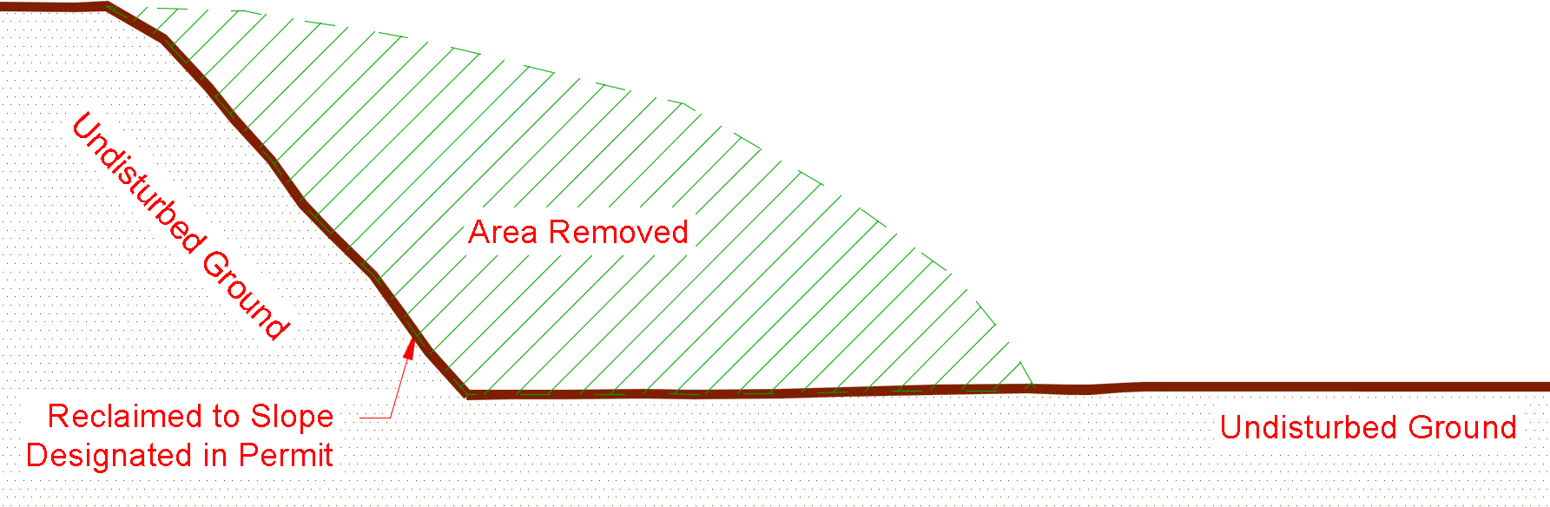

This mining method would be implemented at or near the following locations within the permitted boundary (check all that apply) All North South West East Northwest Northeast Southwest Southeast
Additional Information:

  - Other Scenario
Describe:

- Any slope steeper than 3:1 with a height of 5 feet or greater, present for any length of time, is considered to be a highwall. Will this site have highwalls? No Yes If Yes, skip to D5-8b.
  - If No, explain in detail how this site will be mined without ever creating a highwall on-site. Note that mining without a highwall is not typical and is difficult to achieve.
Answer:
  - If Yes,
    - The maximum length of highwall on-site at any given time will be: linear feet. Note: This number must be used on the Reclamation Bond Spreadsheet.
    - The maximum height of highwall on-site at any given time will be: feet. Note: This number must be used on the Reclamation Bond Spreadsheet and will typically be consistent with the maximum depth of mining (see Section C1-1).
    - If the maximum height of highwall identified in D5-8 above is not identical to the maximum mine depth identified in C1-1 (i.e. ), explain in detail how the site will be mined:
    - Choose the highwall scenario below that best depicts how this site will be mined:

- Cut & Fill Scenario (complete Highwall section on Reclamation Bond Spreadsheet)
  - understands that choosing this scenario requires that a buffer of unmined area be kept between the highwall and the permit/bonded boundary. Therefore, will maintain an adequate buffer to allow for cut-and-fill to be conducted.
  - NOTE: It is recommended that if the cut-and-fill scenario is to be used, the maximum advanced position of the highwall be clearly marked on the ground with durable markers to ensure enough material remains in place for slope reduction.

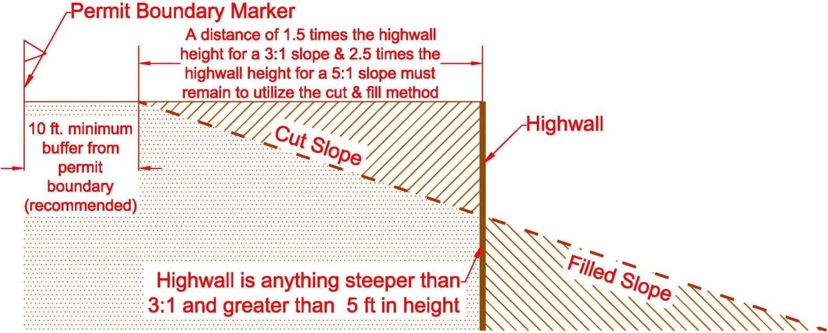

- Backfill Scenario for areas where the Cut & Fill Method is not an Option (Complete Section D6 – Mine Material Backfill)
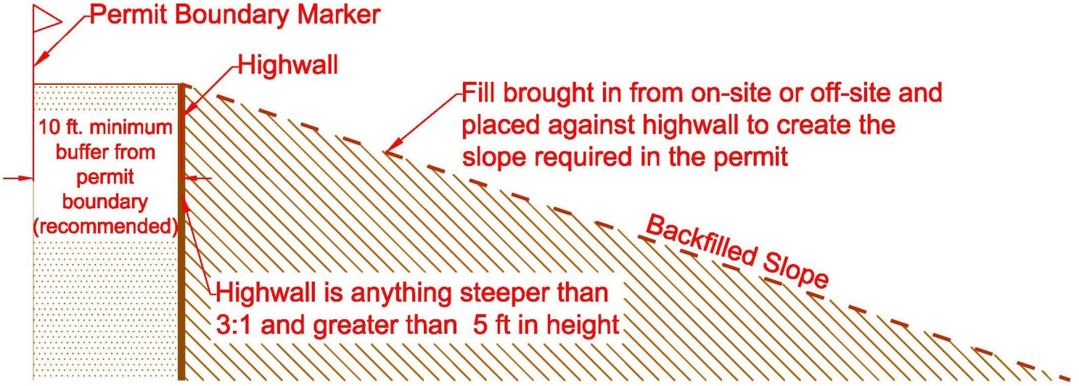

D6. MINE MATERIAL BACKFILL [ARM 17.24.218(1) & 17.24.219]
- If “Backfill Scenario” was chosen in D5-8(a) or if any mine area backfill locations are planned (e.g. using material to raise the level of the pit floor to accomplish the reclamation plan), complete this section. If not, skip to Section D7.
Highwall Backfill* Mine Area Backfill**

Show the planned backfill location(s) on the Site Map or Reclamation Map and provide the following information:
- Describe where the backfill material will come from:
On-site – Describe:
Off-site- Describe:
- Material type(s) to be used as backfill (check all that apply):
Pit Run Gravel Oversize Rock Reject Fines Backhaul (Clean Fill Only)
Other:

*Highwall Backfill: must identify the linear feet, height, and slope of highwall to be backfilled on the Reclamation Bond Spreadsheet under “Highwall Backfill.” Additionally, must bond for transport/placement cost for the quantity of material to be placed against the highwall for backfill under the “Backfill Transport/Placement” cost line item ($2/cy for on-site generated backfill and $15/cy for off-site generated backfill).
**Mine Area Backfill: must identify the acreage, depth, and compaction percentage on the Reclamation Bond Spreadsheet under “Mine Area Backfill.” Additionally, must bond for transport/placement cost for the quantity of material to be placed on-site for backfill under the “Backfill Transport/Placement” cost line item ($2/cy for on-site generated backfill and $15/cy for off-site generated backfill).

D7. FACILITIES [MCA 82-4-434] & [ ARM 17.24.218(1)(e), ARM 17.24.218(1)(i) & 17.24.219(1)(b)]
      - If an Asphalt Plant, Wash Plant, or Concrete Plant was checked in A1-2c or A1-10 above, complete this section. If Not, skip to D7-2.
  - Asphalt Plant – If stationary or near a water feature, identify the specific or general location on the Site Map.
Must be checked in section A1-10 for a new permit and A1-2c for an Amendment
Must remain in compliance with D1-1.
- Where will the asphalt plant be set up?
Answer:
- A small amount of asphalt waste generated from daily startup and shutdown of the asphalt plant is expected; therefore, a maximum of 300 cubic yards of asphalt can be located onsite, near the asphalt plant. However, the asphalt waste must be removed when the asphalt plant is removed from the site, unless the site is permitted and bonded to store asphalt onsite.
- Describe additional restrictions or commitments on location of asphalt plant (placement away from water, residences, etc.)

  - Concrete Plant - If stationary, or near a water feature, identify the specific or general location on the Site Map.
Must be checked in section A1-10 for a new permit and A1-2c for an Amendment
    - Where will the concrete plant be set up?
Answer:
    - Describe what will be done with wastewater created from the concrete plant.
will dispose of wastewater in an off-site location, greater than 300 feet from the permitted boundary, and in an area that would not impact surface or ground water.
will dispose of wastewater on-site or within 300 feet of the permitted boundary, and in an area that would not impact surface or ground water (location must be shown on Site Map).
Other: Describe:
    - Where will truck washouts occur?
will conduct truck washouts in an off-site location, located greater than 300 feet from the permitted boundary, and in an area that would not impact surface or ground water.
will conduct truck washouts on-site in or within 300 feet of the permitted boundary, and in an area that would not impact surface or ground water (location must be shown on Site Map).
Other: Describe:
    - Describe how and where return loads and excess or reject product will be handled or stored. If on-site or within 300 feet of the permitted boundary, show the location on the Site Map.
Concrete will be poured into casts to make products
Concrete will be poured on-site and buried under 3 feet of material suitable for sustaining the postmining land use.
Other:

  - Wash Plant - If stationary, or near a water feature, identify the specific or general location on the Site Map.
Must be checked in section A1-10 for a new permit and A1-2c for an Amendment
    - Where will the wash plant be set up?
Answer:
    - How many settling ponds will be used for the wash plant? 1 2 3 4
Other
    - What will the approximate depth of the settling pond(s) be? Answer: feet
    - Will settling pond(s) be lined? No Yes
If Yes, type of liner:
    - Where will the wash plant obtain its water?
On-site well or well within 300 feet of permit boundary (Identify location on Site Map)
Surface water source within 300 feet of permit boundary (Identify location on Site Map)
Source located greater than 300 feet from permitted boundary
Other:
    - Will the water from the wash plant be recycled back into the wash plant? Yes No
If No, explain:
    - must show the location of the wash plant and any settling ponds or other wash plant features on the Site Map.
    - If attaches the Opencut Mining Section’s Wash Plant Settling Pond Guideline, check the appropriate box on page 2.

- Will salt or a salt mixed with product be stored on-site? Yes No
If No, skip to D8.
If Yes, complete the following:
  - Show the proposed salt material stockpile(s) on the Site Map.
  - Indicate the maximum quantity of salt or salt product that would be stored on-site: cubic yards
  - Describe how salt materials would be stored on-site:
Storage Pad: Asphalt Pad Concrete Pad Other Impermeable Surface – Describe:
Cover: Enclosed Structure Roof Only Tarp Other Cover – Describe:
Other Storage Method:
  - Describe the measures to be taken to protect on and off-site surface water and ground water from deterioration of water quality due to salt storage per 82-4-434(2)(l), MCA & ARM 17.24.218(1)(h).
Answer:

D8. ASPHALT & CONCRETE RECYCLING [ARM 17.24.206; 17.24.219(1)(b); & 17.24.221(3)]
- Asphalt Recycling – Typically, recycling involves accumulating materials containing asphalt, crushing these materials periodically, and stockpiling the resulting crushed asphalt product as is or blending it with other suitable materials. These recycled products are commonly used to surface roads, and operations permitted to operate an asphalt plant may also use these as feed into the plant.
Asphalt is considered to have the potential to impact water quality. As a result:
- An operation that imports materials containing asphalt must be permitted to store the debris awaiting recycling. Note: Imported debris may be a mixture of various materials (e.g. asphalt, concrete, soil, gravel, etc.). However, if the debris contains asphalt, it must be permitted as asphalt storage.
- Similarly, if a site permitted to operate an asphalt plant will stockpile asphalt produced on-site (e.g. excess or reject material), the operation must be permitted and bonded for asphalt storage.

  - Will asphalt or materials containing asphalt be stockpiled at the site? Yes No
If No, skip to D8-1b.
If Yes, must comply with the following requirements for stockpiled asphalt:
- The maximum amount of asphalt or material containing asphalt awaiting recycling that will be on-site at any time is cubic yards.
- This maximum value must be used in the Reclamation Bond Spreadsheet to calculate the cost to either recycle (i.e. crush) the asphalt, or dispose of it off-site in a lawful manner.
- Asphalt must be stored in the “asphalt stockpile area” shown on the Site Map.
- Asphalt must be kept out of ground water and surface water (runoff channels, puddles, ponds, etc.); the only water that should come in contact with the asphalt stockpile is rain and snow.
- Imported asphalt must not be buried or otherwise disposed of on-site. During the final reclamation process, on-site asphalt stockpiles must be: a) removed from the site and disposed of in a lawful manner, or b) recycled into useful products which are removed from the site or used on-site to surface roads that are included in the approved postmining land use. Only on-site generated asphalt that has never left the site can be buried on-site as long as it is buried at least 25 feet above the ordinary high water table and under 3 feet of clean fill material suitable for sustaining the postmining vegetation.

  - Will on-site generated asphalt be buried on-site? Yes No
If No, skip to D8-2.
If Yes, item C of the Landowner Consultation Form must be checked “Yes.” In addition, § 82-4-434(2)(l), MCA requires the DEQ to protect surface and ground water from deterioration of water quality and quantity that may arise as a result of the Opencut operations. The Opencut Mining Section may require that a ground water monitoring plan and monitoring well installation plan be designed to protect ground water. Therefore, the below items must be addressed to bury on-site generated asphalt.
    - What is the distance between the bottom of the proposed buried asphalt and the ordinary high water table?
Answer: feet. (Buried on-site generated asphalt must be located at least 25 feet above the ordinary high water table.)
    - How was the elevation of the ordinary high water table on-site confirmed?
Monitoring wells were installed to confirm ordinary high water level (data must be attached and the Monitoring Well Installation Plan on page 2 must be checked).
Other:
    - Where will the required 3 feet of material suitable for sustaining postmining vegetation be obtained?
Answer: (Ensure that the additional fill is bonded for on the Reclamation Bond Spreadsheet)

- Concrete Recycling – Hardened concrete is not considered to have potential to impact water quality. As a result, concrete debris from construction or demolition projects may be imported to the site and stockpiled pending recycling or used as mined-area backfill. Similarly, sites permitted to operate a concrete plant may stockpile excess or reject product that becomes hardened on-site.
  - Will hardened concrete be stored at the site? Yes No
If No, skip to Section D-9.
If Yes, must comply with the following requirements for hardened concrete:
- When concrete is deposited at the site, any protruding metal must be cut off and collected. Any metal exposed during subsequent handling, transfer, crushing, or recycling must promptly be freed and collected. As a result, no protruding metal should be visible at any time. Salvaged metal must periodically be transported off-site for recycling or other lawful disposal.
- Concrete must be stored in the “concrete stockpile area” shown on the Site Map.
- Concrete present at the site during the final reclamation process must be a) removed from the site and disposed of in a lawful manner, b) recycled into useful products, or c) buried on-site under at least 3 feet of clean fill material suitable for sustaining the postmining vegetation.
Note: If asphalt is present in concrete stockpiles, the site must be permitted for asphalt recycling (refer to Section D8-1 above.)

D9. REJECT FINES [ARM 17.24.219]
- Reject fines are natural or crushed rock that is generally ¼ inch or smaller. Reject fines are usually created from screening product/material. Reject fines are typically pushed back into the pit to act as backfill before replacing the overburden and soil, or they are hauled off-site.
- Will reject fines be created at this site?
Yes No
If No, skip to Section D10.
If Yes, how will reject fines be handled at this site? Check all that apply:
        - Reject fines will be hauled off-site before accumulating to 10,000 cubic yards.
        - Reject fines will be periodically placed back into the mine area as operations progress through the life of the permit. Reject fines will not be allowed to accumulate to more than 10,000 cubic yards.
        - Reject fines will be stockpiled and used for reclamation at a later date.
          - The maximum quantity of fines to be stockpiled is cubic yards*
*Note: If more than 10,000 cubic yards of stockpiled reject fines will be located on-site, the entire stockpile must be bonded for on the Reclamation Bond Spreadsheet at a rate of $1.00 per cubic yard. Ensure the Reclamation Bond Spreadsheet is consistent with the quantity entered in this section.
        - Other:

D10. SOIL, OVERBURDEN, & MINE MATERIAL COMMITMENTS [MCA 82-4-434(2)(c)] & [ARM 17.24.218(1)(c-d) & 17.24.219(1)(c) & 17.24.220(2)(b)]
- will comply with the following requirements:
  - Prior to conducting any Opencut operations, soil and overburden must be stripped separately to the average thicknesses identified in Section C2–4. (Note: Stripping soil may create low spots that collect water, necessitating the establishment of drainage ways, or the construction of raised roadbeds and work areas.)
  - must strip, stockpile, save and replace all soil (and overburden if sufficient soil is unavailable) to a minimum depth of 24 inches or to another depth approved in writing by the DEQ and record the average thicknesses of soil to be replaced in Section C2-4.
  - All stripped soil and overburden must be: i) hauled directly to areas prepared for reclamation and re-soiling, or ii) promptly stockpiled and protected from erosion, comingling, contamination, compaction, and unnecessary disturbance. At the first seasonal opportunity, must shape and seed, with an approved perennial seed mix, any stockpile that will remain for 2 or more years.
  - Designate all soil and overburden stockpiles with signage that is legible, visible, and placed so that equipment operators and inspectors may readily identify the type of stockpile being worked for the life of the stockpile.
  - must not haul soil off-site, give it away, or sell it without written approval from the DEQ.
  - Soil and overburden must be handled separately and will avoid mixing these materials, or handling them when wet or frozen. Overburden must be stockpiled only on areas where soil has been stripped to the required depth. Soil may be stockpiled on stripped or unstripped areas.
  - A minimum 10-foot wide buffer zone stripped of soil and needed overburden must be maintained along the crest (edge) of highwalls. This practice helps to ensure that soil will not be lost to mining. Highwalls are defined in D5-8.
  - Soil, overburden, and mine material stockpiles must be kept out of drainage bottoms and off of slopes steeper than 3:1. All excavated and/or processed mine material must be: i) removed from the site, ii) buried on-site, or iii) left for the landowner in accordance with the Landowner Consultation form and Section E7.
  - Burn pile residue, building demolition debris, metal, plastic, tires, and other wastes must be disposed of off-site and in a lawful manner, unless otherwise stated in the permit.
  - All clean fill (i.e. dirt, sand, fines, gravel, and oversize rock) that cannot, or will not, be buried during final reclamation must be removed from the permit area prior to bond or liability release request, with the exception of materials left for the landowner.

D11. ADDITIONAL IMPACTS [MCA 82-4-434(2)(m)] & [ARM 17.24.218(1)(f & k)]
- Are there residences within 1,000 feet of the permit boundary? Yes No

- Indicate the methods and materials that would be used to mitigate impacts of the processing equipment listed in Section A1-10 from the neighboring properties.
Berms Buffer zones Dust mitigation Equipment enclosures Fences Paving
Restricted Hours Revegetation Speed limits Vegetative screens
Other/Additional Information:

D12. ADDITIONAL COMMITMENTS [MCA 82-4-434(3)(g)&(h) & MCA 82-4-437] & [ARM 17.24.214 & 17.24.218(1)(l)]
- understands that obtaining an Opencut Mining Permit does not relieve ’s obligation to comply with any other applicable federal, state, county, or local statute, regulation, or ordinance. Therefore, is responsible for identifying and obtaining any other permits and approvals from other agencies required for the proposed activities (Refer to “How to Obtain and Comply with an Opencut Mining Permit” on the Opencut website). Obtaining an Opencut permit does not necessarily mean that an Operator can legally mine the site without first obtaining permits from other agencies.

- will comply with the following requirements:
- Key personnel and subcontractors involved in Opencut operations must be informed of the requirements of this Plan and must be provided a copy of this Plan. In addition, they must be shown each boundary marker location and informed of the importance of the markers.
- Proper precautions must be taken to prevent wildfires.
- Appropriate protection must be provided for identified cultural resources that could be affected by Opencut operations. If any other cultural resources are discovered, must: i) temporarily halt work, or move to another area, and ii) promptly notify the State Historic Preservation Office (406-444-7715).
- By March 1st of each year, must complete and return the Annual Production Report (APR) form that the Opencut Mining Section sends early in the year. must report the requested information regarding mining conducted during the preceding calendar year. In addition, must calculate the fee for the preceding year’s production (per cubic yard of material mined) and submit payment to the DEQ along with the APR.

D13. ADDITIONAL INFORMATION [MCA 82-4-432(1) & 82-4-434(2)] & [ARM 17.24.222]
1. If applicable, provide additional water protection, mining, and processing information not addressed above.
Answer:

SECTION E – RECLAMATION PLAN

E1. RECLAMATION TIMEFRAME [MCA 82-2-431(10) & (11); 82-4-434(2)(k); 82-4-434(3) & (4)] & [ARM 17.24.219(1)]
- Reclamation must be:
- Completed in accordance with this Plan and as concurrent with the Opencut operations as feasible.
- Completed on an area no longer needed for Opencut operations within one year after the cessation of such operations.
- Completed on an area that no longer has the right to use for Opencut operations within one year after the termination of such right.
- Completed by the Term of the Permit (final reclamation date) that specifies below.
- must specify the final reclamation date based on various business and environmental factors, including:
- The estimated demand for mine materials, the expected rate of production, and accessible material reserves.
- The time required to establish productive vegetation comparable to that growing on similar undisturbed land nearby. Typical minimum timeframes for revegetation are:
- At least 2 additional years to establish vegetation and control noxious weeds on grassland and forest areas.
- At least 1 additional year for the first successful harvest on cropland.
- Final reclamation of the site is complete when the postmining land use has been achieved, including successful revegetation or crop harvest, and noxious weed control. Therefore, DEQ recommends that be sure to allow sufficient time for successful vegetative growth, thereby avoiding the need to submit an amendment application requesting only to extend the final reclamation date.
- Final Reclamation Date is: Month December, Year
- certifies that the reclamation date chosen fits the operator’s production and business needs.
Note:
- If will not be able to achieve the postmining land use by this date, an amendment application must be submitted to extend the final reclamation date. Such an application must be submitted well in advance of the reclamation date to allow time for processing and approval of the amendment.
- If the final reclamation date passes before achieves the postmining land use, the permit would no longer be valid. The operator would subsequently be required to cease all Opencut activities and enter into an agreement with the DEQ Enforcement Program to either reclaim the site to the permitted postmining land use or re-permit the site.
- The expiration or termination of a permit does not relieve from the obligation to conduct reclamation as required by the plan of operation or the liability for costs of reclamation exceeding the amount of the bond.

E2. POSTMINING LAND USES [MCA 82-4-434(1) & (2)] & [ARM 17.24.219(1)(a)]
        - The site will be reclaimed to the postmining land use(s) below. Show all postmining land uses on the Reclamation Map.
Permitted Access Road(s): Length Width
Internal Road(s): Length Width
Cropland, Rangeland and/or Pasture (cropland requires 5:1 or flatter slopes for reclamation & Rangeland and/or Pasture require 3:1 slopes or flatter for final reclamation)
Year-round Pond: Fishery Livestock Recreation Wildlife Other:
Seasonal Pond: Purpose- Wetland Seasonal Wetland
Berms Fences Landowner Equipment Storage Area*
Landowner Material Stockpile Area*
Industrial/Commercial** Residential** Vegetative Screens Other:
*Landowner Equipment Storage Areas & Landowner Material Stockpile Areas must be shown on the Reclamation Map (include approximate acreage).
**Residential and Industrial/Commercial land uses may require submittal of planning documents and approvals.
understands that all soil taken from residential or industrial/commercial areas must be kept on site for reclamation and cannot be removed or sold until the DEQ has determined the postmining land use has been met, thereby verifying the soil is not needed to reclaim the area, or other remaining areas. This verification is achieved when submits a Phase I or Phase II release request, the site is inspected, and the release request is approved.
Note: If site plans change, must submit an amendment application to update the postmining land use(s).

- What facilities and structures will remain after reclamation of the site is completed?
None Concrete Structures Gravel or Paved Surface Area Office Scale
Other:

- Describe the purpose of leaving these facilities or structures intact.
Answer:

E3. PONDS AND WETLANDS [MCA 82-4-434(1) & (2)] & [ARM 17.24.219(1) & 17.24.221(5)]
- If Section E2 above does not designate a pond, seasonal pond, or wetland as a postmining land use, skip to Section E4; otherwise, proceed to E3-2 below.
- As a water feature would remain, complete the Pond and Wetland Design Worksheet, check the appropriate box on page 2, and include the worksheet with the application submittal. The Pond and Wetland Design Worksheet can be found here: http://deq.mt.gov/Mining/opencut (click on the “Forms” tab).
- understands that all soil taken from the pond or wetland area must be kept on-site for reclamation and cannot be removed or sold until the DEQ has determined the postmining land use has been met, thereby verifying the soil is not needed to reclaim the pond or wetland area, or other remaining areas. This verification is achieved when submits a Phase I or Phase II release request, the site is inspected, and the release request is approved.
- has consulted with DNRC and understands the requirements regarding water rights and ground water development related to reclaiming to the postmining land uses identified in E2-1. The DNRC water right flow chart can be accessed here: http://deq.mt.gov/Mining/opencut.
Additional Information (if applicable):

E4. SITE CLEANUP, GRADING AND RECLAMATION [ARM 17.24.219(1) & 17.24.221(5)]
- must comply with the following requirements:
  - Leave reclaimed surfaces in a stable condition, graded to drain to low areas where applicable, and blended into the surrounding topography and drainageways. Note: Irregular contours are preferred for livestock and wildlife habitat; areas of unvarying slope should be minimized; and drainageways must be reclaimed similar to surrounding natural conditions.
  - Leave reclaimed surfaces with 5:1 or flatter slopes for hayland and cropland, 4:1 or flatter slopes for sandy surfaces, and 3:1 or flatter slopes for other areas (The DEQ may approve steeper slopes on a case by case basis).
  - Leave reclaimed surfaces at least 3 feet above the seasonal high water table level for dryland reclamation and at least 3 feet below the seasonal low water table level for pond reclamation (The DEQ may approve seasonal ponds for certain situations).
  - Retrieve and properly use, stockpile, or dispose of all refuse and spilled mine materials (e.g. chips, oversize, etc.) found in the permit area and along access roads as such materials will impair revegetation.

- Indicate the grade of the steepest slope that would remain after the site is reclaimed.
3:1 4:1 5:1 6:1 Other:
Note: This reclamation slope ratio must be used on the Reclamation Bond Spreadsheet.
If a slope of 3:1 or flatter was checked, skip to E4-3.
If the Other box was checked above and intends to have slopes steeper than 3:1, address the following:
must provide a slope stability study prepared by a professional engineer licensed in accordance with
Title 37, chapter 67, part 3, MCA, or a geologist with five years of post-graduate academic or professional work experience in the field of soil or rock mechanics, documenting that the slopes will remain stable [ARM 17.24.219 (c)].
Slope Stability Analysis Attached (check the appropriate box on page 2)
Further Description (if applicable):

- Will the site be graded to blend in with surrounding topography? Yes No
If No, explain in detail how the site will be graded:

- Would a water collection area remain for final reclamation?
Yes No
- If Yes, where will precipitation/stormwater/snow-melt, etc. concentrate or drain to in the reclaimed depression?
  - Seasonal or year-round wetland or pond (applicable postmining land use must be checked in E2).
  - Runoff collection area(s) in bottom of depression graded specifically to collect any runoff, thereby not impacting other areas of the site with ponding or pooling of water.
- Approximate location of water collection area(s) must be shown on the Reclamation Map
Water collection area is < ½ acre in size;
Water collection area is > ½ and < 1 acre in size – Explain why water collection area needs to be greater than ½ acre in size
  - Other-Describe:

- If No, describe where stormwater will concentrate or drain to, i.e. water will flow to the (check all that apply):
  - Water would infiltrate into the ground East North Northeast Northwest South
Southeast Southwest West
Further Description:
  - Water will flow off-site via:
Reclaimed drainages, swales, etc. within the permitted boundary Reclaimed slopes
Other-Describe:

Note: ARM 17.24.221(5) requires that the Reclamation Map contain arrows depicting the anticipated direction of water flow across the reclaimed site.

E5. SOIL AND OVERBURDEN SURFACE PREPARATION AND REPLACEMENT
[ARM 17.24.202(14) & 17.24.219(1)(g)]
- Compacted soil and overburden must be tilled to allow air and water movement, root penetration, and the subsurface drainage necessary for plant growth. Will alleviate compaction by deep-tilling or ripping all compacted surfaces to a depth of at least 12 inches before re-soiling? Yes No
Note: The DEQ recommends the following:
- Ripping or deep tilling is not required for non-compactable materials such as sand and gravel.
- Ripper shanks should be spaced about equal to the ripping depth.
- Rip along contours where possible and when soil and overburden are dry enough to shatter.
- Protect ripped areas from recompaction.
If No, explain in detail how overburden and soil compaction would be alleviated, or explain why relieving compaction would not be necessary:

- Indicate the methods to be used to relieve soil compaction and prepare the seedbed.
Chiseling Disking Harrowing Packing Other:

- will limit the presence of large rocks that are not characteristic of the soil prior to disturbance and may inhibit successful revegetation and agricultural production. Method(s) that will be used include:
Blading Off and Removal of Large Rocks Rock Picker Rolling Screening Hand Picking Other:

E6. REVEGETATION [MCA 82-4-431(2)(c) & 82-4-434(2)] & [ARM 17.24.218(1)(j) & 17.24.219(1)(h)]
- must comply with the following requirements:
  - Establish vegetation capable of sustaining the designated postmining land use(s).
  - Use certified weed-free seed and comply with local weed district requirements.
  - Seed during the late fall or early spring seeding season (unless otherwise approved) and seed along contours for drill seeding.
  - Ensure that areas seeded or planted to perennial species can be, and are, appropriately protected and managed from the time of seeding or planting through two growing seasons, or until site stabilization and revegetation are achieved, whichever is longer.
  - Revegetation success on non-cropland areas is achieved when vegetation capable of sustaining the designated postmining land use has been established. Revegetation success on cropland areas is achieved when a crop has been harvested from the entire area and the yield is comparable to those of crops grown on similar undisturbed sites under similar growing conditions.
  - Except for those postmining land uses that do not require vegetation, each surface area of the site that will be disturbed will be revegetated when its use for the Opencut operation is no longer needed.
  - must attach the Opencut Mining Section’s Weed Board Notification of Opencut Operation form that has submitted to the weed board in the county or counties in which the proposed operation is located and check the appropriate box on page 1.

- Will apply fertilizer, compost, mulch, or other soil amendments? Yes No

- The primary method of seeding will be: Drilling* Broadcasting**
*Sagebrush seed cannot be drill seeded and must be broadcast at the rates identified in the sagebrush seed mix. Grass and forb seeds in a sagebrush seed mix can be drill seeded.
**Broadcast seeding must be at double the rate used for drilling (i.e. 24 lbs/acre or more).

- The DEQ’s Seed Mix Guideline is available on the Opencut Mining Section’s website at http://deq.mt.gov/Mining/opencut (click on the “Forms” tab).
Will seed mixes described in the Seed Mix Guideline be used for final reclamation? Yes No
If No, complete the table below with a custom seed mix.
If Yes, check the appropriate box on page 2, attach a copy of the guideline, and indicate below which seed mix(es) would be used.
Native Grazing/Pasture Non-Native Grazing/Pasture
Native Rangeland (for moist/riparian regions)
Native Rangeland (for arid regions) Wetland Seed Mix (for pond edges or wetland areas)
OR
Cropland seed mix designated by Landowner at time of reclamation
OR
Recommended Seed Mixes for Sage Grouse Habitat
If the site is in general, core, or interconnectivity sage grouse habitat, must choose the appropriate seed mix below, unless the landowner has requested an alternate seed mix (refer to the Landowner Consultation form).
Northern Region Central & Southeastern Regions Southwestern and South Central Regions

In the table below, describe the seed mix species and rates of seeding (pure live seed per acre) that will be used:

SEED TYPE | SEED RATE
TOTAL SEEDING RATE | 0.0 pounds pure live seed/acre

Additional Seeding Information (if applicable):

- Indicate the measures to be used to manage and protect the site until reclamation vegetation is established.
Noxious Weed Control (mandatory) Fencing (include cost of fencing on the Reclamation Bond Spreadsheet)
No Grazing ( should secure written commitment from landowner)
Other:

- Indicate the method(s) or types of erosion control Best Management Practices (BMPs) that would be used at this site during reclamation to inhibit erosion and promote plant growth. must maintain the below checked erosion control BMP’s during reclamation to protect water quality and prevent sediment from leaving the site (as needed):
Equipment Tracking (orientated to trap moisture and break water flow) Erosion Control Blankets Mulch
Seeding/Harrowing Along Contour Slopes 5:1 or Flatter Straw Bales
Vegetated Buffer Strip Wattles Other:

E7. MATERIAL REMAINING FOR LANDOWNER [ARM 17.24.203(5); 17.24.206; 17.24.219(1)(b); & 17.24.221(5)(c)]
- Does Question B of the Landowner Consultation form indicate that mine material will remain at the conclusion of Opencut operations; or, if the landowner is the Operator, will mine material remain at the conclusion of Opencut operations?
Yes No
If No, skip to Section E8.
- The following requirements apply to leaving mine material for the landowner at the conclusion of Opencut operations:
- Landowner mine materials must be left in a single location that will be accessible by road. If the landowner stockpile is not adjacent to an existing public road, the road to the stockpile must be shown on the Reclamation Map.
- Landowner mine material stockpiles must be segregated into piles of similar types and grades.
- Landowner mine material stockpiles must be located in the area designated on the Reclamation Map.
- must leave the quantity of soil necessary to reclaim the stockpile area within 100 feet of the mine material stockpile to remain for the landowner.
            - Thickness of soil required to be stripped from the site is 0 inches * acres (estimated number of acres that will be occupied by the soil stockpile area) = 0 cubic yards of soil that must remain for the landowner material stockpile area.

E8. ADDITIONAL INFORMATION [MCA 82-4-432(1) & 82-4-434(2)] & [ARM 17.24.222]
1. If applicable, provide additional reclamation information not addressed above.
Answer:

SECTION F – RECLAMATION BOND CALCULATION [MCA 82-4-433] & [ARM 17.24.203 & ARM 17.24.220]

Government Operators: Skip to Section G.

Non-Government Operators:
- Attach a proposed Reclamation Bond Spreadsheet and check the appropriate box on page 1.
- The purpose of the Reclamation Bond Spreadsheet is to provide a reasonable estimate of the cost for the DEQ to reclaim the site in accordance with the Opencut Mining Plan of Operation & Application at the time of the site's maximum permitted disturbance. As a result, the estimated costs include equipment mobilization and project administration. The DEQ will review the proposed bond calculation and make a final determination as to the required bond amount.
- Bond is not required to be posted for government operators or for acreage permitted as Non-Bonded until the acreage is needed for Opencut operations. Prior to commencing any such operations, must submit a Request to Modify Bonded Acreage form, supporting documents, and post additional bond (if appropriate) on the undisturbed acreage. No Opencut activities, including equipment parking, can begin on non-bonded acreage until the Request to Modify Bonded Acreage form, supporting documents, and bond are approved in writing by the DEQ.
- understands that the DEQ may adjust the bond yearly.
- Provide additional information relevant to the Reclamation Bond Spreadsheet if applicable:

Proceed to Section G – Certification and ensure it is fully completed

SECTION G – CERTIFICATION [MCA 82-4-432(1)(e)] & [ARM 17.24.222(3)]

The person signing below represents that (check one box):
I am an officer or an employee of and I am duly authorized to bind the Operator identified on page 1 of the Opencut Mining Plan of Operations & Application as a corporation, limited partnership, limited liability company, or other corporate entity in good standing and authorized to do business in Montana, and in this capacity I acknowledge and certify that:
Or
I am the Operator identified on page 1 of the Opencut Mining Plan of Operation & Application and I acknowledge and certify that:
- The attachments that follow my signature are incorporated into and enforceable as part of the Opencut Mining Plan of Operation & Application;
- has the legal right to conduct Opencut operations in the permit area described in the Opencut Mining Plan of Operation & Application;
- consents to and acknowledges that the DEQ and its representatives may access the site to inspect the permit area at any reasonable time, and that while the DEQ attempts to provide reasonable notice of an inspection to when practicable under the circumstances, inspections may be conducted without prior notice as necessary to determine whether Opencut operations are being conducted in compliance with the permit, Act, and rules [82-4-422(1)(d) and 425, MCA] & [ARM 17-24-206(3)].
- I have read and understand all the information, representations, terms, requirements, and conditions set forth in Opencut Mining Plan of Operation & Application;
- The information, representations, and statements provided or acknowledged in the Opencut Mining Plan of Operation & Application are, to the best of my knowledge and belief, true and correct; and,
- agrees to abide by and comply with the Opencut Mining Act, Montana Code Annotated sections 82-4-401 through 82-4-446, and Administrative Rules of Montana 17.24.201 through 17.24.226, and all representations, terms, requirements, and conditions set forth in the Opencut Mining Plan of Operation & Application and the Opencut Mining Permit approved by the DEQ, and communicate the same to any contractor or supervisor who directs Opencut operations under authority of the Opencut Mining Permit.

By:
 | Signature |  | Legibly print or type name
Title Date

