

Residential buildings energy code summary

Overview
Montana homebuyers appreciate the comfort and warmth of a well-designed energy-efficient home. All new homes in Montana must meet the minimum requirements of the 2021 International Energy Conservation Code (2021 IECC) with Montana amendments. This publication is a summary of the 2021 IECC residential provisions with Montana amendments. A copy of the 2021 IECC can be ordered at ICC Website or by calling 800-786-4452. For more information regarding the Montana Energy Code go to the Montana DEQ Website or call 406-444-0281. The 2021 IECC, with Montana amendments, took effect on June 10, 2022. Certified jurisdictions may take up to 90 days from their notification date to adopt the code.
Cities, towns, and counties who choose to adopt the building code are required to enforce the state energy code in their jurisdiction. A listing of certified jurisdictions that have adopted building codes is available at the Montana DLI website. Outside of these building code jurisdictions, builders are required to meet the requirements of the energy code and to show energy code compliance through a self-certification process by providing a written statement to the homeowner stating the house meets the state energy code requirements. The home builder may provide the certification by signing and dating the Energy Code Compliance Label shown on page 15.
Below are significant changes to the Montana Energy Code explained in more detail in this document:
- Mechanical ventilation systems (bath and kitchen exhaust fans) are required to pass an air flow test
- All permanent light fixtures must be high-efficacy lighting sources
- Blower door test has a new option making it easier for small houses to pass the test
- One additional energy efficiency feature is required
- Ceiling insulation level R-60, entire area R-49
The statewide energy code gives house buyers an additional tool to use in making their purchase decision. The Energy Code Compliance Label is required in all new residential construction and is a way for the builders to certify that the house meets the minimum code levels for insulation, window, and heating system efficiencies and other energy features required in the new residential construction. The label also ensures the information about these features is not lost over time. The label should be permanently affixed to the house’s electrical breaker box, so subsequent owners will have the same information available to them.
Not only do home builders and home buyers benefit from this code, but Montana wins too. Energy efficient homes consume less energy than homes not built to meet the energy code. Less energy needs to be produced to heat and cool energy-efficient homes which helps conserve Montana’s fossil fuel resources and protects our environment.

What Buildings Are Covered Under the Statewide Energy Code?
The Energy Code applied to all new residential buildings, additions, repairs, and renovations in Montana (with exceptions noted below) regardless of fuel type (gas, electricity, or other). Unaltered portions of existing buildings do not need to comply with this code. Residential buildings (R-2, R-3, or R-4) with more than three floors above ground must comply with the commercial energy code requirements of the 2021 IECC.
The following are exempt from this code:
- Farm and ranch buildings, any private garage or private storage structure attached to a home.
- Buildings that are classified or determined to be eligible for a listing in the National Register of Historic Places, and Housing and Urban Development (HUD) code manufactured homes.
- Log homes must follow ICC-400 requirements.

Ways to Show Energy Code Compliance
There are three primary ways to demonstrate that the thermal envelope of one-and two-family dwellings meet the requirements of the Montana Energy Code (2021 International Energy Conservation Code with the Montana amendments).
- Follow the prescriptive path listed below on Table 1
- Use REScheckTM, a computer analysis tool, to show compliance
  - A free download of the REScheckTM is available at U.S. Department of Energy.
  - REScheckTM requires inputs of the areas and insulation efficiency levels for ceilings, walls, and windows.
- Energy Rating Index Option (ERI)

Table 1 – Insulation and Window Requirements by Component
Component | Insulation or Efficiency Level (Contains some Montana Amendments)
Ceiling | R-60/49^{A}
Exterior Wall | R-21 or R-13+R10 CI^{B}
Mass Wall | R15-20^{C}
Floor | R-30^{D}
Basement Wall | R-19/R15 CIE
Slab Perimeter | R-10, ^{F} from the top edge for 4ft
Crawlspace Wall | R-19/15 CI^{G}
Window/Door U | U-.30^{H}
Skylight | U-.55

The R-value requirement listings are for insulation materials only, not for structural components such as drywall or siding. All materials, systems, and equipment must be installed in accordance with the manufacturer's installation instructions.
- R-49 is acceptable if the full height of uncompressed R-49 insulation extends over the wall top plate at the eaves. See figure 4, page 11.
  - Where there is not enough space to achieve Table 1 ceilings insulation levels, R-30 is allowed in up to 250ft² or 10% of the space, whichever is less.
  - Insulation markers with at least one-inch sized numbers are required at least every 300ft² of attic space and must face the access opening.
  - Attic access hatches and doors must be weather-stripped or sealed and baffled to prevent loose insulation from spilling into the living spaces and insulated to its surrounding area’s requirements. Vertical access doors to unconditioned spaces must have at least a U-factor of 0.30, approximately R-3.
- The second number is a listing of continuous insulations (CI), which is insulation that runs continuously over structural members and is free of thermal bridging. Foam sheathing over exterior wall framing is an example of continuous insulation.

Table 2 – R402.26 Requirement for Steel-Frame Wall (R-Value)
Steel-Framed Wall 16” O.C.- R-13 + 9.5 or R-15 + 9.1 or R-19 + 8.4 or R-21 + 8.1
Steel-Framed Wall 24” O.C.- R-13 + 8.3 or R-15 + 7.7 or R-19 + 6.9 or R-21 + 6.5
Cavity insulation R-value is listed first, followed by continuous insulation R-Value

Structural Insulated Panels (SIP) with at least 5.5” of foam and insulated concrete foam systems (ICF) with at least 2” of foam on each side, usually surpass the R-21 wall requirements because of their lack of thermal bridging. A REScheckTM analysis can be used to show compliance.
- Mass walls are above grade walls of concrete, concrete block, insulated concrete forms (ICF), brick (other than brick veneer), or earth. R-20 applies when more than half the insulation is on the interior of the mass wall. Log walls must comply with ICC 400 requirements.
- Floor insulation must be in contact with the underside of the floor sheathing.
- Basement walls, whether the space is finished or not, require R-19 cavity or R-15 continuous insulation level.
- Slab-on-grade floors with a floor surface less than 12” below grade require R-10 insulation, which should extend downward from the top of the slab on the outside or inside of the foundation wall. The insulation should extend 4ft by any combination of vertical and horizontal placement that extends out from the slab or under the slab (see the insulated slab option on page 4 and 5). Insulation extending away from the building must be protected by pavement or at least 10” of soil. The top edge of the insulation installed between the exterior walls and the edge of the interior slab may be cut at 45º angle. Exposed insulation shall have a weather-resistant protective covering extending at least 6” below grade level. Heated “slab-on-grade” includes floors with heating elements, hydronic tubing, and ductwork within or under the slab require at least R-5 under the entire slab floor. Follow the manufacturer’s recommendations for insulation levels for heated slab floors.
- If floor is not insulated, unvented crawlspace walls require a minimum of R-19 cavity or R-15 continuous insulation. Insulation must cover the entire foundation wall.
- Because the U-factor is the inverse of the R-value, a lower U-factor indicates a window that has better thermal capabilities than a window with a higher U-value. Example: A U-0.30 rated window is more efficient than a U-0.32 rated window. Up to 15ft² of glazing and one hinged door up to 24ft² is exempt from the U-factor requirements. Skylights must have a U-factor of at least 0.55.

Insulated Slab Options
Slab perimeter insulation must be at least R-10 from the top edge for at least 4ft. A minimum of R-5 is required under entire area of a heated slab-on-grade floor and is recommended under all heated slab floors.

Figure 1

Option 1
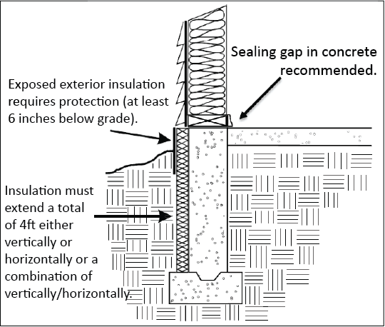

Option 2
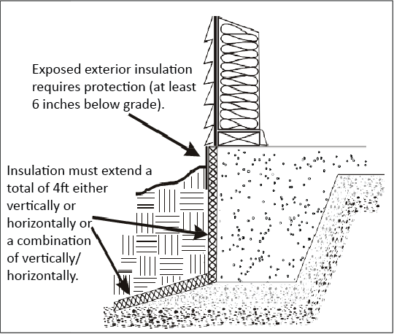

Option 3
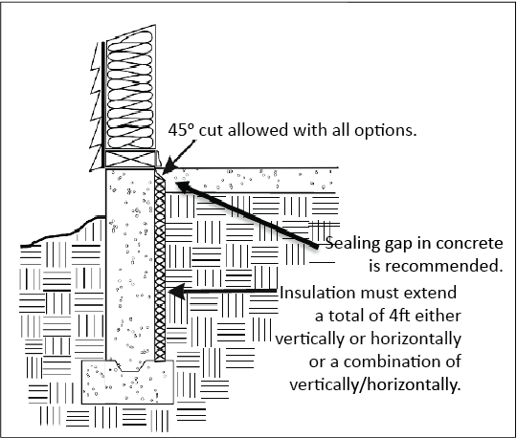

Vented Non-Heated Crawlspace with Floor Insulation
An option for insulating a crawlspace is to insulate the floor and install code-required venting. This option treats the crawlspace as an unconditioned space. Insulation levels are listed in Table 1 under the floor requirements or follow REScheckTM results for the building. Venting, air sealing, heating system sealing, duct, and pipe insulation requirements are listed on figure 2.

Figure 2
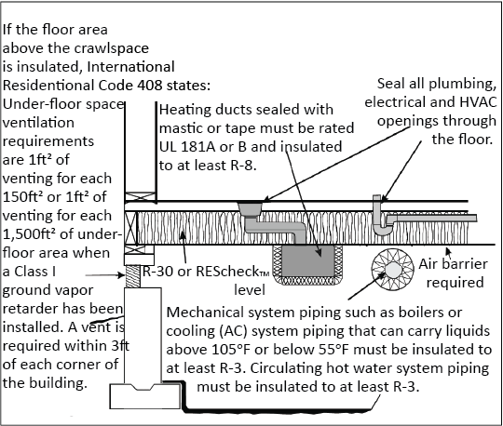

Unvented Heated Crawlspace with Insulated Foundation Walls
As an alternative to insulating the floors over a crawlspace; crawlspace walls may be insulated when the crawlspace is not vented to the outside. Temporary crawlspace vent openings are allowed during construction. Those vent openings must be closed, sealed, and insulated to the same R-value of the surrounding crawlspace wall when construction is complete and prior to final inspection. Crawlspace wall insulation must be permanently attached to the wall and cover the entire height of the crawlspace wall. Exposed earth in the unvented crawlspace must be covered with a continuous Class I vapor retarder, such as 6mil polyethylene. All joints of the ground cover must be overlapped at least 6” and be sealed or taped. The edges of the ground cover must extend at least 6” up the foundation wall and be attached to and sealed to the foundation wall. See figure 3, page 7. Unvented heated crawlspaces require air flow with either an exhaust or supply air option.

Exhaust Air Option
This code option requires continuously exhausted air from the crawlspace at a rate of 1 cubic ft per minute (cfm) for each 50ft² of crawlspace. The ground in the crawlspace must be covered with a Class I vapor retarder, such as 6mil polyethylene. Section 408.3 of the IRC requires an air pathway to the common area (such as duct or transfer grille).

Crawlspace Exhaust Air Option
A sealed vapor retarder is part of a radon mitigation system. See figure 5, page 14. Note: Radon mitigation systems are not required by the energy code, unless the 2021 IRC appendix AF has been adopted by the local jurisdiction.
Section 408.3 of the IRC requires the exposed earth to be covered with a continuous vapor retarder. Joints of the vapor retarder must be overlapped by 6” and must be sealed or taped. The edges of the vapor retarder must extend at least 6” up the foundation wall and be attached to and sealed to the foundation wall.

Figure 3
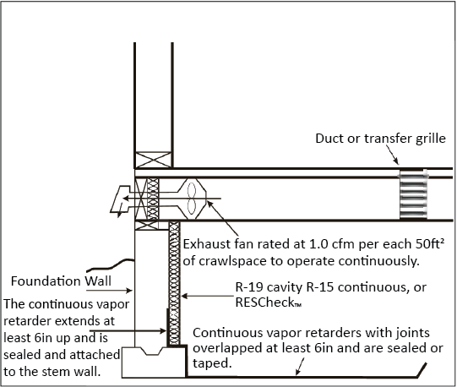

Supply Air Option
This code option is accomplished by supplying a small amount of airflow into the crawlspace; 1cfm of airflow of each 50ft² of crawlspace. Below are three ways for supplying air into crawlspaces:
- Heat recovery ventilator that provides supply and return air.
- Heating/air conditioning system that supplies air.
- Supplemental fan that provides supply air.
During the season when the heating/air conditioning system is not operating; the recommendation is to have the air handler or supplemental fan cycled on for 5 minutes each hour.
The IRC requires an air pathway from the crawlspace to the common area (such as a duct or transfer grille). See figure 3, above.

Air Sealing Requirements – Section R402.4
Uncontrolled air leakage in the building envelope can significantly increase heating bills, allow warm moist interior air to enter building cavities with potential for moisture damage, and cause uncomfortable drafts. Therefore, the energy code requires an air barrier to control air leakage. The Montana energy code requires compliance with the air barrier, the installation requirements, and requires the house tightness to be blower door tested.

Blower Door Test – Section R402.4.1.2 (Montana Amended)
A blower door test is performed using a large fan assembly placed in an exterior door opening. The fan draws air out of the building while measuring the air flow required to create a pressure difference of 50 Pascals with reference to the outside. A blower door test measurement of a building’s air tightness that shows 4 air changes per hour or less when tested at 50 Pascal (4 ACH50) is required. Where required by the code official, testing shall be conducted by an approved party. Multi-unit residential buildings (3 stories or less in height above grade place) may be tested as an entire building or individual units may be tested. For dwelling units less than 1500 sq ft a test measurement, showing 0.30 cfm per square feet or less of the building enclosed surface area is an option for compliance.

Air Barrier and Insulation Installation Requirements
An air barrier is one or more materials joined together in a continuous manner to restrict or prevent the passage of air through the building envelope and its assemblies. The energy code includes table R402.4.1 that lists the air barrier and insulation installation requirements for sixteen building envelope components.
Some of the air leakage areas that must be sealed with an air barrier material, durable caulk, or foam sealant are:
- Openings between the building structure and exterior windows and door frames.
- Openings around electrical wire, boxes, recessed light fixtures, and plumbing piping through the attic, exterior walls, and other unheated spaces.
- Dropped ceilings or chases adjacent to the thermal boundary.
- Behind the tub and showers on exterior walls.
- Common walls between dwelling units.
- Attic access openings, drop-down stairs, and knee-wall doors.
- Rim/band joist junctions.
- Top plate at exterior walls.
- Electrical/communication boxes on the thermal boundary (exterior walls and ceilings) must be air sealed or NEMA OS4 listed.
- HVAC registered boots.
- Recessed lighting installed in the thermal envelope shall be airtight, IC rated and sealed to the drywall.
- Fireplace – An air barrier shall be installed on fireplace walls and fireplaces shall be gasketed doors.
Some of these locations are shown in Figure 4, page 11. Note: Fiberglass and cellulose are not acceptable air barrier materials. Generally, the facing materials used on fiberglass batt insulation cannot be adequately sealed to be considered an air barrier.
Insulation placed in the thermal envelope of the building (walls, ceilings, dropped ceilings/soffit, rim joints, fireplace walls, shower/tub) must be in substantial contact and continuous alignment with the building envelope air barrier. See Figure 4, page 11.

Insulation Installation Requirements
Batt insulation must be cut to fit around wiring, piping and fill narrow cavities and must be contact with the air barrier. Wall corners and headers located in the thermal boundary must be insulated.
Insulation markers must be placed facing the attic access showing the thickness of insulation. The markers must be placed at least one for every 300ft² throughout the attic.
Eave baffles are required in vented attics insulated with air permeable insulation (fiberglass and cellulose). The baffles (any solid material) must extend from the soffit and eave vents, over the top of the insulation, and maintain an opening as least the size of the vent.

Mechanical Ventilation Requirements – Section R403.6

Kitchen and Bathroom Exhaust Fan Requirements IRC M 1505.44
Kitchen fans must provide at least 100 cfm (cubic feet per minute) intermittent or 25 cfm of continuous air flow. Bathroom toilet room fans must provide at least 50 cfm of intermittent or 20 cfm of continuous air flow. Bathroom and toilet room fans must be vented/exhausted to the outdoors; these fans cannot discharge into the attic, crawlspace or any area inside the building.
Mechanical ventilation systems (bath and kitchen exhaust fans) are required to pass an air flow test. Kitchen hoods are exempt if they have at least a 6” duct, vented to the exterior, and with no more than one elbow.

Whole House Mechanical Ventilation Requirements
The energy code requires a whole-house mechanical ventilation system that at least meets the specifications listed in the International Residential Code (IRC) or International Mechanical Code (IMC). Those requirements can be accomplished by installing a fan in a bathroom, utility room, hallway or another location, sized according to the square-foot size of the house and number of bedrooms as specified on the following IRC Table M1505.4.3(1).

IRC Table M1505.4.3(1)
Continuous whole-house mechanical ventilation system airflow rate requirements in cubic feet per minute (ft3/min). Match dwelling unit floor area (ft²) with corresponding number of bedrooms for mechanical ventilation system airflow rate.
Dwelling Unit Floor Area (ft²) | 0 to 1 Bedrooms | 2 to 3 Bedrooms | 3 to 4 Bedrooms | 6 to 7 Bedrooms | 8+ Bedrooms
<1,500 | 30 | 45 | 60 | 75 | 90
1,501–3,000 | 45 | 60 | 75 | 90 | 105
3,001-4,500 | 60 | 75 | 90 | 105 | 120
4,501-6,000 | 75 | 90 | 105 | 120 | 135
6,001-7,500 | 90 | 105 | 120 | 135 | 150
>7,500 | 105 | 120 | 135 | 150 | 165
If the ventilation system doesn’t operate continuously, then the capacity of the fans must be increased as specified by the table M1505.4.3.(2).

Table M1505.4.3.(2)
Intermittent whole-house mechanical ventilation rate factors.
Run-Time Percentage in Each 4-Hour Segment | Factor
25% | 4.0
33% | 3.0
50% | 2.0
66% | 1.5
75% | 1.3
100% | 1.0
Mechanical ventilation option to Table M1505.4.1(1) Ventilation rate in cfm = (0.01 X total square Ft area of house) + (7.5 X [number of bedrooms+1]).
Example: A 1,600 ft², 3-bedroom house requires (.01 X 1600) + (7.5 X 4) = 46cfm. The mechanical ventilation rate may be reduced by 30% if conditions listed in M1505.4.3 are met.
The whole-house mechanical ventilation fan must meet minimum efficiency requirements. Bathroom and utility room fans less than 90 cubic feet per minute (cfm) must deliver at least 2.8 cfm per watt. Fans larger than 90 cfm, range hoods, and in-line fans must deliver at least 3.5 cfm per watt (cfm/W).

Table R403.6.2 Whole-House Mechanical Ventilation System Fan Efficiency*
Fan Location | Air Flow Rater Minimum (cfm) | Minimum Efficacy (cfm/W)
HRV or ERV | Any | 1.2
In-line fan | Any | 3.8
Other exhaust fan | Less than 90 | 2.8
Other exhaust fan | More than or equal to 90 | 3.5
Air-handler integrated to tested and listed HVAC equipment | Any | 1.2
*When tested in accordance with HVI Standard 916

Additional Efficiency Package Options R408
One feature must be added to the house:
- Enhanced envelope performance with an analysis showing the overall total building envelope (UA) is 95% or less of the (UA) of an identical proposed minimum code building.
- Installation of at least 95% furnace/16 SEER air conditioner.
- Installation of at least 10 HSPF/16 SEER air source heat pump.
- Installation of at least 3.5 COP ground source heat pump.
- Installation of 82 EF (gas) water heaters or 2 EF electric water heater.
- Installation of at least 0.4 solar fraction solar water-heating system.
- 100% of ducts and hair handler located entirely within the building’s thermal envelope.
- 100 % of ductless thermal distribution or hydronic thermal distribution system located completely inside the building’s thermal envelope.
- Achieve air leakage rate of 3 ACH 50 or less and install HRV or ERV with at least 75% sensible recovery efficiency.

Figure 4-Air Sealing and Prescriptive Path Insulation Requirements
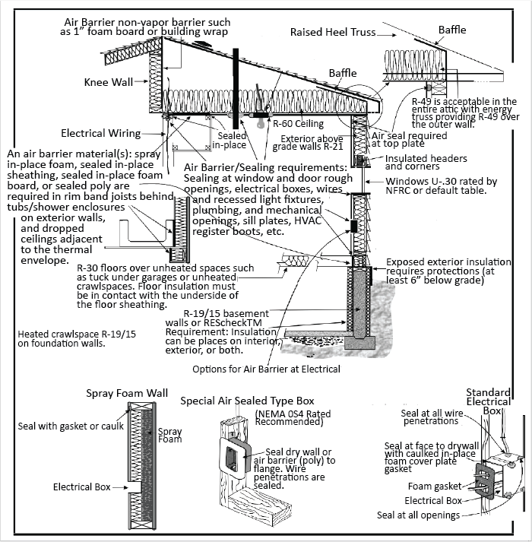
Note: Silicone and petroleum-based caulk are not recommended for contact with wires.

Recessed Light Requirements – Section R402.4.5
Recessed lights that are installed in the building thermal envelope (typically a ceiling with unheated space above) must be sealed to limit air leakage between conditioned and unconditioned spaces. All recessed lights must be IRC rated and labeled as meeting ASTM E 283. All recessed lights shall be sealed with a gasket or caulk between the housing and interior ceiling or wall covering.

Rooms Containing Fuel Burning Appliances – R402.4.4
When air ducts provide outside air to an open combustion fuel burning appliance (typical gas water heater), the appliance must be in an isolated and sealed room; with walls, floors, and ceilings insulated to at least basement insulation requirements and with a gasketed door, or the appliance must be located outside the building’s thermal envelope. Combustion air ducts passing through conditioned space must be insulated to at least R-8. Exemptions are fireplaces and stoves with exterior air supply and sealed combustion appliances.

Systems – Section R403

Programmable Thermostats – Section R403.1.1
Programmable thermostats are required for forced air (furnaces). The thermostat must be able to setback or temporarily operate the system to maintain temperatures down to 55ºF or up to 85ºF. It must be initially programmed with a heating temperature no higher than 70ºF and with air conditioning a cooling temperature no lower than 78ºF. Hot water boilers must have an outdoor setback control that decreases the boiler water temperature based on the outside temperature. Heat pumps with supplementary electric resistance heat must have controls that, except during defrost, precent supplemental heat operation when heat pump can meet the heating load.

Duct Insulation – Rection R403.1.1
Supply and return ducts (3 inches in diameter and larger) located outside conditioned space must be insulated to at least R-8. Ducts smaller than 3 inches in diameter, located outside conditioned space, must be insulated to at least R-6. Supply and return ducts buried within ceiling insulation must have at least R-8 and surrounded by at least R-19, excluding R-value of duct insulation. Ductwork located in ventilated attic spaces must have insulation above and against the ducts equal to the attic insulation level, less the R-value of the insulation on the duct. To be considered inside conditioned space, the ducts must be inside the air barrier, usually the drywall ceiling.

Duct Sealing and Testing – Section R403.3.2 Montana Amended
All ducts, both supply and return, air handlers, filter boxes, and building cavities used as ducts, shall be sealed. Building cavities cannot be used as supply ducts. Building framing cavities may be used as return ducts, if there are no atmospherically vented combustion appliances (furnace, boiler, water heater) located outside of a sealed and insulated room to the basement wall, floor and ceiling requirements and if the duct system is tested having total leakage no more than 4 cfm per 100 sq ft of conditioned floor space of the house.
Ducts located outside conditioned space must be tested for tightness. For ductwork located in ventilated attic spaces, duct leakage to outside the building thermal envelope must be 1.5 cfm per 100 sq ft or less of conditioned floor area served by the duct system.
Duct testing is not required for heat energy recovery ventilation systems not integrated with heating or cooling systems. Duct leakage testing is not required if all ducts and the air handler are located within the thermal envelope.

Mechanical System Pipe Insulation – Section R403.4
Mechanical system piping such as boiler or cooling (AC) system piping that can carry fluids above 150ºF or below 55ºF must be insulated to at least R-3.
Circulating hot water system piping must be insulated to at least R-3. These systems must also include automatic or readily accessible manual switches that can turn off the hot water circulating pump when system is not operating.

Hot Water Pipe Insulation – Section R403.5.2
R-3 insulation is required for the following:
- Piping ¾ inch diameter and larger
- Piping serving more than one dwelling unit
- Piping is located outside conditioned space
- Piping from the water heater to a distribution manifold
- Piping is located under a floor slab (not part of in-floor heating system)
- Buried piping
- Supply and return piping in recirculating systems, other than cold water pipe return, demand recirculation systems

Proper Sizing of Heating and Cooling Equipment – Section R403.7
Heating and cooling equipment sizing shall be based on building loads calculated in accordance with ACCA Manual S&J or other approved heating and cooling calculation method. In the past many heating and cooling systems were oversized, resulting in increased installing and operating costs.

Lighting Requirements – Section R404
All permanent light fixtures must be high-efficiency lighting sources.

Exterior Lighting Controls – Sections R404.3
Where the total permanently installed exterior lighting power is greater than 30 watts, the lighting must be controlled by a manual switch permitting automatic shut off actions. Lighting serving multiple dwellings is exempt. Lights must automatically shut off when daylight satisfies the lighting needs. Override controls are allowed if they return automatic control to normal within 24 hours.

Existing Buildings – Chapter 5
Additions, alterations, or repairs to an existing building or building system must comply with the energy code. Spaces undergoing a change in occupancy resulting in an increase in energy demand must comply with the energy code. Unaltered portions of an existing, lawfully in existence at the time of adoption of this code, need not comply with the energy code. The following alterations are exempt from the energy code provided that the energy use in the building is not increased:
- Storm windows over existing windows
- Existing ceiling, wall, or floor cavities exposed during construction provided they are filled with insulation
- Construction where the existing roof, wall or floor cavity is not exposed
- Roof re-cover
- Roofs without insulation in the cavity and where the sheathing or insulation is exposed during re-roofing shall be insulated either above or below the sheathing
- Surface applied window film installed on existing single pane fenestration assemblies to reduce solar heat gain provided that the code doesn’t require window replacement
- Heating ducts extended less than 40ft into unconditioned space need not be tested
- New building sections are exempt from the blower door testing requirement

Radon Mitigation
Because of the potential for indoor high levels of radon, the Montana Department of Environmental Quality recommends new houses have a basic radon mitigation system installed during construction. Additional information listed in 2021 IRC Appendix AF Radon Control Methods. Contact the Montana Radon hotline for more information at 1-800-546-0483.

Figure 5 – Radon Mitigation System in Crawlspace (not required by state code)
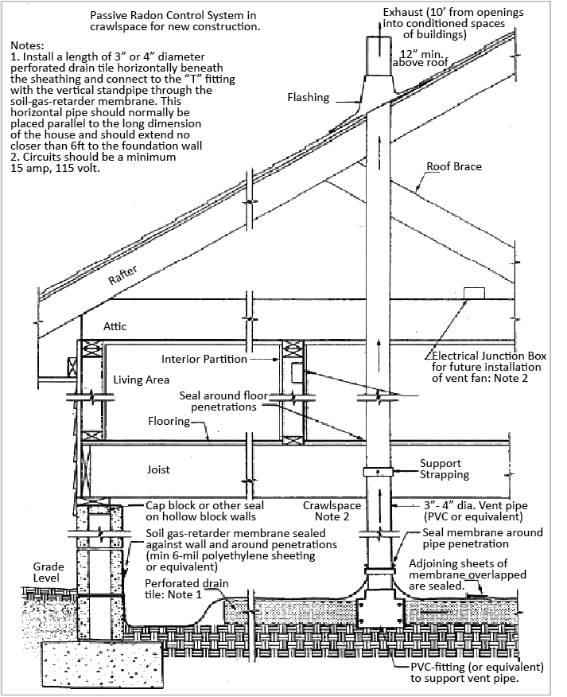

Energy Efficiency Component Labels
Energy efficiency component labels are available at no cost from many sources. Several utility companies distribute labels as a public service. Local Montana Homebuilder Association offices in Billings, Bozeman, Great Falls, Helena, Kalispell, and Missoula distribute labels to their members. The labels are also available from the Montana Department of Environmental Quality’s Energy Bureau in Helena, MT call 406-444-0281 for more information.

Figure 6 – Energy Code Compliance Certificate with Prescriptive Path Listings
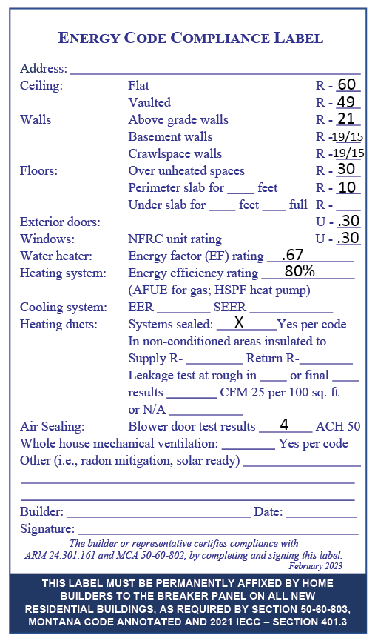

Glossary of Energy Efficient Terms
A good comparison shopper needs to understand certain units of measurement, such as MPG (miles per gallon) when shopping for a new car. Shopping for energy efficiency also involves knowing a few units of measurement. Energy Efficiency Components Label may contain five or more different units of measurement. The following definitions will help you crack the code for energy efficiency.

R-value – The units used to measure the insulating value of an object. The high the R-value, the more insulating value an object has. Example, a high-density batt of fiberglass insulation for 2”x6” wall has an R-value of 21.
U-value – The U-value is a measurement of heat flow through a material or a composite. The U-value of a window is the reciprocal of its R-value (U=1/R). For instance, a window with a U-value of 0.33 is equivalent to an R-value of 3 (0.33=1/3). Because the U-value is the inverse of the R-value, a lower U-value indicated a window that has better insulating capabilities than a window with a higher U-value.
BTU – A British Thermal Unit is the amount of heat energy needed to raise the temperature of one pound of water by one-degree F.
NFRC Unit Rating – The National Fenestration Rating Council determines the U-value for most windows. This rating is placed on a label attached to all new NFRC rated windows. If the NFRC rating is available, the home builder should use this number when filling in the U-value on the Energy Efficiency Components Label.
UEF – A water heater’s energy efficiency is determined by the Uniform Energy Factor, which is based on how much energy the water heater uses and how much energy is used to power the water heater itself. The higher the uniform energy factor, the more efficient the water heater.
AFUE – Annual Fuel Utilization Efficiency is a measurement of the effectiveness of gas and oil space heating systems. All furnaces and boilers in the United States are required to have an AFUE rating of at least 80%. The most efficient gas furnaces have an AFUE of 92% to over 98%, while the most efficient gas hot-water boilers have AFUE rating of 84% to 95%. Energy-efficient oil furnaces have similar AFUE ratings, in the mid 80% to 90%. The most efficient oil-fired hot water boilers have efficiencies that are slightly lower, with AFUE ratings up to around 90%.
HSPF – Heating Seasonal Performance Factor is a metric used in the evaluation of air source heat pumps when in heating mode and it measures how well your heat pump will perform in the heating mode. The higher the HSPF rating, the more efficient the heat pump.
SEER – Seasonal Energy Efficiency Ratio is a metric used in the evaluation of an air conditioner or air source heat pumps in cooling mode. The higher the rating the more efficient the unit.
EER – Energy Efficiency Ratio is the ratio of the cooling capacity in BTUs per hours to the power input (in watts). The higher the EER rating, the more efficient the air conditioner.

Additional Energy Conservation Resources
Organization | Location
Building American Solution Center | Washington, DC
Building Science Corporation | Westford, MA
Better Built Northwest | Portland, OR
Efficient Windows Collaborative | Washington, DC
Energy and Environmental Building Association | Bloomington, MN
EPA Home Performance with Energy Star | Washington, DC
MT Department of Environmental Quality | Helena, MT
National Center for Appropriate Technology | Butte, MT
U.S. Department of Energy | Washington, DC
National Fenestration Rating Council
North American Insulation Manufacturers Association

