Energy Code Guide for new home construction
Use this checklist to help ensure your home is comfortable, healthy, and energy code compliant.
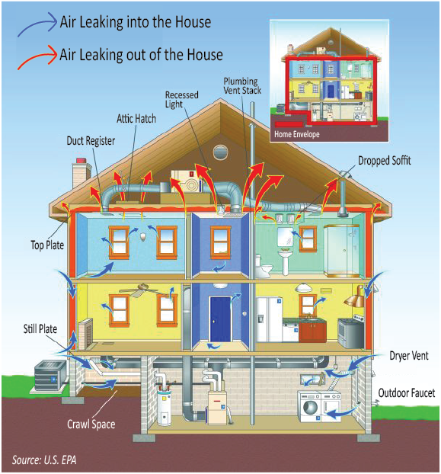

Montana’s energy code provides minimum requirements for the efficient design and construction of new and renovated houses. All new Montana houses, regardless of location, must meet the requirements of the state energy code.
You can use this guide to verify a few of the energy code requirements. While the guide does not include every requirement, it will help you asses a home and make an informed decision about the quality of construction and likelihood the home will be energy efficient. Code compliance can be accomplished by completing basic air sealing requirements and following an energy code path of prescribed insulation levels, and window/door efficiencies or by using REScheckTM, a free computer modeling analysis software, is available from the U.S. Department of Energy and may be used to meet compliance. Energy code path levels are listed on the energy efficiency components label on the next page. If you do not feel comfortable using this guide, or for a more complete investigation, consider having a qualified independent third party complete a code compliance checklist.

Energy Code Compliance Label
Check that a completed energy code compliance label has been placed on or in the electrical breaker panel. The label should list the insulation levels, as well as efficiency ratings of the installed windows, doors, water heating, and heating/cooling equipment. It is also a way for the home builder to comply with Montana law, which requires builders to certify their homes meet the statewide minimum code standards.

Ceiling and Attic Insulation
The minimum energy code path requirement for the ceilings and attics is R-60 insulation, which is about 17 inches of fiberglass or cellulose insulation. R-49 meets code if that level is achieved over the entire ceiling/attic when an energy truss is used. Check that the attic access hatch/door is insulated and sealed.

Sample Energy Code Compliance Label with Filled in Energy Code Path Levels
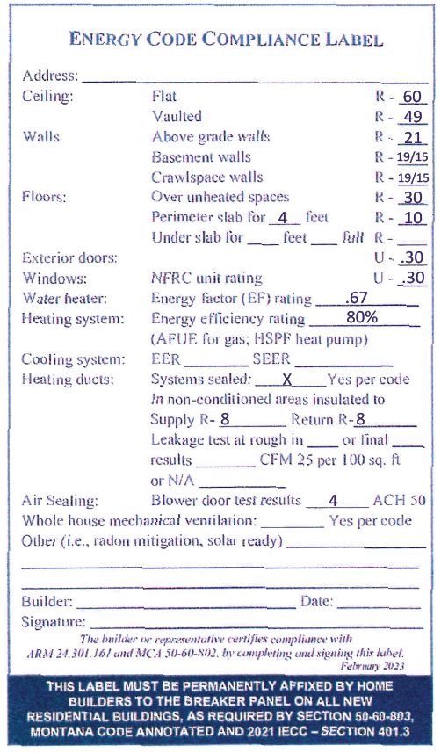

Above-Grade Wall Insulation
The energy code path requires minimum R-21 for above-ground walls. A REScheckTM analysis may allow a lower level. If less than R-21, ask to see a copy of the REScheckTM analysis.

Basement Walls
Check to see that the basement walls are insulated; finishing is not required. The insulation can be placed on the outside, inside, or combination. The energy code path requires a continuous layer of R-15, such as a layer of foam installed on the foundation wall, or R-19 batts if the insulation is places in a framed wall. The rim/floor joist is located where the floor meets the wall and should be insulated and have an air barrier, usually spray foam or foam boards sealed in-place. If lower R-values are listed, ask to see a copy of the REScheckTM analysis, confirming code compliance.

Crawlspace
Check that the floor above the crawlspace or the foundation walls are insulated. Typically, the walls are insulated, creating a heated crawlspace and the ground is covered with a moisture barrier, usually plastic sheathing sealed around the edges. The insulation should be installed without gaps. The rim/floor joist, located where the floor meets the foundation wall, should be insulated and have an air barrier. The air barrier is usually spray foam or foam boards sealed in-place. If the crawlspace is heated, any crawlspace vents should be sealed shut. A heated crawlspace should have some air flow such as a small exhaust fan drawing air out, or a register in the heating duct supplying air and an opening/transfer grill in the floor connecting the crawlspace to the upper floor.

Windows
Check the energy components label for the U-factor rating for the windows. The lower the U-factor, the better. U-factors generally range from .20 (little heat loss) to .50 (high heat loss). The energy code path requires U-.30 or better. A REScheckTM analysis may allow a higher U-value. Some manufacturers label their products with serial numbers or other data that can be used to track down the efficiency rating. If there is no documentation of the U-factors, try contacting the customer service department of the window manufacturer to confirm the efficiency of the installed products.

Heating and Cooling Systems
A system sized too small could result in an uncomfortable home; if too large, it may cycle on and off more than necessary which may shorten the life of the equipment. Was the system sized in accordance with ACCA Manual S and J or another approved heating and cooling equipment sizing method? These calculations consider house tightness, insulation levels and window placement efficiency.

Programmable Thermostat
Programmable thermostats are required on forced air (furnaces) and can provide an energy savings of about 10 percent when used as recommended. Hot water boilers must have an outdoor setback control that decreases the boiler water temperature based on the outside temperature.

Heating Ducts
Check that all seams in the ductwork are sealed with mastic or approved tape (regular duct tape is not approved). Leaky ducts can be responsible for 10-30 percent of the energy loss in a home. The code requires the entire duct system be tested for tightness if any part of the ductwork is in an unheated/unconditioned part of the house, such as an unheated attic or garage. The test results should be listed on the energy component label. Supply ducts located outside of the conditioned part of the house must be insulated to at least R-8.

Air Sealing and Ventilation
The energy code requires air sealing around windows, doors, electrical boxes on the exterior walls and ceilings, and openings where pipes and wires pass through the building shell. Air leakage is often responsible for 10-30 percent of total home energy loss. Check to see if pipes, wires and utility lines, and other openings have been sealed. Most of the air leakage sites will be hidden in the attic, walls, and floors. Because the house is sealed for comfort and efficiency, it is important to ventilate the house in a controlled way. Code-required mechanical ventilation options range from a centrally located efficient (bath) fan to a heat recovery ventilation (HRV) system that bring fresh air into the house while recovering about 70 percent of the heat from the stale air that is being drawn out of the house.

Blower Door Test
Blower door testing is required to confirm the air sealing requirements have been met. The test results should be listed on the Energy Code Compliance Label and must be 4 air changes per hours at 50 pascal pressure (listed as ACH50) or less. A blower door is a large fan assembly, temporarily placed in an exterior doorway, which draws air flow and determines the air leakage rate of the house. Very efficient tight houses may have leakage rates of only 0.6 to 2.5 ACH 50.

Infrared Camera Investigation (Optional)
An infrared (IR) camera shows the temperature of the house’s surfaces. Improperly insulated areas will appear colder than expected in winter and warmer than expected in summer. Consider having an IR investigation to confirm the house has been properly insulated. An IR investigation conducted with a blower door analysis can detect air leakage.

Energy Efficiency Lighting
The code requires all permanent lighting fixtures must be high efficiency lighting sources.

Contact Us
For more information, contact the Montana Energy Office at Montana Department of Environmental Quality at 406-444-0281.

