Alternative Energy Revolving Loan Program

Outcomes Report, Fiscal Year 2025

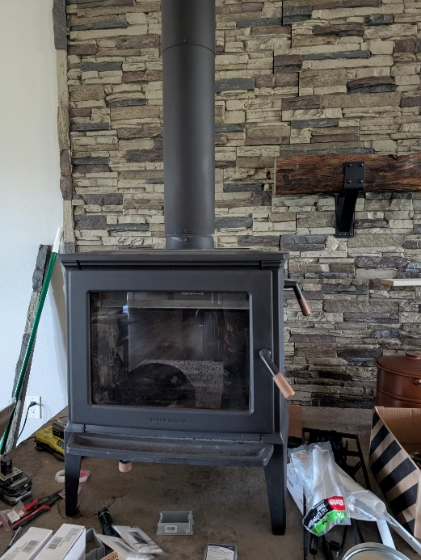
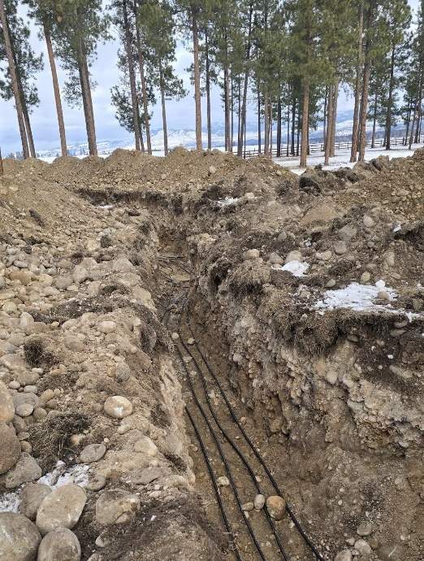

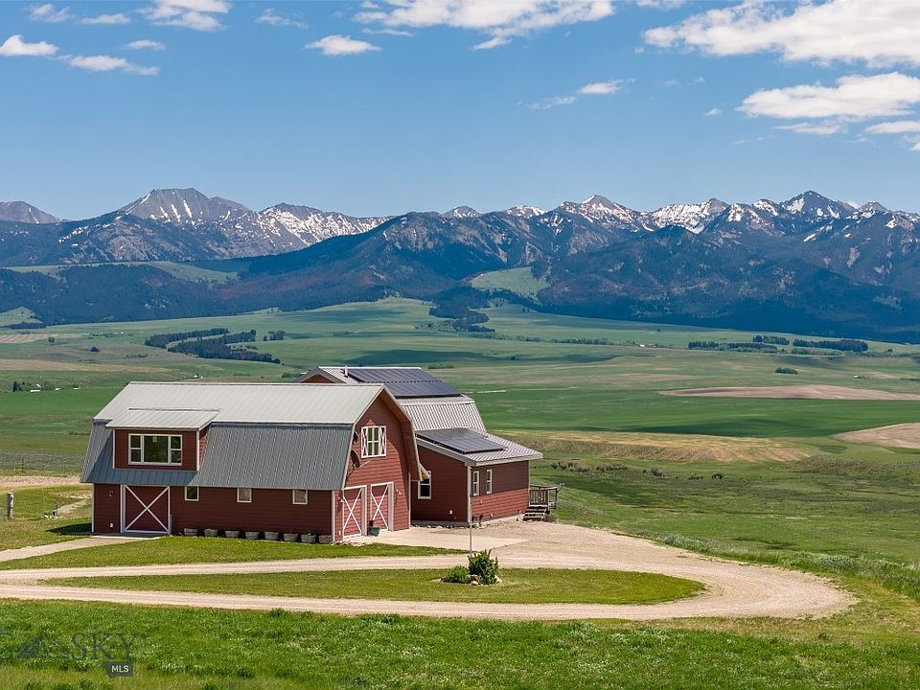
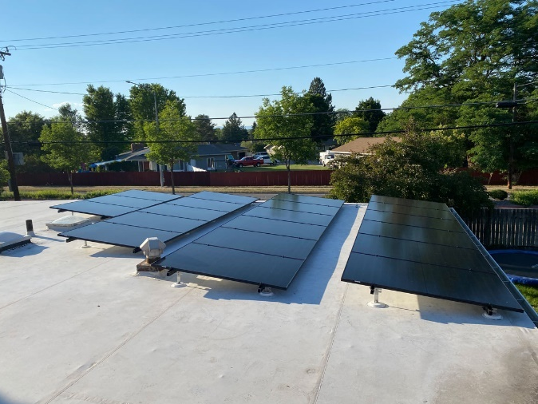



Report prepared by Meranda Bass
Energy Planning Section
Montana Department of Environmental Quality

August 2025

I. INTRODUCTION
The Alternative Energy Revolving Loan Program (AERLP) was established in 2001 by the Montana Legislature to provide low-interest loans for the purpose of building alternative energy systems (75-25-101, et seq., Montana Code Annotated (MCA)). Individuals, small businesses, units of local government, units of the university system, and nonprofit organizations are eligible borrowers. In addition to alternative energy systems, capital investments for energy conservation purposes may be financed through the program when those measures are installed in conjunction with an alternative energy system funded by the AERLP.

Loans are limited to a maximum of $40,000 with a maximum term of ten years (75-25-101 (4), MCA). The interest rate was fixed for calendar year 2024 at 3.5% and remained at 3.5% for calendar year 2025.

The AERLP is managed by the Energy Bureau at the Department of Environmental Quality (DEQ). Loan underwriting, origination, and servicing are provided by a contracted financial institution, the Montana Business Assistance Connection (MBAC). Pursuant to MCA 75-25-101(2), the AERLP is capitalized by air quality penalties collected by DEQ. In addition, the program received a one-time grant in 2010 from the U.S. Department of Energy (DOE) through the federal American Recovery and Reinvestment Act (ARRA). State and DOE funds are tracked and reinvested separately.

This report summarizes loan program activity and reports outcome measures of the AERLP in fiscal year 2025 (FY25), which started July 1, 2024, and ended June 30, 2025. DEQ policy EN-AERLP-04 establishes the content of the annual outcomes report. DEQ is required by statute to assess the following outcome measures, at a minimum (75-25-103, MCA):
- a loan loss ratio of under 5%;
- the types of alternative energy systems that provided the best overall results for residences and those for small businesses; and
- a determination of the amount of energy that was produced because of participation in the program.

II. LOAN PROGRAM ACTIVITY & HIGHLIGHTS
Loan applications and loans issued
A total of forty-two applications were received, reviewed for technical and financial feasibility, and funded in FY25 for a total of $1,147,867 (Figure 1). An additional twenty-eight applications were received and reviewed for technical and financial feasibility. However, twenty-three of those applications were withdrawn by the applicant, one exceeded twelve months in the queue and was withdrawn (17.85.110(4), ARM), and four applications were declined based on financial merit. Since April 2023, the demand for the loan program has exceeded funds available. This has led to an increase in withdrawn applications as applicants either forgo their projects, find other means to purchase or finance their projects, or exceed one year in the application pool.

---
Cover page photos of FY25-funded projects (clockwise from top left): wood stove in Roundup; ground source heat pump loop field in Stevensville; roof mounted solar array in Missoula; roof mounted solar array in Wilsall.

Figure 1: Loans issued in FY25
 | Number of loans | Amount of loans | Average Loan
State funds | 37 | $1,058,008 | --
DOE funds | 5 | $89,859 | --
TOTAL | 42 | $1,147,867 | $27,330

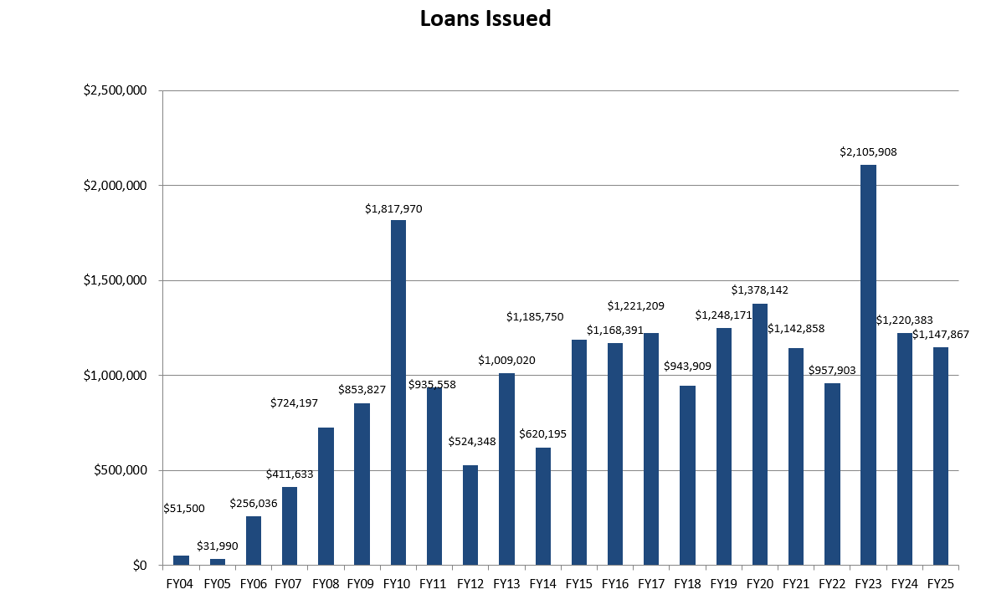
Figure 2: Total loan amounts issued by fiscal year

Borrowers
Similar to previous years, the majority of AERLP borrowers in FY25 were individuals (36 loans), followed by businesses (6 loans). There were no loans issued to non-profits, local governments, or units of the university system.

Technologies funded
In FY25 there were thirty-three loans issued for grid-tied solar photovoltaic (PV) arrays, five loans issued for off-grid solar arrays, three loans issued for ground source heat pumps, and one loan issued for a biomass woodstove. There were ten loans that included batteries and four energy conservation measures installed across three loans. The energy conservation measures were installed in conjunction with one or more alternative energy systems. Figure 3 charts the number of energy systems funded in FY25. Please note that because loans were issued for multiple energy systems, and/or energy conservation measures, the count of systems funded exceeds the total number of loans issued.

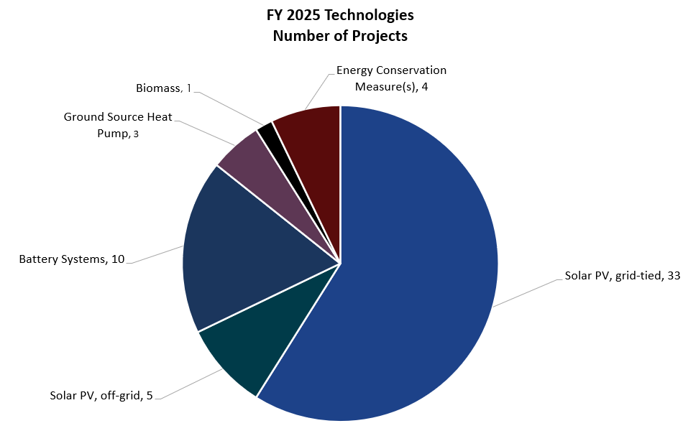
Figure 3: Systems funded in FY25, by technology

Project Locations
In FY25, loans were issued for projects in eighteen counties across Montana. See Figure 4 below for a summary of the number of loans in each community.

Figure 4: Locations of FY25 AERLP projects by county and city

County | City | Number of loans
Broadwater | Townsend | 1
Carbon | Joliet | 1
Cascade | Cascade | 1
 | Sun River | 1
Flathead | Columbia Falls | 1
 | Kila | 1
Gallatin | Bozeman | 6
 | Three Forks | 2
 | West Yellowstone | 1
Jefferson | Clancy | 1
Lake | Arlee | 1
Lewis & Clark | Helena | 3
Lincoln | Troy | 1
Madison | Cameron | 1
Missoula | Clinton | 1
 | Lolo | 1
 | Missoula | 7
Musselshell | Roundup | 1
Park | Wilsall | 1
Ravalli | Stevensville | 2
Sanders | Plains | 2
Silver Bow | Butte | 2
Teton | Choteau | 1
Yellowstone | Billings | 2

III. LOAN-LOSS RATIO
A total of ten loans have defaulted over the program’s two-decade history with no loans defaulting in FY25. Loan balances are not written off or considered a loss until all efforts to collect the loan balance and fees have been exhausted. Seven loans have been written off as losses. Funds have been recovered through collection on three loans, and one loan is in active collections. Statute requires the loan-loss ratio for the program to remain under five percent (75-25-103(1), MCA). The total amount of funds written off as losses is $154,129, which amounts to a loan-loss ratio of 0.74 percent, well below the statutory guideline. The loan-loss ratio is calculated based on the total amount of loans issued over the life of the program ($20,843,742).

IV. BEST OVERALL RESULTS
The type of alternative energy system that provides the best overall results for Montana residences and small businesses varies by site and by the amount and type of energy used by the building’s occupants. However, the majority of projects funded by the AERLP in FY25 were solar PV arrays, which is likely due to the availability of the technology, the cost of the technology, minimal maintenance requirements, long useful life of the equipment (20-30 years), and adaptablity of the equipment to a variety of building types and applications. The attributes of solar PV and other technologies funded by the AERLP are discussed below.

Solar Photovoltaic (PV) systems financed through the AERLP saw a decrease in cost of 4.8% from FY24 to FY25. The pre-incentive installed costs for grid-tied PV systems averaged $2.89/watt in FY25, down slightly from $3.03/watt in FY24, and far below the $8 - $10/watt average when the AERLP was established in 2001. The systems included in the FY25 solar PV cost analysis range in size from 4.15 kW to 75.115 kW, with an average size of 13.5 kW. The demand for solar PV systems continues to be strong.

Ground source heat pumps (GSHPs) continue to be a popular choice for heating systems where the technology can replace higher cost heat sources (electric resistance heat or propane), and in electric service territory where volumetric electric rates are low. Heat pump systems move heat from the ground into buildings and can provide water heating and air conditioning as well.

Solar water heating can be a cost-effective energy supply, however very few businesses in the state offer solar thermal installation services. The technology is a particularly good match for car washes, laundries, hotels, and other buildings that use large quantities of hot water.

Biomass heating systems are widely available, as is fuel in forested areas of the state. Low-emission wood or biomass combustion devices (15-32-102 (6), MCA), including pellet stoves and wood stoves certified by the U.S. Environmental Protection Agency, are eligible for funding through the AERLP.

V. ENERGY PRODUCTION
The amount of energy produced by projects financed by the AERLP in FY25 (Figure 5) is determined based on standard engineering calculations and assumptions. The calculations are for projected energy production in the first year of operation, based on the installed generating or energy output capacity of each technology type.
The projected output of all the solar PV systems funded in FY25 is estimated using the National Renewable Energy Laboratory’s “PV Watts” program, with default system parameters, and is based on the average solar radiation in Great Falls, an area that receives average solar radiation for Montana. Ground source heat pump estimates are calculated based on the equipment specifications, location, and building type. The energy output of each technology has been converted to kilowatt hours (kWh) and millions of British thermal units (MMBtu) per year for comparison purposes.

Figure 5: Projected generating capacity and energy output of FY25 projects
 | Solar PV | GSHP | Biomass | TOTAL
# of systems funded | 38 | 3 | 1 | 41
Generating capacity | 493.175 kW | 13 tons | 60,000 Btu/hr. | --
kWh/year | 657,638 | 75,378 | 14,656 | 747,672
MMBtu/year | 2,244 | 257.2 | 50.01 | 2,511.21

VI. ADMINISTRATIVE COSTS
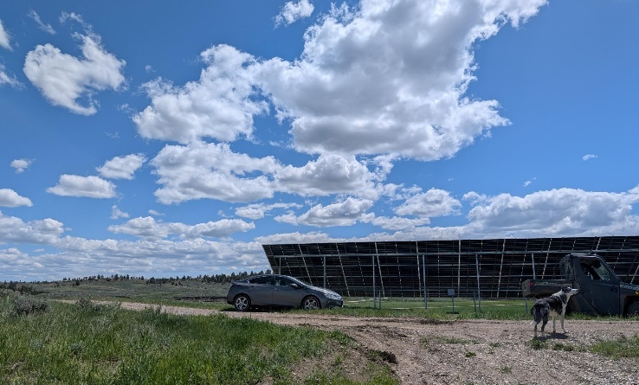
Administrative costs for the AERLP include staff and program support salaries, promotional materials and ads, printing, travel, and contracted financial services. Contracted financial services include loan underwriting, origination, and servicing. Montana statute caps administrative costs at 10 percent of the total loans (75-25-102 (3), MCA). DEQ policy EN-AERLP-01 further elaborates that the administrative costs ratio be calculated based on the total loans outstanding at the beginning of the fiscal year. FY25 administrative costs totaled $167,827, equivalent to 3.2 percent of the total outstanding loan balance ($5,242,651), which is below the statutory 10 percent cap.
DEQ staff visit FY24 funded grid tied
solar array completed in Lavina.

National Renewable Energy Laboratory, PV Watts Tool

