Per and Polyfluoroalkyl Substances (PFAS) Site Summary, Malmstrom Air Force Base, Montana

Preliminary Assessment (PA) – 2015
14 potential areas of concern were identified as potential PFAS source areas and 6 of them were recommended for further investigation.

Site Investigation (SI) – 2016 & 2017
The investigations concentrated on the six areas on MAFB identified in the PA where AFFF firefighting foam was historically used. Primary sources of AFFF are related to firefighting activities, spray testing of mobile fire-response vehicles, fire suppression system testing, firefighting training, a 600 gallon AFFF spill, and surface dissipation of AFFF to storm water outfalls. All six areas had concentrations of PFOA or PFOS that exceeded screening levels in one or more media. Please refer to Attachment A from the January 17, 2025, Memorandum from the Office of the Secretary of Defense for the current DoD screening levels for residential soil and tap water. The highest concentration of combined PFOS and PFOA in surface water at a single location (Outfall 3) was 1,690 nanograms/liter (ng/L) and 5,739 ng/L in groundwater (Fire Station - Building 349). The highest PFOS concentration in soil was 890 micrograms/kilogram (µg/kg), 11,000 ug/kg in subsurface soil and an estimated concentration of 160j µg/kg in sediment.

DEQ PFAS Surface Water Sampling - 2019
The Whitmore Ravine is located on the north side of MAFB. Several of MAFB’s storm water outfalls discharge into the ravine and then into the Missouri River. In 2019 DEQ personnel sampled the surface water in the ravine to determine if PFAS was entering the environment via the storm water discharge system. Total PFAS concentration in surface water in Whitmore Ravine was reported at 12,920 ng/L (PFOA – 256 ng/L, PFOS – 932 ng/L). The suspected PFAS source is aqueous film forming foam (AFFF). PFAS is introduced into the environment from multiple sources, storm water outfalls.

Remedial Investigation (RI) 2022 - 2026
The US Air Force is currently conducting a RI to determine the extent and magnitude of PFAS contamination. Additional assessment has been implemented at 6 PFAS impacted areas. Three rounds of investigation have been completed.

Round 1 Field Investigation
•PFAS-free water sampling
•Surface soil sampling (96 samples)
•water/sediment sampling (1st event) (12 surface water samples/14 sediment samples
• Synoptic water levels at existing wells
• Groundwater screening using High Resolution Site Characterization (HRSC) methods (Hydraulic Profile Tool/Electrical Conductivity) and installation of temporary wells (52 temporary monitoring wells)
• Groundwater sampling at existing wells and newly installed temporary wells (69 groundwater samples)
• Conceptual Site Model (CSM) updated (update #1) based on results from these activities.

Round 2 Field Investigation
• Surface water/sediment sampling (2nd event) (15 surface water samples/32 sediment samples)
• Subsurface soil sampling (73 subsurface soil samples)
• Background soil sampling (43 surface soil samples)
• Monitoring well installation, development, and surveying (24 monitoring wells)
• Synoptic water levels and groundwater sampling from new and existing wells (27 groundwater samples from new and existing monitoring wells)
• Vadose zone sampling (17 lysimeters were installed)
• CSM updated (update #2) based on results from these activities

Round 3 Field Investigation
• Vadose zone sampling (4th and final quarter of lysimeter sampling was conducted in October 2025)
• Temporary well abandonment (dry wells)
Subsurface soil sampling (5 locations)
Monitoring well installation, development, and surveying (6 monitoring wells)
• Synoptic water levels and groundwater sampling
• Whitmore Ravine sampling (surface soil, surface water, sediment samples)
Prepare CSM update #3 based on results from these activities

Supplemental Site Investigation (SSI) Addendum-Off-Base Drinking Water Site Inspection - 2024
7 domestic wells located north/northwest of MAFB were sampled for PFAS in February/May 2024. All results were below reporting limits.

Best Management Practices (BMPs)
The 2019 PFAS sampling results from the Whitmore Ravine indicate stormwater discharge of PFAS from Malmstrom into the Missouri River. It is likely that PFAS continues to discharge into the river. However, BMPs for stormwater runoff have been implemented to reduce the volume of PFAS leaving the base and entering the Missouri River via storm water outfalls. The Air Force has instituted several BMPs to reduce PFAS in stormwater discharges, including aqueous film-forming foam (AFFF) sundown: hangars have been locked out / tagged out of AFFF, and only water is used in fire suppressant systems. The Air Force is in the process of switching to fluorine free foam (F3) for their fire and emergency vehicles.

Upcoming work
PFAS data from 4 years of investigations will be incorporated into a RI Report. The target date for the Draft Final RI Report to be submitted to the DEQ is for early 2nd quarter 2026 and finalized by the end of July 2026.

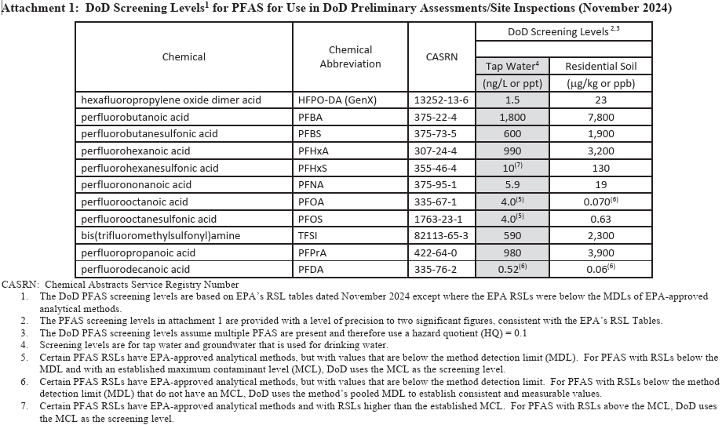

For additional information, please contact Scott Gestring at (406) 444-6471 or e-mail sgestring@mt.gov .

Updated October 30, 2025

