Helena Army Aviation Support Facility - Perfluoroalkyl and Polyfluoroalkyl Substances (PFAS) Site Summary

Preliminary Assessment (PA) - 2018
In October 2018, contractors hired by the Army National Guard (ARNG) finalized a PA Report for the Helena Army Aviation Support Facility (HAASF). Interviews with current and former employees confirmed there were four potential Perfluoroalkyl and Polyfluoroalkyl Substances (PFAS) release areas that warranted further investigation.

Site Inspection (SI) - 2020
Contractors conducted a SI during July 2020 to further evaluate potential sources of PFAS and determine the nature and extend of PFAS contamination on-site. No fire suppression events, or firefighting training activities were conducted at the HAASF, so the area of interest where PFAS was potentially released to the environment was limited to the detention pond and surrounding area. Aqueous film forming foam (AFFF) associated with testing of the fire suppression system at Hangar 60 along with approximately 5-gallons of Tri-Max30 that were spilled near Hangar 60 during filling of one of the portable fire extinguishers likely entered the storm drain system and discharged into the detention pond.

Five soil borings/monitoring wells and two surface soil borings were installed during the Site Inspection to evaluate PFAS impacts to soil and groundwater. The soil and groundwater samples were analyzed for a subset of 18 PFAS compounds.

Analytical results were compared to the Montana DEQ-7 human health groundwater standard for combined and individual Perfluorooctane Sulfonate (PFOS) and Perfluorooctanoic Acid (PFOA) of 70 nanograms per liter (ng/L) and Department of Defense DoD screening levels (SLs) for soil and groundwater listed below. Soil from 0-2 feet was compared to Residential SLs, 2-15 feet compared to Industrial SLs, and greater than 15 feet was not compared to either SL.

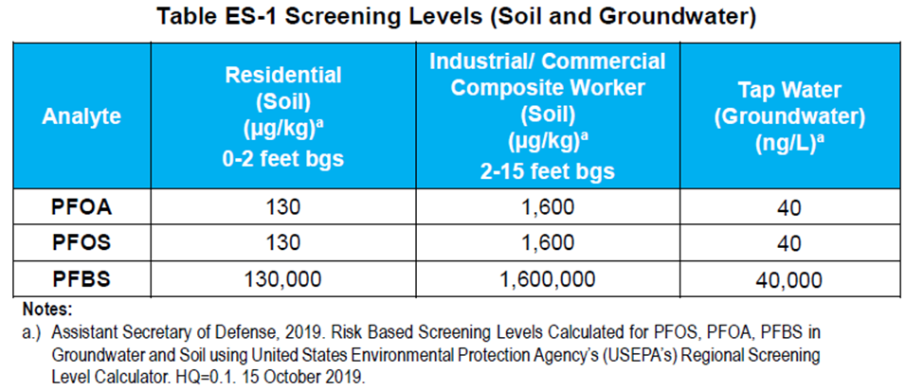
There were no PFOA or PFBS detections in soil, and PFOS was present in only one soil sample. PFOS was reported at a concentration of 1.72 micrograms per kilogram (ug/kg) from soil boring/monitoring well (AOI1-05/HAASF-MW005) located adjacent to the detention pond. The duplicate sample reported 2.37 ug/kg. The groundwater analytical results from monitoring wells (HAASF-MW005 and HAASF-MW003), located adjacent to and downgradient of the detention pond respectively, were above the Montana DEQ-7 groundwater standard of 70 ng/L for PFOS/PFOA either separately or combined. Monitoring well HAASF-MW005 reported PFOS at 775 nanograms per liter (ng/L), and PFOA at 9.59 J ng/L. The duplicate sample reported 814 ng/L PFOS and 10.7 ng/L PFOA. HAASF-MW003 reported a PFOS concentration of 175 ng/L and PFOA at 9.07 J ng/L. The results from the other three monitoring wells were below 70 ng/L. PFBS was detected in groundwater, but at concentrations several orders of magnitude below the SLs.

Off Site Drinking Water Sampling - 2021
With PFAS groundwater standard exceedances at the facility boundary, five domestic drinking water wells downgradient of the HAASF were sampled in early 2021 to determine if there were impacts to drinking water. The analytical results PFOA, PFOS, and PFBS were all below SLs and the DEQ-7 groundwater standard that were in place at the time. However, the results from one of the domestic wells exceeds the SLs in the 2024 DoD PFAS memo (refer to Attachment A below for the 2024 SLs).

Remedial Investigation (RI) – 2023 -2026
A RI consisting of 3 phases of field work was implemented in 2023 to further evaluate the magnitude and extent of PFAS contamination associated with the HAASF.

Mobilization 1 – 2023.
Soil
Vertical profiling (3 locations), 7 vadose zone samples. Sample results were below DoD screening levels.
Surface water/sediment
7 co-located surface water and sediment. Sediment results were below DoD screening levels. Surface water not present.

Groundwater
Grab samples at water table (3 locations), vertical profiling (6 locations). Results indicate PFAS compounds vertically dispersed. Vertical profile point HAASF-VP01 reported 1,100 ng/L PFOS at 43-45’ bgs, 670 ng/L at 63-65’ bgs, and 330 ng/L at 73-75’ bgs.

Mobilization 2 – 2024.
Soil
Rapid Site Characterization (RSC) grid to refine spatial distribution of PFAS in drainage ditch.
Vertical profiling for risk assessment
  - 47 samples collected at 0-2 feet (ft) below ground surface (bgs)
  - 30 samples collected at 2-15 ft bgs
  - 18 samples collected at over 15 ft bgs
  - 18 grain size samples collected
  - 15 total organic carbon (TOC) samples collected

Groundwater
Additional vertical profiling points installed for further delineation.
Nested well pairs were installed based on vertical profiling results.
  - 13 vertical profile borings installed
  - 9 monitoring wells installed
  - 48 groundwater samples were collected
Quarterly groundwater monitoring was initiated.

Production Well Sampling - 2024
Five production wells located downgradient of the HAASF were sampled in 2024. Results for four Missouri River Treatment Plant wells were below screening levels. The production well at the Builder’s First Supply exceeds the DOD 2024 screening levels (refer to Attachment A).

Phase 3 – fall 2025 or spring 2026
Phase 3 will consist of the installation of 20 additional groundwater monitoring wells to further delineate the lateral and vertical extent of the PFAS plume. Additional soil sampling will also be conducted to define impacts to shallow soil in the discharge areas from the retention pond.
The work was scheduled to start near the end of October 2025. However, the contractor needs to get a Federal Aviation Administration Determination of No Hazard to Navigation before they can proceed, as the area they are going to investigate is owned by the airport authority. The determination may be delayed until spring 2026 due to the federal government shut down.

RI Reporting
The start date for the RI reporting is September 2026 and the end date is December 2027.

HAASF Bottled Water Update
The residence downgradient of the HAASF that reported a drinking water exceedance from their domestic well is still being provided bottled water.

