
Text Box Below For DEQ Admin

Air Quality Bureau Source Test Protocol Worksheet

General Information
Facility Contact Information  Company Name: Facility Name: MAQP # (if applicable): Operating Permit (OP) # (if applicable): Facility Address: City: State: Zip: Mailing Address:  City: State: Zip: | Stack Testing Contractor  Testing Company Name: Mailing Address: City: State: Zip: Contact Name: Contact Title: Contact Email: Phone: (cell) (office)
Additional Contracted Services (Lab/Analytical, External QA/QC, etc.)
Company Name: Contractor’s Purpose: Mailing Address: City: State: Zip: Contact Name: Contact Title: Contact Email: Contact Phone: (cell) (office)
Other contractors’ information in attached file.
Facility Responsible Official Contact

Name: Title: Email:
Phone: (cell) (office)
Facility Environmental Contact

Name: Title: Email: Phone: (cell) (office)
Facility Description
Provide a brief description of the facility operations:
Emitting Units to be Tested

Number of emitting units to be tested:

Information for Emitting Unit ID:
(complete pages 2 - 4 for each emitting unit to be tested)
Emitting unit name and description:
Describe pollution control equipment and ID (as appropriate):
Continuous operation? Batch operation?
If batch: Batch duration: Batches per day:
Additional emitting unit information (optional):

Source Test Planning
Proposed test date(s): |  | Control equipment shall be operated under normal conditions during test? Yes No  If ‘No’, please explain:
Maximum rated capacity*: Average process rate*: Proposed test rate*:
Based on:
90 -110% of maximum load Normal operating load
>50% of maximum load for Relative Accuracy Test Audit (RATA) (as applicable)
Other, please explain:
 |  | Planned fuel types and gross heating value (as applicable) during testing*:
The following are required for a complete protocol:
- Block flow diagram/description of process facility
- Diagram of stack showing sampling ports, platform and adjacent duct work.
 |  | Anticipated fuel feed rates during testing*:
Additional source test planning information in attached file (optional).

Source Test Program Details for Emitting Unit:
(complete pages 2 - 4 for each emitting unit to be tested)
Pollutant | Emission Limit(s) |  |  |  | Test Frequency |  | Compliance Determination Permit Reference  Condition No(s). | Applicable State/Federal Rule or Consent  Decree No(s).
Pollutant | Limit* |  | Permit  Reference Condition No(s). |  |  |  | Compliance Determination Permit Reference  Condition No(s). | Applicable State/Federal Rule or Consent  Decree No(s).
Example: Particulate  Matter (PM) | 0.01 grains/dry std cubic feet (dscf) |  | II.A.1 |  | Every 4 years |  | II.B.1, II.B.2,  II.B.4, II.B.6 | MAQP #0166-04,  NSPS Subpart I
Explain how this testing fulfills the requirements of the applicable condition(s) and requirement above (e.g., meets required scheduled testing, establishes operating limits, RATA, etc.):
Identify Standard Test Methods Used
Method 1 – Selection of Sampling Points and Traverse Points for Stationary Sources Method 2 – Determination of Stack Gas Velocity and Volumetric Flow Rate Method 3 – Gas Analysis for the Determination of Dry Molecular Weight
Method 3A – Determination of Oxygen and Carbon Dioxide Concentrations in Emissions from Stationary Sources
Method 4 – Determination of Moisture Content in Stack Gases
Additional Test Methods to be Performed (as appropriate)
Parameter or Pollutant Measured |  | Test Method | No. of Runs Required | No. of Runs Anticipated |  | Anticipated Sample Time and Volume for Each Run*
Example: PM |  | Method 5 | 3 | 3 |  | 60 minutes, 31.8 dscf
List all test methods above required to participate in the stationary source audit program:
Discuss any federal test method deviations and analytical deviations (as applicable):
Additional test method information attached (optional).

Stack Details for Emitting Unit: , (complete pages 2 - 4 for each emitting unit to be tested)

Figure 1: Minimum No. of Traverse Points for Particulate Traverses
Duct Diameters that Measurement Site is Upstream from Flow Disturbance* (Distance A/D)

Figure 3: Circular Stack Cross-section

24 or 25ª Points
Minimum Number of Traverse Points

Points

Points

Points

Points

D

Figure 4: Rectangular Stack Cross-section
W

Duct Diameters that Measurement Site is Downstream from Flow Disturbance* (Distance B/D)

Figure 2: Minimum No. of Traverse Points for Velocity (Non-Particulate)
Traverses L
Duct Diameters that Measurement Site is Upstream from Flow Disturbance* (Distance A/D)

Table 1: Cross-section Layout for Rectangular Stacks
Minimum Number of Traverse Points

Points

Points
Number of Traverse Points | Matrix
9 | 3x3
12 | 4x3
16 | 4x4
20 | 5x4
25 | 5x5
30 | 6x5
36 | 6x6
42 | 7x6
49 | 7x7

Points

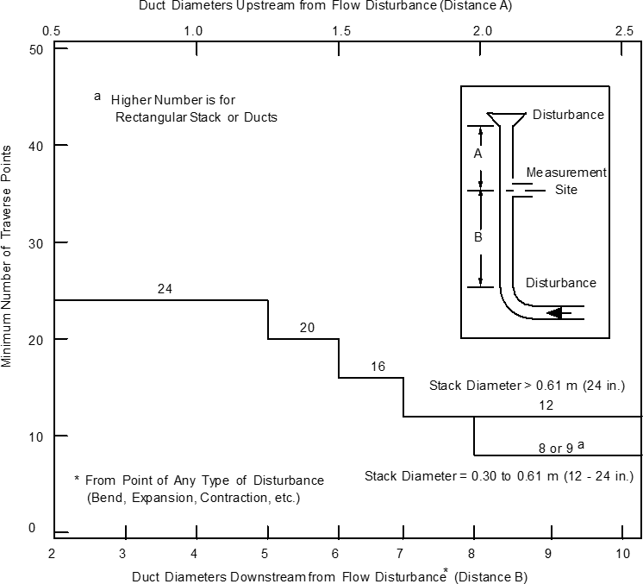
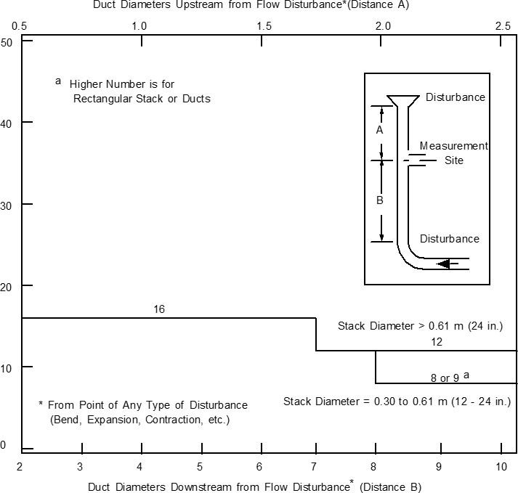
Circular Stack Details (as applicable)
(see Figures 1, 2, & 3)
Stack Diameter (D): inches Port Distance from:
Upstream Disturbance (A): inches Downstream Disturbance (B): inches Measured on site: Yes No
Area of Stack: square inches Upstream Diameters (A/D): Downstream Diameters (B/D): No. of Particulate Traverse Points Required: No. of Non-particulate Traverse Points Required:
No. of Sampling Ports:
Rectangular Stack Details (as applicable)
(see Figures 1, 2, & 4, Table 1)
Length of Stack (L): inches Width of Stack (W): inches Port Distance from:
Upstream Disturbance (A): inches Downstream Disturbance (B): inches Measured on site: Yes No
Equivalent Diameter (D): inches Area of Stack: square inches Upstream Diameters (A/D): Downstream Diameters (B/D): No. of Particulate Traverse Points Required: No. of Non-particulate Traverse Points Required:
No. of Sampling Ports: Matrix:

Duct Diameters that Measurement Site is Downstream from Flow Disturbance* (Distance B/D)

Additional Information
Describe any safety equipment DEQ needs to bring to observe testing (as applicable):
Describe safety concerns or hazardous conditions at the facility and/or sampling location (as applicable):
Additional information applicable to the proposed emission testing or other comments (as applicable):
Please identify all additional files or attachments that complete this source test protocol*:
File Name | File Content
Example: Attachment A – Test Information for EU ID 42.pdf | Set of pages 2-4 for emission unit 42
 | Block flow diagram/description of process facility (required)
 | Diagram of stack w/ sampling ports, platform, & adjacent duct work (required)
*Any information required to be submitted, that has been declared confidential under the appropriate procedures, may be referenced or submitted separately.
Contractor/Consultant Endorsements
I certify that emissions testing will be conducted as described in this protocol. Every effort will be made to obtain reliable, repeatable, and representative data using approved test methods.
Company Name: Company Representative: Title:
Signature: Date:
(sign or insert your e-signature)

Facility Responsible Official Endorsements
I have reviewed the information being submitted in its entirety and, based on information and belief formed after reasonable inquiry, I certify that the statements contained in this submittal are true, accurate, and complete. This form is submitted as a DEQ-approved appropriate alternate equivalent to the Protocol requirements found in the Montana Source Test Protocol and Procedures Manual per Administrative Rules of Montana 17.8.106(2).
Responsible Official Name: Title:
Signature: Date:
(sign or insert your e-signature)

How to Submit this Protocol
- Electronically submit to your facility’s Air Quality Bureau contact or DEQ-ARMB-Admin@mt.gov, or
- Mail to: Department of Environmental Quality Air Quality Bureau,
1520 E. 6th Ave.
P.O. Box 200901,
Helena, MT 59620-0901
- Questions: (406) 444-3490

Schedule Reminder
- Submit a protocol at least 25 working days prior to the proposed test date.
- Confirm the test date at least 3 days prior to beginning test.
- Submit source test report within 60 days of test date, unless another schedule is required by rule.

