Information for Emitting Unit ID:
Emitting unit name and description:
Describe pollution control equipment and ID (as appropriate):
Continuous operation? Batch operation?
If batch: Batch duration: Batches per day:
Additional emitting unit information (optional):

Source Test Planning
Proposed test date(s): |  | Control equipment shall be operated under normal conditions during test? Yes No  If ‘No’, please explain:
Maximum rated capacity*: Average process rate*: Proposed test rate*:
Based on:
90 -110% of maximum load Normal operating load
>50% of maximum load for Relative Accuracy Test Audit (RATA) (as applicable)
Other, please explain:
 |  | Planned fuel types and gross heating value (as applicable) during testing*:
The following are required for a complete protocol: Block flow diagram/description of process facility
Diagram of stack showing sampling ports, platform and
adjacent duct work.
 |  | Anticipated fuel feed rates during testing*:
Additional source test planning information in attached file (optional).

*Include units of measure.

Source Test Protocol Worksheet

May 2026

Source Test Program Details for Emitting Unit:
(complete pages 2 - 4 for each emitting unit to be tested)
Pollutant | Emission Limit(s) |  |  |  | Test Frequency |  | Compliance Determination Permit Reference  Condition No(s). | Applicable State/Federal Rule or Consent  Decree No(s).
Pollutant | Limit* |  | Permit  Reference Condition No(s). |  |  |  | Compliance Determination Permit Reference  Condition No(s). | Applicable State/Federal Rule or Consent  Decree No(s).
Example: Particulate  Matter (PM) | 0.01 grains/dry std cubic feet (dscf) |  | II.A.1 |  | Every 4 years |  | II.B.1, II.B.2,  II.B.4, II.B.6 | MAQP #0166-04,  NSPS Subpart I
Explain how this testing fulfills the requirements of the applicable condition(s) and requirement above (e.g., meets required scheduled testing, establishes operating limits, RATA, etc.):
Identify Standard Test Methods Used
Method 1 – Selection of Sampling Points and Traverse Points for Stationary Sources Method 2 – Determination of Stack Gas Velocity and Volumetric Flow Rate Method 3 – Gas Analysis for the Determination of Dry Molecular Weight
Method 3A – Determination of Oxygen and Carbon Dioxide Concentrations in Emissions from Stationary Sources
Method 4 – Determination of Moisture Content in Stack Gases
Additional Test Methods to be Performed (as appropriate)
Parameter or Pollutant Measured |  | Test Method | No. of Runs Required | No. of Runs Anticipated |  | Anticipated Sample Time and Volume for Each Run*
Example: PM |  | Method 5 | 3 | 3 |  | 60 minutes, 31.8 dscf
List all test methods above required to participate in the stationary source audit program:
Discuss any federal test method deviations and analytical deviations (as applicable):
Additional test method information attached (optional).

*Include units of measure.

Source Test Protocol Worksheet

May 2026

Stack Details for Emitting Unit: , (complete pages 2 - 4 for each emitting unit to be tested)

Figure 1: Minimum No. of Traverse Points for Particulate Traverses
Duct Diameters that Measurement Site is Upstream from Flow Disturbance* (Distance A/D)

Figure 3: Circular Stack Cross-section

24 or 25ª Points
Minimum Number of Traverse Points

Points

Points

Points

Points

D

Figure 4: Rectangular Stack Cross-section
W

Duct Diameters that Measurement Site is Downstream from Flow Disturbance* (Distance B/D)

Figure 2: Minimum No. of Traverse Points for Velocity (Non-Particulate)
Traverses L
Duct Diameters that Measurement Site is Upstream from Flow Disturbance* (Distance A/D)

Table 1: Cross-section Layout for Rectangular Stacks
Minimum Number of Traverse Points

Points

Points
Number of Traverse Points | Matrix
9 | 3x3
12 | 4x3
16 | 4x4
20 | 5x4
25 | 5x5
30 | 6x5
36 | 6x6
42 | 7x6
49 | 7x7

Points

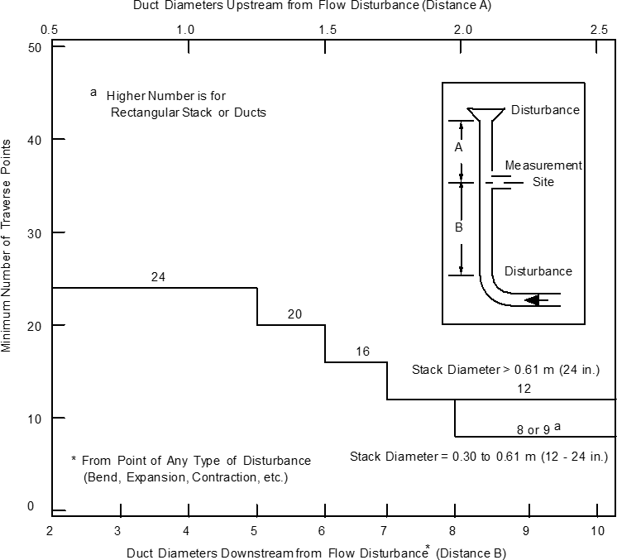
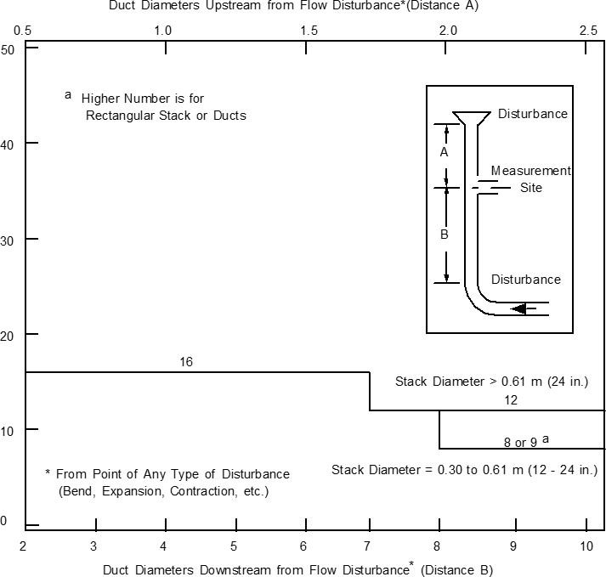
Circular Stack Details (as applicable)
(see Figures 1, 2, & 3)
Stack Diameter (D): inches Port Distance from:
Upstream Disturbance (A): inches Downstream Disturbance (B): inches Measured on site: Yes No
Area of Stack: square inches Upstream Diameters (A/D): Downstream Diameters (B/D): No. of Particulate Traverse Points Required: No. of Non-particulate Traverse Points Required:
No. of Sampling Ports:
Rectangular Stack Details (as applicable)
(see Figures 1, 2, & 4, Table 1)
Length of Stack (L): inches Width of Stack (W): inches Port Distance from:
Upstream Disturbance (A): inches Downstream Disturbance (B): inches Measured on site: Yes No
Equivalent Diameter (D): inches Area of Stack: square inches Upstream Diameters (A/D): Downstream Diameters (B/D): No. of Particulate Traverse Points Required: No. of Non-particulate Traverse Points Required:
No. of Sampling Ports: Matrix:

Duct Diameters that Measurement Site is Downstream from Flow Disturbance* (Distance B/D)

