
Air Quality Bureau Source Test Protocol Worksheet

General Information
Facility Contact Information | Stack Testing Contractor
Company Name: | Name:  Mailing Address: City: State: Zip: Contact Name: Contact Title: Contact Email:  Phone: (cell) (office)
Facility Name:
MAQP # (if applicable):
Operating Permit (OP) # (if applicable):
Facility Address:
City: State: Zip:
Mailing Address:
City: State: Zip: | Additional Contracted Services (Lab/Analytical, External QA/QC, etc.)
Facility Responsible Official Contact
Name: | Company Name:
Title: | Contractor’s Purpose:
Email: | Mailing Address:
Phone: (cell) (office) | City: State: Zip:
 | Contact Name:
Facility Environmental Contact
Name: | Contact Title:
Title: | Contact Email:
Email: | Contact Phone: (cell) (office)
Phone: (cell) (office) | Other contractors’ information in attached file.
Facility Description
Provide a brief description of the facility operations:
Emitting Units to be Tested

Number of emitting units to be tested:

1 of 6 January 2019

Information for Emitting Unit ID: _EU 001

(complete pages 2 - 4 for each emitting unit to be tested)
Emitting unit name and description:
EU001 - natural gas-fired boiler
Describe pollution control equipment and ID (as appropriate):
Low-NOx Burners
Continuous operation? Batch operation? □
If batch: Batch duration: Batches per day:
Additional emitting unit information (optional):
The proposed testing is the initial NOx compliance test following the replacement of the burners in 2019.

I
*Include units of measure.
Control equipment shall be operated under normal conditions during test? Yes □No
If ‘No’, please explain:
Planned fuel types and gross heating value (as applicable) during testing*:
Natural gas; 1,050 Btu/scf
Anticipated fuel feed rates during testing*:
129,000 scf/hr

Source Test Planning
Proposed test date(s): _03/22/2019
Maximum rated capacity*: _1 50 MMBtu/hr
Average process rate*: _120 MMBtu/hr
Proposed test rate*: _135 MMBtu/hr
Based on:
90 -110% of maximum load
□ Normal operating load
>50% of maximum load for Relative Accuracy Test Audit (RATA) (as applicable)
Other, please explain:
The following are required for a complete protocol:
- Block flow diagram/description of process facility
- Diagram of stack showing sampling ports, platform and
I adjacent duct work.
Additional source test planning information in attached
file (optional).

Source Test Program Details for Emitting Unit:
(complete pages 2 - 4 for each emitting unit to be tested)
Pollutant | Emission Limit(s) |  |  |  | Test Frequency |  | Compliance Determination Permit Reference  Condition No(s). | Applicable State/Federal Rule or Consent  Decree No(s).
Pollutant | Limit* |  | Permit  Reference Condition No(s). |  |  |  | Compliance Determination Permit Reference  Condition No(s). | Applicable State/Federal Rule or Consent  Decree No(s).
Example: Particulate  Matter (PM) | 0.01 grains/dry std cubic feet (dscf) |  | II.A.1 |  | Every 4 years |  | II.B.1, II.B.2,  II.B.4, II.B.6 | MAQP #0166-04,  NSPS Subpart I
Explain how this testing fulfills the requirements of the applicable condition(s) and requirement above (e.g., meets required scheduled testing, establishes operating limits, RATA, etc.):

Identify Standard Test Methods Used
Method 1 – Selection of Sampling Points and Traverse Points for Stationary Sources Method 2 – Determination of Stack Gas Velocity and Volumetric Flow Rate Method 3 – Gas Analysis for the Determination of Dry Molecular Weight
Method 3A – Determination of Oxygen and Carbon Dioxide Concentrations in Emissions from Stationary Sources
Method 4 – Determination of Moisture Content in Stack Gases
Additional Test Methods to be Performed (as appropriate)
Parameter or Pollutant Measured |  | Test Method | No. of Runs Required | No. of Runs Anticipated |  | Anticipated Sample Time and Volume for Each Run*
Example: PM |  | Method 5 | 3 | 3 |  | 60 minutes, 31.8 dscf
List all test methods above required to participate in the stationary source audit program:
Discuss any federal test method deviations and analytical deviations (as applicable):

Additional test method information attached (optional).
*Include units of measure.

Stack Details for Emitting Unit: EU 001 omplete pages 2 - 4 for each emitting unit to be tested)

Circular Stack Details (as applicable) (see Figures 1, 2, & 3)
Stack Diameter (D): 80 inches Port Distance from:
Figure 1: Minimum No. of Traverse Points for Particulate Traverses
Duct Diameters that Measurement Site is Upstream from Flow *Disturbance* (Distance A/D)

Figure 3: Circular Stack Cross-section

Upstream Disturbance (A): 220
Downstream Disturbance (B): 365
inches inches

Measured on site: 121 Yes
Area of Stack: 5027
0 No

square inches

24 or 25a Points
◄ D ►

Upstream Diameters (AID): 2.8 Downstream Diameters (B/D): 4.6
No. of Particulate Traverse Points Required: NA
No. of Non-particulate Traverse Points Required:1§

Points

Points

� Points
Minimum Number of Traverse Points

� Points

Figure 4: Rectangular Stack Cross-section
◄ w ►

No. of Sampling Ports: 2

Rectangular Stack Details (as applicable) (see Figures 1, 2, & 4, Table 1)
Length of Stack (L): NA inches Width of Stack (W): NA inches
&

Duct Diameters that Measurement Site is Downstream from Flow Disturbance* (Distance B/D)
Figure 2: Minimum No. of Traverse Points for Velocity (Non-Particulate)
Traverses L
Duct Diameters that Measurement Site is Upstream from Flow Disturbance* (Distance A/D)

Port Distance from:
Upstream Disturbance (A): NA

inches
T gggg

Downstream Disturbance (B): NA inches Measured on site: D Yes D No
Equivalent Diameter (D): NA inches

Table l: Cross-section Layout for Rectangular Stacks

Area of Stack: NA square inches Upstream Diameters (AID): NA
Downstream Diameters (B/D): NA

Points

- --..

Points
Minimum Number of Traverse Points
Number of Traverse Points
9
12
16
Matrix 3x3 4x3
4x4

No. of Particulate Traverse Points Required: NA
-----

20
5x4
25 5x5
Points

No. of Non-particulate Traverse Points Required: NA
No. of Sampling Ports: NA Matrix: NA

Duct Diameters that Measurement Site is Downstream from Flow Disturbance* (Distance B/D)
30 6x5
36 6x6
42 7x6
49 7x7

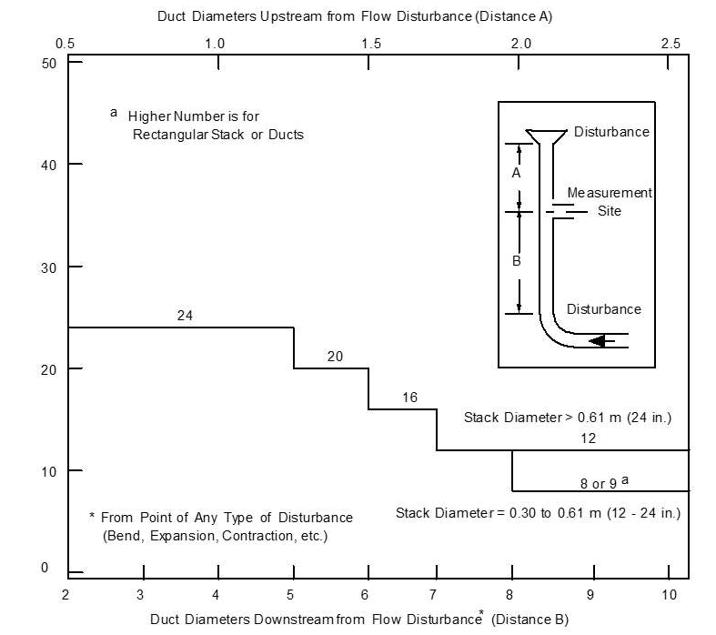
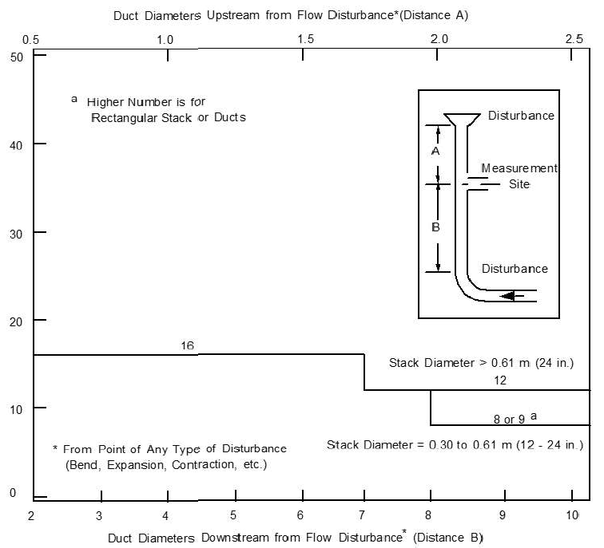
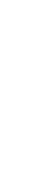
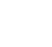
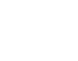
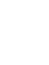
Source Test Protocol Worksheet 4 of6 January 2019

Additional Information
Describe any safety equipment DEQ needs to bring to observe testing (as applicable):

Describe safety concerns or hazardous conditions at the facility and/or sampling location (as applicable):
Additional information applicable to the proposed emission testing or other comments (as applicable):

Please identify all additional files or attachments that complete this source test protocol*:

*Any information required to be submitted, that has been declared confidential under the appropriate procedures, may be referenced or submitted separately.
Contractor/Consultant Endorsements
I certify that emissions testing will be conducted as described in this protocol. Every effort will be made to obtain reliable, repeatable, and representative data using approved test methods.
Company Name:
Company Representative:
Title:
Signature: _S_h_a_w_n_Cla_r_k Date: _F_e_b_ru_a_ry 1_, _20_1_9
(sign or insert your e-signature)
File Name | File Content
Example: Attachment A – Test Information for EU ID 42.pdf | Set of pages 2-4 for emission unit 42
 | Block flow diagram/description of process facility (required)
 | Diagram of stack w/ sampling ports, platform, & adjacent duct work (required)

Facility Responsible Official Endorsements
I have reviewed the information being submitted in its entirety and, based on information and belief formed after reasonable inquiry, I certify that the statements contained in this submittal are true, accurate, and complete. This form is submitted as a DEQ-approved appropriate alternate equivalent to the Protocol requirements found in the Montana Source Test Protocol and Procedures Manual per Administrative Rules of Montana 17.8.106(2).
Responsible Official Name:
Title:
Signature: _J_a_ck_i_S_mith Date: _F_e_b_ru_a_ry 5_, _2_0_1_9

(sign or insert your e-signature)

How to Submit this Protocol
Electronically submit to your facility’s Air Quality Bureau contact or DEQ-ARMB-Admin@mt.gov, or
Mail to: Department of Environmental Quality Air Quality Bureau,
1520 E. 6th Ave.
P.O. Box 200901,
Helena, MT 59620-0901
Questions: (406) 444-3490

Schedule Reminder
Submit a protocol at least 25 working days prior to the proposed test date. Confirm the test date at least 3 days prior to beginning test.
Submit source test report within 60 days of test date, unless another schedule is required by rule.

