
Montana Department of Environmental Quality Registered Portable Air Quality Emission Source Submission Walkthrough
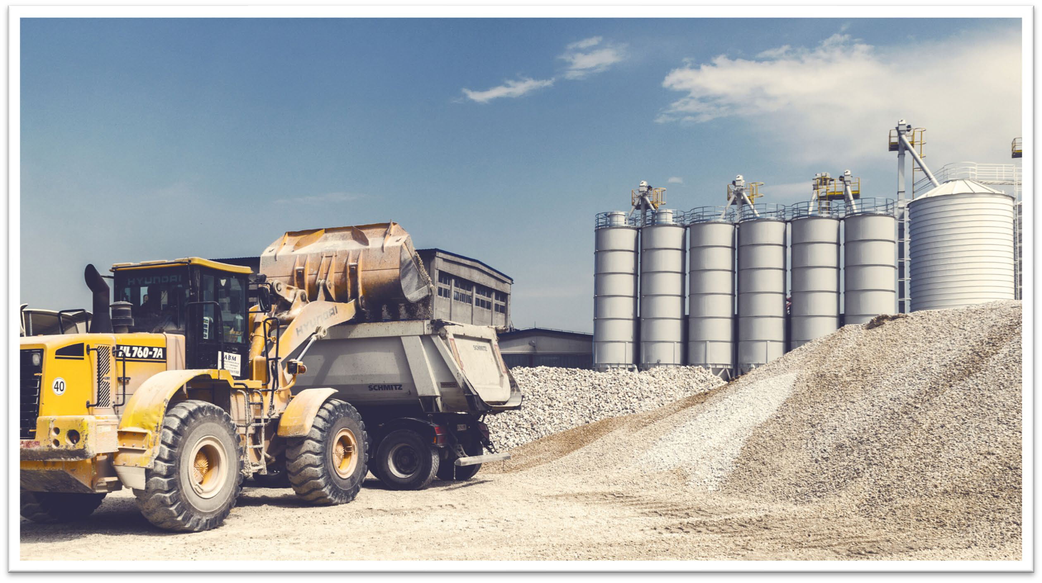

Introduction
- To hopefully make the process of registering portable equipment easier, DEQ is moving to an electronic submittal system.

- Operators will no longer submit a pdf with their registration information; the registration will occur through a website.
- The same process will occur for deregistration as well.
- The goal is to make the process more efficient for both operators and DEQ staff.

Process

- Operator submits initial operator registration form.
  - This step is not necessary if operator has previously submitted operator registration paperwork.
- DEQ reviews operator registration and approves or denies submission.
  - Operator will receive email from DEQ with approval or denial.
- Operator submits registration information for portable equipment for estimated operating date.
  - Each piece of equipment will get its own registration (i.e. if you have both a crusher and a batch asphalt plant, you will submit a separate registration for each).
- DEQ reviews portable equipment registration and approves or denies submission.
  - Operator will receive email from DEQ with approval or denial.
  - If approved the location will display on the public registration dashboard as pending.
- Operator submits registration information for portable equipment for confirmed operating date.
  - Each piece of equipment will get its own registration (i.e. if you have both a crusher and a batch asphalt plant, you will submit a separate registration for each).
- DEQ reviews portable equipment registration and approves or denies submission.
  - Operator will receive email from DEQ with approval or denial.
  - If approved the location will display on the public registration dashboard as active.
- Operator submits registration information for portable equipment for removal date.
  - Each piece of equipment will get its own removal form (i.e. if you have both a crusher and a batch asphalt plant and are removing both, you will submit a separate removal form for each; if only removing the crusher for example, you will only submit a removal form for the crusher).
- DEQ reviews portable equipment removal.
  - Operator will receive email from DEQ confirming removal.
  - The location will be removed from the public registration dashboard.
- Operator submits deregistration form.
  - If an operator ceases operations in the State of Montana, or if they remove a piece of equipment from a facility with no intention to operate at the facility again, the operator will submit a deregistration form.
  - After the form is submitted, DEQ and the operator will both receive a notification, and the operator and/or equipment/facility will be removed from the public registration dashboard.
- Annual Production Reporting
  - All operators conducting operations with the State of Montana are required to submit an annual production report between January 1 and March 31 to report the previous years production activities. This allows DEQ to properly assess operating fees.

Initial Operator Registration

- If the operator has previously registered as an operator with DEQ Air Quality Bureau, the initial operator registration can be skipped and go straight to registration of equipment. This includes if you registered the previous way, by submitting a hard copy form or pdf.
- To register as an operator:
  - Go to https://survey123.arcgis.com/share/848b86616f7245c5aedcbe9ab2a88f3a?portalUrl=https://gis.mtdeq.us/portal
  - Click “I Agree” on the notice

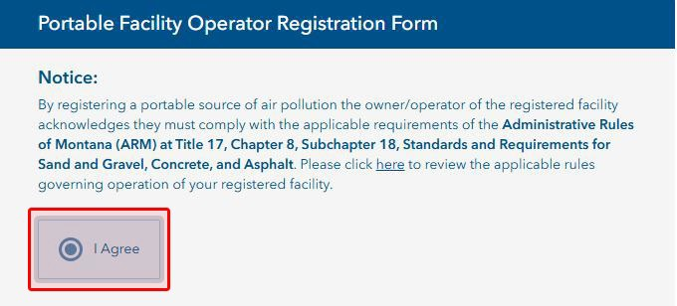

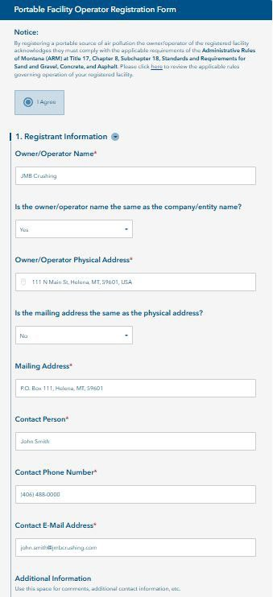
Initial Operator Registration

- Fill out the Registrant Information section.
  - Owner/Operator Name
  - Company Entity Name (if different than owner/operator name)
  - Owner/Operator Physical Address
  - Mailing Address (if different than physical address)
  - Contact Person
  - Contact Phone
  - Contact E-Mail
  - Additional Information

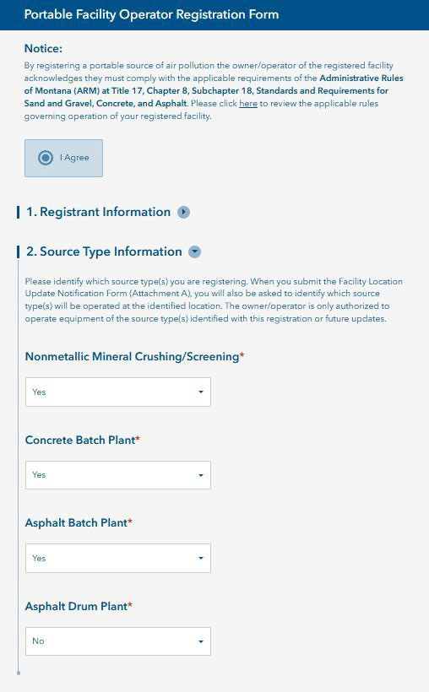
Initial Operator Registration

- Fill out the Source Type Information section.
  - Select Yes/No for each source type (yes if you are registering the specified equipment, no if you are not).

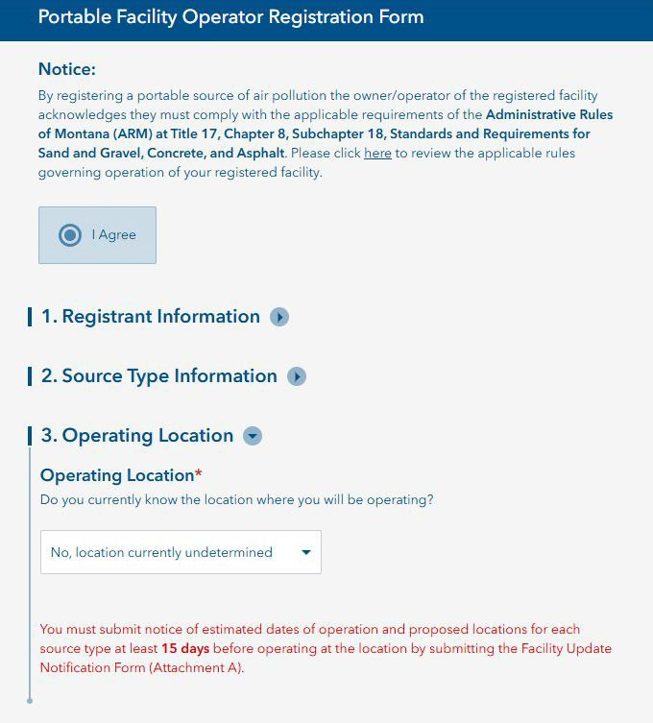
Initial Operator Registration

- Fill out the Operating Location section.
  - Indicate if you know the current operating location.

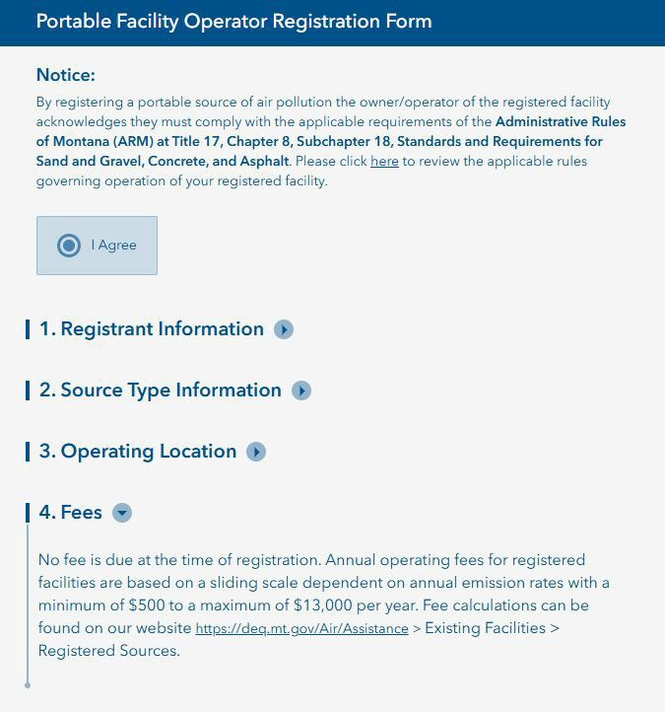
Initial Operator Registration

- Review the relevant Fees section.

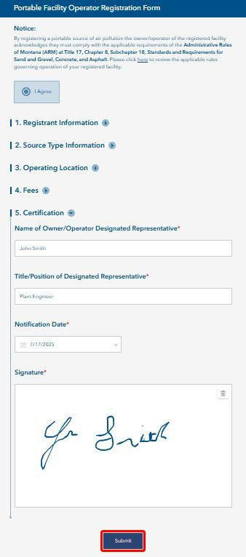
Initial Operator Registration

- Fill out the Certification section.
  - Provide Name of Owner/Operator Designated Representative
  - Provide Title of Designated Representative
  - Provide Notification Date (date you are submitting the form)
  - Provide Signature

- When you have completed filling in all information, click the
Submit button at the bottom of the form.

Initial Operator Registration

- You will see the screen below/left if your registration was successfully submitted.
- DEQ staff will receive an e-mail with your information and will review the submission.
- You will receive an e-mail back from “DEQ sapowerautomate” with approval or denial (example below/right).

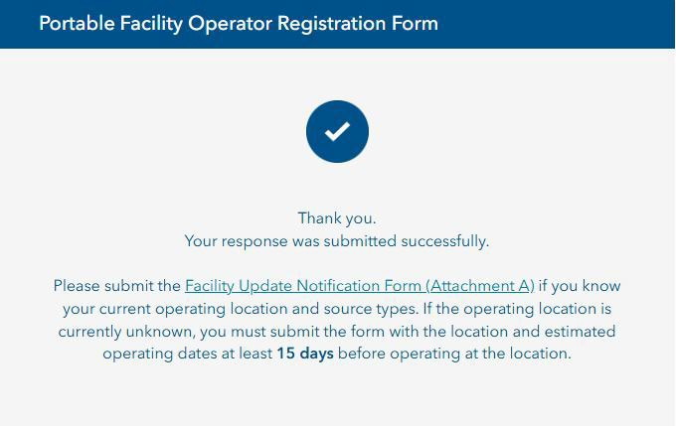
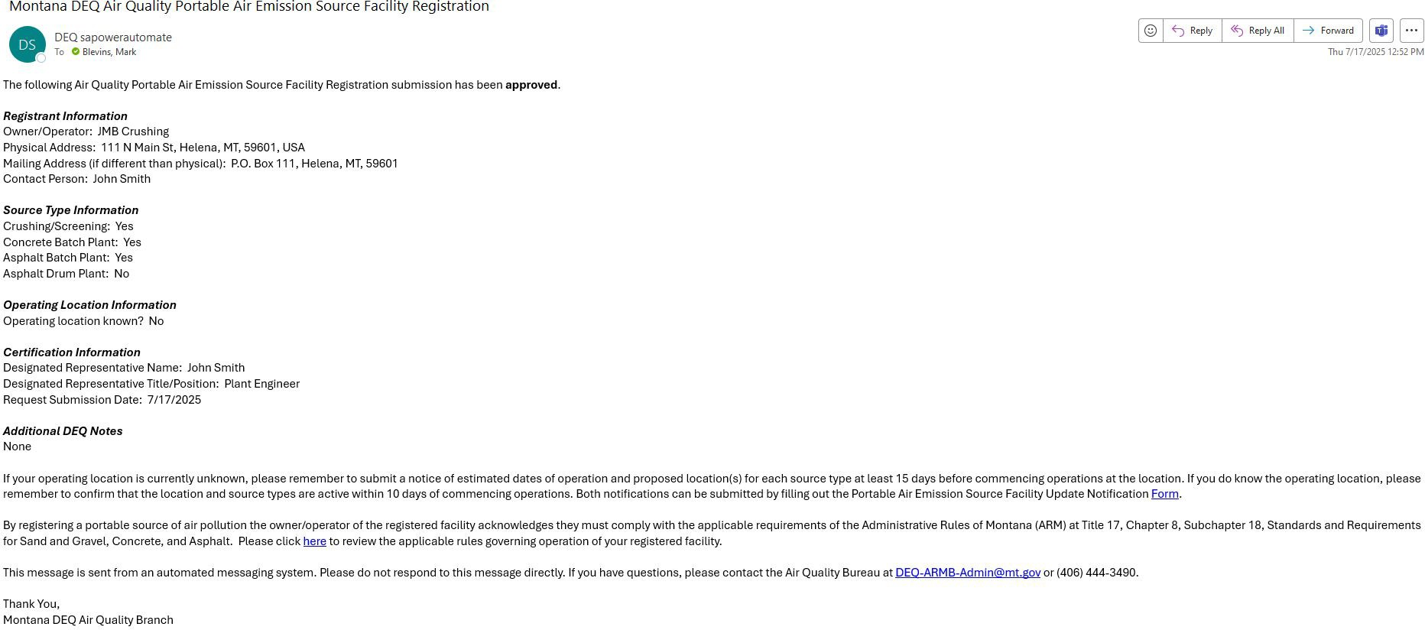

Portable Equipment/Emission Source Registration

- To continue registering the operating equipment, do one of the following (all go to the same form)
  - Click the link in the successful submission window where it says: “Facility Update Notification Form (Attachment A)”.
  - Click the link in your approval e-mail for the initial operator registration (if you filled out that form).
  - Click the link below (also will be available on DEQ Air Bureau’s website)
    - https://survey123.arcgis.com/share/be005baad18542c8aa37167e7ee6eaac?portalUrl=https://gis.mtdeq.us/portal

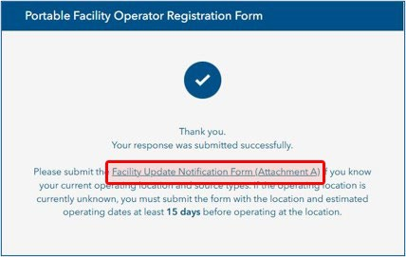
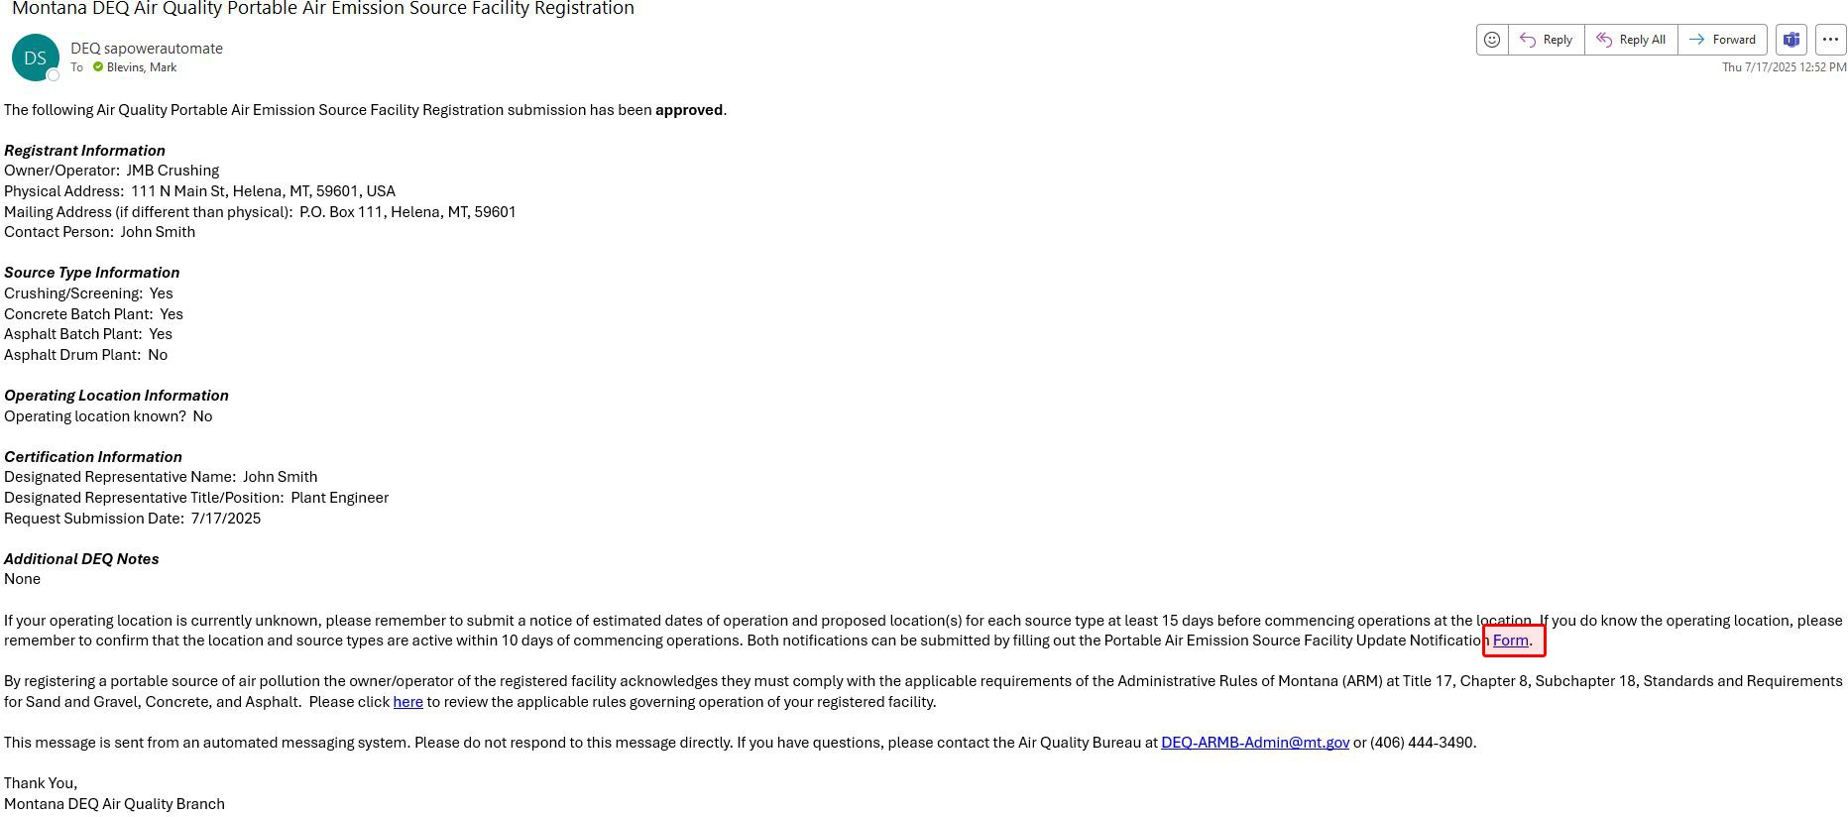

Portable Equipment/Emission Source Registration

- Once you are on the portable equipment registration website:
  - Click “I Agree” on the notice

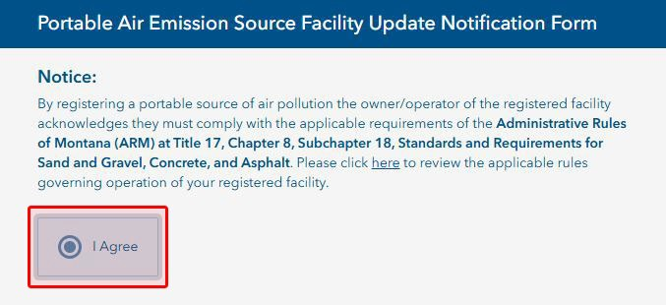

Portable Equipment/Emission Source Registration

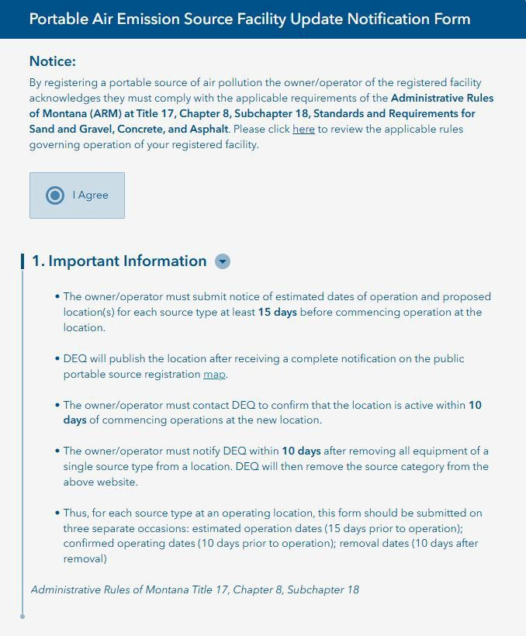
- Review the Important Information section.

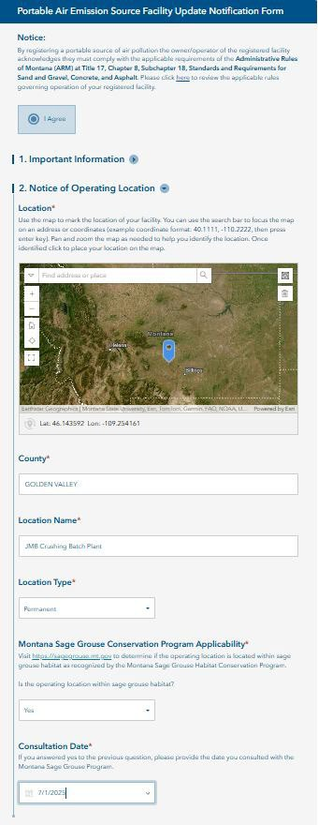
Portable Equipment/Emission Source Registration

- Fill out the Notice of Operating Location section.
  - Provide the location of your facility/equipment.
    - You can enter in coordinates or an address in the search bar, or you can pan and zoom around the map to set your location. The blue dot on the map is where your location has been set. You can change the location by clicking the map.
  - The county field will auto-populate based on where you click on your map.
  - Provide the facility/location name.
  - Identify the location type (permanent or temporary).
  - Identify if the location is within sage grouse habitat. If yes, provide the date you consulted with the Montana Sage Grouse Program regarding your facility/location.

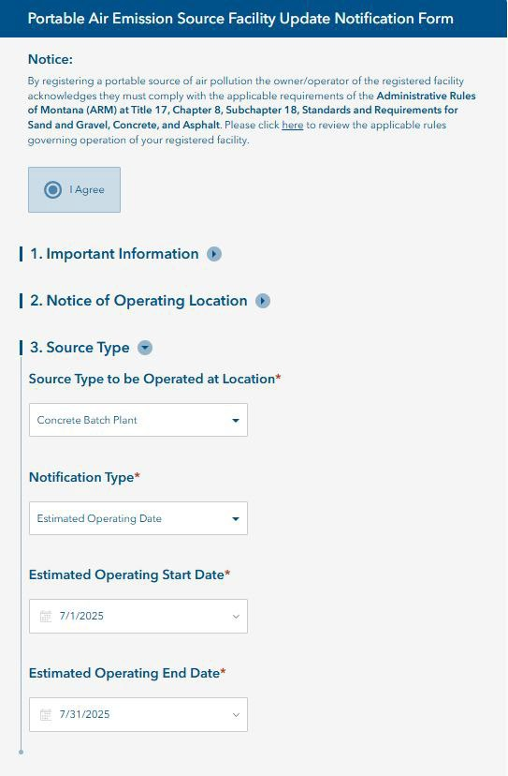
Portable Equipment/Emission Source Registration

- Fill out the Source Type section.
  - Select the Source Type to be operated at the location.
    - If registering multiple source types, you will submit a form for each source type.
  - Select the Notification Type you are submitting for and the relevant dates.
    - You must first submit the estimated operating dates.
    - When you know the confirmed operating date, you will then submit this form again, picking confirmed operating date as the notification type.
    - When you are ready to remove the equipment, you will then submit this form again, picking removal date as the notification type.
    - Thus, for a single new emission source, you will submit this form three times: one for the estimated operating date, once for the confirmed operating date, and once for the removal date. You will do this for each source type you are registering.

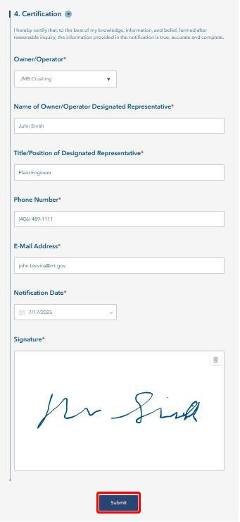
Portable Equipment/Emission Source Registration

- Fill out the Certification section.
  - Select the Owner/Operator.
    - If your owner/operator name is not listed, it means you have not completed the initial owner/operator registration form described earlier in this document. You will need to complete this form before registering your equipment.
  - Provide Name of Owner/Operator Designated Representative
  - Provide Title of Designated Representative
  - Provide Phone Number
  - Provide E-Mail
  - Provide Notification Date (date you are submitting the form)
  - Provide Signature

- When you have completed filling in all information, click the
Submit button at the bottom of the form.

Portable Equipment/Emission Source Registration

- You will see the screen below/left if your registration was successfully submitted.
- Click the link if you need to submit a form for additional source locations
- DEQ staff will receive an e-mail with your information and will review the submission.
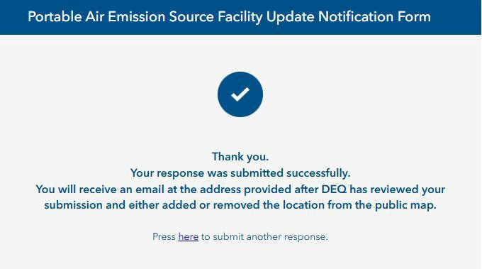
- You will receive an e-mail back from “DEQ sapowerautomate” with approval or denial (example below/right). You will receive an email for each notification type you submit for (i.e. estimated operating dates, confirmed dates, and removal dates).
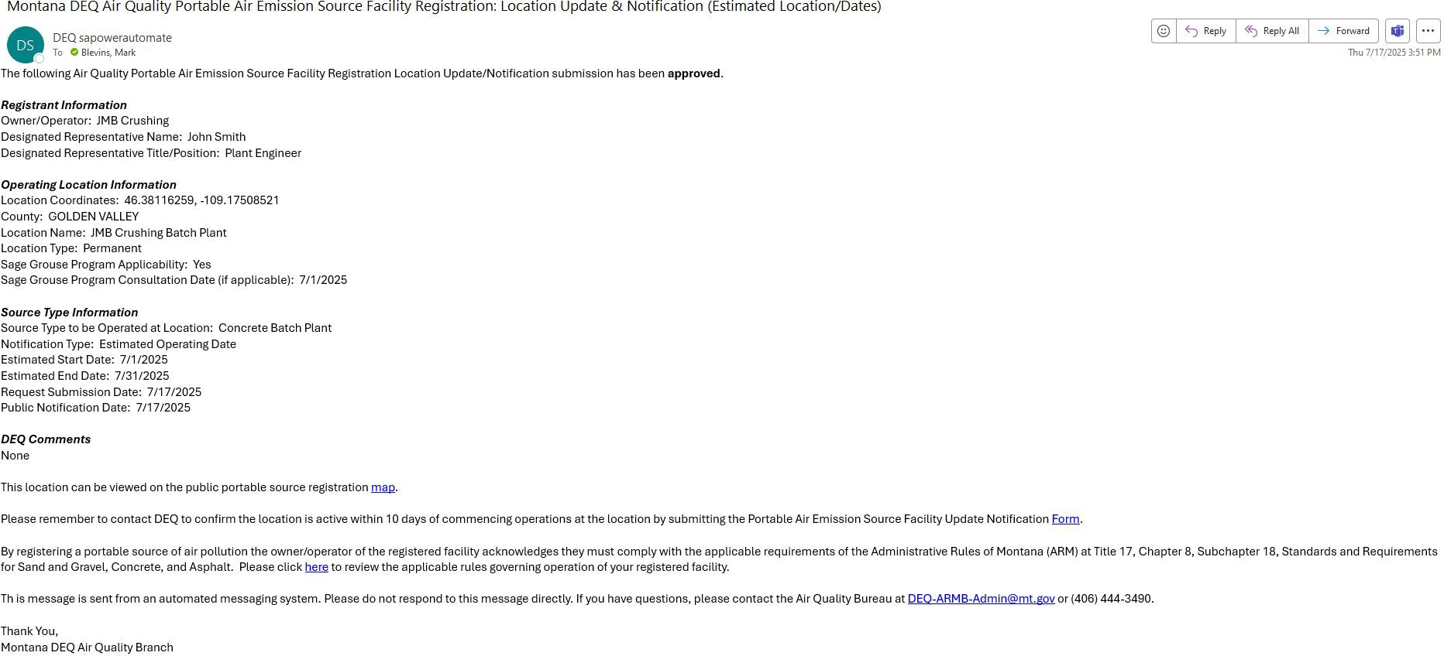

Public Registration Dashboard/Map

- You can view the locations of pending (estimated operating dates) and active (confirmed operating dates) source locations on the public registration dashboard map.
  - https://gis.mtdeq.us/portal/apps/dashboards/d0e1a39878d84c73b25345ad07957f91
  - You can use the filters on the left side of the map to narrow down the locations displayed on the map.
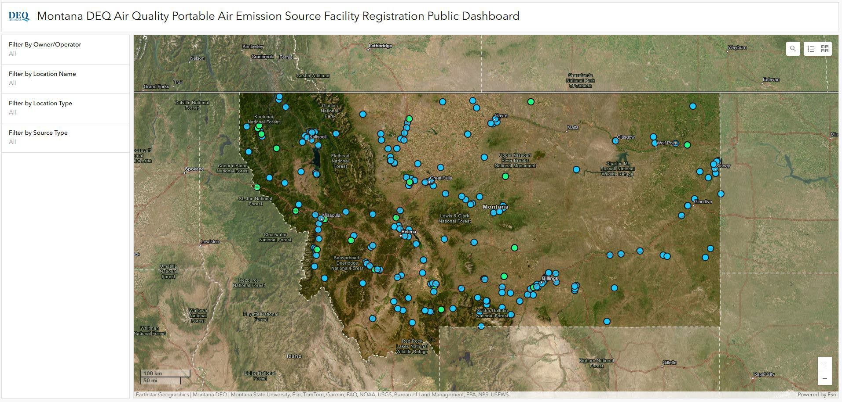

Operator and/or Portable Equipment/Emission Source Deregistration

- If an operator ceases operations in the State of Montana, or if they remove a piece of equipment from a facility with no intention to operate at the facility again, the operator will submit a deregistration form.
- To deregister as an operator or to deregister equipment at a facility:
  - Go to https://survey123.arcgis.com/share/92b234880900455982b0093ac356783e?portalUrl=https://gis.mtdeq.us/portal
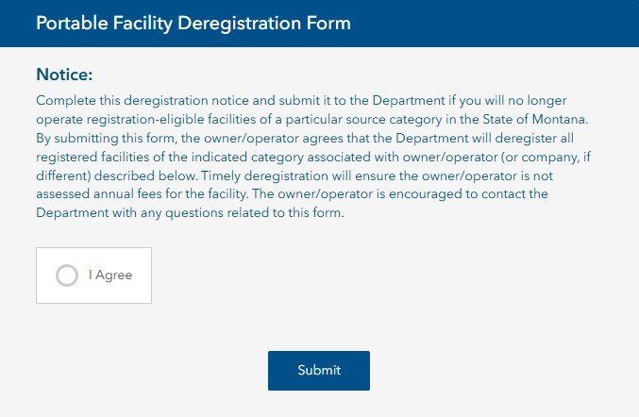
  - Click “I Agree” on the notice

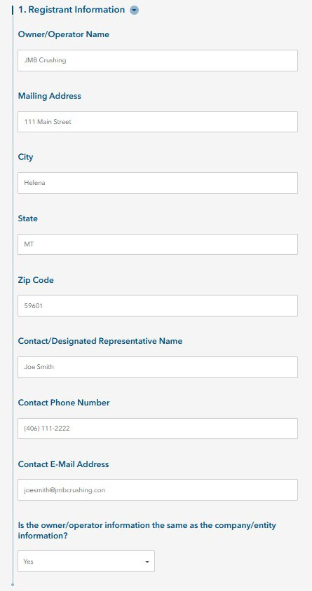
Operator and/or Portable Equipment/Emission Source Deregistration

- Fill out the Registrant Information section.

Operator and/or Portable Equipment/Emission Source Deregistration

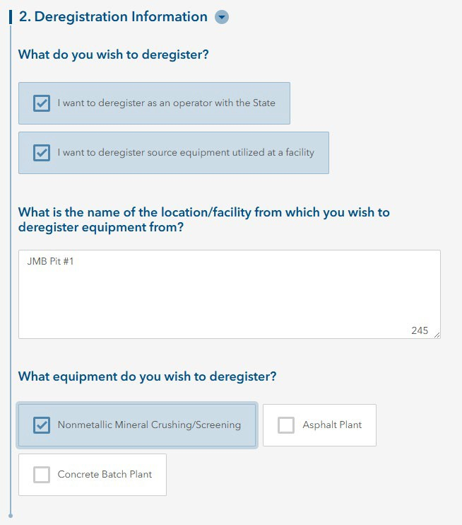
- Fill out the Deregistration Information section.
  - Select whether you are deregistering as an operator, deregistering equipment at a facility, or both.
  - If you select that you want to deregister source equipment, you will enter additional information about the name of the location/facility, as well as the equipment type you are deregistering.

Operator and/or Portable Equipment/Emission Source Deregistration

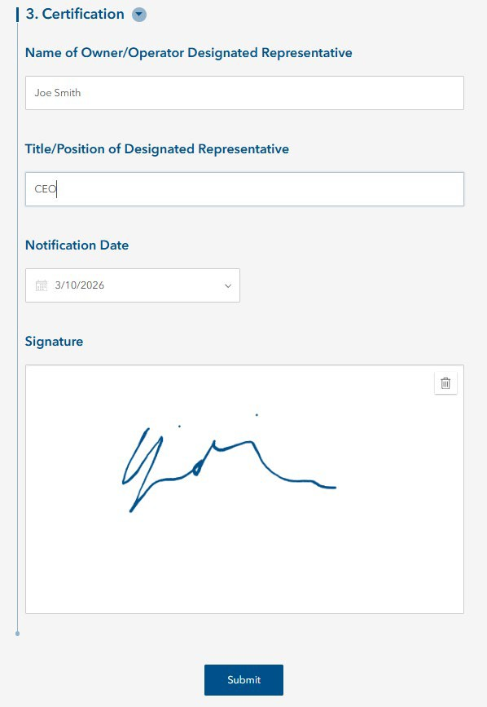
- Fill out the Certification section, then click Submit.

Operator and/or Portable Equipment/Emission Source Deregistration

- You will see the screen below/left if your deregistration was successfully submitted.
- DEQ staff will receive an e-mail with your information and will review the submission.
- DEQ staff will update your records to deregistered and your information will be removed from the public map.
- You will receive an e-mail from “DEQ sapowerautomate” confirming your deregistration.

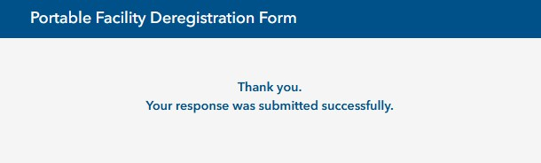
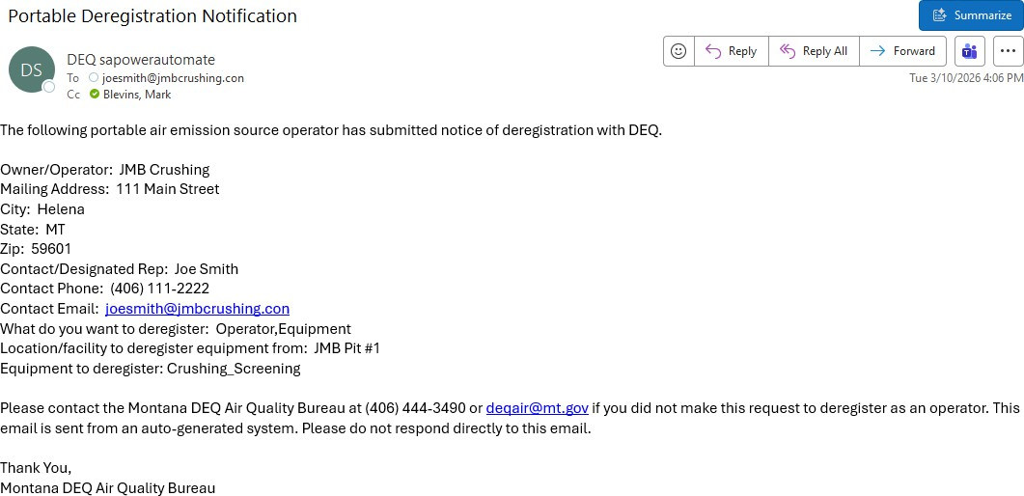

Annual Production Reporting

- During the time period from January 1 through March 31, operators should submit their annual production numbers for the previous year. This is how DEQ assesses annual fees.
- To submit an annual production report go to:
  - https://survey123.arcgis.com/share/03b9db81ed444c44931eb3da494cb083?portalUrl=https://gis
.mtdeq.us/portal

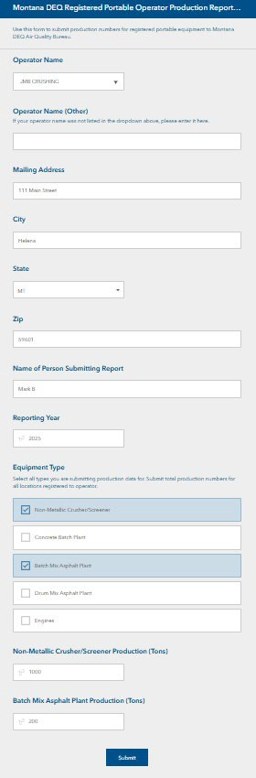
Annual Production Reporting

- Select your Operator Name from the dropdown.
  - If your operator name isn’t available, type it in the Operator Name (Other) field.
- Enter the operator Mailing Address, State, City, and
Zip.
- Enter the Name of the person submitting the report.
- The Reporting Year will automatically populate and is not editable. If there is an issue with this, please contact DEQ Air Bureau.
- Select all applicable Equipment Types you need to supply production numbers for. You can select multiple types. If you select a type, a field will open for you to enter your production numbers into.
- Click Submit when you are finished.
- DEQ will receive your form and calculate your annual fees based on the production numbers you reported.

Contact

- If you have issues or questions regarding this process or accessing and/or filling out the forms, please contact the DEQ Air Quality Bureau at deqair@mt.gov or 406-444-3490.



Thank You!

