

Instructions for Completing the Annual Air Quality Emission Inventory

The Emission Inventory Detail (Inventory) report is comprised of two parts. The Summary Page, and the subsequent Detail Page(s). Completing the Inventory requires you to review and edit both of these pages, and then submit the edited forms to the Montana Department of Environmental Quality (Department). The following instructions briefly summarize the Inventory completion process in three stages: I. the Summary Page; II. the Detail Page(s); and, III. Inventory Submittal. If you have questions of any kind through this process, please contact the Department representative that sent you the Inventory document.

The SUMMARY PAGE
The Summary Page looks like the following example:
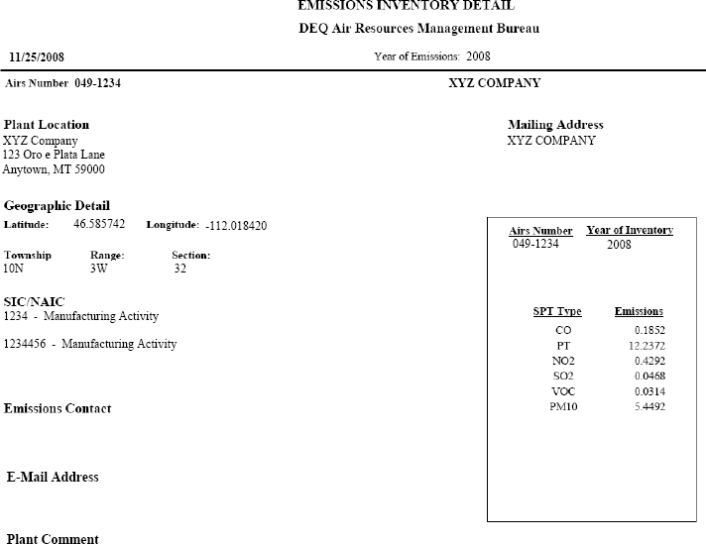

Edit the Summary Page as follows:
  - Carefully review the listed location and mailing addresses, the Geographic Detail information, and the listed SIC and NAICS codes. Update or complete these fields as necessary. Do not ignore any field or leave any blanks.

  - In the Emission Contact field, list the individual that the Department may contact for information about the contents of the edited Inventory. Include telephone number and e-mail information, as well as a mailing address if it is different from the facility mailing address.

  - In the E-Mail Address field, list an address that future correspondence and Emission Inventories may be sent to. The Department is moving towards a process where activities like the Emission Inventory will be completed electronically, without any paper where possible. Future Annual Emission Inventory Processes will likely be conducted electronically. To begin this process the Department must have a valid e-mail address for each facility. This address may be the same as the Emission Contact address or a different address for official facility information. If you leave this field blank the Department will assume that you do not wish to participate in an electronic submittal process.

  - No editing of the pollutant information in the small box is necessary. The listed values represent the pollutant totals from the previous year’s Inventory, and will be automatically updated by the Department when your edits are received.
  - In the PLANT COMMENT field, a notation may be present from actions taken in previous years. Add a comment here if you have additional information you wish to convey to the Department about your Inventory.

An edited Summary Page might look like this:
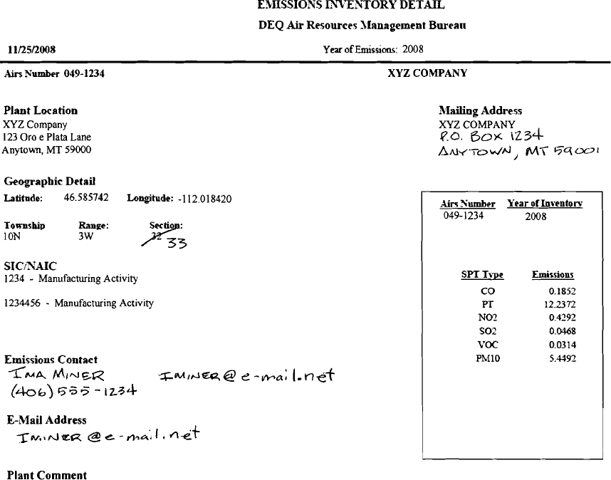

The Detail Pages
The Detail Pages look like the following example. The information listed on the Detail Pages displays the data that your facility submitted for the last reporting year. It is broken down by the process or type of equipment that emits air pollutants at your facility (the emitting points), and the air pollutants that each point emits. For most facilities, the three most significant columns on the page are identified by numbered arrows as follows:
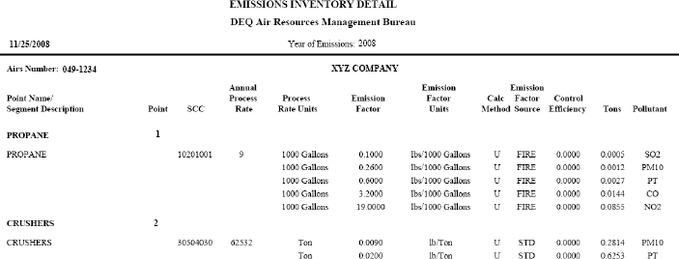


●
 The names of the processes or emitting Points.
 The Annual Process Rate at which each point operated.
● The units defining each of the Process Rates.

In the example above, the XYZ Company reported that Point 1 combusted 9,000 gallons of propane during the last reported calendar year. At Point 2, crushers at the facility processed 62,532 tons of material during the last reported calendar year.

All Facilities
Follow these steps to edit the Inventory Detail Pages:

  - Identify or calculate the process rate at which each emitting point operated through the year. Make sure the units match the listings in the column titled Process Rate Units (Arrow ). Cross out the value printed in the Annual Process Rate column (Arrow ) and write in the rate for the last calendar year for each point. (See the example on the following page).
  - Make sure all the applicable equipment that emits air pollutants is listed. If you have added emitting points in the last year through the de minimis process, write them in at the bottom of the page. Include the Process Rate and Process Rate Units for each point. If you have worked with the Department to identify an Emission Factor for the point, and if you know the SCC code for the process, include that information as well.

For most facilities the Inventory is complete at this point. Scan sections B and C below to see if they apply to your facility. If not, submit your edited Inventory to the Department as described in Section III.

Facilities with Emission Rate Changes
For more complex facilities or facilities where a stack test has been conducted, an additional Inventory editing step will be required. The column titled Emission Factor contains values that predict the amount of each air pollutant emitted per unit of process rate. These values may only be modified if you have documentation that justifies the change. For example, if the facility in the example above had performed and reported a stack test in the last year on the propane combustion process, the Emission Factors should be changed to reflect the results of the test and more accurately report the year’s total emissions. Changes to the Emission Factors can also result when the Federal Environmental Protection Agency (EPA) updates its databases of emission factors (referred to as AP-42 and the FIRE databases). If you can document a change to any of the emission factors, do the following:

  - Cross out the factor to be changed and write in the new emission factor.
  - Write in the corresponding emission factor units in the appropriate column.
  - Write in the source of the emission factor information in the Emission Factor Source column. (For example, “FIRE” refers to the EPA FIRE database. “STD” refers to stack test data).

Facilities with Control Equipment Changes
If your facility operates equipment to control certain air pollutants and the equipment has experienced a documented modification in its efficiency, you may write in a change in the column titled Control Efficiency. The values are listed as decimal percentages, so a 50% control efficiency would be listed as 0.5000. Quite frequently the Inventories do not list control efficiencies here, even when control equipment is functioning at the facility. In these cases the effects of the control equipment are built in to the Emission Factor, rather than listed as a separate Control Efficiency. It is recommended that you discuss any potential changes to reported Control Efficiencies with the Department.

An edited Detail Page might look like this:
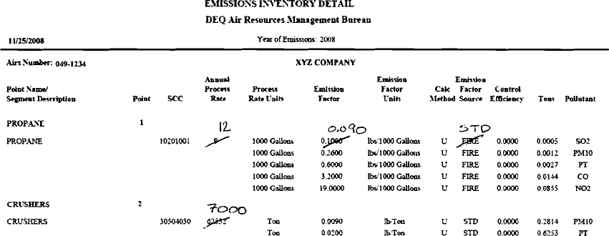

Inventory Submittal
When you have completed all of your edits, send the Inventory back to the Department at the address listed below. To allow you the greatest amount of time to review and ensure the accuracy of the updated emission inventory after it has been compiled, please submit the requested information as soon possible after January 1. However, the information must be received by the Department no later than February 15. Please submit your Inventory information to the attention of the individual who originally sent it to you at the following address:
Montana Department of Environmental Quality Air Quality Bureau
P.O. Box 200901
Helena, Montana 59620-0901

Once the Department receives and validates your Emission Inventory changes and information, air emission totals for each pollutant at your facility will be calculated, and then an updated copy will be returned to you for your review. Your annual operating fees for the next year will be assessed based on this report. In order to maintain your air quality permit these fees must be paid, even if your facility did not operate in the last calendar year.

