 | DEPARTMENT OF  ENVIRONMENTAL QUALITY  Air Resources Management Bureau  Air Registration Section  GUIDANCE STATEMENT | Effective Date:07/09/09
 |  | Authored By: Mark Ewanic
 |  | Approved By: Dave Aguirre
 |  | Manual Section: Section I General Procedures, 1-6
Title: Oil or Gas Well Facilities and Calculating Potential to Emit (PTE)
Applicability: All Montana Registered Oil or Gas Well Facilities
Title, Date & Author of Superseded Guidance or Policy Statement (if any): Oil & Gas Well Facilities and Calculating Potential to Emit (PTE), 06/01/07, Vickie Walsh

PURPOSE

The purpose of this guidance statement is to clarify the determination of potential to emit (PTE) for oil or gas well facilities as defined in 75-2-103(13), Montana Code Annotated (MCA).

BACKGROUND

In the spring of 2004, the Department of Environmental Quality – Air Resources Management Bureau (Department) became aware that there were many oil or gas well facilities that exceeded the PTE permitting threshold and would therefore be required to obtain a Montana Air Quality Permit (MAQP) prior to construction and operation of a facility. The Department undertook a review process and ultimately the Montana Legislature and the Department made some statutory and rule changes, respectively, to deal with oil or gas well facilities. In January of 2006, the Department was inundated with MAQP applications for oil or gas well facilities. As a result, in April 2006, Administrative Rules of Montana (ARM) Title 17, Chapter 8, Subchapter 17, Registration of Air Contaminant Sources was finalized.

Questions regarding calculation of PTE for an oil or gas well facility have been brought up by industry. PTE is defined under the ARM as, "Potential to emit means the maximum capacity of a facility or emitting unit, within physical and operational design, to emit a pollutant. Any physical or operational limitation on the capacity of the facility or emitting unit to emit a pollutant, including air pollution control equipment and restrictions on hours of operation or on the type or amount of material combusted, stored, or processed, is treated as part of its design only if the limitation or the effect it would have on emissions is federally enforceable. Secondary emissions are not considered in determining potential to emit.”

METHODS

The issue in determining PTE for an oil or gas well facility is to determine “…the maximum capacity of a facility or emitting unit, within physical and operational design, to emit a pollutant.” A general facility set-up, showing typical emitting points at an oil or gas well facility, is shown in the figure below.

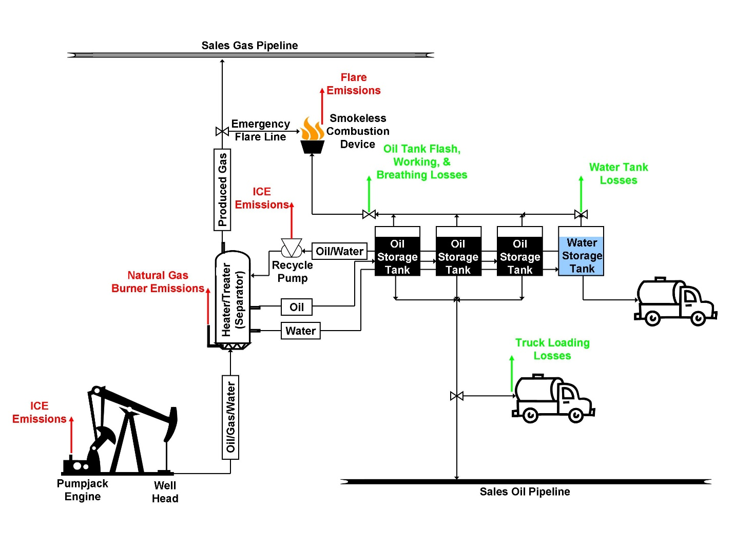

PTE must be based on the maximum daily operational capacity that is not expected to be exceeded during normal operation. If oil and/or gas production exceeds the rate at which the facility was registered, the facility may be out of compliance with registration and/or emission control requirements. The following sections provide general guidance for determining PTE for the standard emitting units found at oil or gas well facilities.

Internal Combustion Engines
Potential emissions from internal combustion engines (ICEs) must be calculated based on 8,760-hours per year (hrs/yr) operation and the manufacturer's guaranteed maximum rated design capacity (horsepower). The horsepower (hp) rating should not be adjusted for elevation or temperature. Emission factors used in calculations are typically manufacturer guaranteed emission factors or AP-42 emission factors. Also, if the heat content of the fuel is not available, a value of 1020-British thermal units/standard cubic feet (Btu/scf) may be assumed.

Natural Gas Burners
Potential emissions from natural gas burners must be calculated based on 8,760-hrs/yr operation and the manufacturer's maximum rated design capacity of the burner. If the burner efficiency is not known, a value no greater than 80% may be assumed. Emission factors used in calculations are typically manufacturer guaranteed emission factors or AP-42 emission factors. Also, if the heat content of the fuel is not available, a value of 1020-Btu/scf may be assumed.

Produced Oil Storage Tanks
Emissions from oil storage tanks include flashing losses, working losses, and breathing losses. Flashing losses occur when the vapors are released from the crude oil (or other hydrocarbon liquid) in the storage tanks as it is transferred from a higher pressure vessel (separator) to a lower pressure vessel (storage tank). Working losses are those losses caused as the tank is filled and emptied; and, breathing losses occur from the daily changes in temperature and barometric pressure. The potential emissions from oil storage tanks must take into account all three losses.

A variety of software packages and other empirical methods to estimate tank flashing losses, working losses, and breathing losses are available. In general, the Department accepts the use of Peng-Robinson or S-R-K methods based on widely acknowledged principals of behavior for hydrocarbon vapors and liquids. The use of default values offered or non site-specific data is discouraged unless adequate justification (e.g., analytical data was taken from a nearby well producing from the same geologic formation, etc.) can be provided. Default values or non site-specific data may not be acceptable when evaluating/reviewing PTE as it pertains to facility emission control requirements, emission inventories, or deregistration requests.

As stated above, the oil production rate used to calculate potential oil storage tank emissions should be a daily maximum production rate not expected to be exceeded during normal operation. Any analytical sample should be acquired using accepted methods, consistent with the requirements of the selected method/model, to ensure sample integrity.

Produced Water Storage Tanks
Potential emissions from produced water storage tanks can be estimated using the methods described in AP-42 Chapter 7: Liquid Storage Tanks, providing sufficient information on the physical and chemical properties of the mixture (i.e., water and petroleum liquids) in the water tanks is known. Since analytical data for the water and petroleum liquids mixture are often not available, the Department has determined that using EPA-450/3-85-001a – Volatile Organic Compound Emissions from Petroleum Refinery Wastewater Systems - Background Information for Proposed Standards is an acceptable alternative to estimating potential water storage tank emissions. EPA-450/3-85-001a gives an emission factor of 0.0000195-ton VOC per barrel of wastewater produced for wastewater in an oil-water separator. The water production rate used to calculate potential water tank emissions should be a daily maximum production rate not expected to be exceeded during normal operation.

Produced Gas
Potential emissions resulting from the produced gas depend on the design of the facility. The Department determined that oil or gas well facilities that were designed to route produced gas to a sales pipeline or use all of the produced gas to power on-site equipment do not normally disconnect these lines and allow the gas to vent to atmosphere. As a result, PTE from such a facility may not need to include the total emission from produced gas. Instead, if a smokeless combustion device is used in situations when the produced gas can not be routed to the sales pipeline or the facility does not operate without the produced gas as fuel, the PTE is determined using a method consistent with the Department’s and Environmental Protection Agency’s (EPA) guidance on backup/emergency generators.

When determining whether the pipeline or produced gas-powered equipment is an inherent part of the design, the following three primary questions must be answered.

- Is the primary purpose of the equipment (e.g., pipeline, pumpjack engine, heater/treater burner) to control air pollution?

- Where the equipment is recovering product, how do the cost savings from product recovery compare to the cost of the equipment?

- Would the equipment be installed if no air quality regulations were in place?

For example, a facility, such as one shown in the above figure, routes oil and water from the heater/treater (separator) to the storage tanks and the produced gas is primarily routed to a sales pipeline. In emergencies (e.g., pressure in sales pipeline prevents produced gas from entering) the produced gas can be sent to a smokeless combustion device. In determining the PTE from this example facility, the answer to the three primary questions above may be:

- Is the primary purpose of the equipment to control air pollution?
No, the pipeline’s primary purpose is to gather hydrocarbons to transport them for sale and use.

- Where the equipment is recovering product, how do the cost savings from the product recovery compare to the cost of the equipment?
Product recovery is the sole reason the pipeline is installed and the cost savings of the product recovered far outweighs the cost of the pipeline. The only reason the well is completed and the pipeline installed, instead of plugged and abandoned, is recovery of the hydrocarbons through the pipeline outweighs abandonment.

- Would the equipment be installed if no air quality regulations were in place?
Pipelines have been installed long before air quality regulations were in place. Therefore, even without air quality regulations, the oil and gas industry would continue to collect hydrocarbons for sale and use. The primary way hydrocarbons are collected is through the use of pipelines.

The determination from this example would be that the facility is inherently designed to send gas to the pipeline. Therefore, the PTE calculation would not include the potential gas emissions sent to the pipeline.

The manner and annual hours of operation used in determining produced gas potential emission estimations will, however, depend on the facility design. The following questions pertaining to the facility design should be answered in order to determine produced gas PTE:

- Is the facility designed to route produced gas to a sales pipeline?

- Is a smokeless combustion device installed on-site?

- If a smokeless combustion device is installed on-site, is the facility designed to route produced gas to it (either full-time or in emergencies)?

- If routed to a smokeless combustion device in emergencies, are the hours of operation expected to exceed 2,000-hrs/yr?

The following flowchart can be used to help determine what manner and annual hours of operation should be considered when calculating produced gas PTE.

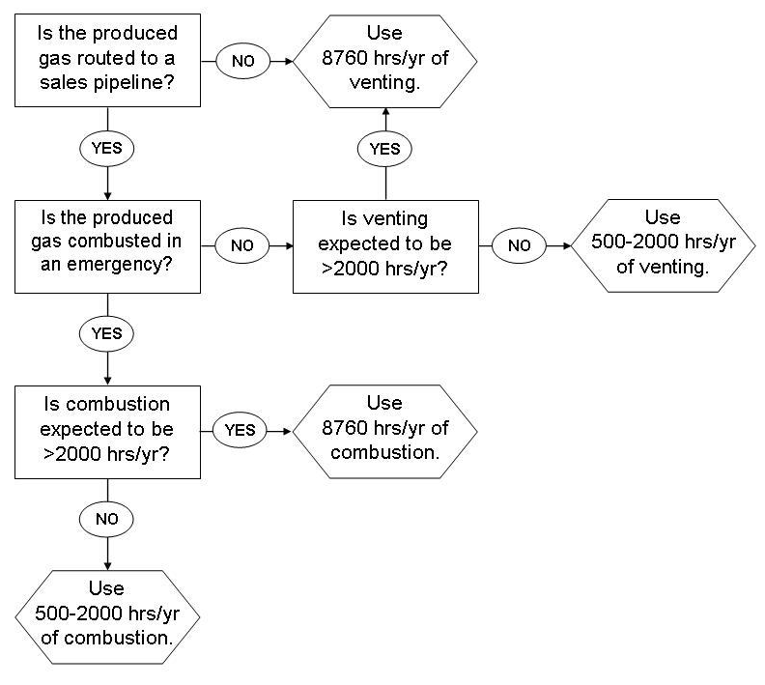

Continuing with the example facility above, produced gas is primarily routed to a sales line; and, in emergencies the produced gas is re-routed to an on-site smokeless combustion device. Historically, the facility has never needed to combust the produced gas for more than 2,000-hours in a given year. In determining the manner and annual hours of operation for the produced gas PTE, the answers to the above questions would be:

- Is the facility designed to route produced gas to a sales pipeline?
Yes, a pipeline is in place to route produced gas to a sales line. The primary method of handling produced gas is routing it to the sales pipeline.

- Is a smokeless combustion device installed on-site?
Yes, the site has a smokeless combustion device installed on-site.

- If a smokeless combustion device is installed on-site, is the facility designed to route produced gas to it (either full-time or in emergencies)?
Yes, the produced gas can be routed to the on-site smokeless combustion device. This is done only during periods when the produced gas can not be routed to the sales pipeline.

- If routed to a smokeless combustion device in emergencies, are the hours of operation expected to exceed 2,000-hrs/yr?
No, historically the hours of combusting produced gas have been much less than 2,000-hrs/yr.

The determination from this example would be that the PTE calculation to determine the produced gas emissions would need to account for 500- to 2,000-hrs/yr of combusting the produced gas.

Truck Loading Losses
Loading losses occur as stored oil is loaded into the tank and hydrocarbon vapors in the empty tank are displaced to the atmosphere. The Department has determined that the methods estimating tank loading losses found in AP-42 Chapter 5.2 – Transportation and Marketing of Petroleum Liquids are acceptable when determining PTE. The oil production rate used to calculate truck loading loss emissions should be a daily maximum production rate for the facility that is not expected to be exceeded during normal operation.

Fugitive Equipment Leaks
Emissions from fugitive equipment leaks may be estimated using EPA methods or with applicable software. The number of components (e.g., connectors, flanges, open-ended lines, pumps, valves, etc.) at the facility may be counted or estimated. However, estimates must have proper justification (e.g., based on facility drawings or numbers observed at similar facilities). PTE must be calculated based on 8,760-hrs/yr operation.

CONCLUSION

This guidance is only intended for use at oil or gas well facilities as defined by 75-2-103(13), MCA, and is not intended to be applied to other industries and/or facilities. Alternative methods for determining PTE, not described in this guidance, may be acceptable. The Department will review PTE determinations on a case-by-case basis.

