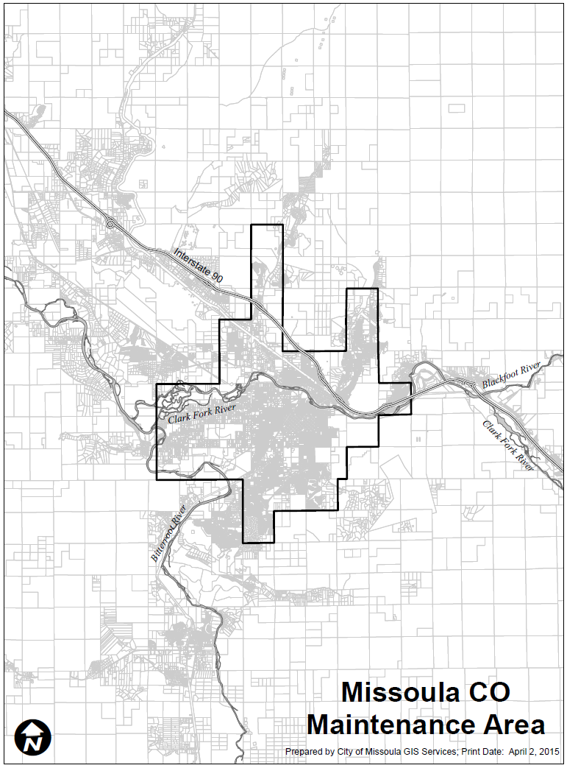
Missoula was designated as a nonattainment area for the 1971 Carbon Monoxide standard on March 3, 1978. On September 17, 2007, the area was reclassified to attainment and placed under a maintenance plan. The area bounded by lines from Universal Transverse Mercator (UTM) coordinates: begin, 700,000m E, 5,347,000m N, east to 704,000m E, 5,347,000m N, south to 704,000m E, 5,341,000m N, west to 703,000m E, 5,341,000m N, south to 703,000m E, 5,340,000m N, west to 702,000m E, 5,340,000m N, south to 702,000m E, 5,339,000m N, east to 703,000m E, 5,339,000m N, south to 703,000m E, 5,338,000m N, east to 704,000m E, 5,338,000m N, south to 704,000m E, 5,336,000m N, west to 702,000m E, 5,336,000m N, south to 702,000m E, 5,335,000m N, west to 700,000m E, 5,335,000m N, north to 700,000m E, 5,340,000m N, west to 695,000m E, 5,340,000m N, north to 695,000m E, 5,345,000m N, east to 700,000m E, 5,345,000m N, north to 700,000m E, 5347000m N.
Missoula was designated as a nonattainment area for the 1971 Carbon Monoxide standard on March 3, 1978. On September 17, 2007, the area was reclassified to attainment and placed under a maintenance plan. The area bounded by lines from Universal Transverse Mercator (UTM) coordinates: begin, 700,000m E, 5,347,000m N, east to 704,000m E, 5,347,000m N, south to 704,000m E, 5,341,000m N, west to 703,000m E, 5,341,000m N, south to 703,000m E, 5,340,000m N, west to 702,000m E, 5,340,000m N, south to 702,000m E, 5,339,000m N, east to 703,000m E, 5,339,000m N, south to 703,000m E, 5,338,000m N, east to 704,000m E, 5,338,000m N, south to 704,000m E, 5,336,000m N, west to 702,000m E, 5,336,000m N, south to 702,000m E, 5,335,000m N, west to 700,000m E, 5,335,000m N, north to 700,000m E, 5,340,000m N, west to 695,000m E, 5,340,000m N, north to 695,000m E, 5,345,000m N, east to 700,000m E, 5,345,000m N, north to 700,000m E, 5347000m N.

