
Weather, Air Quality, & Open Burning

There’s snow on the ground and it’s finally safe to burn, but DEQ still says I cannot burn.
Why?
DEQ’s primary concern with open burning is to protect the air quality, which means burning only during periods of good dispersion. Unfortunately, periods of good dispersion are less frequent in the cold months than in the warm months. This document will address the relationship between the weather, air quality, and open burning.

What is dispersion?

Dispersion is the atmosphere’s ability to mix the air and any pollutants in the air, such as smoke.

When Dispersion is Good
When Dispersion is Poor

- Smoke will rise and become diluted to the point where it is no longer visible, and then high atmospheric winds blow smoke away.
- The airspace is large enough that there should be no air quality impacts from smoke.
- The air does not mix well.
- Smoke can obstruct visibility and impact the air quality.

What does the sun and weather have to do with open burning?

Open burning is more restrictive in the cold months because dispersion is generally poor. | Open burning is less restrictive in the warm months because dispersion is generally good.
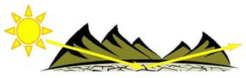 | 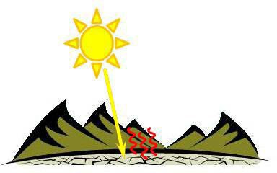
From late fall to early spring, the days are shorter, and the sun is low in the sky. Long nights create more nighttime cooling, and the low sun angle is not an effective means of heating the ground. Much of the solar radiation reflects off the surface of the earth without heating the ground or surrounding air, and snow reflects even more of the sun’s energy. We can see that there is little to no solar influence in the cold months, which is so important for mixing the air to create good dispersion. | From late spring to early fall, the days are longer, and the sun is higher in the sky. When the sun is high in the sky, the solar rays hit the ground more directly, which heats the ground and the lowest levels of the atmosphere. The air near the ground becomes warm, rises, and mixes with the rest of the atmosphere. This mixing is key for good dispersion, because we want an energetic and well-mixed atmosphere to mitigate air quality impacts by getting smoke “up and away.”

Another problem that arises in the cold months in western Montana is frequent valley inversions, where cold air sinks and becomes trapped in the valleys. A warm layer above creates a sort of lid that prevents any vertical mixing, especially with weak solar energy. These valley inversions can last for a few hours or well over a week in some valleys. Any pollution that is produced, from car exhaust to dust and wood stove smoke, will increase and remain trapped under this lid until the inversion can break and allow the air to mix.
• Clear skies or high clouds
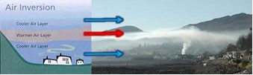

So how can we find good dispersion days in the cold months?
Without the sun’s influence, we must look for active weather patterns for periods of good dispersion and “windows of opportunity” for open burning. As a general rule, we never want to burn under a ridge of high pressure; we want to wait for the energy created by a low pressure system.
Characteristics of a high pressure system  - Calm wind  - Creation or strengthening of valley inversions | Characteristics of a low pressure system  - Increased cloudiness  - Breezy to strong winds  - Cold front  - Precipitation

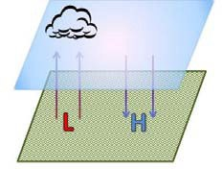
We can use the diagram above to help show why high-pressure systems (H) are “bad” and why low-pressure systems (L) are “good.” You can think of these systems as large columns of air. In a high-pressure system, there is a lot of air in this column. It is heavy, sinks toward the ground, and prevents the mixing of air. Conversely, the air around a low-pressure system is unstable, rises, and is well-mixed. In the cold months, only low- pressure systems create enough energy in the atmosphere to produce mixing and good dispersion!
You can submit a winter burn request at: deq.mt.gov/Air/Programs/burning

