EQuIS Data Processor (EDP) Quick-start Guide for e-TREADS

Waste Management and Remediation Division

Montana Department of Environmental Quality

July 26, 2017



Table of Contents

1 EQuIS Electronic Data Processor (EDP) Overview 3

2 EDP Installation 3

2.1 Download and Install the EDP Application 3

2.2 Download the Montana DEQ e-TREADS format 4

2.3 Download the Montana DEQ e-TREADS Reference Values 4

2.4 Registering the EQuIS Data Processor 4

3 Using the EDP 7

3.1 EDP Main Window 7

3.2 Loading EDD Files 8

3.3 Error Logs 9

3.4 Correcting Errors in the EDD 9

3.4.1 Using Find and Replace 10

3.4.2 Miscellaneous Tool Bar Features to Assist in Correcting Errors 11

3.5 Saving Changes to the EDD File 11

3.6 Using EDP to Attach Documents 12

3.7 The Data Package 12

4 EDP Updates 13

4.1 Montana DEQ E-TREADS Format Updates 13

4.2 Montana DEQ e-TREADS Reference Value Updates 13

5 Contacting the e-TREADS Administrator 13

# EQuIS Electronic Data Processor (EDP) Overview

This document provides a quick overview on how to download, install, and use the EQuIS Data Processor (EDP) software to check and submit Montana Department of Environmental Quality (MTDEQ) e-TREADS Electronic Data Deliverables (EDDs).

The EDP is a standalone application that must be used by data providers to check their EDD files prior to submission to e-TREADS. The EDP performs a series of formatting checks on the EDD and then identifies any records that have errors. The EDP checks data for the following:

1. Required Fields
2. Field Length
3. Data Types
4. Valid Reference Values
5. Duplicate Rows
6. Range Checking
7. Record Parent-Child Relationships

If errors are detected, the application allows the data provider to correct the errors directly in the EDP. After all errors have been corrected, the EDP must be re-run to ensure that no errors remain. EDD files that pass through the EDP error-free should also result in an error-free import into the e-TREADS database, as long as the EDD submittal process is followed. The EDP does not compare the data in the EDD to the data in the e-TREADS database, so it is possible to receive an error when submitting to e-TREADS if the data in your EDD does not relate to data in the database.

All e-TREADS materials referenced in this guidance manual are available on DEQ’s e-TREADS support website located at [http://deq.mt.gov/Land/rem/etreads](http://deq.mt.gov/Land/IMTS/e-TREADS.aspx).

# EDP Installation

To use the EDP application, the following four steps must be completed in the order shown:

1. Download and install the EDP application
2. Download the e-TREADS Format
3. Download the e-TREADS Reference Values
4. Register the EDP Application

The download page for the EDP application and associated files can be accessed from the e-TREADS Support website hosted by EarthSoft: <http://earthsoft.com/products/edp/edp-e-treads-format-for-the-montana-department-of-environmental-quality/>

## Download and Install the EDP Application

From the e-TREADS Support website hosted by EarthSoft: <http://earthsoft.com/products/edp/edp-e-treads-format-for-the-montana-department-of-environmental-quality/>

1. Click on the EQuIS Data Processor (EDP) version 6.x link to start the download.
2. Open the directory where the EDP file was downloaded and double click the file to start the installation wizard. Follow the step by step procedure to finish the installation.

## Download the Montana DEQ e-TREADS format

From the e-TREADS Support website hosted by EarthSoft: <http://earthsoft.com/products/edp/edp-e-treads-format-for-the-montana-department-of-environmental-quality/>

1. Click on the e-TREADS format that corresponds to the version of EDP you already have EDP installed (i.e., 5.6.x or 6.x).

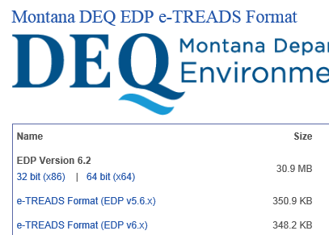

Screen Shot of File Download Website (note the “Modified” column for the latest file version date)

## Download the Montana DEQ e-TREADS Reference Values

From the e-TREADS Support website hosted by EarthSoft: <http://earthsoft.com/products/edp/edp-e-treads-format-for-the-montana-department-of-environmental-quality/>

1. Click on the e-TREADS Valid Values (RVF) and save the file to the e-TREADS format folder.

## Registering the EQuIS Data Processor

After the EDP program has been installed, you must register the software with a free registration key:

1. Double click the EDP icon on your desktop to open the program.

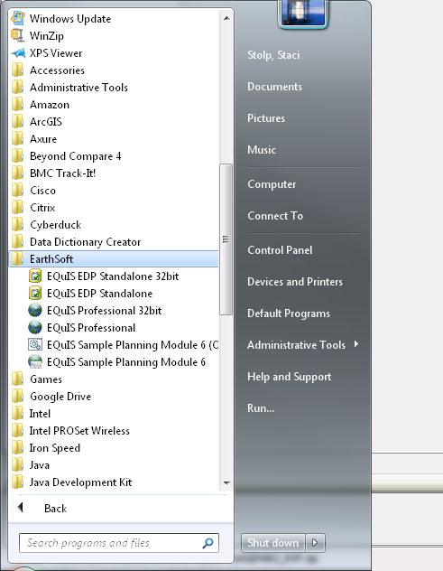

1. Click on the “notepad with green checkmark” icon in the upper left corner to open a drop down menu.

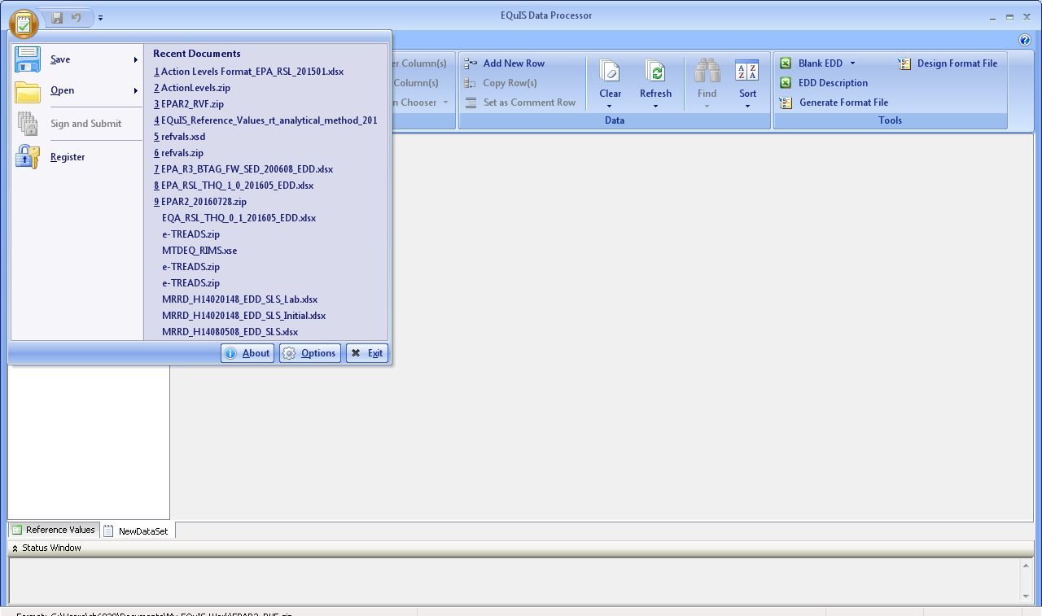

1. Click on the “Register” icon. A new window will open. At the bottom of this window click the link to “request registration key for this computer.”



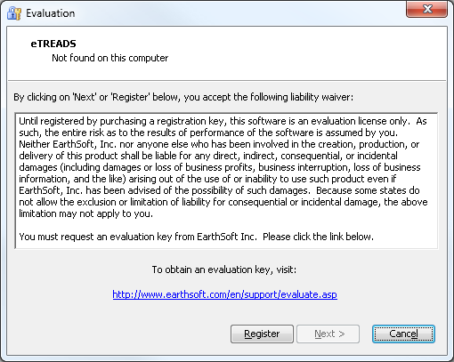

1. Complete the Registration Form and Click Submit. A registration key will be emailed to you, usually within one day.

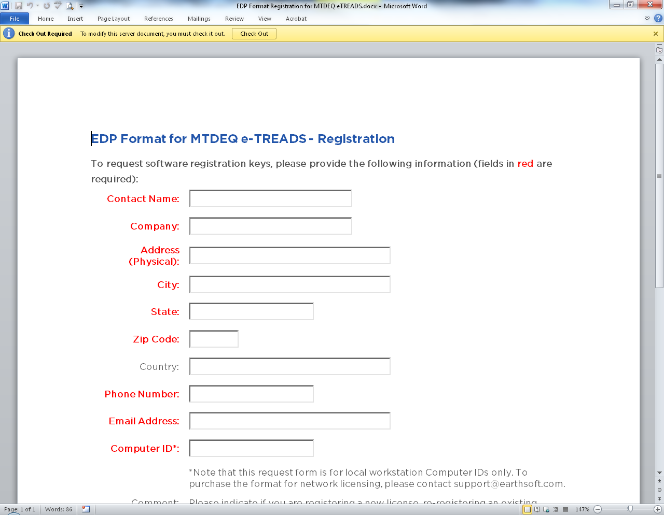

EarthSoft Registration Form to Request Key Code for EDP Software

1. Once you receive the e-mail with a registration code, copy & paste that code back into the EDP Software Registration window under the “New Key Codes” box and click “Save Key(s)” button to complete your registration. Then click “OK” to close the registration window.



Software Registration Window

After the EDP is installed and registered, the MTDEQ e-TREADS Format File must be loaded.

1. Start the EDP program (it may already be open if you just completed registration).
2. Select the “checklist” icon labeled Format in the upper left corner.
3. Select the e-TREADS.zip file. (Note, if you did not save the Format Files to the default location when downloading, you may have to browse to their location on your computer.)
4. Click Open.

The MTDEQ e-TREADS Format Files are displayed along the left side of the window in the EDP program.

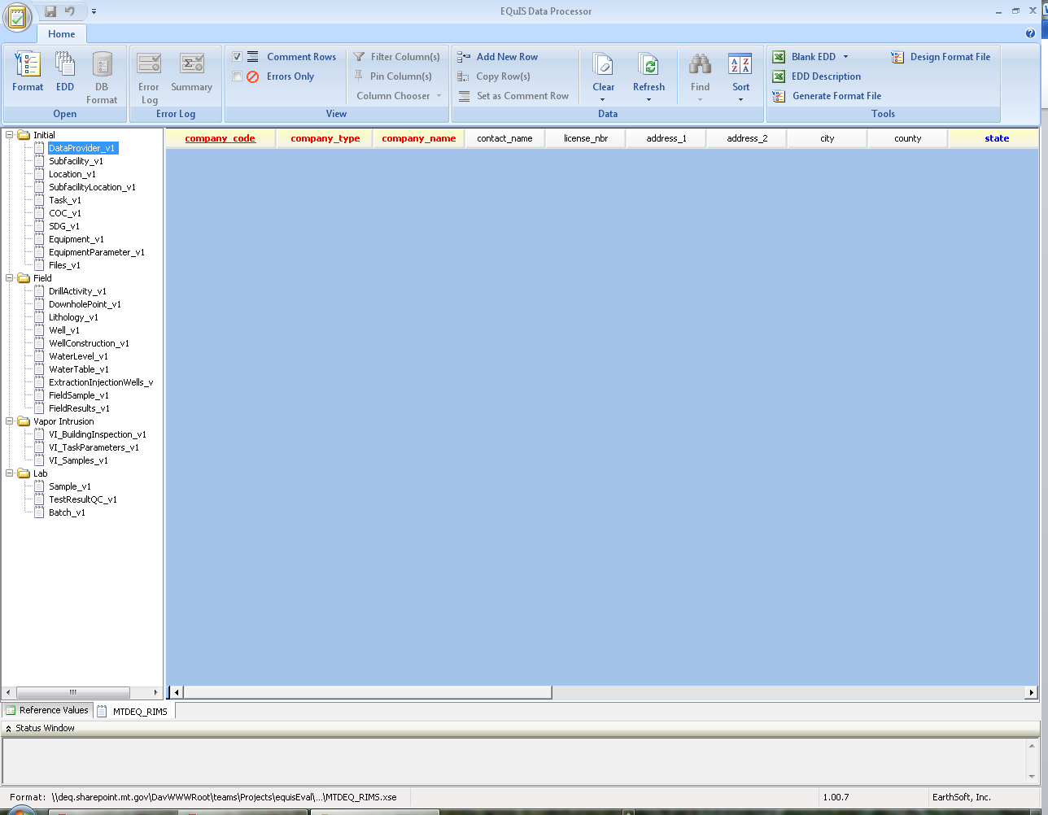

MTDEQ Format Tables Displayed in EDP Window

# Using the EDP

To start the EDP application, select Start 🡪 All Programs 🡪 EarthSoft 🡪 EQuIS Data Processor from the Windows ‘Start’ menu.

## EDP Main Window

The EDP main window contains all the tools you’ll need to use to load, review, and update your EDD file.

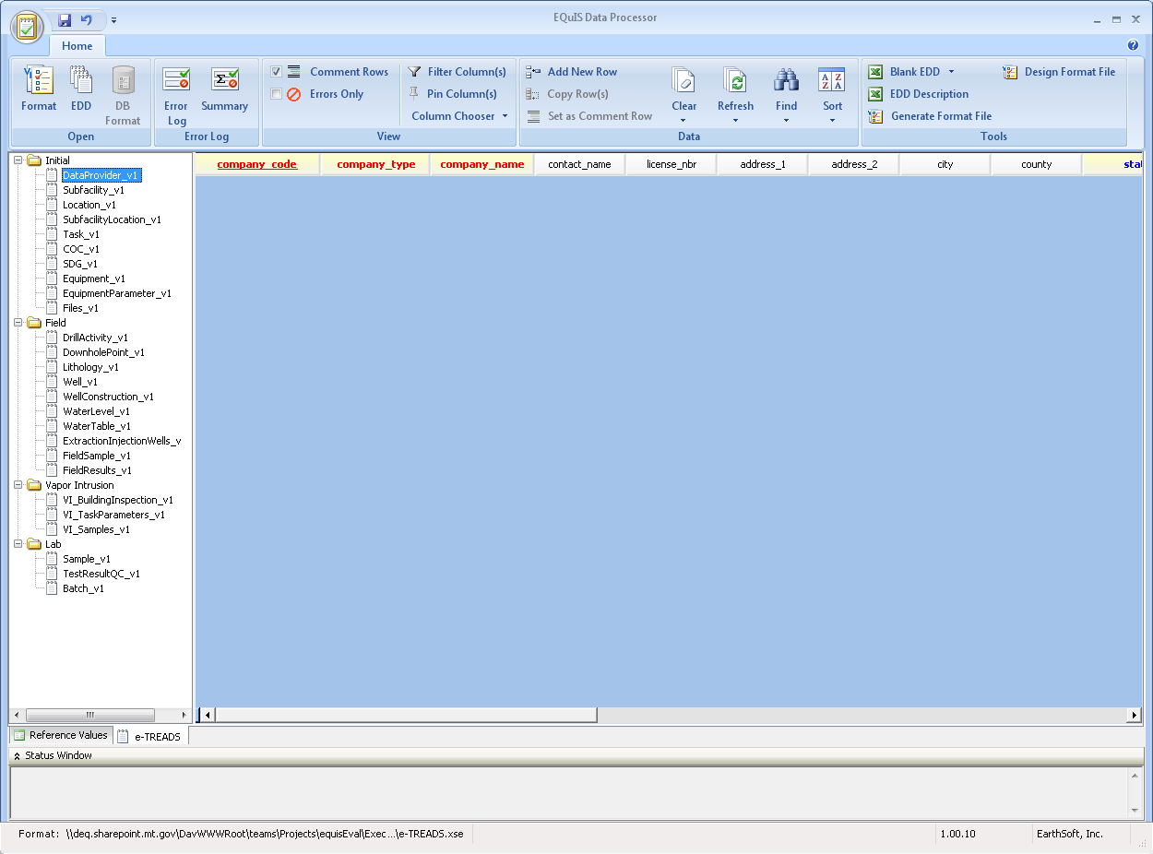

**4**

**3**

**1**

**2**

1. **Home Menu** – The home menu has options to:  
   1. Open an EDD or format
   2. Save an EDD
   3. Sign & Submit
   4. Register the EDP application
   5. Exit the application
2. **Sections of the EDD Format[1]**

The left pane contains the sections of the EDD format. These correspond to the worksheets in the Excel version of the EDD. Once an EDD is loaded, clicking on each of these sections will bring up the associated data.

1. **Tool Bar**

The tool bar stretches across the EDP window and has options to:

* 1. Open a Format, EDD, Error Log, or EDD Summary
  2. Turn comment rows off
  3. Select only rows with errors
  4. Turn column filters on
  5. Pin columns
  6. Choose which columns to show
  7. Add a new row to an EDD section
  8. Clear data from an entire table, an entire EDD, or an entire data package
  9. Refresh data in a selected row, table, or everything
  10. Find and replace text
  11. Sort columns ascending or descending
  12. Open a new blank EDD or open a description of the EDD

1. **Data**

The main portion of the window is devoted to displaying the data associated with each section of the EDD. At the top of the data portion are column headers which have tool tips. To access these tool tips, simply hold your mouse over the column header name. The tool tips give a brief description of the field and include information about field length and whether a field is required, conditional, or optional.

## Loading EDD Files

To load an Excel or Access EDD file containing multiple data sections[2]:

1. Click the “EDD” button from the Open menu
2. Browse to the file, and select “Open”.
3. The EDP will then load all the worksheets/tables of the EDD file into the appropriate formats. Once the file is loaded the data can be displayed by selecting the sections in the left pane. Sections with errors will have red text and sections with no errors will be green.

## Error Logs

After an EDD has been loaded, EDP will produce an error log that can be saved as an HTML formatted file. EDP has two types of error logs: a detailed error log that lists details about each error, or an error summary that lists the type and count of each error in the EDD.

1. In the top tool bar, select ‘Error Log’ to save and view a detailed list of the errors in the current EDD. Use the Browse window to locate the desired location to save the file. After ‘Save’ is selected the error log will open.

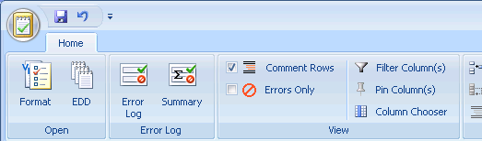

1. Select ‘Summary’ to save and view a summary of all the errors in the current EDD. Use the Browse window to locate the desired location to save the file. After ‘Save’ is selected the error log will open.



1. If there are no errors, the next step is to validate the data in the EDD using the [Data Validation Form or equivalent (non-lab data providers only)](http://deq.mt.gov/Portals/112/Land/WMRD/DataInformationResources/EQUIS/Documents/2015-12-15%20DV%20Guidance%20Checklist%20PDF%20Version%201.0%20Distributed%20(1).pdf).

## Correcting Errors in the EDD

As described in Section 1.0, the EDP application performs a series of formatting checks on the EDD and then identifies any records that have errors. The fields with errors will be shaded different colors depending on the type of error. A description of the error is provided when the cursor is placed over the field. In the example below, the company_code value in row 1 is not a valid value.

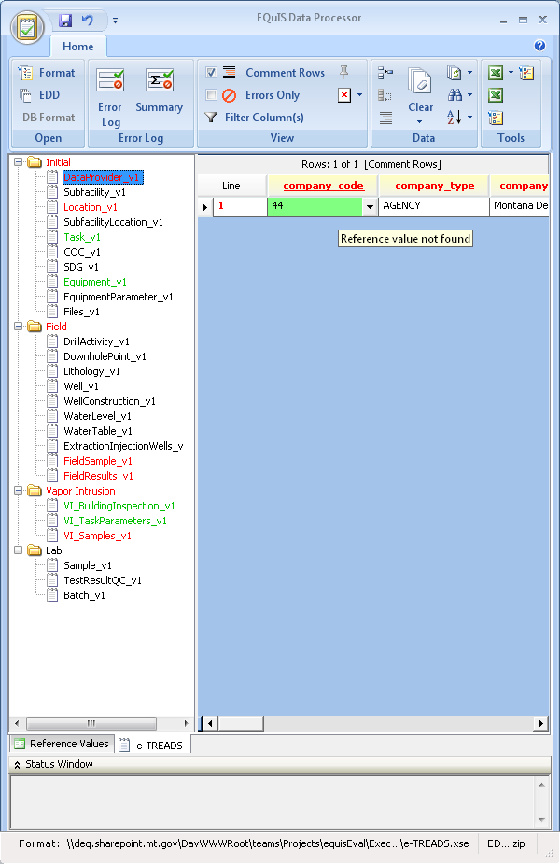

For most errors, there are two correction methods:

1. **Correct directly in EDP:** To get the most out of the EDP application, DEQ recommends correcting errors directly within EDP. Click in the error field and type the correct value. If the field is restricted to a list of valid values, the valid values will be provided in a drop-down list by clicking on the down arrow located on the left side of the field. Once an error is corrected and the cursor is moved out of the field (i.e. user clicks on another field) the shading signifying an error should disappear. If you believe you have corrected an error but the field remains shaded, refresh the EDD by selecting ‘Refresh Table’ in the tool bar. Selecting refresh will run the formatting checks again.
2. **Correct in original EDD file**: Exit the EDP application and then open the EDD file. Correct the error in the EDD file, resave the EDD, and then re-load the EDD back into EDP to check for additional errors. This method is best if you’re dealing with large EDD files that have many of the same errors (such as an incorrect valid value in 1,000 records).

Note: If data providers believe that a new reference value is required, they should follow the process described in Section 3.1.2 of the ‘e-TREADS Guidance Manual’ to request that the value be added.

### Using Find and Replace

The ‘Find and Replace’ function allows searching the EDD for specified values and then replacing those values with another value. This function is useful when there are a number of similar values that need to be changed. The ‘Find and Replace’ function is activated by selecting the binocular icon located in the Data section of the tool bar. The ‘Find and Replace’ dialog box will appear. Type the value to be replaced in the ‘Find What’ field and type the new value in the ‘Replace With’ field. Select ‘Find’ to view fields with the value and ‘Replace’ to replace the original value with the new value.

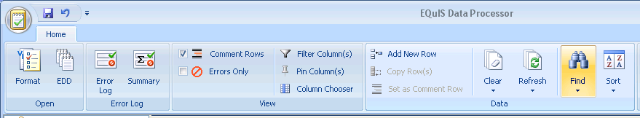

### Miscellaneous Tool Bar Features to Assist in Correcting Errors



There are several tool bar features to assist in correcting errors:

1. **View toolbar section**
   1. **Comment Rows:** Check the box to show comment rows. Comment rows are non-data rows, typically the two header rows in each section of your EDD. In EDP, comment rows have orange text.
   2. **Errors Only:** Check the box to show only rows with errors. This is very helpful when searching for records with errors, especially in larger EDDs.
   3. **Filter Columns:** Select ‘Filter Columns’ to turn on the column filter feature. When on, the filter icon will appear next to each column name. To filter a column, select the filter icon and choose your desired filter option: All, Custom, Blanks, Non-blanks, or an individual column value.
   4. **Pin Columns:** Select ‘Pin Columns’ to turn on the pin column feature. When on, the pin icon (a small push pin) appears next to each column name. To pin a column, click the pin icon next to the column to wish to not move. The pin icon will rotate down and the column will move in front of non-pinned columns.
   5. **Column Chooser**: Select the Column Chooser to select which columns you wish to view. A dialog window will appear that allows you to turn on or off each column. Column configurations can also be saved and loaded.
2. **Data toolbar section**
   1. **Add New Row:** By selecting ‘Add New Row’, a blank row will be added to the bottom of the current EDD section you’re viewing. This allows the user to enter data directly into the EDD via EDP, plus the format rules are applied as the data is entered.
   2. **Set as Comment Row:** If a comment row appears as a data record, highlight the row and select ‘Set as Comment Row’. In the Excel version of the EDD, comment rows are marked with a pound sign (#).
   3. **Find and Replace:** See section 3.4.1
   4. **Sort:** After selecting a column, select Sort to sort the records in ascending (A to Z, smallest to largest) or descending (Z to A, largest to smallest) order.

## Saving Changes to the EDD File

Changes made to the EDD directly in the EDP application are not automatically saved to the original EDD file that was loaded. To save the changes made:

1. Select Save 🡪 EDD from the Home Menu.

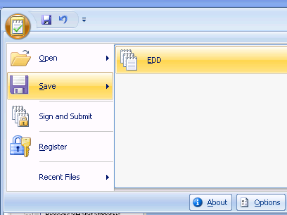

1. Browse to where you’d like to save the file. If you want to save the EDD as an Excel workbook with each section on a separate worksheet, select ‘Excel Workbook’ from the ‘Save as type:’ drop-down menu. Enter a file name and select ‘Save’. Select ‘Ok’ when asked if you would like to proceed saving the file.

## Using EDP to Attach Documents

Documents can be associated with an e-TREADS EDD via the “Files” worksheet. The fields in the “Files” worksheet can be filled out before the EDD is imported into EDP or they can filled out within EDP. With both methods, the following steps need to be completed in order for the Sign and Submit feature to work properly:

1. After the EDD has been loaded with no errors, go to the “Files” section of the EDD.
2. Select the button in the File_Name field of “Files” section. The button will not appear until the mouse hovers over the field.
3. Browse to the document to be uploaded and select ‘Open’.
4. If it was a document in the “Files” section, the File_Type and File_Date fields will also be populated after the document is opened. Now the EDD is ready for the Sign and Submit feature.

## The Data Package

When all of the tables that comprise the EDD have been loaded into the EDP and no errors are shown in each table when the “Errors Only” box is checked, and you have completed the [Data Validation Form or equivalent (non-lab data providers only)](http://deq.mt.gov/Portals/112/Land/WMRD/DataInformationResources/EQUIS/Documents/2015-12-15%20DV%20Guidance%20Checklist%20PDF%20Version%201.0%20Distributed%20(1).pdf), you are ready to create and submit your final data package. . The data package is a single .zip file that consists of the EDD, any attached documents referenced in the EDD, and the data provider’s user certificate. The EDP program has a feature which zips (compresses) the loaded files, and names the zip file with a standardized naming convention.

1. Click the icon in the upper left corner 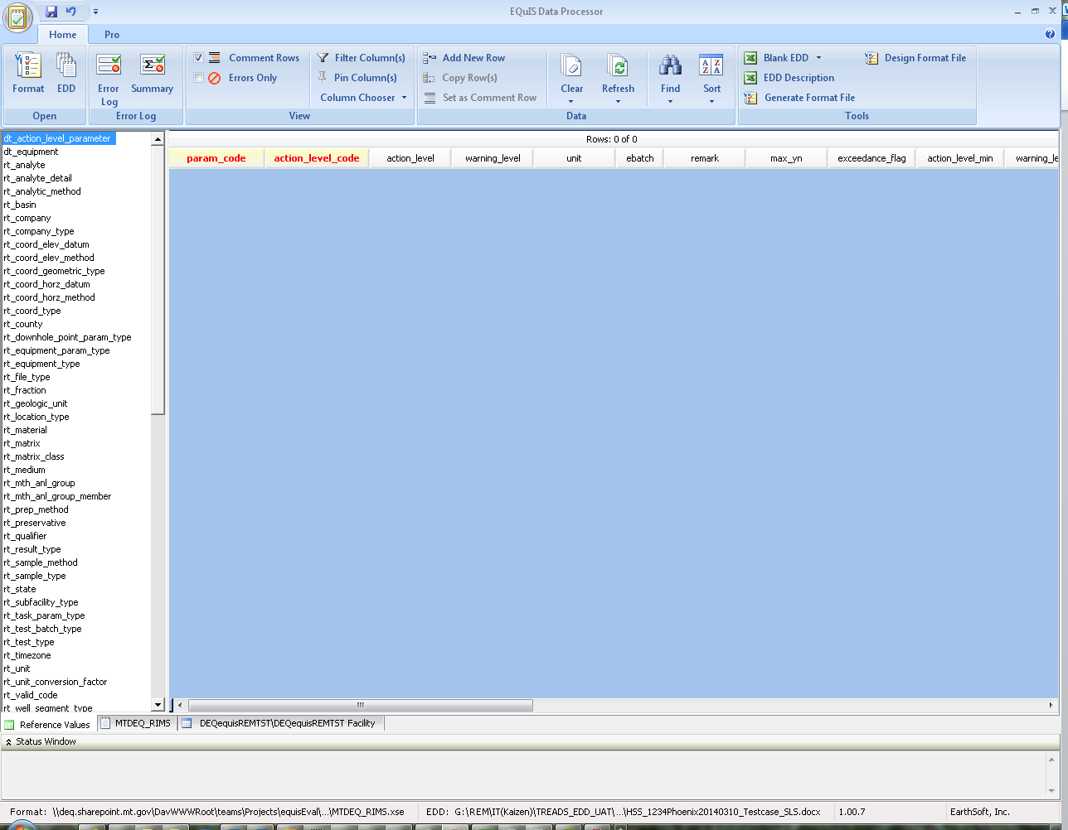
2. Select Sign and Submit. A Sign and Submit window will open.
3. Enter your user id and password that you received from MTDEQ e-TREADS.
4. Select the appropriate Program Code and Facility Name from the drop down lists (Check with the MTDEQ Project Manager for the appropriate values).
5. The zip file will be saved to C:\My Documents\My EQuIS Work.
6. The zip file should then be emailed to the e-TREADS EDD submission email account at eTREADS@mt.gov and the MTDEQ Project Manager for the site should also be cc’d on the email.

# EDP Updates

## Montana DEQ E-TREADS Format Updates

If DEQ makes changes to the Montana DEQ e-TREADS format, the EDP application will need to be updated with the new format files. DEQ does not plan to make frequent updates to the format, but occasionally DEQ may need to add or modify business rules or fields. If updates have been made to the format, a message will be sent through the e-TREADS ListServ notifying users that an updated format file is available for download. Follow the steps in Section 2.2 of this manual to download and install the updated format files.

## Montana DEQ e-TREADS Reference Value Updates

New reference values are likely to be added multiple times a year. Sample Collection Method and Analytical Method are examples of two fields that commonly require updates. If new reference values have been added, a message will be sent through the e-TREADS ListServ notifying users that an updated reference value file is available for download. Follow the steps in Section 2.3 of this manual to download and install the updated reference value file.

# Contacting the e-TREADS Administrator

For questions, concerns, and comments regarding the MTDEQ e-TREADS EDD submittal please consult the EDD manual and/or contact the MTDEQ e-TREADS Administrator eTREADSAdmin@mt.gov.

For help using the EDP program or getting the updated format files installed, please contact the EarthSoft Help Desk:

* http://www.earthsoft.com/support/help-desk/, or
* support@earthsoft.com, or
* (800) 649-8855

1. For more information on the e-TREADS EDD format, please refer to the [e-TREADS EDD Guidance Manual](http://deq.mt.gov/Portals/112/Land/WMRD/DataInformationResources/EQUIS/Documents/e-TREADS_EDD_Manual.docx).
2. Ibid.