Water Resource
Monitoring Methods Selection Guide (MMSG)
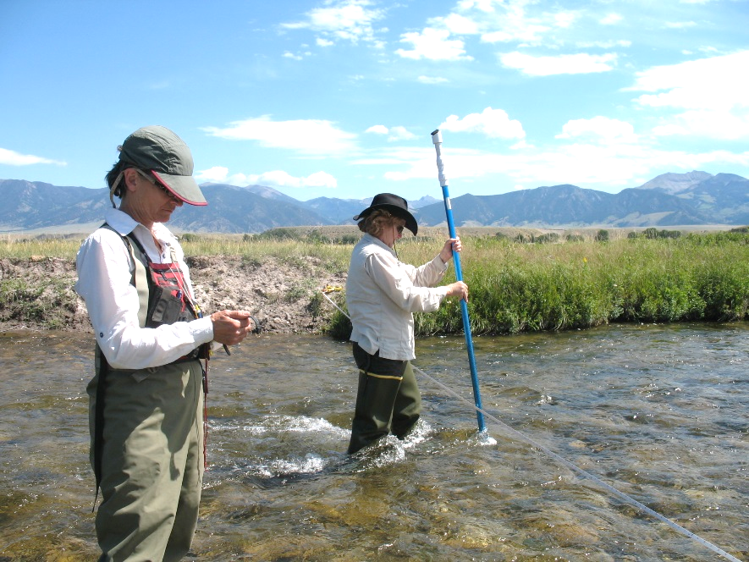

Version 1.0
Updated April 13, 2020

Authors
Katie Makarowski
Water Quality Specialist
Montana Department of Environmental Quality
W. Adam Sigler
Water Quality Associate Specialist
Montana State University Extension Water Quality

Table of Contents
Table of Contents 1
Authors and acknowledgements 2
How to use this guide 3
How this guide is organized 4
1. Current conditions 5
2. Pollution source assessment 8
3. Project effectiveness 11
4. Trend analysis 13
5. Outreach and education 15
Glossary of terms 16
Additional resources 18
Index of Parameters 19
Biology Methods 22
Chemistry Methods 41
Land Use Methods 55
Physical Methods 64
Riparian Methods 111

Suggested Citation:
Makarowski, Katie, Sigler, W. Adam, 2020. Water Resource Monitoring Methods Selection Guide, Version 1.0. Prepared by: Montana Department of Environmental Quality & Montana State University Extension Water Quality.

Authors and acknowledgements
Co-authorship is shared equally between the two authors. The authors would like to thank the following individuals for assistance with document development: Mark Ockey (MDEQ), Eric Trum (MDEQ), Holly Kreiner (MSUEWQ), Claire Bickford (MSUEWQ) and the following individuals for review/edits: Torie Haraldson (Gallatin Local Water Quality District), Tracy Wendt (Sun River Watershed Group), Sierra Harris (The Nature Conservancy), Patrick Cross (Yellowstone Ecological Research Center), and Claudia Macfarlane (Big Sky Watershed Corps, Ruby Valley Conservation District/Watershed Council).
Front cover image: Madison Stream Team volunteers monitoring on O’Dell Creek; image used with permission by the Madison Conservation District.

How to use this guide
This guide is to help people while designing monitoring efforts to articulate monitoring objectives to achieve goals, select appropriate parameters to achieve those objectives, and select appropriate monitoring methods for each parameter.
A goal is a desired outcome from an effort and can be relatively broad.
Example Goal 1: Address the algae concern in Spring Creek. (related to Current Conditions; Section 1)
Example Goal 2: Identify pollution source(s) that are contributing to impairments in Dell Creek. (related to Source Assessment; Section 2)

Step 1: State your goals
Prior to using this guide to determine your objectives, parameters of interest, and data collection methods, it is important to clarify your goals. The sections of this document are organized around five categories of goals: Section 1: Current Conditions, Section 2: Pollution Source Assessment, Section 3: Project Effectiveness, Section 4: Trends, and Section 5: Outreach and Education.

Step 2: Articulate your objectives and select associated parameters of interest
An objective is more focused than a goal and outlines specific and measurable steps for achieving your goal. Objectives should typically start with the word “To” and include the following details:
- A specific parameter or group of parameters
- A specific location or reach of a waterbody
- A relevant timeframe
- Specific context that is central to the question.

For each of your goals, browse the list of general objectives and associated parameters in Sections 1-5 of this document. These sections contain general objectives to provide ideas, but they are missing the specifics needed to make your objectives complete. Write your own detailed objectives, including specific parameters of interest, using the examples of detailed objectives provided in blue boxes throughout document for guidance.

Step 3: Select methods associated with identified parameters
Example Objective: To determine changes in nitrate concentration between point A and point B during July and August in the town section of Dell Creek where the highest septic system density occurs.

See the Section titled “Index of parameters” to find standard operating procedures (SOPs) for each of the parameters you have selected to monitor. The appendix contains an overview of each method and step-by step instructions for many common data collection methods.

Step 4: Write your SAP and SOP to document your sampling plan
Summarize your goals, objectives, parameters, and methods into a Sampling and Analysis Plan (SAP). The Additional Resources section has guidance for SAP development. Your SAP should be accompanied by a Standard Operating Procedure (SOP) which provides detailed instructions for use in the field; the SOPs in the appendix can be adapted to develop your own.

How this guide is organized
The sections of this guide are organized by categories of goals, and sections are in a logical order which often follows the evolution of monitoring programs over time.
- A group might first be interested in determining the current condition of water resources (Section 1).
  - A subsequent objective might be identifying sources of pollution (Section 2), used to guide implementation of water quality improvement projects.
    - After projects are implemented it is prudent to follow-up with project effectiveness monitoring (Section 3).
      - Finally, trend analysis (Section 4) allows your group to determine how conditions change over time.

An additional important and ongoing objective for many watershed groups is to provide outreach and education to increase knowledge, engagement, and stewardship of water resources in their local communities. Methods for education-based monitoring and assessing the success of your outreach efforts are presented in Section 5.
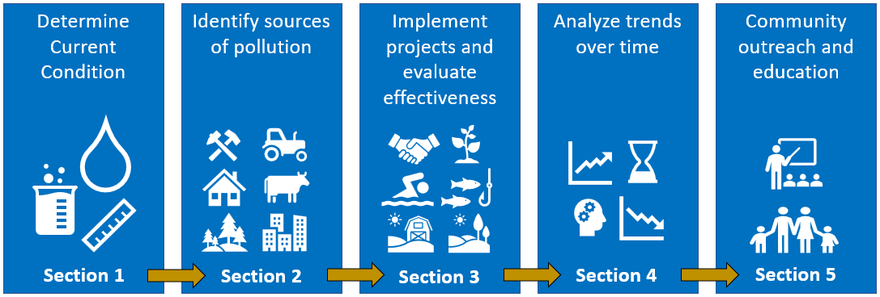
This guide also includes a glossary, a list of additional resources, an index of parameters, and an appendix with standard operating procedures for a variety of monitoring methods.

Current conditions
Gathering information on current conditions provides a snapshot of a waterbody’s health that can be used for a variety of purposes. The method you select for monitoring your parameter(s) of interest should be tailored to the reason you are assessing current conditions.
Example: Presence of water quality concerns
Locals have observed algae growth in Elm Creek downstream from where the Elm Creek Spring flows into the creek and are curious whether high nutrient concentrations in the spring could be contributing to the issue.
Their objective is:
“To characterize nutrient concentrations in the Elm Creek Spring by collecting samples from the spring orifice each month from July – September for nitrogen (TN), phosphorus (TP), nitrate + nitrite (NO₂₊₃₎, and ammonia (NH₃₊₄) analysis.”

One common reason for collecting information on current conditions is to determine whether there are water quality concerns. To accomplish this, you should compare your collected data to the water quality standards or other thresholds that relate to the concern. See the “Additional resources” section for water quality references.

Another reason your group might monitor current conditions is to determine conditions prior to an anticipated change in the watershed (for example, a change in land management or implementation of a restoration project). Monitoring before an anticipated change is called “baseline monitoring.” Baseline data can be compared to similar data collected after the change occurs to evaluate subsequent effects on water quality.
Example: Baseline conditions monitoring
A watershed group is working with a local landowner to provide an alternative water source for her livestock. Prior to this change, the group makes a goal to collect baseline information on the current health of the riparian area so they can quantify the success of their project later on.
Their objective is:
“To characterize riparian vegetation along the landowner’s 0.5 mile stretch of Rocky Creek by performing a Greenline Assessment in August of the year prior to project implementation.”

Waterbodies that do not meet state water quality standards are considered “impaired waters.” While only MDEQ has the jurisdiction to classify a waterbody as impaired, MDEQ may incorporate data collected by volunteers or others during water quality assessments if the data meets data quality and submittal requirements specified in MDEQ’s assessment methods and elsewhere.

See the Additional Resources section for links to Montana water quality standards and the MDEQ Clean Water Act Information Center where you can access Montana’s list of impaired waters.

A list of objectives and relevant parameters associated with determining current conditions is provided below:
To characterize channel morphology and instream habitat
- Physical – bank erosion hazard index
- Physical – flood prone width and entrenchment ratio
- Physical – greenline to greenline width
- Physical – large woody debris
- Physical – pool frequency (e.g., number of pools per 1000 ft)
- Physical – pool tail grid toss – percent fine sediment < 6mm in pool tails
- Physical – residual pool depth
- Physical – riffle pebble count with gravelometer – median particle size (D50)
- Physical – riffle pebble count with gravelometer – percent fine sediment <2mm and or < 6 mm in riffles
- Physical – Rosgen stream type
- Physical – water surface slope
- Physical – width/depth ratio
To characterize riparian vegetation
- Riparian – multiple indicator monitoring – greenline composition
- Riparian – multiple indicator monitoring – stream bank stability and cover
- Riparian – riparian greenline assessment
To characterize fine sediment deposition in critical habitats for fish or other aquatic life
- Physical – pool tail grid toss – percent fine sediment < 6mm in pool tails
- Physical – riffle pebble count with gravelometer – percent fine sediment <2mm and or < 6 mm in riffles
To characterize nutrient concentrations
- Chemistry – dissolved oxygen – daily delta
- Chemistry – water samples for chemical constituents (TN, TP, NO2+3, NH3+4)
To characterize metal concentrations
- Chemistry – water samples for chemical constituents (metals)
- Chemistry – water samples for chemical constituents (metals)
To characterize nuisance algae growth
- Biology – algae – harmful algal blooms
- Biology – benthic algae biomass (chlorophyll-a, ash-free dry mass)
To characterize the aquatic biological community
- Biology – fish community characterization
- Biology – macroinvertebrate assemblage
- Biology – periphyton assemblage: peri- 1 and peri-1 mod
- Biology - phytoplankton

Pollution source assessment
Once a water quality concern has been identified (for example, a waterbody isn’t meeting water quality standards for a pollutant), it is useful to identify the source(s) of pollution. Identifying the land area where a pollutant is coming from sets the stage for working with the responsible entity to address the issue. We overview two common approaches used to identify sources.
Example: Reach Break Monitoring
Locals are familiar with a sedimentation issue at the downstream end of Burd Creek. They want to know if this issue extends upstream beyond the town of Burd and surrounding development or if stormwater runoff from unpaved areas in and around town is the likely source.
Their objective is:
“To assess stream bottom percent fine sediment in Burd Creek at three sites below the town of Burd and three sites above the town to see if there is a clear increase in sediment loading to the creek in the town reach.”

The first approach is reach break monitoring. This involves collecting data at several locations along a stream to distinguish the reaches or tributaries from which the largest increases in concentration or load occur. Once reach breaks have been identified, more detailed assessments of specific reaches of interest often follow.
Concentration: The amount of a substance in a specific volume; expressed as mass/volume (e.g., mg/L).
Pollutant Load: Determining the amount of pollutant coming from different sources requires calculation of load. Load is the amount of pollutant moving in a stream over a given time (example: kilograms per year) and is calculated as concentration times flow rate; expressed as mass/time (e.g., lbs/day)
The second approach is land use specific assessment, which land uses that are commonly associated with different pollutants are evaluated (e.g., extent and proximity to waterbody of concern). This requires knowledge of which pollutants are associated with different land uses. For example, septic systems typically release nitrate but not metals, and mining typically contributes metals but not bacteria. Land use specific assessments may involve water monitoring at strategic locations informed by changes in land use or may be conducted without physical monitoring by estimating impact using aerial images or GIS.
A point source of pollution comes from a discrete, single identifiable source such as a pipe, is legally defined, and is regulated by state and federal agencies. A classic example is a wastewater treatment plant that discharges to a nearby waterbody.

Non-point sources of pollution come from various places spread out across a watershed, such as runoff of fertilizer from lawns and fields or sediment from forest roads.

Example: Land Use Specific Assessment
A watershed group is concerned about a metals impairment issue on Tucker Creek.
Their first objective is:
“To assess which land uses in the Tucker Creek watershed could be contributing metals to the creek and to determine where these land uses are present in the watershed.”

A list of objectives and the relevant parameters associated with identifying or quantifying pollution sources are provided below:
To determine which tributaries or stream reaches are contributing the largest concentrations or loads of pollutants; or to determine the farthest upstream extent of major pollutant sources.
- Chemistry – bottom sediment chemistry
- Chemistry – water samples for chemical constituents (nutrients, metals, other)
- Land Use – disturbance- extent of surface disturbance
- Land Use – general land use assessment
- Land Use – residential development
- Physical – pool tail grid toss – percent fine sediment < 6mm in pool tails
- Physical – riffle pebble count with gravelometer – percent fine sediment <2mm and or < 6 mm in riffles
- Riparian – riparian greenline assessment
To evaluate roads as a source of pollution or an obstacle to fish passage
- Chemistry – water samples for chemical constituents (chloride, sodium, magnesium, TDS, oil and grease, phosphorus, other)
- Chemistry – oil and grease in water column
- Land Use – road impact assessment – density of unpaved roads
- Land Use – road impact assessment – extent of road related erosion reaching stream network
- Land Use – road impact assessment – length of roads adjacent to streams
- Land Use – road impact assessment – number of roads crossing streams
- Physical – culvert orientation to channel grade
- Physical – culvert size
To evaluate agricultural land use as a source of pollution
- Land Use – farming – extent of cultivated farming area
- Land Use – farming – extent of specific farming practices (e.g., fallow)
- Land use – livestock – confinement areas and proximity to streams
- Land Use – livestock – land area or number of parcels with grazing present
- Land use – livestock – presence versus absence in an area of interest
- Riparian – multiple indicator monitoring – greenline composition
- Riparian – multiple indicator monitoring – stream bank alteration
- Riparian – multiple indicator monitoring – stream bank stability and cover
- Riparian – multiple indicator monitoring – stubble height
- Riparian – multiple indicator monitoring – woody species use
- Riparian – riparian greenline assessment

To evaluate mining as a source of pollution
- Land use – disturbance – extent of surface disturbance
- Land Use – mine related disturbance assessment – presence of discharging adits
- Land Use – mine related disturbance assessment – presence of tailings and proximity to stream network
- Land Use – mine related disturbance assessment – types of mining present in watershed

Project effectiveness
Project effectiveness monitoring accompanies implementation of management or restoration measures and helps determine whether those efforts are producing the expected results. This section addresses monitoring focused on the success of specific projects rather than larger scale (cumulative) outcomes, which is covered in Section 4 - Trend analysis. When selecting methods, consider that instream water quality can take decades to reflect elimination of pollutant sources and/or effects from restoration activities.
Example: Short-term project effectiveness
A Conservation District implemented a stream bank restoration project on an incised section of Bear Creek. To ensure the design is functioning as planned, they plan to re-visit and assess the project following implementation.
Their objective is:
“To revisit the project site on Bear Creek for three years in September to assess percent survival of willow plantings and to ensure that the grade control structure is still in place and functioning as designed.”

Project effectiveness monitoring can demonstrate whether a project is functioning as designed or if maintenance or additional action is needed to meet goals. Monitoring the appropriate short-term indicators helps ensure the project is on its way to meeting water quality goals. Monitoring short-term indicators can also help inform future restoration and resource management, demonstrate improvement to stakeholders, or meet legal obligations that may be associated with the project. If individual projects are meeting localized short-term objectives, they are assumed to be contributing to improved water quality even if in-stream improvements are difficult to measure.
Example: Long-term project effectiveness
The same Conservation District in the short-term example above is also concerned about high summertime temperatures causing stress on trout in Bear Creek which is also a motivation for working with the landowner to implement the riparian vegetation project. Their hope is that over time, increased woody riparian vegetation will decrease water temperatures by stabilizing banks, reducing channel width, and increasing channel shading.
Their objective is:
“To measure hourly air and water temperature at two locations on Bear Creek during July and August over the next 10 years to determine the number of days the water temperature exceeds 67 degrees F and to assess whether maximum daily water temperatures are getting lower relative to maximum daily air temperatures over time.”
A list of objectives and the relevant parameters associated with evaluating project effectiveness are provided below:
To assess whether vegetative cover is improving
- Riparian – riparian species composition
- Riparian – upland species encroachment
- Riparian – vegetation survival rate
- Riparian – weed growth
To assess whether stream bank stability is improving
- Physical – bank erosion hazard index (BEHI)
- Riparian – multiple indicator monitoring – greenline composition
- Riparian – multiple indicator monitoring – stream bank stability and cover
- Riparian – multiple indicator monitoring – stubble height
- Riparian – riparian greenline assessment
To quantify pollutant load reduction from project implementation
- See MDEQ Load Reduction Estimation Guide referenced in Additional Resources section
To determine whether livestock management practices have improved watershed conditions.
- Land use – livestock – presence of managed riparian pastures
- Land use – livestock – percent of riparian area with existing grazing plan
- Land use – livestock – presence versus absence in an area of interest
- Land use – livestock – time in riparian
- Riparian – multiple indicator monitoring – greenline composition
- Riparian – multiple indicator monitoring – stream bank alteration
- Riparian – multiple indicator monitoring – stubble height
- Riparian – riparian greenline assessment
- Riparian – width of riparian buffer
To determine whether road pollution sources are being reduced
- Chemistry – water samples for chemical constituents (chloride, sodium, magnesium, TDS, oil & grease, phosphorus, other)
- Land Use – road impact assessment – density of unpaved roads (road length per area)
- Land Use – road impact assessment – extent of road related erosion reaching stream network
- Land Use – road impact assessment – length of roads adjacent to streams
- Land Use – road impact assessment – number of roads crossing streams
- Physical – culvert orientation to channel grade
- Physical – culvert size

Trend analysis
Monitoring changes in water resource conditions over time is referred to as a trend analysis. Water quality may improve or degrade over time. It seems intuitive that with better resource management and restoration project implementation within a watershed, water quality will improve. However, many watersheds experience increasing stress from intensified land use, increasing population, and climate change which may result in degrading water resource conditions despite efforts to improve management.
Example: Local-scale trend analysis
A local group has been observing an algae growth issue in Park Creek downstream from a waste disposal lagoon for a subdivision. The subdivision is going to connect to an advanced treatment facility and the group wants to see if there is a reduction in the algae issue.
Their objective is:
“To monitor the amount of algae growth in August in Park Creek immediately downstream from the disposal lagoon for 5 years following the project to see if the algae issue improves.

To accurately evaluate trends in water quality, data must be collected consistently over time with the same or at least comparable methods. If methods are inconsistent over time, it may not be possible to tell if differences are due to changes in the waterbody or simply due to changes in how the data is collected.

Trend analysis typically requires use of statistics to determine whether an apparent increase or decrease is significant given the scatter (noise) in the data.

Evaluation of trend can be done at a local scale (i.e., individual sites or stream reaches) or at the watershed scale. Some parameters assessed at an individual site are only related to conditions immediately surrounding the site, while other parameters integrate the effects from the entire watershed upstream from that point. For example, percentage of the stream channel shading at a site is completely a function of vegetation and other conditions at that site. Water quality on the other hand is determined by conditions extending from that site to the headwaters plus instream processes.
Example: Watershed-scale trend analysis
A watershed group has been working with the local conservation district and local farmers to increase the amount of cover crops planted in a watershed over the last 10 years. The intent is to reduce nitrate leaching to groundwater that feeds Spring Creek.
Their objective is:
“To assess changes in nitrate concentrations in Spring Creek during baseflow (fall & winter) to assess whether nitrate concentrations in groundwater feeding the stream are decreasing following the change in management.”

Trend monitoring methods should be selected with basic understanding of the amount of background variability in the parameter relative to the magnitude of change that is expected. For example, if instream nutrient concentrations oscillate daily between 0.01 and 0.1 mg/L, and the expected change in concentration over a five-year period is 0.05 mg/L that change could be very difficult to detect unless sampling times are tightly controlled.

An example of an objective and the relevant parameters associated with trend analysis are provided below:
To evaluate instream pollutant concentration changes over time
- Chemistry – water samples for chemical constituents (metals)
- Chemistry – water samples for chemical constituents (TN, TP, NO₂₊₃, NH₃₊₄)
- Physical – turbidity – benchtop meter
- Physical – turbidity – turbidity tube
To evaluate algae growth changes over time
- Biology – benthic algae biomass (chlorophyll-a, ash-free dry mass)

Outreach and education
An important and ongoing objective for many watershed groups is to enhance public knowledge about water quality conditions and concerns, increase public engagement in restoration efforts, and foster watershed stewardship in their communities. Social monitoring can be used to assess the success of outreach, education, and engagement efforts. We are not currently including methods for social monitoring in this document.

A list of objectives and relevant parameters associated with outreach and education is provided below:
To demonstrate basic water monitoring and water science concepts with youth
- Student ability to perform a specific monitoring method
- Student level of understanding of a water resource concept
To increase public understanding of local water quality conditions and concerns
- Number of volunteers participating in educational event (loosely tied to knowledge gain)
- Pre and post event surveys
- Survey question which ask participants to rate knowledge before versus after an event
To increase public engagement in citizen science water monitoring efforts
- Number of volunteers who participate in volunteer program
- Number of visits to monitoring website
- Number of people who sign up for more information at community event
- Number of people who receive report of findings
- Number of visits to educational sections of website (e.g., Google analytics)
- Number of people that open educational e-newsletter (e.g., Mailchimp)
To foster public stewardship of water resources
- Number of participants in volunteer projects
- Number of people who implement a best management practice

Glossary of terms
Adit – an adit is an entrance to a mine.
Allotment – an area of public land that is leased from the federal government for grazing.
Benthic – the bottom of a stream, lake, or wetland and commonly related to sediment. This term is commonly used in an ecology context and generally relates to things that live on the bottom of a stream.
Goal - a desired outcome from an effort and can be relatively broad
Greenline – a linear grouping of perennial plans at or near the water’s edge along a stream channel.
Land use based assessment – an assessment of potential influence on a waterbody based on land use adjunct to or within the watershed of the stream, combined with general knowledge about the potential pollutant types associated with different land uses.
Load – quantity of pollutant moving in a stream over a period of time; measured by multiplying concentration by flow rate.
Long-term - a somewhat ambiguous term to indicate a relatively long period of time; thinking about water quality this probably most commonly means multiple years to decades.
Non-point source pollution – a term that has a legal definition, which is effectively anything not legally defined as a point source under the Clean Water Act. It is also a term sometimes used generally to indicate pollution sources that are spread out over space and often enter streams through groundwater or during storm events.
Objective – a desired outcome from an effort that is more focused than a goal and outlines specific and measurable steps for achieving your goal. It should typically start with the word “To” and include specific information about the parameter that will be monitored, where and when.
Parameter – a condition or element that can be measured and quantified. Dissolved oxygen, pH and nitrate concentration are simple examples, along with all of the bulleted items under the objectives in Sections 1-5 above.
Point source pollution – a term that has a specific legal definition under the Clean Water Act. It is also a term sometimes used generally to indicate a very specific and easily identified source of pollutant, commonly entering a stream through a pipe or constructed conveyance.
Pollutant load – the mass of a pollutant per unit time moving in a stream. Load is calculated by multiplying concentration (mass of pollutant per volume of water) by discharge (volume of water per time). Common units for loads to be reported in are kilograms per year or sometimes pounds per day.
Reach break monitoring – a method of collecting stream data where sampling locations are selected based at points where there are meaningful changes in the landscape. Reach breaks might be defined by changes in land use, changes in channel form, large tributary confluences, etc.
Reach-scale – a somewhat ambiguous term to indicate a length of stream over which observations are made. Some stream monitoring methods define reaches in a very quantitative way, for example 20 times the bankful width of the stream.
Short-term - a somewhat ambiguous term to indicate a relatively short period of time; thinking about water quality this could mean months or a few years.
Stubble – the portion of vegetation remaining after it is grazed by wildlife or livestock.
Watershed-scale – this term indicates that the area under consideration is delineated by the boundary of a watershed, but this term alone is ambiguous in terms of actual area. USGS Hydrologic Unit Codes (HUCs) for watersheds are commonly used to identify watershed areas. An 8-digit HUC commonly has an area of 1000 to 2000 square miles and is often what people mean when they say “watershed-scale.” However, a 10-digit HUC (commonly 100 to 200 square miles) or a 12-digit HUC (commonly 20 to 50 square miles) could also be considered “watershed-scale.”

Additional resources
Load Reduction Estimation Guide
  - Source: Montana DEQ
  - https://deq.mt.gov/Portals/112/Water/WPB/Nonpoint/Publications/Guidance%20Documents/Load%20Reduction%20Estimation%20Guide.pdf
Sampling and Analysis Plan (SAP) Template
  - Source: Montana DEQ
  - http://deq.mt.gov/Portals/112/Water/WPB/Nonpoint/Publications/Volunteer%20Monitoring/SAP_TEMPLATE_VM_3.21.16.docx
Sampling and Analysis Plan (SAP) template – Supplemental Guidance
  - Source: Montana DEQ
  - http://deq.mt.gov/Portals/112/Water/WPB/Nonpoint/Publications/Volunteer%20Monitoring/SAP_VM_SupplementalGuidance2018.pdf
Montana water quality standards (Circular DEQ-7)
  - Source: Montana DEQ
- http://deq.mt.gov/Portals/112/Water/WQPB/Standards/PDF/DEQ7/DEQ-7.pdf
Montana Nutrient Standards
  - Source: Montana DEQ
  - http://deq.mt.gov/Portals/112/Water/WQPB/Standards/PDF/NutrientRules/CircularDEQ12A_July2014_FINAL.pdf
DEQ Clean Water Act Information Center
  - Source: Montana DEQ
  - http://deq.mt.gov/Water/Resources/cwaic
Restoring Rivers One Reach at a Time: Results from a Survey of U.S. River Restoration Practitioners (Bernhardt et al. 2007)
  - Source: Restoration Ecology Journal
  - https://onlinelibrary.wiley.com/doi/abs/10.1111/j.1526-100X.2007.00244.x

All of the parameters of interest are included in the numbered list below and are in alphabetical order within category. Parameters that have SOPs in the appendix have (SOP) after their title and those that do not have an SOP developed yet have (No SOP) after their title.

Index of Parameters
Biology Methods 22
Algae - Harmful Algal Blooms (Guidance Only; No SOP) 23
Benthic Algae Biomass (SOP) 24
Fish Community Characterization (No Guidance; No SOP) 30
Macroinvertebrate Assemblage (SOP) 31
Periphyton Assemblage: Peri-1 and Peri-1 Mod (SOP) 35
Phytoplankton (SOP) 38
Chemistry Methods 41
Bottom sediment chemistry (No Guidance; No SOP) 42
Oil and Grease in Water Column (Guidance Only; No SOP) 43
Dissolved oxygen - daily delta (No Guidance; No SOP) 44
Water Samples for Chemical Constituents (SOP) 45
Land Use Methods 55
Disturbance- extent of surface disturbance (Guidance Only; No SOP) 56
Farming (Guidance Only; No SOP) 57
extent of cultivated farming area 57
extent of specific farming practices (e.g., fallow) 57
General Land Use Assessment (Guidance Only; No SOP) 58
Livestock (Guidance Only; No SOP) 59
confinement areas and proximity to streams 59
land area or number parcels with grazing present 59
presence of managed riparian pastures 59
percent of riparian area with existing grazing plan 59
presence versus absence in an area of interest 59
time in riparian 59
Mine Related Disturbance Assessment (Guidance Only; No SOP) 61
presence of discharging adits 61
presence of tailings and proximity to stream network 61
types of mining present in watershed 61
Residential Development (No Guidance; No SOP) 62
Road Impact Assessment (Guidance Only; No SOP) 63
density of unpaved roads (road length per area) 63
extent of road related erosion reaching stream network 63
length of roads adjacent to streams 63
number of roads crossing streams 63
Physical Methods 64
Bank Erosion Hazard Index (BEHI) (SOP) 65
Culvert Orientation to Channel Grade (Guidance Only; No SOP) 74
Culvert Size (Guidance Only; No SOP) 75
Flood Prone Width and Entrenchment Ratio (SOP) 76
Greenline to Greenline Width (No Guidance; No SOP) 80
Large Woody Debris (No Guidance; No SOP) 81
Pool Frequency (No Guidance; No SOP) 82
Pool Tail Grid Toss (SOP) 83
percent fine sediment < 6mm in pool tails 83
Residual Pool Depth (SOP) 88
Riffle Pebble Count with Gravelometer (SOP) 91
median particle size (D50) 91
percent fine sediment <2mm and/or < 6 mm in riffles 91
Rosgen stream type (Guidance Only; No SOP) 96
Turbidity 97
Benchtop Meter (SOP) 97
Turbidity Tube (SOP) 102
Water Surface Slope (SOP) 105
Width/Depth Ratio (SOP) 108
Riparian Methods 111
Multiple Indicator Monitoring (BLM) (Guidance Only; No SOP) 112
Greenline Composition 112
Stream Bank Alteration 112
Stream Bank Stability and Cover 112
Stubble Height 112
Woody Species Use 112
Riparian Greenline Assessment (DEQ) (SOP) 113
Riparian Species Composition (No Guidance; No SOP) 118
Upland Species Encroachment (Guidance Only; No SOP) 119
Vegetation Survival Rate (No Guidance; No SOP) 120
Weed Growth (Guidance Only; No SOP) 121
Width of Riparian Buffer (Guidance Only; No SOP) 122

Biology Methods

Algae - Harmful Algal Blooms (Guidance Only; No SOP)

  - Public Health & Safety: Harmful Algal Blooms
    - From mt.gov
  - Harmful Algal Blooms
    - From the Montana AWRA and DEQ
  - HAB Guidance Document (2019)
    - From the MT DEQ and DPHHS

Benthic Algae Biomass (SOP)
Benthic Algae Biomass (Chlorophyll-a and Ash-Free Dry Weight)

Method Overview
Samples of attached algae are collected from a known surface area of stream bottom at eleven transects within a sampling frame using any combination of three methods (i.e., template, hoop, and core). The collection method selected at each sampling location depends on the dominant substrate. Algae samples are analyzed for chlorophyll-a (mg/m²) and ash-free dry weight (g/m²). The result values represent a measure of the total algal biomass present throughout the sampling frame.

Specifications
Applicable Waterbody Type: WADEABLE STREAMS

Scale: WATERBODY

Limiting Conditions:
- Applicable only during summer growing season (e.g., July 1 – September 30).
- Not applicable for un-wadeable streams, lakes or large rivers.
- Related methods for medium rivers (e.g., partially wadeable but only along one bank) and for large rivers are available in DEQ’s Sample Collection and Laboratory Analysis of Chlorophyll-a Standard Operating Procedure.
Skills Required:
- Must be able to wade and stand in moving water along the extent of a sampling frame.
- Must be able to determine dominant substrate category in representative area.
Time Required:
- Minimum 1 person
- Approximately 2 hours per site.
Considerations:
- Sampling frame should be relatively homogenous (e.g., no tributaries, withdrawals, or return flows; relatively similar land use and canopy cover).
- Must confirm before starting that a sufficient length of stream is accessible to fit the entire sampling frame (40x wetted width).
Equipment and Software:
- Field form
- Measuring tape
- Cut-off piece of PVC pipe (Schedule 40 - 1 1/2” nominal I.D.) which results in an internal area of approximately 12.5 cm²; internal diameter of template should be checked and be within 3.93 to 4.05 cm (+/- 4% area error).
- Pocket knife
- Toothbrush
- Tap water in squirt bottle
- Shallow plastic tray
- Vacuum hand pump vacuum with tubing
- Nalgene filtering unit
- GF/F glass fiber filters (0.70 µm)
- Tweezers or forceps
- Metal hoop (30 cm diameter, 710 cm² area)
- Scissors
- Cut-off 60 ml syringe (5.6cm²)
- Aluminum foil
- 50 cm³ centrifuge tubes (plan for 11 per site, or 22 per site if not using petri dishes)
- Petri dishes (plan for 11 per site)
- Small Ziploc bags (plan for 11 per site)
- Large (gallon) Ziploc bags (plan for 1 per site)
- Labels
- Clear tape
- Sharpie
- Cooler with ice or dry ice (preferred)
Data Needs:
- Known surface area of template, core and hoop.
- Property boundaries or other sampling frame access barriers.
Method Type: quantitative

Repeatability: HIGH

Other Names: DEQ Benthic Algae SOP; DEQ Chlorophyll SOP

Method Source: Montana Department of Environmental Quality (DEQ). 2019. Sample Collection and Laboratory Analysis of Chlorophyll-a Standard Operating Procedure, Rev. 7. WQPBWQM-011. Helena, MT: Montana Department of Environmental Quality.

Keywords: benthic algae, chlorophyll, chlorophyll-a, ash-free dry weight, algae biomass

Procedure
Lay out the 11-transect sampling frame
- Determine the length of the sampling frame:
- Measure the wetted width at five places around the site (e.g., two upstream, two downstream, and one at the location where water samples and other data is being collected). The site is known as the “F site.”
- Calculate the average wetted width.
- Multiple the average wetted width by 40. The sampling frame length must equal 40 times the average wetted with or a minimum of 150 meters, whichever is larger.
- Calculate the distance between transects within the sampling frame by dividing the total length of the sampling frame by ten.
- Use a tape to measure upstream and downstream from the F site and flag 11 transects labeled A through K, with A marking the furthest downstream point of the sampling frame and K labeling the most upstream point of the sampling frame (see 11-Transect Sampling Frame Figure).
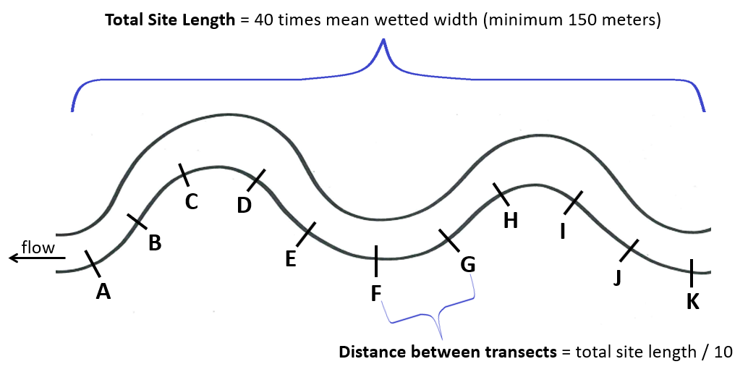
11-Transect Sampling Frame Figure

Collect one algae sample at each of the 11 transects within the sampling frame
NOTE: always sample from downstream to upstream to avoid disturbing the substrate where samples will be collected.
- Randomly select where along transect A (right (R), left (L), or center (C)) the sample will be collected.
NOTE: If more than one biological parameter is being collected simultaneously from the same sampling frame (e.g., macroinvertebrates and chlorophyll-a), ensure that each sampler selects a different R, L, or C starting point to avoid overlap at each transect.
- Approach the R, L or C sampling location on each transect from downstream and identify an area of stream bottom approximately 1m².
- Determine which of three methods for collecting attached algae (hoop, core or template) will be used depending on the dominant substrate type in that area of stream bottom.
- If the substrate is predominantly gravel or cobble, use the template method.
- If the substrate is predominantly sand or silt, use the core method.
- If the area is covered by plant and/or algae matter, obscuring the substrate, use the hoop method.
- If using the template method:
- Select a representative rock from the area of stream bottom and place it in a shallow pan with the light-facing side upwards.
- Use forceps to position a 0.7µm micron glass fiber filter on the Nalgene filtration unit, assemble the unit and attach the vacuum hand pump.
- Place a template with a 12.5 cm² area (e.g., a slice of PVC pipe with internal diameter 3.93 to 4.05 cm) on the rock.
- Use a sharp-pointed tool to trace around the inner diameter of the template.
- Use a pocket knife to scrape the area to remove as much algae as possible, then use a wetted toothbrush to gently scrub to remove any remaining algae and place all algae material removed from within the template area into the filter unit.
- Use the vacuum hand pump to pass all water through the filter so that all algae material is captured on the filter. Do not exceed 9 mmHg of pressure on the vacuum pump. Use a small squeeze bottle of tap water to rinse the knife, toothbrush, template area on the rock, and the walls of the filtration unit, but minimize rinse water use to assure that all water will move through the filter.
- When filtration is complete, use forceps to remove the filter, fold it in half on itself and place it in a petri dish or centrifuge tube.
NOTE: In some cases, when rocks are very small (smaller than template diameter, but still too large for core sampling), instead of using 1 representative rock, place several small representative rocks inside the template diameter and follow the process as described in the above paragraphs.

NOTE: In some cases, rocks have very low levels of algae so that scrapings from a single template will result in very little material on the filter (i.e., little or no color observed on the filter). To ensure that the sample is sufficient to achieve detectable levels, up to 3 templates from the same rock (or from other representative rocks in the observation locale) can be collected and all the scraped material is then captured on the same filter. Record the number of templates aggregated on the single filter and provide this information to the lab.

NOTE: In some cases, rocks have very high levels of algae and with scrapings from a single template the filter clogs prior to all water passing through. If this occurs, pour the remaining algal material/water from the upper half of the Nalgene unit into a clean pan. Remove the first clogged filter, fold it in half on itself, and place it in the petri dish or centrifuge tube. Then, load a second filter onto the Nalgene unit and filter the remaining water/algae material. Both filters are placed in the petri dish or centrifuge tube together. Record the number of filters associated with the single template and provide this information to the lab.
- If using the hoop method:
- Place the hoop (made by wrapping a stiff wire around the bottom of a 5 gallon bucket and adjusted to 710 cm² area or 30 cm diameter) over the representative area and lower it to the stream bottom.
- Collect all algae and plant material from within the hoop and place it in a clean tray. Use scissors or a knife to detach algae and plants from the substrate; cut around the inner circumference of the hoop so that only material within the hoop is retained, not that that extend beyond the surface area of the hoop or downstream.
- Transport the tray to a stable place o the bank and physically separate the algae from the plant or moss material. Discard any material that is not algae.
- Minimize the amount of water retained in the tray by decanting and gently squeezing water from the algae.
- Place the algae into a small zippered plastic bag.
- If using the core method:
- Identify a portion of substrate comprised of fine silt or sand.
- Drive the core (5.6 cm² core can be created by cutting the end off of a 60 cc syringe) into the substrate to a depth of 5-10 cm. The syringe plunger may have to be drawn up as the body of the syringe is pushed into the substrate, as the plunger may have too much friction within the barrel to rise on its own.
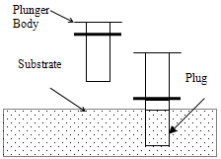
- Remove the syringe core from the substrate and immediately invert the syringe containing the plug to prevent the plug from sliding out of the barrel; to minimize loss of a loose plug, place fingers over the end of the syringe as it is pulled out of the hole and up through the water column.
- Extrude the core so the upper 1 cm of the core remains in the syringe and slice off and discard the lower portion. Place the 1 cm portion in a 60 ml centrifuge tube. Assure that all the material adhering to the rubber surface of the plunger-end is carefully collected, as most of the chlorophyll is located there.
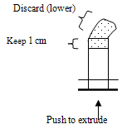
- Proceed upstream from transect to transect, selecting the most appropriate collection method (template, core or hoop) at each of the 11 transects following a R, L, C pattern.
Label, store and preserve the sample
- Label each of the 11 individual samples with waterbody name, collection method (hoop, core, or template), collection date, and transect letter.
- Place a label on each sample container (petri dish, centrifuge tube or plastic zipper bag) and cover the label with clear tape to prevent water damage.
- Wrap each sample in aluminum foil and place all 11 samples together in a large plastic zipper bag.
- Store the sample frozen on dry ice until it is received by the analytical laboratory.
Document the sample collection
- For each transect, record the location along the transect where sampling took place (R, L, C), the method used (H-hoop, C-core, T-template), the number of templates used, the number of filters used, and the dominant algae observed at the sampling site. When finished, inventory the number of samples per method in the box in the upper right corner of the form.

Data Analysis
- Indicate that the lab should analyze both chlorophyll-a and ash-free dry weight.
- Indicate whether the lab will composite the samples at the lab by method or analyze each sample individually. Typically, it is more cost-effective to have the lab composite samples by method.
- Calculate an average chlorophyll-a (mg/m²) and ash-free dry weight (g/m²) for the site:
- If result values are reported individually for each of the 11 transects, a simple average can be calculated (i.e., add all result values together and dividing by the total number of transects sampled).
- If samples are composited by method and therefore result values are reported for all templates combines, all hoops combined, and all cores combined, calculate a weighted average that takes into account the number of samples collected using each method.
NOTE: The weighted averages for AFDW do not include results from core samples because non-algal organic matter contained in the core will skew the results.
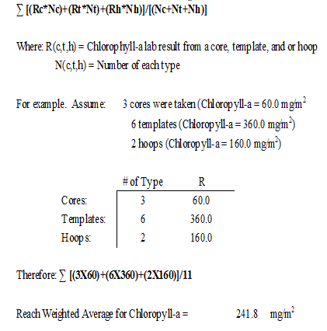

- Compare sitewide averages for chlorophyll-a and ash-free dry weight against thresholds recommended in Suplee and Watson (2013):
- 125 mg Chla/m2 and 35 g AFDM/m2 for all ecoregions except Northwestern Glaciated Plains
- 165 mg Chla/m2 and 70 g AFDM/m2 for Nporthwestern Glaciated Plains ecoregion

Fish Community Characterization (No Guidance; No SOP)
Future development here if useful

Macroinvertebrate Assemblage (SOP)
Macroinvertebrate Assemblage Reachwide Kick Samples (MAC-R-500)

Method Overview
Benthic macroinvertebrates are collected from eleven transects along a sampling frame. Samples from each transect are composited together with others and analyzed for taxonomic counts.

Specifications
Applicable Waterbody Type: WADEABLE streams, MEDIUM RIVERS

Scale: WATERBODY

Limiting Conditions:
- Not applicable for un-wadeable streams, lakes or large rivers.
Skills Required:
- Must be able to wade and stand in moving water along the extent of a sampling frame.
Time Required:
- Minimum 1 person
- Approximately 2 hours per site
Considerations:
- Typically only performed during baseflow conditions.
- Sample analysis is costly; verify the data is needed before collecting.
Equipment and Software:
- 1L wide mouth Nalgene sample jars/bottles
- Ethanol (EtOH 95%)
- 500-micron (µm) D-frame kick net with handle
- 500-micron (µm) wire sieve
- Large plastic tray (white or clear)
- Small plastic spoon
- Tweezers or forceps
- Clean rag for drying bottle before labeling
- ParaFilm wax film
- Cooler or box
- Spray bottle (optional)
- 5-gallon bucket for elutriation (optional)
Data Needs:
- Property boundaries or other sampling frame access barriers.
Method Type: quantitative

Repeatability: MEDIUM

Other Names:
- Bug sampling, kick method, EMAP method
Method Source:
- Feldman, D. 2012. Sample Collection, Sorting, Taxonomic Identification, and Analysis of Benthic Macroinvertebrate Communities Standard Operating Procedures. Helena, MT: Montana Department of Environmental Quality, Water Quality Planning Bureau.
Keywords: benthic macroinvertebrates, aquatic insects

Procedure
Lay out the 11-transect sampling frame
- Determine the length of the sampling frame:
- Measure the wetted width at five places around the site (e.g., two upstream, two downstream, and one at the location where water samples and other data is being collected). The site is known as the “F site.”
- Calculate the average wetted width.
- Multiple the average wetted width by 40. The sampling frame length must equal 40 times the average wetted with or a minimum of 150 meters, whichever is larger.
- Calculate the distance between transects within the sampling frame by dividing the total length of the sampling frame by ten.
- Use a tape to measure upstream and downstream from the F site and flag 11 transects labeled A through K, with A marking the furthest downstream point of the sampling frame and K labeling the most upstream point of the sampling frame.
11-Transect Sampling Frame Figure

Collect one macroinvertebrate kick sample at each of the 11 transects within the sampling frame
NOTE: always sample from downstream to upstream to avoid disturbing the substrate where samples will be collected.
- Pour a small amount (≤ 500ml) of 95% ethanol (EtOH) in the sample jar(s) prior to collecting the sample; this will help avoid predation and decomposition during sample collection.
- Randomly select where along transect A (right (R), left (L), or center (C)) the sample will be collected.
NOTE: If more than one biological parameter is being collected simultaneously from the same sampling frame (e.g., macroinvertebrates and chlorophyll-a), ensure that each sampler selects a different R, L, or C starting point to avoid overlap at each transect.
- Approach the R, L or C sampling location on each transect from downstream and identify an area of stream bottom to sample.
- Position a 500um D-frame kick net within a representative portion of the designated channel location and hold the net vertically upright with the base of the frame in contact with the substrate and the open portion of the net facing into the flow.
- View an area of substrate within 1ft² upstream from the net and collect a kick sample:
- Use hands to pick up each piece of large substrate (e.g., larger than a golf ball), brush off any organisms into the net, and discard outside of the sampling area.
- Use feet (e.g., heel or toe of a boot) to disturb the substrate in the 1ft² sampling area immediately upstream from the net for 30 seconds. If there is flow, organisms will dislodge from the substrate and flow into the net. Carefully avoid sweeping the substrate and organisms out of the path of flow in front of the net opening while kicking. If there is no flow, hands or feet may need to be used to direct material into the net. If the sampling location contains dense aquatic vegetation, sweep the net back and forth across the area to capture dislodged organisms.
- Immerse the net several times to remove fine sediments and concentrate the sample in the bottom of the net, taking care not to lose any organisms.
- Carefully transfer the entire contents of the net into 1-liter wide-mouth polyethylene sample jar(s), including all organisms, substrate, plant, algae and wood debris; it is acceptable to discard very large pieces of substrate following a careful inspection and remove of any organisms. Consider one or more of the following methods for transferring the sample:
- Rinse large rocks, sticks, and other debris into the net and thoroughly inspect them prior to discarding.
- Use a small plastic spoon to scoop the sample into the sample jar.
- Inspect the entire inner surface of the net and use clean forceps to remove any organisms clinging to the net and place them into the sample jar.
- Dump the contents of the net into a 500µm sieve, rinse stream water through the sieve to clean the sample of fine sediment and transfer the sample into the jar.
- Elutriate to separate the organic and inorganic portions by submerging the sample in a 5-gallon bucket containing water, vigorously swirling the sample in the water, decanting the floating material into a 500µm sieve, and transferring from the sieve into the sample jar. Repeat this process several times until almost the entire organic portion of the sample has been removed. Then transfer the inorganic portion to different sample jars and submit these along with the organic portions to the analytical laboratory.
- Spray organisms clinging to the net with a dilute (10%) ammonia or (95%) EtOH solution to detach them from the net.
- Partially immerse the net in the stream to concentrate the detached organisms at the base of the net and/or use forceps to transfer organisms directly into the jar.
- Proceed upstream from transect to transect to collect samples at each of the 11 transects following a R, L, C pattern and composite samples together into sample jars:
- The kick samples from the 11 transects composited together into 1-liter wide-mouth polyethylene sample jars.
- Each sample jar must be filled at least halfway with 95% ethanol (EtOH) to ensure the sample is properly preserved and will not begin to decompose before it can be analyzed. Therefore, each sample jar should not be filled any more than halfway with sample material and all jars should be filled to the top with EtOH. Once a jar is less than or equal to half-full with sample material, begin filling another jar.
- Close the jars tightly between transects and during transport to ensure sample is not lost.
- Estimate how many jars you will need; expect 2-3 jars per site in mountain streams dominated by large substrate and 4-5 jars per site in prairie streams dominated by sand or silt.
NOTE: Thoroughly inspect the net after each sampling event to ensure that all organisms have been removed to prevent contamination between sites.
- Upon completion of sampling at all 11 transects, top off each sample jar with 95% ethanol (EtOH) so the entire jar is full. Gently invert each sample jar 3 times to distribute the preservative.
- Affix a sample label which indicates the total number of jars used and cover the label with clear plastic tape.
- Seal the jar lid with wax film to prevent leakage, and store samples upright and avoid light exposure by storing them at room temperature in a cooler or box.
NOTE: EtOH is flammable! Close the lid tightly and use ParaFilm wax to seal the cap to prevent leakage.

Data Analysis
- Macroinvertebrate samples are analyzed by taxonomists and raw taxonomic counts are provided. Many options for taxonomic count-based metrics are available to be used to evaluate macroinvertebrate populations depending on specific interests (e.g., number of taxa, % EPT taxa, % tolerant taxa, Hilsenhoff Biotic Index score).

Periphyton Assemblage: Peri-1 and Peri-1 Mod (SOP)

Method Overview
Periphyton samples are collected from all representative surfaces/habitats within a sampling frame. Sub-samples from each sampled location within the frame are composited together with others and analyzed for taxonomic counts.

Specifications
Applicable Waterbody Type: WADEABLE STREAMS

Scale: WATERBODY

Limiting Conditions:
- Method as developed for wadeable streams to ensure all available habitats are adequately represented; may be applicable for medium or large rivers if sampling area is sufficiently accessible to sample all representative habitats.
Skills Required:
- Must be able to wade and stand in moving water along the extent of a sampling frame.
Time Required:
- Minimum 1 person
- Approximately 30 minutes per site
Considerations:
- Typically only performed during baseflow conditions.
- Sample analysis is costly; verify the data is needed before collecting.
Equipment and Software:
- 50 ml (50 cm³) centrifuge tube
- Formalin (40% formaldehyde solution) for preserving samples
- Folding pocket knife
- Aluminum foil
- Toothbrush
- Turkey baster
- Small plastic tray
- Parafilm wax
Data Needs:
- Property boundaries or other sampling frame access barriers.
Method Type: quantitative
Repeatability: MEDIUM
Other Names:
- Periphyton, diatoms
Method Source:
- Water Quality Planning Bureau (WQPB). 2011. Periphyton Standard Operating Procedure. Helena, MT: Montana Department of Environmental Quality, Water Quality Planning Bureau. Report WQPBWQM-010_FNL.
Keywords: algae, periphyton, diatoms

Procedure
Identify the sampling frame
- Two options are available for sampling within a sampling frame, depending on which will be more efficient based on which other sampling activities are being completed at the same site visit.
- PERI-1 method: Periphyton samples can be collected with a less formally-delineated sampling frame which spans at least 50 meters upstream and 50 meters downstream from the initial arrival site (~100m total). This approach is most appropriate when periphyton is the only biological parameter being collected during a site visit to save time and effort by not measuring and flagging transects.
- PERI-1 mod method: Periphyton samples can be collected within the 11-transect sampling frame.
- If using the PERI-1 mod method, determine the length of the 11-transect sampling frame and hang flagging to mark transects:
- Measure the wetted width at five places around the site (e.g., two upstream, two downstream, and one at the location where water samples and other data is being collected). The site is known as the “F site.”
- Calculate the average wetted width.
- Multiple the average wetted width by 40. The sampling frame length must equal 40 times the average wetted with or a minimum of 150 meters, whichever is larger.
- Calculate the distance between transects within the sampling frame by dividing the total length of the sampling frame by ten.
- Use a tape to measure upstream and downstream from the F site and flag 11 transects labeled A through K, with A marking the furthest downstream point of the sampling frame and K labeling the most upstream point of the sampling frame (see 11-transect Sampling Frame Figure).

Collect a single composite sample comprised of multiple sub-samples
- Identify the natural substrates that appear throughout the sampling frame and note their relative abundance in proportion to one another (e.g., gravel or cobble surfaces, boulder surfaces, mud surfaces, submerged vegetation, submerged woody debris).
- Collect sub-samples of periphyton throughout the sampling frame from each type of natural substrate in proportion to the relative abundance of the substrate type at the site. The goal is to collect a single composite sample that is a miniature replica of the stand of algae which are present at the study site.
- If using the PERI-1 method, walk along the sampling frame from downstream to upstream, collecting material as you encounter the representative substrates.
- If using the PERI-1 mod method, proceed upstream from transect A to transect K, collecting material from substrates near each transect.
- Material collected throughout the sampling frame is composited into a single 50 cm³ centrifuge tube until a total volume of 45ml is reached. Sub-samples may be collected directly into the centrifuge tube or may first be collected into a small tray, then mixed well and transferred into the centrifuge tube.
NOTE: the total volume of sample collected at the site must not exceed 45ml to ensure that there is space remaining for an adequate volume of preservative. Since the centrifuge tube is fairly small and will fill quickly, field personnel must be careful not to over-add any particular batch of sampled material. To aide in this, material from the entire sampling frame can be first collected in a plastic tray, then the material in the tray can be thoroughly mixed and a sub-sample of this material can be transferred to the centrifuge tube.
- To collect samples from various types of substrates:
- Hand pick small pieces of macroalgae in proportion to their abundance at the site.
- Use a pocket knife and/or toothbrush to scrape microalgae from the entire upper surface of several rocks.
- List algal film off of near-shore sediments and mud surfaces.
- Use a pocket knife to scrape submerged branches or woody debris.
- Use a turkey baster to suck up small quantities of fine sediment in depositional areas.
- Tear off small pieces of submerged vegetation.
- If the end of the sampling frame is reached, verify whether there are any natural substrates present within the sampling frame that were not represented (or under-represented) and return to sub-sample these substrates as needed.
- Once the sample collection is complete, if the sample volume does not reach the 45ml line on the centrifuge tube, use the cap of the centrifuge tube to scoop a small amount of ambient stream water into the centrifuge tube until the 45 ml volume is reached.
- Put on gloves and use the dropper to add 5ml of formalin to the centrifuge tube. Secure the cap back onto the centrifuge tube and gently invert the tube three times to mix the formalin into the sample.
- Stretch parafilm wax around the tightened lid of the centrifuge tube to minimize leakage.
- Affix a label to the centrifuge tube with stream name and location, name of the collector, and the date, and cover the label with clear plastic tape.
- Store the samples unrefrigerated and protected from the light; wrap with aluminum foil and/or store in a closed box or cooler until delivery to the laboratory.

Data Analysis
- Periphyton samples are analyzed by taxonomists and raw taxonomic counts are provided. Many options for taxonomic count-based metrics are available to be used to evaluate periphyton populations depending on specific interests (e.g., nutrient or sediment increaser taxa metrics).

Phytoplankton (SOP)
Phytoplankton (Chlorophyll-a in Water Column)

Method Overview
A known volume of lake water is collected from just below the water surface and is passed through a filter. These samples are then analyzed by the laboratory to determine the amount of chlorophyll on the filter which provides a measure for the amount of algae present in the water column.

Specifications
Applicable Waterbody Type: large rivers; streams; ephemeral and intermittent streams; lakes; wetlands

Scale: WATERBODY

Limiting Conditions:

Skills Required:
- Ability to accurately measure volumes of water.
Time Required:
- Minimum 1 person
- Approximately 30 minutes
Considerations:
- Chlorophyll-a breaks down readily in sunlight; efforts should be taken to minimize exposure of the sample to sunlight, including performing filtering in a shaded location, using a dark bottle to collect the sample, and setting up the filter apparatus prior to sample collection to minimize time between sampling and filtration.
- The volume of water filtered must be recorded.
Equipment and Software:
- Field form
- 1L dark Nalgene bottle
- 100-250ml graduated cylinder
- Petri dishes or centrifuge tubes
- Squeeze bottle with tap water
- Vacuum hand pump vacuum with tubing
- Nalgene filtering unit
- Tweezers or forceps
- GF/F glass fiber filters (0.70 µm)
- Aluminum foil
- Cooler with dry ice

Data Needs:
- none
Method Type: quantitative

Repeatability: high

Other Names: chlorophyll-a in water column

Method Source:
- Montana Department of Environmental Quality (DEQ). 2019. Sample Collection and Laboratory Analysis of Chlorophyll-a Standard Operating Procedure, Rev. 7. WQPBWQM-011. Helena, MT: Montana Department of Environmental Quality.
Keywords: phytoplankton, algae, chlorophyll-a

Procedure
- Identify an appropriate place to collect the sample:
- Water can be safely accessed.
- Water column is well-mixed.
- Water is deep enough to submerge the collection unit (graduated cylinder or bottle).
- A shaded location is available nearby in which to perform filtering.
- Set up the filter apparatus:
- Ensure the filter unit is clean and free of debris.
- Use clean forceps to place a glass fiber filter (0.70 um) on the filter holder. Use a small amount of tap water (not stream or lake water) from a squirt bottle to settle the filter.
- Place the top of the filter flask on top of the filter, grasp the cuff and carefully screw it on tight without tearing the filter.
- Attach the vacuum hand pump with tubing.
- Triple-rinse the dark Nalgene bottle with ambient stream or lake water; avoid disturbing the water column in the area where the final sample will be collected.
- Grab a water sample from an undisturbed location using 1L dark Nalgene bottle and transport the sample to a shaded location for filtering.
NOTE: Avoid exposing samples to direct sunlight during processing.
- Measure 20 ml or more of sample water into the graduated cylinder, pour into the filter funnel, and draw the sample through the filter using the vacuum hand pump.

NOTE: To avoid rupture of fragile algal cells, do not exceed 9.0 inches Hg on the vacuum gauge.
- Continue measuring additional sample water using the graduated cylinder, adding it to the filter flask and passing it through the filter until a sufficient sample has been filtered. The volume of water filtered may vary from 20ml to 1000ml or more. When filtration slows and the filter has developed a distinct green (or green-brown) color, sufficient sample has been filtered.
NOTE: Do not allow the filter to clog! If a filter completely clogs while water remains in the upper half of the apparatus, discard the filter and start again, using less water volume.

- When finished filtering, unplug the hand pump, remove the top of the filter flask, and use forceps to fold the filter in half with the colored side folded in on itself, and place the filter in the petri dish or centrifuge tube. Label the petri dish with site ID, date, and the sampler’s name, and cover the label with clear tape. Wrap the labeled petri dish in aluminum foil to eliminate light exposure and place the sample in a ziplock bag.
- Immediately place the sample in a cooler with dry ice and store it frozen until it is received by the analytical laboratory. If dry ice is not used to freeze samples while in the field, samples must be stored in a cooler surrounded by regular ice at <6°C while in the field, then frozen solid in a freezer prior to shipping.
- Record the total volume of water filtered on the field form!
NOTE: It is very important to keep track of and record the total volume of water that you filtered to collect the sample.

Data Analysis
Phytoplankton data is generally reported as mg chlorophyll-a per liter. Chlorophyll-a concentrations maybe compared across multiple sites or through time at a single site.

Chemistry Methods

Bottom sediment chemistry (No Guidance; No SOP)
Future development here if useful

Oil and Grease in Water Column (Guidance Only; No SOP)
  - A Guide to Oil in Water Monitoring for Environmental Compliance
    - From Arjay Engineering (Canada-based)
  - Techniques for Measuring Oil in Water
    - From Spectro Scientific, references EPA standards
  - Oil and Grease in Water by Hexane Extraction and Gravimetry
    - From British Columbia government website
  - If sampling for oil and grease related constituents that are present in the water column (volatile organic compounds, methane, petroleum, hydrocarbons, etc.), reference the SOP for “Water Samples for Chemical Constituents”

Dissolved oxygen - daily delta (No Guidance; No SOP)
Future development here if useful

Water Samples for Chemical Constituents (SOP)

Method Overview
Water column samples are collected directly from a waterbody for chemistry analyses using grab procedures. Samples are generally unfiltered if total recoverable fractions are to be analyzed and are generally filtered through a 0.45µm filter if dissolved fractions are to be analyzed.

Specifications
Applicable Waterbody Type: large rivers; streams; ephemeral and intermittent streams; lakes; wetlands

Scale: Waterbody

Limiting Conditions: Must specify need for composite or depth-integrated samples in SAP and plan sampling techniques and equipment accordingly.

Skills Required:
- Ability to safely wade or use watercraft to navigate to sampling location.
Time Required: One person minimum; approximately 30 minutes

Considerations:
- Sample collection method selection depends on site conditions (e.g., wadeable, watercraft needed, sampling surface only or multiple depths)
- Analytical requirements per analyte will determine whether samples must be filtered or not, acid preserved or not, on ice or frozen, etc.
- Samples will either be hand-delivered or shipped to the analytical laboratory; care must be taken to ensure required sample temperatures are maintained and that samples will arrive at the lab within required holding time limits.
Equipment and Software:
- Sample bottles
- Labels
- Pencil or fineline permanent marker
- Clear tape to cover labels
- Preservative, if needed
- Cooler(s) for sample storage
- Ice or dry ice for sample preservation
- Filters and syringes (if using)
- Van Dorn or Kemmerer with cable, messenger, weights, winch (if using)
- Extension pole sampler with collection bottle (if using)
- Decontamination procedures and supplies, if using collection equipment at multiple sites
Data Needs:
- Agreements must be made with analytical labs to ensure that data formatting requirements are adhered to in electronic data deliverables (EDDs).
Method Type: Quantitative

Repeatability: High

Other Names: Grab samples

Method Source: Makarowski, K. 2019. Standard Operating Procedure for Sample Collection for Chemistry Analysis: Water, Sediment, and Biological Tissue. Version 1.0. Helena, MT: Montana Department of Environmental Quality, Water Quality Planning Bureau.

Keywords: grab, water sample collection, analyte

Procedure
Considerations
- Collect samples from safe locations (e.g., where sampler can safely wade, stand, or reach from boat or water’s edge)
- Collect waters from a well-mixed portion of the water column (avoid stagnant or backwater)
- Prevent surface scum or bottom sediments from entering sample bottle.
- Sample upstream or away from disturbances to the water column.
- Specify which sample collection and processing techniques are used in your SAP, including any project specifications such as compositing or depth-integrating samples
- Specify the container, volume, analytical method, holding time, and reporting limits for each analyte in your SAP.
- For each sample, maintain a record of chain-of-custody signatures from the time the sample is collected to the time it is relinquished to lab personnel.
- Adhere to each sample’s preservation and handling requirements
- Avoid contamination of samples with the following practices:
- Use new or acid-washed containers
- Triple-rinse containers prior to filling, as directed
- Decontaminate sampling equipment, as needed, before use at each site
- Avoid hand contact with the interior of containers and lids, and wear gloves (latex or nitrile, powder-free) as directed, when collecting especially sensitive samples or to avoid contact with the water when you suspect it is contaminated
- Avoid contact with contaminating surfaces and tobacco products
- Store samples upright and drain sample storage coolers frequently
- Use clean hands/dirty hands technique for parts-per-billion trace element sampling
- Collect samples upstream or away from previous disturbance
- Follow appropriate sample handling procedures and minimize sample handling steps

Grab technique for unfiltered samples:
- Label the bottle and cover the label with clear tape to prevent water damage.
- Carry the bottle to a suitable sampling location:
- Sampler can safely wade and stand or access the water from a boat.
- Water column is well-mixed and deep enough to allow sampler to avoid surface scum and bottom sediments.
- Upstream or away from any disturbance to water column or bottom sediments.
- Triple-rinse the bottle and lid: face upstream into the direction of the flow, collect a small volume of water in the bottle, replace the lid, and shake gently. Discard the rinse water downstream. Repeat this process three times to triple-rinse.
NOTE: Do not rinse bottles that have preservatives added to the bottle prior to sampling (e.g., E. coli, mercury, and dissolved organic carbon sample bottles are often pre-preserved).
- Collect the sample:
- For wadeable locations, submerge the bottle so the mouth is below the water surface but above the bottom and allow the bottle to fill.
- For lake surfaces (from a boat), submerge the bottle until the sampler’s elbow is at the water surface and allow the bottle to fill.
- Leave appropriate headspace:
- For most samples, the bottle should be filled to the shoulder or line that denotes the target volume; this will leave a small amount of head space, especially necessary if preservative will be added to the sample.
- If samples are to be frozen, leave sufficient head space to allow the sample to expand when it freezes without the bottle breaking.
- If samples require zero headspace (e.g., volatile organic analysis (VOA) or ultra-low-level mercury (ULL-Hg)), submerge the container and lid, remove the lid, allow to fill completely, and secure the lid, all while submerged; verify there is no head space or air bubbles; if head space or air bubbles remain, use the lid to add a small amount of water until a convex meniscus forms, then secure the lid.
- If preservative is required to be added to the sample, put on gloves, carefully unscrew the lid, pour the entire contents of the preservative vial into the sample bottle, replace the lid, and gently invert the sample bottle three times to mix the preservative into the sample. Discard the empty preservative vial.
- Store samples upright according to sample preservation and storage requirements (e.g., in a cooler on regular ice at ≤6ºC, or frozen on dry ice).
- Deliver samples to the analytical laboratory within required holding times.
NOTE: The following samples are commonly collected using unfiltered grab sampling techniques: total persulfate nitrogen (TPN), total phosphorus (TP), nitrite plus nitrate (NO₂₊₃), ammonia (NH₃₊₄), total suspended solids (TSS), total dissolved solids (TDS), and total recoverable metals.

Filtered Grab Samples
- Label the bottle and cover the label with clear tape to prevent water damage.
- Carry the bottle, filter and syringes to a suitable sampling location:
- Sampler can safely wade and stand or access the water from a boat.
- Water column is well-mixed and deep enough to allow sampler to avoid surface scum and bottom sediments.
- Upstream or away from any disturbance to water column or bottom sediments.
- Open a new 60 cc syringe package, remove the syringe, and discard the packaging. Triple-rinse the syringe by drawing ambient (stream or lake) water into the syringe, gently shaking, and compressing the syringe to force the water out; repeat this three times.
- Fill the syringe with ambient water (draw water into the syringe from below the water surface at wadeable locations or from the Van Dorn or Kemmerer, if using).
- Open a new 0.45 µm filter package by gripping the blue ring and peeling the cover open. Screw the filter onto the syringe and discard the packaging. Pass a small amount of water through the filter to “prime” the filter.
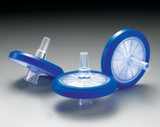
- Triple-rinse the sample bottle with filtered water: plunge a small amount of water (approximately 10-20ml) from the syringe through the filter into the sample bottle. Replace the lid, shake gently, and then discard the rinse water downstream. Repeat this process three times to triple-rinse the bottle with filtered water. When finished rinsing, unscrew and discard the filter used for rinsing.
NOTE: Do not rinse bottles that have preservatives added to the bottle prior to sampling (e.g., E. coli, mercury, and dissolved organic carbon sample bottles are often pre-preserved).
- Refill the syringe with ambient water, open and attach a new filter, and pass a small amount of water through the filter to “prime” it.
- Collect the sample: fill the bottle with filtered water. Often, to fill the bottle will require multiple refills of the syringe; when the syringe is empty, grip the filter’s blue ring, unscrew the filter and refill the syringe, taking care not to contaminate the filter. If the filter is not clogged, screw the filter back onto the syringe and continue filtering until the bottle is sufficiently full. If the filter clogs mid-way throughout filtering, unscrew and discard the clogged filter, refill the syringe, screw on a new filter, pass a small amount of water through the new filter, and continue filtering. Repeat this process until the sample bottle is full.
- Leave appropriate headspace:
- For most samples, the bottle should be filled to the shoulder or line that denotes the target volume; this will leave a small amount of head space, especially necessary if preservative will be added to the sample.
- If samples are to be frozen, leave sufficient head space to allow the sample to expand when it freezes without the bottle breaking.
- If samples require zero headspace (e.g., volatile organic analysis (VOA) or ultra-low-level mercury (ULL-Hg)), submerge the container and lid, remove the lid, allow to fill completely, and secure the lid, all while submerged; verify there is no head space or air bubbles; if head space or air bubbles remain, use the lid to add a small amount of water until a convex meniscus forms, then secure the lid.
- If preservative is required to be added to the sample, put on gloves, carefully unscrew the lid, pour the entire contents of the preservative vial into the sample bottle, replace the lid, and gently invert the sample bottle three times to mix the preservative into the sample. Discard the empty preservative vial.
- Store samples upright according to sample preservation and storage requirements (e.g., in a cooler on regular ice at ≤6ºC, or frozen on dry ice).
- Deliver samples to the analytical laboratory within required holding times.
NOTE: The following parameters are often collected using filtered grab sampling techniques: dissolved orthophosphate also known as soluble reactive phosphorus (SRP) and dissolved metals.

Van Dorn or Kemmerer water samplers – lake water column:
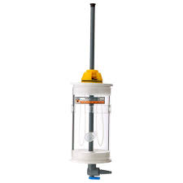(Kemmerer) 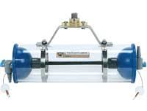 (Van Dorn)
- Securely attach the Van Dorn or Kemmerer to a sturdy line (e.g., rope, chain, cable).
- Open the instrument and secure the rubber stoppers open at each end of the cylinder (Van Dorn: pull the rubber end seals out and back to open, and secure in place using the cables; Kemmerer: hold each end of the cylinder and pull open until it clicks into place);
- Attach the metal weight (called a “messenger”) to the line.
- Determine the desired depth of sampling.
- Hold the messenger above the water surface and lower the Kemmerer to the desired depth; use demarcations on the cable to track depths as it lowers.
- Once the desired depth is reached, hold the instrument in place and release the messenger down the line; it will hit the trigger and the rubber end seals will snap shut.
- Raise the instrument to the surface and verify it is full of water and sealed properly.
- Use the drain valves to release water from the cylinder to perform rinsing and sample collection: follow the unfiltered or filtered grab sample procedures, as applicable.
NOTE: The instrument may be lowered and raised by hand, or you may consider using a winch or pulley boom to assist in lowering and raising, especially when sampling great depths.

NOTE: Consider adding weights around the exterior of the instrument to assist in lowering.

Extension pole sampler technique
NOTE: Direct collection into the sample container being submitted to the laboratory for analysis is always preferred. However, in cases where water samples must be collected from a distance, for example, samples cannot be safely collected via wading, access to the water’s edge is limited, or wading will cause excessive disturbance, an extension (telescopic) pole sampler may be used to collect samples.

NOTE: A new, clean site- and analyte-specific collection bottle may be used with the extension pole sampler. Alternately, if the same collection bottle that is attached to the extension pole will be used at multiple site locations, it must be cleaned and decontaminated between uses using approved decontamination procedures. Project SAPs should specify intended decontamination methods.
- Decontaminate the sample collection bottle (if necessary).
- Attach the clean/decontaminated collection bottle to the telescopic rod by securing the ring clasp.
- Identify a suitable sample location.
- Triple-rinse the collection bottle with ambient water: extend the pole into a well-mixed portion of the water column, submerge the bottle into the water column below the water surface, fill the bottle, remove from the water column, and shake gently to rinse. Discard the rinse water downstream. Repeat this process three times to triple-rinse the bottle.
- Collect the water sample: face upstream into the direction of the flow (if flowing), extend the pole into a well-mixed portion of the water column so the mouth is below the water surface to prevent particulates floating on the water surface from entering the bottle and above the bottom to prevent substrate from entering the sample bottle, and fill the bottle.
- Return the bottle to a stable location on the bank, shore or in the vessel, carefully unfasten the ring clasp and remove the collection bottle from the telescopic pole.
- Transfer water from the collection bottle into laboratory-provided sample bottles: follow unfiltered grab samples procedure or filtered grab samples procedure, as applicable, to rinse sample bottles and collect samples.
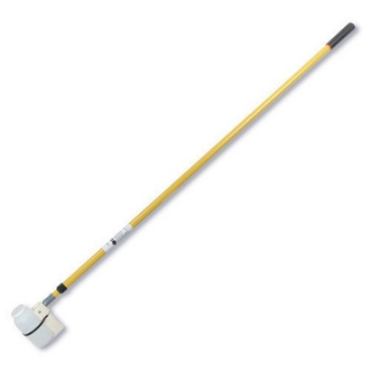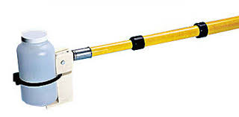

Clean Hands/Dirty Hands sampling technique for parts-per-billion detection limits
NOTE: This procedure requires two people: one person is designated as “clean hands” and the second person is designated as “dirty hands.” “Dirty hands” is responsible for all activities that do not involve direct contact with the sample bottle and water. This method is used to collect samples for ultra-low-level mercury analysis and other trace element analytes with parts-per-billion detection limits.

- Prepare the sample cooler with ice:
- Put on gloves.
- Place a large, clean garbage bag in the cooler to line the cooler.
- Pack ice into sealable gallon-size plastic bags and place the bags of ice inside the garbage bag inside the cooler. Line the bottom and the sides of the cooler with bags of ice to form a “nest” in which sample bottles will be cradled and kept cold; approximately 6-8 bags are needed for average size coolers.
- Place a second large, clean garbage bag inside the first garbage bag; this inner bag provides an additional barrier between sample bottles and bags of ice, and is the bag in which completed samples are placed.
- Close both inner and outer garbage bags and close the cooler.
- Prepare “clean hands” and “dirty hands” sample kits:
- Clean hands kit: Sample bottle (double-bagged and pre-preserved with hydrochloric acid (HCl) or other appropriate preservative), clean hand glove kits (one pair latex gloves and one pair forearm-length rubber gloves in a bag)
- Dirty hands kit: Dirty hand glove kits (one pair latex gloves in a bag), Sample label that is already filled out, clear tape for affixing label to bottle, clean paper towels or napkins in a bag
- Prepare to collect the sample and put on gloves:
- Both people find an appropriate sample location (Section 7.2) along the water’s edge and place the sample kits in a stable and accessible location.
- “Clean hands” enters the water and stands nearby in an area that allows for stable footing.
- “Dirty hands” opens the “dirty” sample kit, removes the “dirty hands” latex gloves from the bag and puts them on. “Dirty hands” opens the “clean” sample kit, removes the bag containing the two sets of “clean hands” gloves, opens the outer sealed plastic bag containing the gloves without touching the inner bag, and holds the outer bag open within reach of the “clean hands” person.
- “Clean hands” reaches into the outer bag, opens the inner bag containing the latex gloves, and puts the latex gloves on their hands.
- “Clean hands” reaches again into the outer bag, opens the inner bag containing the long [yellow] rubber gloves, and puts this second pair of gloves over the first pair on their hands.
NOTE: Once “clean hands” is gloved, they should not touch anything besides the inner bag containing the sample bottle, the sample bottle and cap, ambient (stream or lake) water, paper towels, the sample label and tape strips. If “clean hands” mistakenly touches any surface such as waders, streambanks, boats, vegetation, skin, etc., they should immediately remove the outer pair of gloves and continue the sampling procedure with just the inner pair of gloves.
- Collect the sample:
- “Dirty hands” opens the “clean” sample kit, removes the bag containing the double-bagged, pre-preserved sample bottle, opens the outer sealed plastic bag without touching the inner bag, and holds the outer bag open within reach of the “clean hands” person.
- “Clean hands” reaches into the outer bag, opens the inner bag containing the bottle, and pulls the sample bottle out.
- “Dirty hands” reseals the outer bag and returns it to the “clean” sample kit for later use.
- “Clean hands” carries the bottle to an appropriate sample location (Section 7.2). If the water is not flowing, wade carefully to avoid disturbing the bottom sediments and water column. Facing upstream (if flowing), submerge the bottle completely beneath the water surface, taking care not to disturb the substrate. While the bottle and cap are submerged, unscrew the cap and allow the bottle to fill; to ensure zero headspace, once the bottle is nearly full, quickly tip the bottle back toward you so it is completely upright to release the remaining bubble that often gets trapped at the bottle’s shoulder. As soon as the bottle is full, while still submerged, quickly secure the cap. Remove the bottle from the water column and tip the bottle upside down to verify that there is no head space or air bubbles. If air is trapped, re-submerge and quickly re-open the bottle to release the trapped air and fill completely with water.
NOTE: Do not rinse the bottle as it is pre-preserved and also should not be exposed to the atmosphere.

NOTE: The bottle is glass so extra care must be taken not to break it.
- Dry and label the bottle:
- “Dirty hands” opens the “dirty” sample kit, removes the sealed bag of paper towels/napkins, opens it and extends it within reach of the “clean hands” person.
- “Clean hands” reaches into the bag, removes a paper towel or napkin, and uses it to dry the bottle.
- “Dirty hands” opens the “dirty” sample kit, removes the sample label, removes the label backing, and hands the label to “clean hands”; “clean hands” affixes the label to the bottle.
- “Dirty hands” opens the “dirty” sample kit, removes a tape strip, removes the backing from the tape strip, and hands it to the “clean hands” person; “clean hands” affixes the tape over the sample label.
- Store and transport the sample:
- “Dirty hands” opens the “clean” sample kit, removes the empty double-bag that initially contained the sample bottle, opens the outer bag without touching the inner bag, and extends it within reach of the “clean hands” person. “Clean hands” reaches into the outer bag, opens the inner bag, and carefully places the sample bottle into the inner bag.
- “Clean hands” reseals the inner bag. “Dirty hands” reseals the outer bag and places the double-bagged, full sample bottle into the “clean” sample kit for temporary storage and transport HINT: By working together, both people can assist with squeezing the excess air out of the bags before they are sealed, as long as “clean hands” touches only the inner bag and “dirty hands” touches only the outer bag. Minimizing air in the bags will help ensure that the bottles can be as close as possible to the ice in the cooler despite everything being double-bagged.
- “Dirty hands” places the double-bagged sample bottle from the “clean” sample kit into the inner garbage bag in the ice cooler, taking care that the bottle is as near to ice as possible so it stays sufficiently cold. Both people can now remove gloves.
NOTE: Samples bottles should remain double-bagged and inside the inner garbage bag until they are delivered to the analytical laboratory. If samples must be unloaded from the ice cooler, for example, into a refrigerator for storage, the person unloading the samples should put on at least one pair of clean gloves, lift the entire inner garbage bag out of the ice cooler, tie the bag closed, and gently place the entire bag of samples into the refrigerator without breaking them.

NOTE: The ice supply in the cooler should be monitored closely to keep samples sufficiently cold. It may be necessary to replenish ice in the cooler. To do this, one person should put on a pair of clean gloves, carefully remove the entire inner garbage bag full of double-bagged sample and place it temporarily in a clean, safe place to avoid breaking or contaminating samples. Remove each sealed bag of ice, pour out water, replace with clean ice, reseal, and replace bags of ice into the outer garbage bag lining the ice cooler. Once all sealed ice bags have been replenished, carefully replace the inner garbage bag containing sample bottles and organize as needed to ensure sample bottles are upright and in contact with bagged ice so they stay sufficiently cold.

NOTE: An entirely new set of gloves and other supplies should be used for each routine sample, field duplicate, and field blank.
- Deliver samples to the analytical laboratory within required holding times.

Field Duplicates
NOTE: Duplicate samples are two samples taken from and representative of the same population and carried through all steps of the sampling and analytical procedures in an identical manner. Duplicate samples are used to assess variance of the total method including sampling and analysis.

NOTE: Duplicate samples are typically collected at a rate of 10% of the total number of routine samples being collected for a project for each parameter. For example, if 20 total nitrogen samples are collected, 2 duplicate total nitrogen samples should be collected.
- Label the duplicate sample bottles with the same site, date, and personnel information as the routine samples; add the word ‘duplicate’ to the label or add a code to the site name to differentiate between the duplicate and routine samples. Cover the labels with clear tape to prevent water damage.
- Carry the duplicate bottles to a suitable sampling location alongside the routine samples.
- Rinse the duplicate sample bottles and collect the duplicate samples following the same procedures used for the routine samples.
- Preserve and store the duplicate samples following the same procedures used for the routine samples.
- Deliver the duplicate samples to the analytical laboratory alongside the routine samples.
Field Blanks
NOTE: Field blanks are samples of clean (e.g., laboratory-grade deionized) water prepared in the field following the same rinse, collection, preservation and storage procedures used for routine samples. Field blanks are used to check for contamination introduced by transporting equipment in the field, improper procedures used by field crews, etc.

NOTE: Typically, one set of field blanks is prepared per sampling event for each analyte collected during the sampling event. For example, if a field crew collects samples at multiple sites over multiple days, they would prepare a set of field blanks (i.e., one blank per analyte collected during the sampling) at the end of the trip before they depart from the field at their last site.
- Label the field blank sample bottles with the date and personnel information, and add the words ‘field blank’ to the label or add a code to the site name to differentiate blanks from duplicate and routine samples. Cover the labels with clear tape to prevent water damage.
- In the field (e.g., at your vehicle near your last site), assemble the supplies needed to prepare field blanks (e.g., deionized water, filters and syringes if applicable, preservatives if applicable).
- Rinse the field blank bottles following the same procedures used to rinse the bottles for routine samples (e.g., triple-rinse with unfiltered or filtered water depending on the analyte), using deionized water rather than ambient stream water.
- Pour or filter, depending on the analyte, deionized water into the sample bottle.
- If preservative is added to the routine samples for a parameter, add acide to the field blanks for that analyte as well.
- Store field blanks following the same procedures used for routine and duplicate samples.
- Deliver field blanks to the analytical laboratory alongside the routine and duplicate samples collected during the sampling event.

Calculations and Data Analysis
- Samples are analyzed by the laboratory and result values are provided as electronic data deliverables and lab reports.
- Before uploading into a database, review data quality and add data qualifiers (i.e., data flags”) as needed to signify data quality concerns (e.g., J flags signify that relative percent difference between duplicates exceeds 25%, B flags signify that the result value is ≤ 10 times the concentration detected in the associated field blank).
- Data analysis approaches vary depending on objectives and data availability; refer to the analytical approach detailed in the project sampling and analysis plan.

Land Use Methods

Disturbance- extent of surface disturbance (Guidance Only; No SOP)

    - Soil-Disturbance Field Guide and Forest Soil Disturbance Monitoring Protocol
      - From the USFS
    - Surface Disturbance Analysis and Reclamation Tracking Tool (SDARTT)
      - Hosted by the USGS

Farming (Guidance Only; No SOP)
Relevant Parameters of Interest:

extent of cultivated farming area

extent of specific farming practices (e.g., fallow)
- CropScape and Cropland Data
  - From the United States Department of Agriculture (USDA) and the National Agricultural Statistics Service (NASS): crop raster data produced annually from Landsat imagery

General Land Use Assessment (Guidance Only; No SOP)
This SOP has not been fully developed.

Potential Data Needs:
- Montana Land Use/Land Cover GIS Data
  - From the Montana State Library (MSL Clearinghouse): digital raster map of Montana natural and human land cover, classified from aerial or satellite imagery
    - Pasture, rangeland, and farmland could be obtained from this data
- CropScape and Cropland Data
  - From the United States Department of Agriculture (USDA) and the National Agricultural Statistics Service (NASS): crop raster data produced annually from Landsat imagery
- Montana Stream/River Data
  - From MSL Clearinghouse?

Additional Resources:
- Protocols for Mapping and Characterizing Land Use/Land Cover in Riparian Zones
  - From the United States Geological Survey (USGS)
- Potential tools for spatial analysis of data in the GIS environment:
  - Proximity Analysis tools
  - Raster calculator
  - Spatial Analyst tools

Livestock (Guidance Only; No SOP)

Relevant Parameters of Interest:

confinement areas and proximity to streams

land area or number parcels with grazing present

presence of managed riparian pastures

percent of riparian area with existing grazing plan

presence versus absence in an area of interest

time in riparian

- Rangeland Utilization Monitoring
  - From the USDA/NRCS
- Range and Pasture Inventory Protocols
  - From the NRCS
- Final Plan for Studying the Impacts of Livestock Grazing
  - From the Bureau of Land Management (BLM) for a study area in Oregon
- Grazing Management for Riparian-Wetland Areas
  - From the BLM and United States Forest Service (USFS)
- Related case studies:
  - Effects of Cattle Grazing and Bank Land Use Practices on Trout Populations in Three Stream Sections of the Whitewater River, Minnesota
  - Effects of pasture management and off-stream water on temporal/ spatial distribution of cattle and stream bank characteristics in cool-season grass pastures

Livestock – cattle time in riparian (Guidance Only; No SOP)
    - Graphic from a publication
    - Cattle Temporal and Spatial Distribution in Midwestern Pastures Using Global Positioning (A Progress Report)
      - Iowa State University
    - Researchers track cows to determine riparian area impact
      - Captialpress.com article

Potential Data Needs:
- Hydrologic unit codes (HUCs)
  - Watershed boundaries polygon data from USGS
  - Watershed Boundary Dataset (WBD) from MSL Clearinghouse
- Grazing allotments
  - BLM Grazing Allotment Polygons data
- Montana Stream/River Data
  - From MSL Clearinghouse?

Additional Resources:
- Finding Grazing Allotments
  - This documentation from Oregon is conceptually relevant, and requires data on BLM allotments; similar allotment data from the USFS might be relevant
  - A map package for the study area can be downloaded from this page (may be useful to look at when compiling data for analysis of a different study area)
  - This page also has step-by-step instructions for conducting the analysis in ArcGIS
- Rangeland Administration System Reports
  - Public reports and allotment information from the BLM
- Final Plan for Studying the Impacts of Livestock Grazing
  - From the Bureau of Land Management (BLM) for a study area in Oregon
- Potential tools for spatial analysis of data in the GIS environment:
  - Overlay analysis tools

Mine Related Disturbance Assessment (Guidance Only; No SOP)
This SOP has not been fully developed.

Relevant Parameters of Interest:

presence of discharging adits

presence of tailings and proximity to stream network

types of mining present in watershed

Potential Data Needs:
- Montana mines location data
  - Mine-related GIS data
  - Prospect- and mine-related features on USGS topographic maps
- Montana Stream/River Data
  - From MSL Clearinghouse?

Additional Resources:
- Adit Discharge Monitoring Summary for the Elkhorn and Charter Oak Mines, MT
  - From the USDA Forest Service; does not include detailed monitoring methods
- Adit Discharge Source Control Program
  - From the Montana American Water Resources Association (AWRA)
- Related case studies:
  - Mapping of abandoned mine tailings and acid mine drainage using in situ hyperspectral measurements and WorldView-3 satellite imagery
  - Mine Tailings Mapping Using Landsat Multispectral Imagery of the Versant Basin Amont of Medjerda River in the North of Tunisia
- Potential tools for spatial analysis of data in the GIS environment:
  - Proximity Analysis tools
  - Spatial Analyst tools

Residential Development (No Guidance; No SOP)
Future development here if useful

Road Impact Assessment (Guidance Only; No SOP)
This SOP has not been fully developed.

Relevant Parameters of Interest:

density of unpaved roads (road length per area)

extent of road related erosion reaching stream network

length of roads adjacent to streams

number of roads crossing streams

Potential Data Needs:
- Roads GIS data
  - From MSL Clearinghouse?
- Montana Stream/River Data
  - From MSL Clearinghouse?

Additional Resources:
- Road Density as an Indicator of Road Hazard
  - From the USFS
- Related case studies:
  - A GIS tool to analyze forest road sediment production and stream impacts
  - Spatial and Temporal Characteristics of Road Networks and Urban Expansion
- Potential tools for spatial analysis of data in the GIS environment:
  - Proximity Analysis tools
  - Calculate Geometry
  - Line Density tool
  - Spatial Analyst tools

Physical Methods

Bank Erosion Hazard Index (BEHI) (SOP)

Method Overview
Streambanks with obvious erosion are identified within a study site, and factors that influence erosion are measured (e.g., stream depths, bank dimensions, soil character, vegetation and root depths, and distinguishing potential forces of influence on the bank, including measurement or estimation of near-bank stress. These measurements are used to determine the bank erosion hazard index score

Specifications
Applicable Waterbody Type: streams

Scale: WATERBODY

Limiting Conditions:
- Not applicable to unwadeable streams
- Not applicable if there are no streambanks with obvious erosion
Skills Required:
- It is critical that at least one person in the field crew is able to distinguish among the varied forms of eroding stream banks within a stream system, understand potential land use influence as it relates to erosional processes, and can accurately identify bankfull indicators. This often requires a hydrology or water quality background. This method is not appropriate for all volunteer monitoring efforts.
Time Required:
- Minimum 1-2 people
- Approximately 4-6 hours
Considerations:
- Must determine if the preferred approach of completing a full assessment at all eroding banks will be conducted, or if the alternative of the “add bank” approach will be allowed.
Equipment and Software:
- Field Forms for 500, 1000, and 2000 foot reaches
- Clipboard and pencils
- Calculator
- Roll of flagging
- Sharpie for marking flagging
- 2 Pocket rods
- 6 300-foot tape measures
- 2 100-foot tape measures
- 5 200-foot tape measures
- Measuring rod
- Clinometer
- Ruler for particle size determination (mm)
- GPS unit
- Range finder (for bank height determination when bank is very tall)
- Camera
Data Needs:
- Length and location of study site
Method Type: quantitativE

Repeatability: MEDIUM

Other Names: Bank Erosion Hazard Index, BEHI

Method Source:
- Montana Department of Environmental Quality (DEQ). 2017. Field Methodology for Sediment and Habitat Source Assessment. Helena, MT: Montana Department of Environmental Quality, Watershed Protection Section. WQPBWMSSOP-05, Revision 6.
Keywords: bank erosion, near bank stress, bankfull

Procedure
Delineate the survey site
- Measure or estimate bankfull width. Potential bankfull indicators include (Leopold 1994, Rosgen 1996):
- Examine streambanks for an active floodplain. This is a relatively flat, depositional area commonly vegetated and above the current water level, unless there is a large amount of spring runoff or there has been a substantial rain event (i.e., stream running at bankfull stage).
- Examine depositional features such as point bars. The highest elevation of a point bar usually indicates the lowest possible elevation for bankfull stage. However, depositional features can form both above and below the bankfull elevation when unusual flows occur during years preceding the survey. Large floods can form bars that extend above bankfull whereas several years of low flows can result in bars forming below bankfull elevation.
- A break in slope of the banks and / or change in the particle size distribution from coarser bed load particles to finer particles deposited during bank overflow conditions.
- Define an elevation where mature key riparian woody vegetation exists. The lowest elevation of birch, alder, and dogwood can be useful, whereas willows are often found below the bankfull elevation.
- Examine the ceiling of undercut banks. This elevation is normally below the bankfull elevation.
- Stream channels actively attempt to reform bankfull features such as floodplains after shifts or down cutting in the channel. Be careful not to confuse old floodplains and terraces with the present indicators.
- Determine the length of the survey site based on the bankfull width (see Survey Site and Survey Cell Lengths).
- Determine the length of each cell. The survey site is split into five equidistant cells (see Survey Site and Survey Cell Lengths).

Survey Site and Survey Cell Lengths
Bankfull Channel Width (Feet) | Survey Site Length (Feet) | Length of Survey Cell (Feet)
 |  | Cell 1 | Cell 2 | Cell 3 | Cell 4 | Cell 5
< 10 | 500 | 0-100 | 100-200 | 200-300 | 300-400 | 400-500
> 10 to < 50 | 1000 | 0-200 | 200-400 | 400-600 | 600-800 | 800-1000
> 50 to < 75 | 1500* | 0-300 | 300-600 | 600-900 | 900-1200 | 1200-1500
>75 | 2000* | 0-400 | 400-800 | 800-1200 | 1200-1600 | 1600-2000

- Identify the downstream end of the survey site. When possible, begin at a riffle crest; if no riffles are present, select an alternate starting point.
- Record the GPS location of the downstream end of the survey site on the Sediment and Habitat Assessment Site Information Form.
- Take photos at the downstream end of the survey site, facing upstream and facing downstream; record photo numbers and a brief description of each photo on the Photo Log.
- Beginning at the downstream end of the survey site, string tape measures along the entire length of the survey site along the river right streambank at approximately the bankfull elevation. For a 500’ survey site, string a 200’ tape and a 300’ tape. For a 1000’ survey site, string five 200’ tapes. For a 1500’ survey site, string five 300’ tapes. For a 2000’ survey site, string five 300’ tapes and one 200’ tape.
- Hang brightly-colored flagging at each cell boundary and number the five cells from downstream to upstream.
- Record the GPS location of the upstream end of the survey site on the Sediment and Habitat Assessment Site Information Form.
- Take photos at the upstream end of the survey site, facing upstream and facing downstream; record photo numbers and a brief description of each photo on the Photo Log.

Identify bankfull height
- Mark bankfull indicators with pin flags along the entire length of the survey site. Note any tributary inputs and irrigation diversions or return flows on the Bankfull Elevation Field Form.
- Identify at least five (and up to fifteen) locations with clear bankfull indicators, especially at riffles. Measure the bankfull height (elevation) and record them on the Bankfull Elevation & Slope Assessment Field Form to the nearest tenth of a foot and note:
- the type of feature where the measurement is made,
- which side of the channel the bankfull measurement was made, and
- the type of feature identified as a bankfull indicator.
- Review these measurements and establish a bankfull elevation above water surface for the site and record it on the Bankfull Elevation & Slope Assessment Field Form
Identify eroding streambanks
- Identify streambanks with obvious erosion. Data will only be collected on streambanks that start within bankfull and are obvious sources of sediment (typified by minimal to no vegetation with evidence of recent disturbance or erosional processes).

- Record data collected during the streambank erosion assessment on the BEHI Field Form. Apply these shorthand notations:
RR = river right (based on a downstream orientation)
RL = river left (based on a downstream orientation)
bkf = bankfull
RBF = right bankfull (based on a downstream orientation)
LBF = left bankfull (based on a downstream orientation)
d/s = downstream
u/s = upstream
xs = cross-section
BEHI = Bank Erosion Hazard Index
NBS = Near Bank Stress
- Record the upstream and downstream end of each unique eroding streambank on the BEHI Field Form.
- Give each eroding streambank within the study site a number in ascending order.
- Assess streambank erosion starting at the downstream end, numbering streambanks in ascending order.
Bank Erosion Hazard Index

NOTE: The BEHI score is a metric derived from the following measurements which will be performed in the field at a point representative of the stream bank: bank height, bankfull height, root depth, bank angle, and surface protection (Figure: BEHI Measurement Variables). For each bank, the BEHI score is then adjusted for bank materials and stratification.

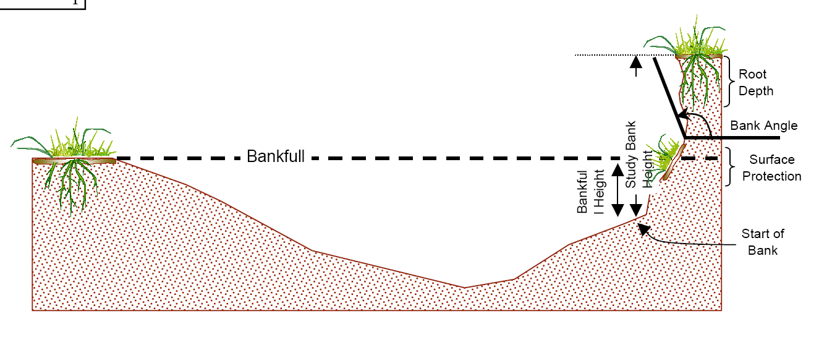
BEHI Measurement Variables Figure (from EPA 2006)
- Estimate the mean bank height (referred to as study bank height in the figure) of the eroding streambank from the toe of the bank to the top of the bank by making several measurements along the eroding streambank. The toe of the streambank is defined as the point where the streambank meets the channel bed.
NOTE: The toe of the streambank will not necessarily be in the water during baseflow conditions.
- Identify the most representative portion of the streambank and perform the BEHI measurements at this spot; record them on the BEHI Field Form. The measurements should be conducted in a location correspondent to the mean height of the eroding streambank:
- Bankfull height: measured from the toe of the bank to the bankfull elevation.
- Root depth: measured as the depth that the predominant roots which are providing stabilization extend into the soil from the top of the bank. The Root System Root-Depth Measurement Figure shows both grass and willow roots; although the grass roots have a higher density, they are shallow and the willow roots are providing more bank stabilization and therefore the root depth of the willows would be recorded.
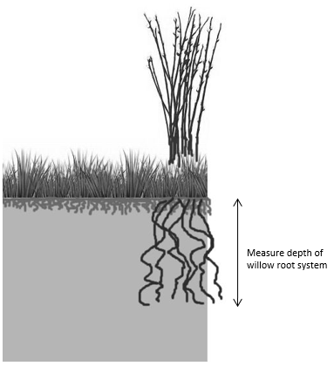
Root System Root-Depth Measurement Figure

- Root density: estimated as percent of the area assessed for root depth that is comprised of plant roots. Record measurements to the nearest 10%.
- Bank angle: measured from a horizontal plane in degrees from the toe of the bank to the top of the bank, with 90º being a vertical bank and >90º being an undercut bank. Bank angle is used to determine risk of mass erosion processes (planar failures, cantilever collapse, etc.). If the bank angle is 90º or less, measure from the toe of the bank, to the top of the bank. If the bank angle is greater than 90º, take the steepest angle extending below the root zone (Examples of Bank Angle Measurements Figure). Record measurements to the nearest 5º.
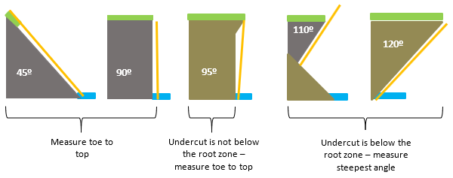 Examples of Bank Angle Measurements Figure

- Surface protection is measured as the percent of the streambank that is not exposed to erosion. A bare stream bank would be 0% surface protection. Surface protection can be provided by sod mats (i.e. vegetated slumps), large woody debris, boulders, root curtains, and/or existing revetments (Rosgen, 2006). If surface protection material is “on” the bank and is secure at bankfull, it should be counted as surface protection. If water can get behind the material and to the bank, it should not be counted as protection (Sod Mat Surface Protection Examples Figure). Record measurements to the nearest 10%.
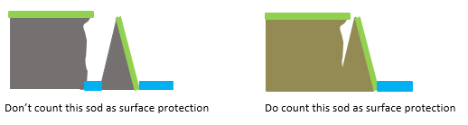
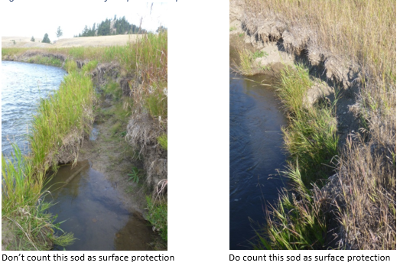
Sod Mat Surface Protection Examples Figure

- Apply the bank material adjustment as follows:
- Cobble: subtract 10 pts (unless gravel/sand >50%)
- Gravel: add 5-10 pts (depending on amount of sand)
- Sand: add 10 pts if exposed to erosion
- Silt/clay: no adjustment

- Apply the stratification adjustment depending on the position of the layers in relation to the bankfull stage. A streambank should be considered stratified when a more erosive layer is situated or “sandwiched” between two less erosive layers within the bankfull zone:
- Add 5-10 points when a more erosive layer is situated between two less erosive layers within the bankfull zone.
Near Bank Stress
- Measure near bank stress (NBS) at the point along the eroding bank that is receiving the most energy:
- Ratio of Near-Bank Maximum Depth to Bankfull Mean Depth (d_{nb}/d_{bkf}): This method calculates the ratio of the near-bank maximum bankfull depth (d_{nb}) to the mean bankfull depth (d_{bkf}). This method is generally most appropriate in relatively straight sections or gently turning bends.
      - Perform five bankfull depth measurements at roughly equal spacing across the bankfull width of the stream channel. Record these measurements in the Bankfull mean depth calculations box on the field form and calculate the mean bankfull depth.
      - Measure the near bank maximum depth, which is the deepest bankfull channel depth (measured from the channel bed to the bankfull elevation) within the 1/3 of the channel closest to the eroding bank along the cross-section. Record this depth on the field form.
      - Calculate the ratio of near-bank maximum depth to bankfull mean depth (d_{nb}/d_{bkf}) and record this value and the subsequent NBS ratings (see Conversion Table) on the BEHI Field Form.

Conversion Table of d_{nb}/d_{bkf} Values to NBS Ratings
NBS ratings based on d_{nb}/d_{bkf}
d_{nb}/d_{bkf} ratio | NBS rating
< 1.00 | Very Low
1.00 – 1.50 | Low
1.51 – 1.80 | Moderate
1.81 – 2.50 | High
2.51 – 3.00 | Very High
> 3.00 | Extreme

“Add Bank” Assessment
NOTE: If collecting the full suite of streambank erosion measurements at every eroding bank within the study site will be too time consuming, “Add Bank” forms may be used to streamline the process, if deemed appropriate by the project leader. Using Add Bank forms are often particularly useful in sites with long, homogenous character that contain frequent eroding banks. Add Bank assessments need not be conducted if time and preference of the field crew allow for full assessments at each eroding bank.
- When an eroding bank is encountered that closely resembles another bank that has already been measured for the full suite of parameters, that bank may be recorded:
- Record the “Add Bank” on the “Additional Streambank Erosion Measurements Form,” continuing along the ascending bank numbering sequence.
- Indicate the number of the bank that the “add bank” is similar to.
- Measure and record any parameters that are unique to the “add bank” (e.g. bank length, average bank height) as well as measurements for any parameters that differ from the similar bank.
- Example: upon encountering the fourth eroding streambank in the site, the field crew decides that is it very similar to the first bank assessed except that the level of surface protection and root density is slightly different. On the ‘Add Bank’ field form, this bank is recorded as Bank #4, the “Similar bank” is recorded as Bank #1, the bank length and average height for Bank #4 is recorded, and then in the comments field the parameters that differ from the referenced bank are recorded (i.e., surface protection and root density).
Photograph each eroding streambank
- Take one photo looking downstream at the eroding streambank and the second photo facing the streambank at the site where the BEHI and NBS assessments were performed. Include the measuring rod and the line level in the photo for reference, with the base of the rod placed at the toe of the streambank. Provide a brief description in the Photo Log (i.e. “d/s view at BEHI 1”, “view toward bank at BEHI 1”).
- If the eroding streambank is “complex” and appears to have more than one BEHI value and/or more than one NBS value, then the streambank may need to be broken into two or more eroding streambank “types”. If only the NBS changes along the streambank, then two separate NBS measurements can be performed for one eroding bank so long as the length of eroding bank associated with each NBS measurement is recorded.
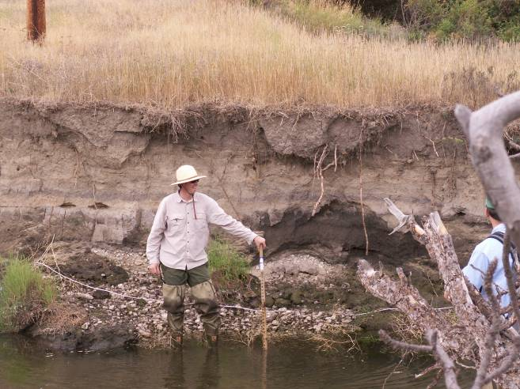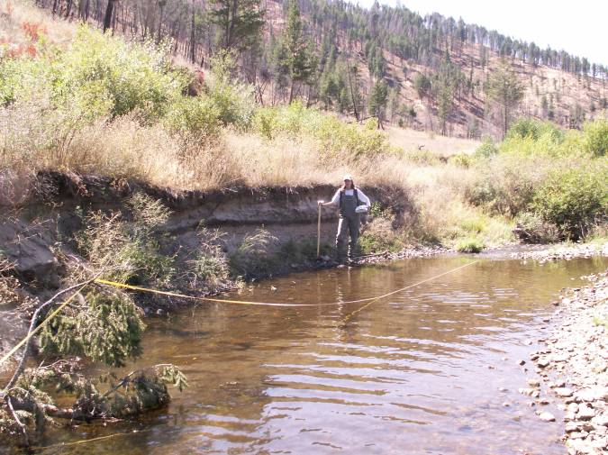
Example of Appropriate Photos of Eroding Streambanks

Data Analysis
- Calculate the following factors:
- Bank Height/Bankful Height
- Root Depth/Bank Height
- Weighted Root Density
- Bank Angle
- Surface Protection
- Extent of Undercut Bank

- Use the calculated values and the tables below to determine the index scores for each factor. 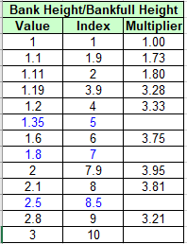 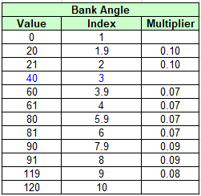 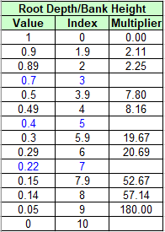 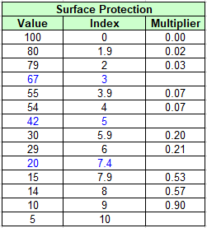 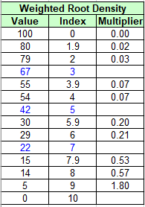

- Add the index scores together and use the table together to determine BEHI score:
- Calculate Near Bank Maximum Depth/Bankfull Mean Depth
- Determine Near Bank Stress rating using the table below:

Culvert Orientation to Channel Grade (Guidance Only; No SOP)
    - Geomorphic Impacts of Culvert Replacement and Removal: Avoiding Channel Incision
      - From the U.S. Fish and Wildlife Service (Oregon)
    - Culverts (general info)
      - From the Montana Department of Transportation
    - Culverts and Fish Passage
      - From the Center of Environmental Excellence (by AASHTO)
    - Potential Impact of Road-Stream Crossings (Culverts) on the Upstream Passage of Aquatic Macroinvertebrates
      - Submitted to the USFS

Culvert Size (Guidance Only; No SOP)
    - See above

Flood Prone Width and Entrenchment Ratio (SOP)

Method Overview
Flood prone area is defined as the area adjacent to the stream that is inundated or saturated when the elevation of the water is at twice the maximum depth at bankfull stage (Rosgen, 2002). Flood prone elevation roughly represents the water elevation during a 50-year discharge. Flood prone width is a factor in determining how entrenched, or vertically contained, a stream channel is (Rosgen 1994). Maximum bankfull depth is measured, and flood prone height (elevation) is calculated as 2x maximum bankfull depth. A measuring tape is stretched between points on the landcape at flood prone height (elevation) on both the left and right bank to determine flood prone width. Entrenchment ratio Is calculated as flood prone width divided by bankfull width.

Specifications
Applicable Waterbody Type: Wadeable Stream, Medium River, Large River

Scale: Waterbody, Stream Reach

Limiting Conditions:
- Requires wadeable riffles which are not present in all streams
Skills Required:
- Ability to distinguish riffles with high accuracy
- Ability to identify bankfull with high accuracy
- Ability to conduct Width/Depth Ratio method with high accuracy
Time Required:
- Minimum 2 people
- Approximately 30 minutes per cross-section
Considerations:
- This method is generally accurate enough to use for general comparisons and to determine Rosgen stream classification; use a laser-level method instead if higher accuracy is needed.
- Easiest to conduct this method at the same time and place as Width/Depth Ratio method.
Equipment and Software:
- Riffle Width/Depth form
- Clipboard
- Pencil
- 200’ measuring tape
- 5 foot measuring pole with 0.1 foot gradations
- Set of two bank pins or Silvey stakes
Data Needs:
- Maximum bankfull depth
- Bankfull width
Method Type: quantitative

Repeatability: Medium

Other Names: floodprone width, flood prone area, incisement

Method Source:
- Rosgen, D. L. 2002. Applied River Morphology. Second Edition. Wildland Hydrology. Pagosa Springs, Colorado.
Keywords: bankfull, flood prone, entrenchment, entrenched, incised, downcut

Procedure
Note: Reference Width/Depth Ratio method for additional instruction.

Flood-prone area is defined as the area adjacent to the stream that is inundated or saturated when the elevation of the water is at twice the maximum depth at bankfull stage (Rosgen, 2002); flood-prone width equates generally to a 50 or 100 year floodplain. Flood-prone width is a factor in determining how entrenched, or vertically contained, a stream channel is. Flood-prone height is calculated as 2x maximum bankfull depth and the width of the floodplain is measured at that elevation.
Measure flood-prone width at each of the four riffles where cross-sections were set up and where width/depth ratio measurements were taken.
Option 1:
- Measure the maximum bankfull depth along the cross-section. Calculate flood prone height (elevation) by multiplying the maximum bankfull depth two (floodprone elevation = 2 X maximum depth). Record flood prone height on the Riffle W/D Ratio field form.
- Measure the distance from left bankfull to the flood-prone elevation.
- One person places a measuring rod on top of the tape at bankfull so that “zero” on the rod is at the bankfull elevation (Flood-Prone Width Option 1 Figure). This person holds the “zero” end of another tape against the measuring rod at the height measured as maximum bankfull depth (effectively at 2x maximum bankfull depth since the bottom of the measuring rod is at bankfull already)
- Another person takes the other end of the tape and stretches the tape parallel out and away from bankfull until they reach a point at that elevation on the landscape (e.g., a terrace); this point denotes the margin of the flood-prone area from left bank.
- Repeat these steps to measure the distance from right bankfull to the flood-prone elevation (i.e., the margin of the flood-prone area from right bank).
- Record Flood-prone distance river left and flood-prone distance river right on the Riffle W/D Ratio field form.
- Indicate on the field form if the distance is > 200 ft.
- Indicate on the field form if the distance is an estimate.
- Calculate and record on the Riffle W/D Ratio field form the total flood-prone width = flood prone width from left bank + bankfull width + flood prone width from right bank
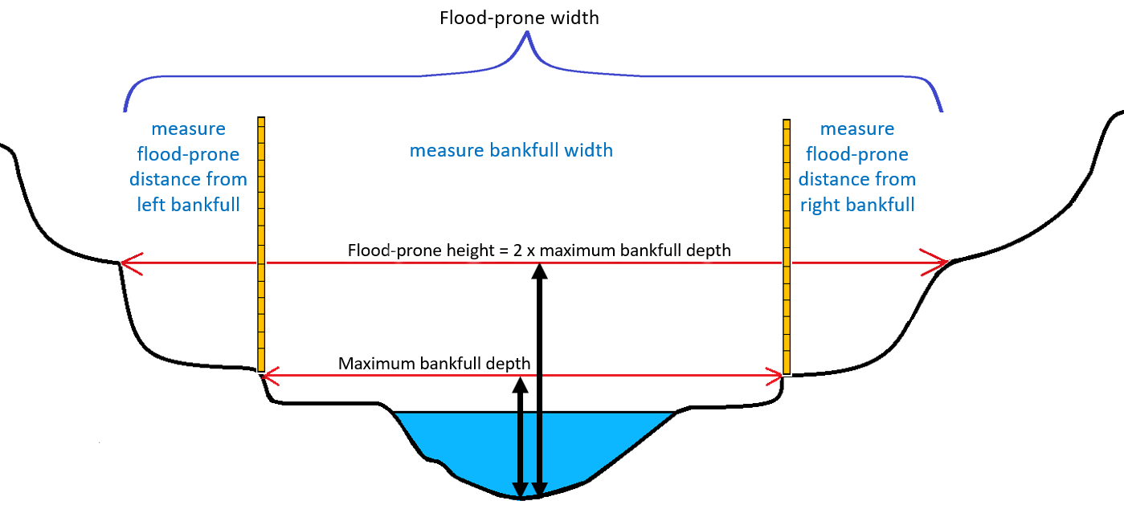
Flood-Prone Width Option 1 Figure

Option 2:
- Measure the maximum bankfull depth along the cross-section. Calculate flood prone height (elevation) by multiplying the maximum bankfull depth two (floodprone elevation = 2 X maximum depth). Record flood prone height on the Riffle W/D Ratio field form.
- One person holds a measuring stick at the point on the cross-section where maximum bankfull depth was measured and holds a measuring tape at flood-prone height (= 2X maximum bankfull depth).
- Two people stretch a measuring tape parallel to the cross-section and horizontal at flood-prone height until they each reach a point with both ends of the tape on the landscape at flood-prone height (Flood-Prone Width Option 2 Figure).
Note: a clinometer may be helpful in determining where on the landscape the extent of the flood prone width is. Place the clinometer at the height of the flood-prone elevation on the measuring rod and look through the clinometer towards the floodplain. Level the clinometer so it reads zero percent slope. The person with the clinometer holds one end of the tape at floodprone elevation at the measuring rod. Another person stretches a tape straight out from the cross-section at floodprone elevation until the point on the landscape is reached when the tape is level.

- Calculate and Record the total flood-prone width on the Riffle W/D Ratio field form
- Indicate on the field form if the distance is > 200 ft.
- Indicate on the field form if the distance is an estimate.

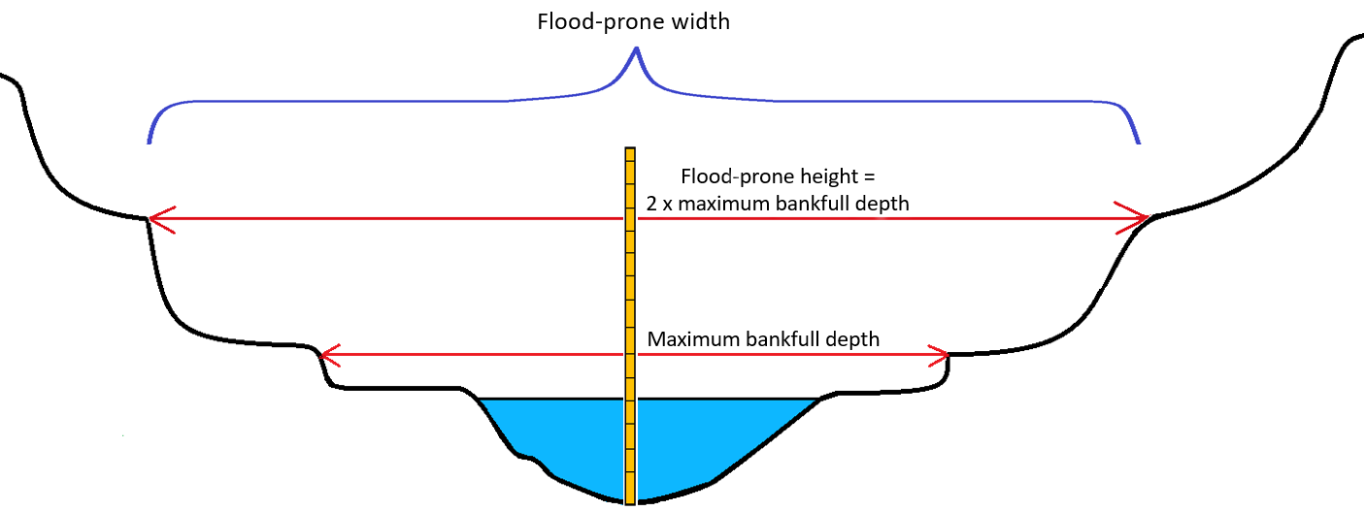
Flood-Prone Width Option 2 Figure

Calculations and Data Analysis
- Calculate entrenchment ratio = flood-prone width divided by bankfull width
- Consult the Key to the Rosgen Classification of Natural Rivers (Rosgen 2002) to begin identifying stream channel classification based on entrenchment ratio and width/depth ratio.
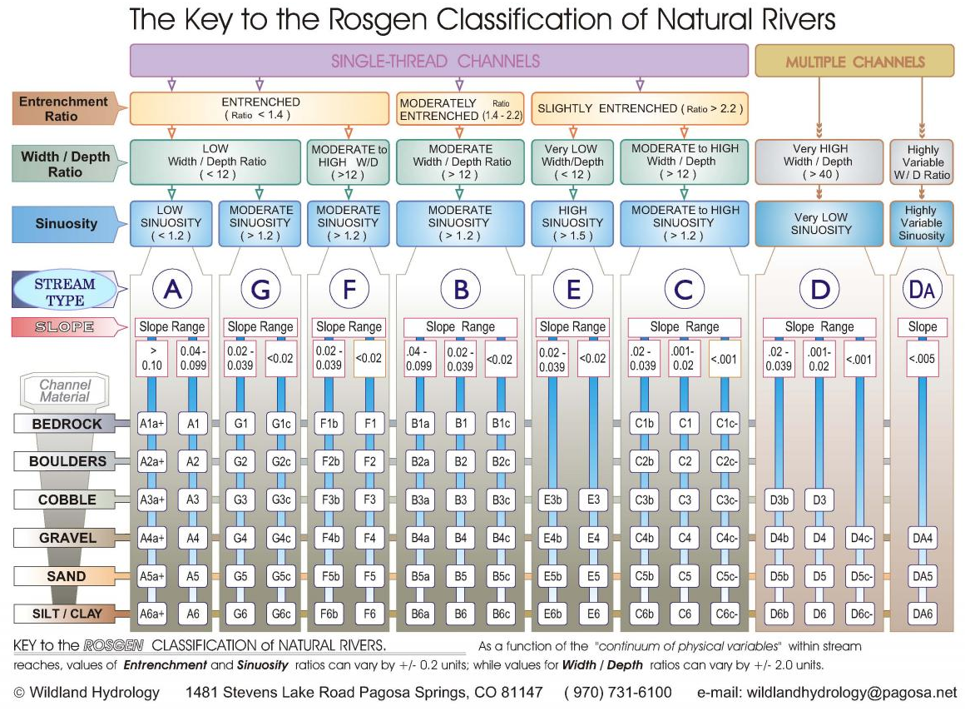

Greenline to Greenline Width (No Guidance; No SOP)
Future development here if useful

Large Woody Debris (No Guidance; No SOP)
Future development here if useful

Pool Frequency (No Guidance; No SOP)
Pool Frequency (e.g. number of pools per 1000 ft)
This section is under development.

Pool Tail Grid Toss (SOP)

Relevant Parameters of Interest:

percent fine sediment < 6mm in pool tails

Method Overview
A grid with 49 intersections is laid over the substrate at three evenly-spaced locations within each pool tail. The number of intersections with substrate less than 6 mm diameter are counted. The metric “percent fine sediment < 6mm in pool tails” is calculated.

A pool tail is located at the downstream end of a pool where the pool begins to narrow and slope upward, and where water tends to move faster before it crests (either called “pool tail crest” or “riffle crest”) and enters the next riffle (Figure 1). Pool tails tend to have gravel substrate and may exhibit upwelling or downwelling that make them desirable locations for salmonid spawning (Keller, et al., 1990).
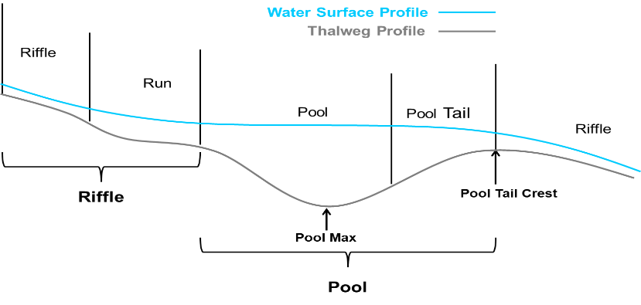
Figure 1. Riffle and Pool Features

Specifications
Applicable Waterbody Type: Wadeable streams

Scale: Waterbody, Stream reach

Limiting Conditions:
- Do not perform grid tosses at sites without riffle crest habitat (many warm water streams)
- Do not perform grid toss at sites naturally comprised of fine sand, silt or clay substrates.
- Collect at or near baseflow conditions when water clarity and visibility is more likely to be ideal
- Measure a minimum of 3 pool features to obtain reach average
- Narrow channel width complicates use of this method
- Requires adequate riffle-pool sequence to form and identify pool tails
Skills required:
- Ability to distinguish pools and pool tails with high level of certainty

Time Required:
- 1 person minimum
- Approximately 30 minutes per pool

Considerations:

Equipment and Software:
- Pool Tail Grid Toss field form
- Clipboard
- Pencil
- Grid
- Piece of Plexiglass or Aquavue Underwater Viewer Tube (preferred)

Data Needs:
- Residual pool depth per pool (used to determine whether pool is suitable for grid toss)
- Maximum depth at riffle crest per pool (used to determine whether pool is suitable for grid toss)
- Pool length (used to determine location within pool tail where grid tosses are performed)

Method Type: Quantitative

Repeatability: Medium

Other Names: grid toss, pool tail fines, fine sediment in pool tails

Method Source:
- cite Montana DEQ Beneficial Use Assessment Sediment SOP
- Archer, Eric K.; Henderson, Richard; Ojala, Jeffrey V.; Gavin, Amanda and Burke, Karen K. 2016. PacFish InFish Biological Opinion (PIBO) Monitoring Program: Effectiveness Monitoring Sampling Methods for Stream Channel Attributes. Unpublished paper on file with PIBO Monitoring Program.

Keywords: pool tail, fine sediment

Procedure
- Identify sampling locations
- Identify a reach of stream that is of similar character throughout (i.e., is relatively homogenous). Consider slope, stream channel confinement, stream type, sinuosity, land use, etc.
- Identify pools within the stream reach that are suitable to perform pool tail grid tosses. To be suitable for a grid toss, a pool must:
- Be formed by the scouring action of water (not formed by logs or some other debris damming the downstream end of the pool; partial damming is acceptable as long as a scour-formed pool tail is present), and
- Meet the depth criteria that residual pool depth (d_{r}) is ≥ 1.5 times the maximum depth of the riffle crest (d_{rc}) (see Residual Pool Depth method)
Note: If all pools fail to meet the minimum depth requirement, sample the four most well-developed pools with a grid toss.

Note: If pools are continually not meeting the minimum depth requirement, but show an obvious elevation change, look for signs that pools are filling due to excess sediment deposition. If pool filling is suspected, make a note on the “Residual Pool Depth and Pool Tail Fines” field form.

- Determine the location within the pool tail where grid tosses will be performed
- Determine the distance downstream from the pool tail crest where grid tosses are performed as either 10% of the pool’s length or 1 meter from the pool tail crest, whichever is less (Figure 2).

- Identify three points along the pool tail at which to perform grid tosses at points 25%, 50%, and 75% across the pool’s wetted width (Figure 2).
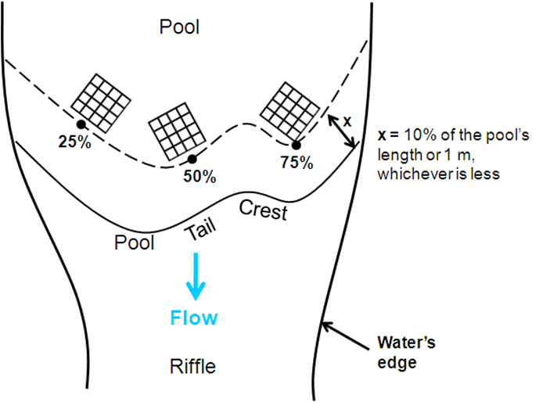
Figure 2. Pool Tail Grid Tosses

- Perform pool tail grid tosses
- Gently toss the grid into the determined location along the pool tail (25%, 50%, and 75%). Make sure the grid is parallel to and following the shape of the pool tail crest (not necessarily straight or perpendicular across the stream channel. If in small streams, the grid tosses overlap, note in the “Comments” section of the “Pool Tail Grid Toss” field form to indicate overlap occurred.
- Use an Aquavue underwater viewer or a piece of plexiglass held against the water surface to clearly observe each of the 49 interior intersections of the grid (Figure 3).

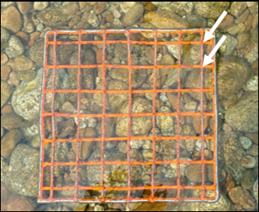
Figure 3. Grid with examples of interior intersections.

Note: The intersection of the grid is 6 mm. Therefore, if the intersection completely obscures the substrate directly below the grid, you know that substrate is less than 6 mm in diameter.

- Count and record the number of the internal intersections of the grid that are < 6mm, that is, the number of intersections where the grid completely covers the particles below.
- Record the number of intersections with particles < 6mm out of the total number of intersections assessed on the “Residual Pool Depth” field form.
- The total number of intersections is typically be 49.
- If the substrate below a portion of the grid is obscured (e.g., by a boulder with b-axis > 512 mm, algae, plants, or organic debris), don’t try to remove the obstruction. Instead, count the number of obscured intersections and subtract that number from the total number of intersections (i.e., 49 minus the number of obscured intersections). Then, record the number of intersections with substrate less than 6mm out of the total number of unobscured intersections. For example, if 9 intersections are obscured, and 5 intersections are < 6mm, you would record “5/40.”
- Estimate the median (i.e., D₅₀) substrate size class of the substrate under the grid for each grid toss and record as: s = sand (< 2 mm), g = gravel (2 mm ‐ 64 mm), c = cobble (64 mm – 256 mm), b = boulder (256 mm ‐ 2048 mm), and bd = bedrock (> 2048 mm).

Note: Substantial deposition of fine sediment in pool tails can seriously limit aquatic habitat. However, very fine layers of sediment (≤ 1 mm deep) on pool tail sediment can be easily brushed aside with the sweep of a fish tail and therefore does not indicate a reduction in suitable aquatic habitat. When counting which intersections are classified < 6mm, keep this in mind. If the particles below the fine sediment are still clearly visible, or if the slightest movement of the Aquavue moves the particles in question, do not count this layer of fine sediment as < 6mm. If the substrate below an intersection is truly blanketed by sediment and you cannot distinguish the detail of the substrate below, count the intersection as having < 6mm fine sediment.

Calculations and Data Analysis
- For each pool tail sampled, add the three grid results to determine the total number of particles < 6mm out of the total number of intersections counted.
- Calculate percent fine sediment < 6mm:
(total number of particles < 6mm counted in all pools ÷ total number of particles counted in all pools) * 100
- Metrics calculated from study streams are often compared to the same metrics calculated from similar datasets, either collected from the same study stream over time, or collected from reference sites that represent conditions in comparable streams where all reasonable land, water or soil conservation practices are in place. Reference data for fine sediment in riffles is often collected using this procedure by DEQ and the U. S. Forest Service PIBO program.

Residual Pool Depth (SOP)

Method Overview
Residual pool depth is the difference in depth or bed elevation between a pool and the downstream riffle crest (Lisle 1987). At multiple pools within a stream reach, measurements are made of 1) the deepest point of the riffle crest at the downstream end of the pool, and 2) the deepest point of the pool along the thalweg. The metric “residual pool depth” is then calculated.

The riffle crest (also referred to as “pool tail crest”) is defined as the geomorphic downstream limit of a residual pool – the line of zero residual depth spanning the width of the channel (Lisle 1987). As flow recedes to zero and connectivity is lost between two consecutive pools, the riffle bed is exposed and the residual pools remain like standing cups of water. The line formed by the downstream edge of the residual pool sketches the riffle crest (Rossi 2012).
Figure 1. Riffle and Pool Features

Specifications
Applicable Waterbody Type: Wadeable streams

Scale: Waterbody, Sampling Reach

Limiting Conditions:

Skills Required:
- Ability to distinguish riffle and pool features, including thalweg and riffle crest, with high accuracy
Time Required:
- 1 person minimum
- Approximately 15 minutes per pool feature
Considerations:
- Collect at or near baseflow conditions when water clarity and visibility is more likely to be ideal
- Measure a minimum of 3 pool features to obtain reach average
- If the site is one long pool (common on warm water streams), with no riffle crest habitat, residual pool depth measurements will not be collected.

Equipment and Software:
- Residual Pool Depth field form
- Clipboard
- Pencil
- 5 foot measuring pole with 0.1 ft gradations
Data Needs:
- Delineated stream reach (consider 20x bankfull width)
Method Type: Quantitative

Repeatability: High

Other Names: residual depth

Method Source:
- Montana DEQ Beneficial Use Assessment Sediment SOP
- Archer, Eric K.; Henderson, Richard; Ojala, Jeffrey V.; Gavin, Amanda and Burke, Karen K. 2016. PacFish InFish Biological Opinion (PIBO) Monitoring Program: Effectiveness Monitoring Sampling Methods for Stream Channel Attributes. Unpublished paper on file with PIBO Monitoring Program.
Keywords: residual depth, pool, channel morphology, geomorphology

Procedure
- Identify sampling locations
- Identify a reach of stream that is of similar character throughout (i.e., is relatively homogenous). Consider slope, stream channel confinement, stream type, sinuosity, land use, etc.
- Record each pool within the stream reach on the “Residual Pool Depth” field form.
- Measure pool features and record on the “Residual Pool Depth” field form (Residual Pool Depth Figure):
- For each pool, identify the riffle crest (at the downstream end of the pool prior to transition into riffle). Probe with a measuring pole to locate the deepest point along the riffle crest. Measure and record the maximum depth at the riffle crest (d_{rc}).
- For each pool, probe with a measuring pole to locate the deepest point of the pool. Measure and record the maximum depth of the pool (d_{p}).
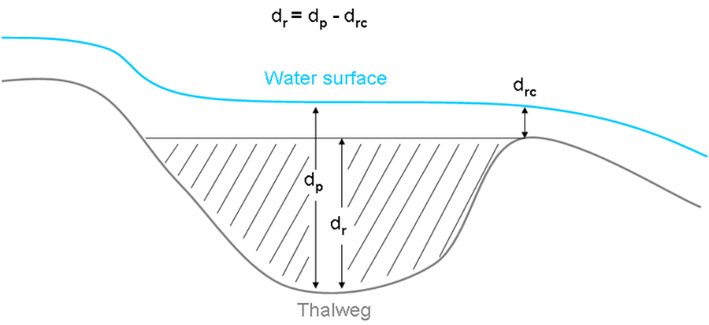
Figure 2. Residual Pool Depth (adapted from Lisle 1987)

Calculations and Data Analysis
- Calculate residual pool depth (d_{r})

Residual pool depth (dr) = maximum pool depth (d_{p}) - maximum depth of the riffle crest (d_{rc})

- Metrics calculated from study streams are often compared to the same metrics calculated from similar datasets, either collected from the same study stream over time, or collected from reference sites that represent conditions in comparable streams where all reasonable land, water or soil conservation practices are in place. Reference data for fine sediment in riffles is often collected using this procedure by DEQ and the U. S. Forest Service PIBO program.

Riffle Pebble Count with Gravelometer (SOP)
Relevant Parameters of Interest:

median particle size (D50)

percent fine sediment <2mm and/or < 6 mm in riffles

Method Overview
Substrate particle size analysis in which substrate particles within the bankfull channel width in riffles are measured using a gravelometer and size classes are tallied. 400 total particles are measured in a stream reach, preferably 100 particles from evenly-spaced transects within each of four riffles. Metrics calculated include percent fine sediment in riffles less than 2 mm, percent fine sediment in riffles less than 6 mm, and median particle size (D50).

Specifications
Applicable Waterbody Type: Wadeable Streams

Scale: Waterbody, Sampling Reach

Limiting Conditions:
- Not applicable to low gradient prairie streams which naturally have substrate comprised all (100%) or mostly fine sediment <2mm.

Skills Required:
- Ability to distinguish riffles with high accuracy
- Ability to identify bankfull with moderate accuracy
- Ability to distinguish B-axis of pebbles with low accuracy

Time Required: Two people minimum; approximately two hours

Considerations:
- Collect at or near baseflow conditions when waterbody can be safely waded

Equipment and Software:
- Pebble count field form per riffle
- Measuring tape
- Bank pins
- Gravelometer
- Tally counter (optional)

Data Needs:
- Homogenous stream reach
- riffle length (used to determine spacing of transects)
- number of suitable riffles within sampling reach (used to determine number of particles to measure per riffle)

Method Type: Quantitative

Repeatability: High

Other Names: pebble count, Wolman pebble count

Method Source:
- Montana DEQ Beneficial Use Assessment Sediment SOP
- Archer, Eric K.; Henderson, Richard; Ojala, Jeffrey V.; Gavin, Amanda and Burke, Karen K. 2016. PacFish InFish Biological Opinion (PIBO) Monitoring Program: Effectiveness Monitoring Sampling Methods for Stream Channel Attributes. Unpublished paper on file with PIBO Monitoring Program.
- Wolman, M.G., 1954. A Method of Sampling Coarse River-bed Material. Transactions, American Geophysical Union 35(6):951- 956

Keywords: particle size, substrate, pebble count, riffle

Procedure
Identify sampling locations
- Identify a reach of stream that is of similar character throughout (i.e., relatively homogenous). Consider slope, stream channel confinement, stream type, sinuosity, land use, etc.
- Choose four riffles within the stream reach (Riffles and Pools Figure). Riffles should be selected at random and distributed throughout the stream reach, not necessarily the first four riffles you encounter. To avoid bias, do not target riffles based on size, ease of access, etc.

Note: You will tally 400 particles total from riffles within the stream reach, measuring 100 particles from each of four riffles whenever possible. If fewer than four riffles are present, distribute the 400 total particles evenly among the riffles that are present. For example, if only two riffles are present, collect 200 particles in each riffle. If the entire site is one riffle, measure 25 pebbles at 16 transects evenly distributed throughout the site.
Definitions of stream features (EPA 2012):
Riffles: Riffles typically are marked by fast, turbulent water running over rocks. Riffles represent the sections of the stream with the steepest slopes and shallowest depths at flows below bankfull. Riffles may have a poorly defined thalweg.
Runs: Runs are characterized by moderate current and little or no turbulence on the surface. They differ from riffles in that depth of flow is typically greater and slope of the bed is less than that of riffles. Runs will also often have a more defined thalweg.
Pools: Pools are the deepest locations of the reach and hold slow moving water. Water surface slope of pools at below bankfull flows is near zero. Pools are often located at the outside of meander bends, or on the downstream end of large obstructions such as rocks or large wood.

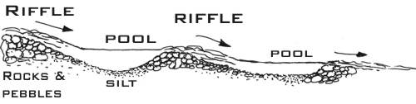
Riffles and Pools Figure (Field Studies Council, 2019)

Note: Always work from downstream to upstream to avoid disturbing the substrate in areas not yet sampled.
- At each riffle selected for sampling, identify four evenly-spaced transects. Measure the length of the riffle, divide the riffle length by 5 to determine the distance between transects, and locate transects at 20, 40, 60, and 80% of the riffle length; orient each transect perpendicular to the channel (Riffle Pebble Count Transects and Sampling Scheme Figure).
- At each transect, determine the distance between particles. Measure the bankfull width of the channel (including both dry and wetted portions) and divide this length by 25. Adjust the number of transects and particles per transect as needed if fewer than four riffles are present.

Collect, measure, and tally particles

- Collect particles along transects that are perpendicular to the stream banks (Riffle Pebble Count Transects and Sampling Scheme Figure), traveling from bankfull to bankfull and from downstream to upstream. For example, sample transect 1 from river left to river right, walk upstream along the bank, then sample transect 2 from river right to river left, and so on.

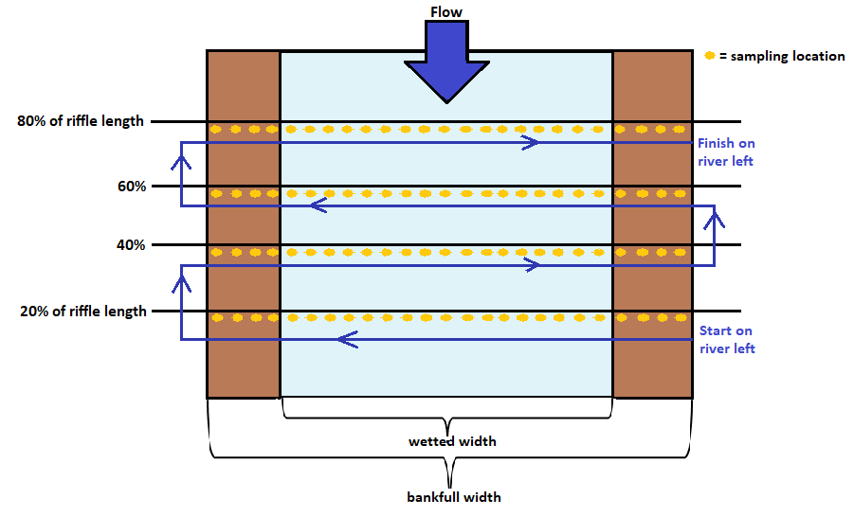

Riffle Pebble Count Transects and Sampling Scheme Figure
- To select particles, at each of the 25 equally-spaced sampling locations along a transect, point directly down off the tip of your boot and pick up the first particle that your finger touches. Lift the particle out of the stream.
- Measure the intermediate axis (B-axis) (Three Axes of a Pebble Figure) of each particle by passing it through the smallest hole in the gravelometer (Gravelometer Figure) that it will fit through. After measuring a particle, place it downstream of the transect so it is not measured again.
- If your finger first encounters silt or fine sand, record the particle as “< 2mm.”
- If your finger encounters an obstruction such as algae, vegetative, or woody debris, carefully move the obstruction so the substrate below can be sampled. If the obstruction cannot be moved without disturbing the substrate below, select a particle just upstream or further along the transect from the obstruction.
- For particles less than 4 mm (the smallest hole in the gravelometer), use the edge of the gravelometer which is 2 mm wide to distinguish whether it is “2.1 – 4 mm” or “< 2 mm.”
- Measure particles greater than 128.1 mm using the notches along the edge of the gravelometer.
- Particles greater than 2056 mm are considered bedrock and should be estimated visually.
- If the particle cannot be moved from the stream bottom (e.g., too large or too embedded), estimate its size to the best of your ability using the gravelometer as a guide. If your finger falls on this large particle multiple times because it is large enough to span multiple sampling distances along a transect, record it each time as an individual count in your tally.

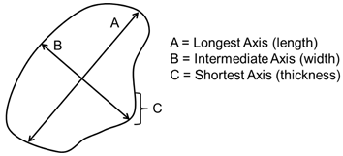
Three Axes of a Pebble Figure (Archer et al., 2012)

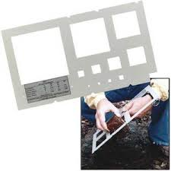
Gravelometer Figure

- Record each particle on the “Riffle Pebble Count” field form
- Tally each particle in the appropriate size category. For example, if the particle fits through the 22.6 mm opening but not the 16 mm opening, record it in the “16.1-22.6 mm” size category.
- Use the “dot/slash” tally system (Dot/Slash Tally Figure) to represent 10 particles (four dots first, then perimeter lines of the box, then diagonal lines within the box).
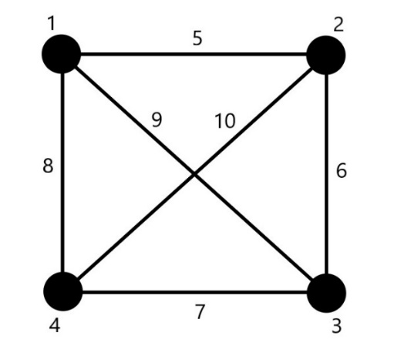
Dot/Slash Tally Figure
- Record each particle tally as either “Wet” if collected within the wetted channel, or “Dry” if collected between the water’s edge and bankfull.
- Record whether the transect is primarily within run or riffle habitat.

Calculations and Data Analysis
- For each riffle, add the tally for all size categories.
- Calculate metrics:
- “percent fine sediment in riffles < 2mm”
(Total number of particles < 2mm ÷ total number of particles collected at site) * 100
- “percent fine sediment in riffles < 6mm”
(Total number of particles < 6mm ÷ total number of particles collected at site) * 100
- median particle size (D₅₀)
(The median size class of all particles)
- Metrics calculated from study streams are often compared to the same metrics calculated from similar datasets, either collected from the same study stream over time, or collected from reference sites that represent conditions in comparable streams where all reasonable land, water or soil conservation practices are in place. Reference data for fine sediment in riffles is often collected using this procedure by DEQ and the U. S. Forest Service PIBO program.
- In DEQ’s sediment assessment method, “percent fine sediment < 2mm” and “percent fine sediment < 6mm” metrics are used in conjunction with a pool tail grid toss metric to determine if a stream is impaired by fine sediment.

Rosgen stream type (Guidance Only; No SOP)
- Fundamentals of Rosgen Stream Classification System
  - From the U.S. EPA
- Stream Classification
  - From the USFS; good graphics

Turbidity

Benchtop Meter (SOP)

Method Overview
Turbidity is the cloudiness of the water and can directly affect aquatic life, but is more typically measured to assess suspended sediment concentrations. This method covers the use of the Hach 2100Q benchtop turbidity meter for collection and analysis of water samples for turbidity. Samples are collected from a waterbody and analyzed with the meter either in the field or back in an office.

Specifications
Applicable Waterbody Type: large rivers; streams; ephemeral and intermittent streams; lakes; wetlands

Scale: PROJECT AREA; WATERBODY; WATERSHED

Limiting Conditions:
- Virtually any water sample can be analyzed for turbidity however consideration of what a sample represents should be evaluated.
- During storm events or high flow conditions, turbidity can vary with depth in the water column or across a stream and can change a lot over a short time.

Skills Required:
- Collection of turbidity samples and analysis with the meter require attention to detail but are not highly technical and do not require extensive knowledge beyond following instructions outlined here.

Time Required: One person can collect a turbidity sample in just a few minutes. Analysis with the meter should take less than five minutes per sample. Time per sample will be shorter if multiple samples are analyzed at once and if it is done on a table top or other convenient location rather than beside a stream.

Considerations:

Equipment and Software:
- Hach 2100Q meter
- Sample cuvettes
- Sample bottles
- Lint free tissues (ChemWipes or similar)
- Preferably deionized water but clean tap water will work for cleaning equipment.

Data Needs:
- Turbidity is typically correlated with discharge (high when flow is high) and during storm events so coordinating turbidity with consideration of flow conditions is valuable.

Method Type: Quantitative

Repeatability: MEDIUM: Variability in results based on who is collecting the sample is less likely to affect outcome of turbidity sampling than the high variability with time. If two teams went out at slightly different times during a storm event, they could get very different results from turbidity sampling. For this reason, approaches like synoptic sampling and collection of large numbers of samples can be valuable with this relatively quick and low-cost data collection method.

Other Names: None

Method Source:
- Adam Sigler and staff at MSU Extension Water Quality wrote this method with some elements taken from the Hach 20100Q user manual.

Keywords: turbidity

Procedure
- Calibration Check
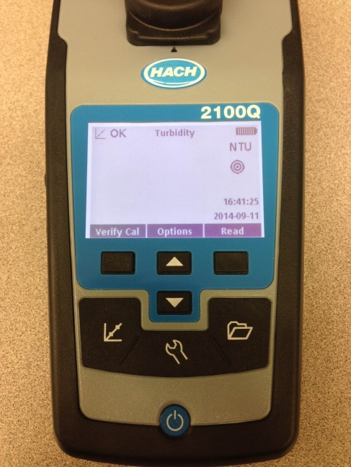
Before using the turbidimeter, perform a Calibration Verification check.
Figure 1. ‘Verify Cal’ button

- Turn the meter on (blue circle button near bottom of meter).
- Pick out the 10 NTU Verification Standard from the turbidimeter case.
- Shake it vigorously for 10 seconds.
- Let it sit undisturbed for 3-5 minutes (to allow air bubbles to dissipate).
- Hold the vial by the cap and wipe the glass with a lint free cloth or Kim wipe and be careful not to touch the glass.
- Insert the standard into the sample cell well, line up the orientation arrow on the bottle and the meter and press “Verify cal’ button (square highlighted button in Figure 1).
- The first screen in image 2 will appear. Press the read button, the meter will stabilize for a few seconds (second screen in Figure 2) and then you will be notified if the calibration verification passed.
- If the verification calibration is not successful, perform a 3 point calibrate with the meter.

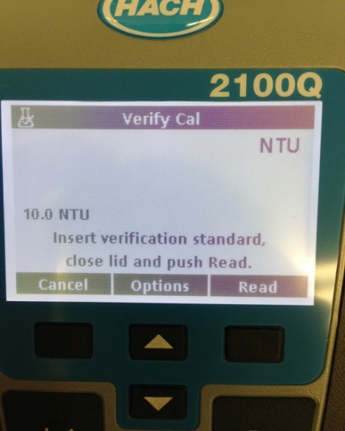
Figure 2. Succession of screen views once verify calibration process is started

- Collecting a sample for turbidity analysis
If the turbidity meter is taken to the field to test samples on site, the turbidity vials from the meter can be filled directly from the stream. Alternatively, bottles can be filled at sites and transported to the meter for analysis. Samples should be analyzed as soon as possible, with 7-day maximum hold time (parallel to suspended sediment samples).
- If you are collecting samples in bottles to be transported, label them with permanent marker before collecting the sample (permanent marker will wipe off of plastic bottles with alcohol so they can be reused). Label the bottle with site ID from the SOP, date and time.
- Bottles should be filled from a well-mixed portion of the stream.
- Bottle and lid should be triple rinsed prior to collecting the sample.
- When collecting the sample, face upstream and fill the bottle from below the water surface but without disturbing the bottom sediments.
- Enough sample needs to be collected to reach (or exceed) the white line in the turbidity vial (approximately 20 mL).
- Replace the lid on the vial or sample bottle.
- If analyzing the sample on site, proceed with the next section in a convenient location at the site. If the sample is being transported, it should be kept cool until being analyzed. If it will be more than a few hours until analysis, samples should be stored on ice.

- Analyzing a Water Sample with the Turbidimeter
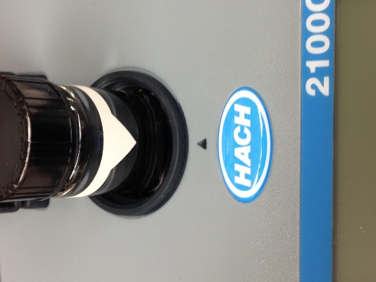
- Fill the glass vial from the turbidity meter with sample to the white line.
Figure 3. Align the white orientation arrow with back orientation mark on the meter.
- By holding the vial by the plastic cap, carefully wipe the glass with a Chem Wipe or lint free cloth and be careful not to touch the glass.
- Turn on the turbidity meter so it is ready to take the reading promptly after the vial is inserted.
- Gently invert the sample a few times and insert the sample vial with the white orientation bar and arrow in line with orientation mark in front of the cell compartment (Figure 3).
- Close the compartment and immediately press ‘Read’ (Figure 4).
- The turbidimeter will beep when it is finished reading the sample.
- Record this number on your field sheet.
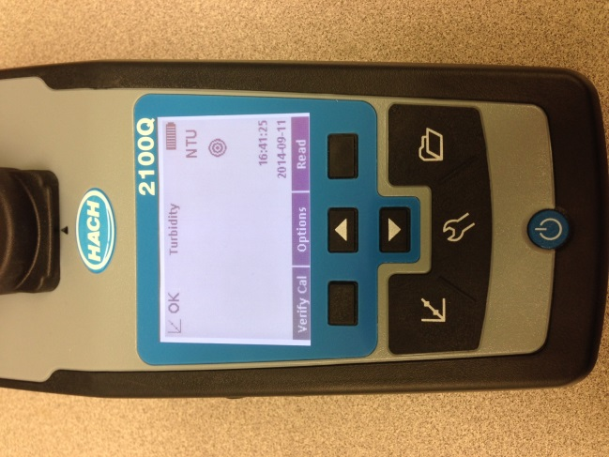
- Remove the vial from the turbidity meter and gently invert a few times, put the vial back in the sample and take another reading.
Figure 4. The read button is highlighted by the yellow circle above.
- Record on the reading on your data sheet
- Repeat this process one more time and record the reading on the datasheet, for a total of 3 readings on the sample.
- Empty the sample vial and rinse with deionized water.
- Once sampling is complete, refill the vial with deionized water for storage.

Calculations and Data Analysis
- The three readings for the sample should be averaged to get the value for the sample.
- Turbidity is related to suspended sediment concentration (higher turbidity NTU readings means higher suspended sediment concentration), so patterns in turbidity can be assumed to be generally parallel to patterns in suspended sediment concentration.
  - If the same samples (or tightly paired samples) are analyzed for both turbidity and suspended sediment concentration, a relationship can be determined for a specific location. The relationship will vary depending on particle size and other characteristics of the sediment which can change with location and time, but with enough samples, the variability/uncertainty in the relationship can be characterized.
- Turbidity samples collected on the same day from locations across a watershed can help paint a picture of where suspended sediment concentrations are the highest.
- If turbidity numbers are intended to estimate where and/or when the highest sediment transport is happening, then discharge must also be measured or acquired from an existing gage. If turbidity is intended to estimate actual sediment loads, then discharge must be known as well as the relationship between turbidity and sediment concentration (see 2a above).

Turbidity Tube (SOP)

Method Overview
This method provides a measure of turbidity, or water clarity. A tubidity tube is a clear tube 122 cm long with a measurement scale along the length of the tube and a black and white secchi disk at the bottom. The tube is filled with water and the water level is drained slowly until the secchi disk becomes visible. The distance from the water level to the secchi disk is recorded and converted to Nephelometric Turbidity Units (NTU).

Specifications
Applicable Waterbody Type: large rivers; streams; ephemeral and intermittent streams; lakes; wetlands

Scale: WATERBODY

Limiting Conditions:
- Preferably performed in a shaded location.
Skills Required:
- Able to look from the top of tube to the ground while tube is held upright.
Time Required:
- Minimum 2 people
- Approximately 20 minutes
Considerations:
- The same person should perform all three readings at a site.
- Take care not to scratch the tube as this will scatter light affect the accuracy of readings.
- Hold the tube in a shaded location, if possible.
- Remove sunglasses before viewing.
Equipment and Software:
- Turbidity (secchi) tube
- Clean cup or container for collecting water
- Field form
Data Needs:
- None
Method Type: semi-quantitative

Repeatability: medium

Other Names: turbidity tube, secchi tube

Method Source:
Keywords: turbidity tube, secchi tube

Procedure
- Carrying the turbidity tube (also known as secchi tube), wade into the water to a well-mixed portion of the channel where the water is steadily flowing; avoid stagnant water and eddies, and also avoid areas that are excessively turbulent. The location should be free of upstream obstructions (for example, not directly downstream from a bridge, boulder, tree, people, dogs, etc.).
- Rinse the tube well, inside and out.
- Verify that the drain tube at the bottom of the instrument is closed by compressing the clip.
- Submerge the turbidity tube below the water surface upstream from where you are standing. The opening of the tube should face upstream. Fill the tube. Use a clean plastic tub or cup to grab additional water, if needed, to fill the tube to the top of the measurement scale (122 cm).
- Holding the tube upright, walk the full turbidity tube out of the water and back to a stable location on the streambank. Select a shaded location where the tube isn’t exposed to direct sunlight. If a fully shaded location is not available, attempt to hold the tube in a position where it is shaded by a person’s body. If sun exposure is unavoidable, it is better to select a location where the tube receives even sun exposure (as opposed to mottled sun and shade).
- Rest the full turbidity tube on the ground in an upright position. The person reading the turbidity tube should hold the tube still and upright. With your eyes 20 – 40 cm (8 – 16 inches) from the top of the tube, peer through the water column and determine if the secchi disc at the bottom of the tube is visible.
- If the disc is visible while the tube is full, record > 122 cm on the Site Visit Form, essentially indicating that the turbidity tube is not sensitive enough to measure turbidity when the water is so clear.
- If the disc is not visible when the tube is full, indicate to your partner that you are ready for them to release the clip that pinches the drain tube and begin releasing water out of the tube. As the water is released, peer carefully down the tube. When the Secchi disk (the black and white disk at the bottom of the tube) first comes into view, instruct your partner to pinch the tube again, stopping the drain.
- Check the level of the water remaining in the turbidity tube by reading the centimeter scale on the side of the tube. Record the measurement in centimeters (cm) on the field form.
- Repeat steps 1 through 8 two additional times, performing three individual turbidity tube measurements.

Data Analysis
- Add the three individual distances together and divide by three to calculate the average distance. Record this average distance (cm) on the field form.
- Use the conversion chart to convert the centimeter distance reading into Nephelometric Turbidity Units (NTUs) and record this NTU value on the field form. For example: 44 cm = 13 NTU.

Distance from bottom of tube (cm) | NTUs
<6.25 | >240
6.25 to 7 | 240
7 to 8 | 185
8 to 9.5 | 150
9.5 to 10.5 | 120
10.5 to 12 | 100
12 to 13.75 | 90
13.75 to 16.25 | 65
16.25 to 18.75 | 50
18.75 to 21.25 | 40
21.25 to 23.75 | 35
23.75 to 26.25 | 30
26.25 to 28.75 | 27
28.75 to 31.25 | 24
31.25 to 33.75 | 21
33.75 to 36.25 | 19
36.25 to 38.75 | 17
38.75 to 41.25 | 15
41.25 to 43.75 | 14
43.75 to 46.25 | 13
46.25 to 48.75 | 12
48.75 to 51.25 | 11
51.25 to 53.75 | 10
53.75 to 57.5 | 9
57.5 to 60 | 8
Over the top | 6

Water Surface Slope (SOP)

Method Overview
Water surface slope is a measure of the change in elevation from the upstream end of a segment to the downstream end of a segment of a stream or river. Slope, or how steep a section of a stream is, is an important physical factor of stream channels as it is related to sediment deposition, flow velocity, etc.

Specifications
Applicable Waterbody Type: StreAMS

Scale: WATERBODY

Limiting Conditions:
- Visibility between two points along a stream reach is often a limited factor for this method; the more disrupted the line of sight, the more individual sections within the reach will need to be measured.
Skills Required:
- Must be able to wade and stand in flowing water and uneven ground.
- Must be able to repeat measurements with a clinometer with reasonable consistency.
Time Required:
- Minimum 2 people
- Approximately 30 minutes to 1 hour
Considerations:
- A single measurement may be possible if there is an unobstructed view between the upstream and downstream end of the reach; more often, the reach must be measured incrementally until the entire reach has been measured, then a weighted average is calculated.
- Increments do not need to be equal in length; length depends on visibility.
- Need to know the total length of the reach and must record the length of each increment of the reach measured
Equipment and Software:
- 2 measuring poles
- Colored flagging
- Clinometer
- Field form
- Clipboard/pencils
- Measuring tape (if the reach isn’t already measured and marked with distances)
Data Needs:
- Record reach length per increment measured
- Record percent slope measurements for each increment
Method Type: SEMI-quantitative

Repeatability: medium

Other Names: slope, gradient

Method Source:
- Montana DEQ Beneficial Use Assessment Sediment SOP

Keywords: slope, gradient, clinometer, steepness

Procedure
NOTE: Slope is measured from the upstream end of the site to the downstream end at the same type of feature (e.g., from the pool tail crest at the top of the site to the pool tail crest at the bottom of the site).

NOTE: A single slope measurement may be made for the entire site only if there is a clear, unobstructed path between the upstream and downstream end of the site; this is uncommon except in areas with little to no tall vegetation. If there is not a clear path between the upstream and downstream end of the monitoring site, measurements of slope from multiple uninterrupted segments will need to be recorded to determine a weighted average of slope for the entire monitoring site.

NOTE: The bottom of both measuring poles must be held steady exactly at the water surface while slope measurements are made. To accomplish this, consider propping the bottom of the pole at the water’s edge on one or the other bank, on a submerged rock within the channel whose top comes right to the water surface, or on top of a boot positioned so the boot is submerged and the top of the boot is at the water surface.
- Determine which person will use the clinometer to take slope measurements.
- Hold two measuring poles next to one another. Identify the height on the poles that is level with the eye of the person who will use the clinometer. Tie a piece of brightly-colored flagging onto each pole at this identical height.
- The person without the clinometer stands at a location as far downstream as there is still a clear, unobstructed path of sight through the clinometer between the two points and holds the measuring rod vertical and with the base at the water surface. The person with the clinometer stands at the upstream end of the monitoring site and holds their measuring pole vertically upright with the base at the water surface (see Measuring Slope Figure).
- The person downstream should stand at a location that was previously flagged during site delineation and mapping so the distance is known, for example, a pool or riffle feature or EMAP transect.
- Both people should stand at a similar position within the channel (e.g., both on right bank, left bank, or mid-channel).
- The person upstream holds the clinometer at the level marked on the measuring pole marked with flagging then, keeping their head straight ahead, peers through the clinometer such that the line of the clinometer lines up with the zero slope mark. The person then gradually tips the clinometer such that it aligns with the brightly-colored flagging on the downstream measuring rod. The person reads the angle indicated on the clinometer.
- Record the distances that correspond with the locations where both people are standing along the site reach as well as the percent slope measured with the clinometer between the two points.
- Before the person downstream moves further downstream, the person with the clinometer walks downstream and positions their measuring rod in the exact location where the downstream person held theirs during the first round of measurements. The second person can then proceed downstream and position their measuring rod at the water surface for the next round of measurements.
- Repeat this process to survey the entire site for slope.
- Calculate the weighted average slope for the entire monitoring site; this is typically completed in the office with the use of an electronic spreadsheet template.

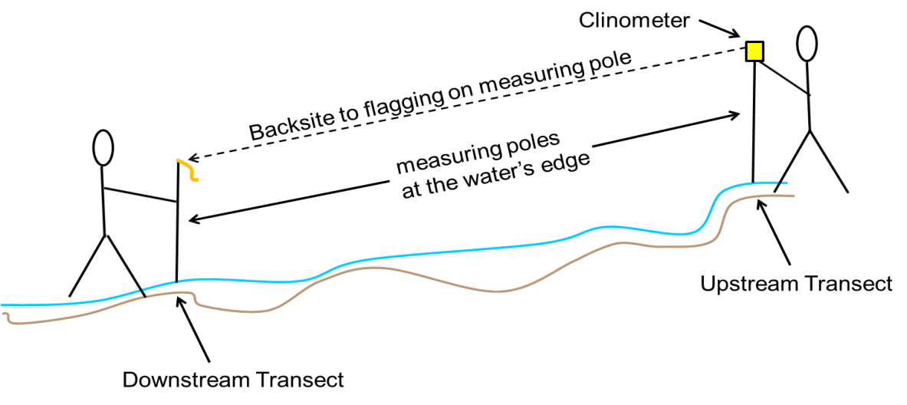
Measuring Slope Figure

Data Analysis
Calculate the weighted average water surface slope for the site:

- Determine the length of each site interval used when measuring slope throughout the site.
- Calculate the weight factor for each distance interval = Distance Site Interval x Total Site Length
- Calculate the weight for each site interval = Weight Factor for Interval x Slope for interval
- Calculate the weighted average slope for the entire site = sum of all intervals’ weighted slopes
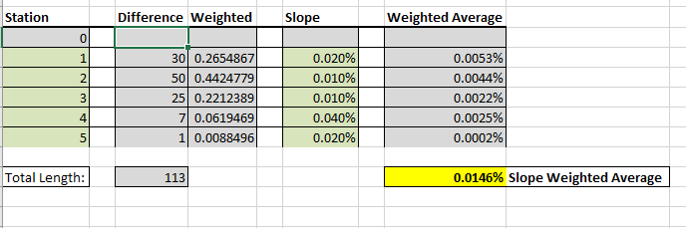

Width/Depth Ratio (SOP)

Method Overview
Cross-sections are set up with a measuring tape perpendicular to the channel at one or more riffle (preferably ≥ 3; a single cross-section is not typically useful unless its exact location is georeferenced such that measurements can be repeated at exactly the same location over time). At each cross-section, bankfull width is measured, and multiple measurements (≥ 10) of bankfull depth are made at evenly-spaced locations along the cross-section. Channel width/depth ratio is defined as the channel bankfull width divided by the mean bankfull depth.

Specifications
Applicable Waterbody Type: Wadeable streams

Scale: Waterbody, stream reach

Limiting Conditions:
- Requires wadeable riffles, which are not present in all streams
Skills Required:
- Ability to distinguish riffles with high accuracy
- Ability to identify bankfull with high accuracy
Time Required:
- 1 person minimum, preferably 2
- Approximately 30 minutes per cross-section
Considerations:

Equipment and Software:
- Riffle Width/Depth form
- Clipboard
- Pencil
- 200’ measuring tape
- 5 foot measuring pole with 0.1 foot gradations
- Set of two bank pins or Silvey stakes
Data Needs:
- Delineated stream reach (consider 20x bankfull width)
- Number and locations of riffles within stream reach
Method Type: Quantitative

Repeatability: High

Other Names: w:d, w/d, channel cross-section

Method Source:
- Montana DEQ Beneficial Use Assessment Sediment SOP
Keywords: bankfull, width, depth, channel form

Procedure
- Identify riffles at which cross-section measurements will occur:
- Measure cross-sections at the same riffles where pebble counts are being conducted (if applicable).
- Some streams do not have defined riffle features, especially low-gradient prairie streams with primarily fine sediment substrate; if classic riffle habitat is not present, measure cross-sections at shallow, wadeable sections of the region between pools.
- ≥ 3 cross-sections are preferred. Alternately, if a specific location is of interest, select a cross-section to georeferenced and consider installing a permanent monument so measurements can be repeated over time at the same exact cross-section.
- Identify the location within each riffle where cross-section measurements will be made. Generally this will be located near the center of each riffle.
Note: Avoid undercut banks, cattle crossings, old road crossings, former bridge crossings, islands, boulders, bars, brushy banks, logs and log or other debris jams, bedrock slides, and uneven water surface.
- Set up the cross-section:
- Identify bankfull elevation on both the left and right banks using indicators such as: active floodplain features, depositional features such as point bars, breaks in bank slope, a change in particle size distribution, elevations where mature key riparian woody vegetation exists, ceilings of undercut banks, or indications that a downcut channel is reforming bankfull features.
- Stretch a measuring tape perpendicular to the channel between bankfull elevation on the left and right bank; secure the tape using bank pins exactly at bankfull. Place the “zero” end of the tape on the left bank. Use caution to ensure the tape is straight, not bowed or sagging.
- Record the bankfull width to the nearest 0.1 on the Riffle Width/Depth field form.
- Measure bankfull depths:
- Divide the bankfull width by 11 to identify 10 equidistant locations along the tape between bankfull. Record these distances on the Riffle Width/Depth field form.
- Beginning at bankfull elevation on river left (zero on the tape), move from river left to river right and use a measuring stick to measure 10 depth measurements. The depth measurements are from the channel bottom to the measuring tape (bankfull depth) (Cross-Section Width/Depth Ratio Figure). Record all depth measurements on the “Riffle Width/Depth” field form.
Note: Bankfull depths (on either side of the transect) will typically be “0” unless the bank is vertical at the bankfull location. If the bank is vertical at the bankfull location, measure and record the depth at this location.
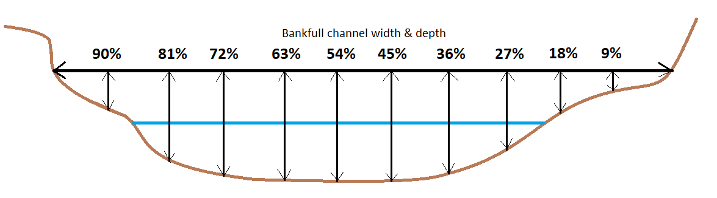
Cross-Section Width/Depth Ratio Figure

Data Analysis
- Determine width/depth ratio for each cross-section measured:
- Calculate the average bankfull depth
- Divide bankfull width by average bankfull depth
- Determine width/depth ratio for the stream reach if measuring multiple cross-sections:
- Median of all width/depth ratios calculated for cross-sections within the reach.

Riparian Methods

Multiple Indicator Monitoring (BLM) (Guidance Only; No SOP)

Relevant Parameters of Interest:

Greenline Composition

Stream Bank Alteration

Stream Bank Stability and Cover

Stubble Height

Woody Species Use

Multiple Indicator Monitoring (MIM) of Streamside Channels and Streamside Vegetation
- From BLM, Technical Reference

Riparian Greenline Assessment (DEQ) (SOP)

Method Overview
The riparian greenline method categorizes riparian vegetation types along the ground cover, understory and overstory over the length of an assessment site. Progressing from the downstream end of the site to the upstream end of the site, every 10-feet the ground cover (<1.5 feet tall), understory (1.5 to 15 feet tall) and overstory (>15 feet tall) riparian vegetation is described. Additional descriptive factors such as livestock pugging, bare or disturbed ground, and invasive plants are also noted. Riparian buffer width is also recorded every 50-feet. Once data collection is complete, the observations for each vegetation category is tallied and the percent cover for each is calculated.

Specifications
Applicable Waterbody Type: STREAMS

Scale: WATERBODY

Limiting Conditions:
- Preferably completed during summer or early fall when vegetation is mature.
Skills Required:
- Must be able to identify general vegetation types.
- Must be able to accurately identify bankfull indicators.
Time Required:
- Minimum 1 person
- Approximately 2 hours
Considerations:
- May be completed by multiple people (e.g., 1 person per bank)
- Note that the greenline assessment is specifically designed for areas in which streambank erosion is influenced by riparian shrub coverage. This measurement is optional in situations where riparian shrubs do not play an important role in streambank stability, such as steep mountain streams in coniferous forests.
Equipment and Software:
- Field Forms for 500-, 1000-, and 2000-foot reaches
- Clipboard and pencils
- Calculator
- Roll of flagging
- Sharpie for marking flagging
- 6 300-foot tape measures
- 2 100-foot tape measures
- 5 200-foot tape measures
- GPS unit
- Rangefinder (optional)

Data Needs:
- Total length of assessment reach
Method Type: semi-quantitative

Repeatability: higH

Other Names: Greenline

Method Source:
- Montana Department of Environmental Quality (DEQ). 2017. Field Methodology for Sediment and Habitat Source Assessment. Helena, MT: Montana Department of Environmental Quality, Watershed Protection Section. WQPBWMSSOP-05, Revision 6.
Keywords: riparian vegetation, greenline, bankfull

Procedure
Delineate the survey site
- Measure or estimate bankfull width. Potential bankfull indicators include (Leopold 1994, Rosgen 1996):
- Examine streambanks for an active floodplain. This is a relatively flat, depositional area commonly vegetated and above the current water level, unless there is a large amount of spring runoff or there has been a substantial rain event (i.e., stream running at bankfull stage).
- Examine depositional features such as point bars. The highest elevation of a point bar usually indicates the lowest possible elevation for bankfull stage. However, depositional features can form both above and below the bankfull elevation when unusual flows occur during years preceding the survey. Large floods can form bars that extend above bankfull whereas several years of low flows can result in bars forming below bankfull elevation.
- A break in slope of the banks and / or change in the particle size distribution from coarser bed load particles to finer particles deposited during bank overflow conditions.
- Define an elevation where mature key riparian woody vegetation exists. The lowest elevation of birch, alder, and dogwood can be useful, whereas willows are often found below the bankfull elevation.
- Examine the ceiling of undercut banks. This elevation is normally below the bankfull elevation.
- Stream channels actively attempt to reform bankfull features such as floodplains after shifts or down cutting in the channel. Be careful not to confuse old floodplains and terraces with the present indicators.
- Determine the length of the survey site based on the bankfull width (see Survey Site and Survey Cell Lengths).
- Determine the length of each cell. The survey site is split into five equidistant cells (see Survey Site and Survey Cell Lengths).

Survey Site and Survey Cell Lengths
Bankfull Channel Width (Feet) | Survey Site Length (Feet) | Length of Survey Cell (Feet)
 |  | Cell 1 | Cell 2 | Cell 3 | Cell 4 | Cell 5
< 10 | 500 | 0-100 | 100-200 | 200-300 | 300-400 | 400-500
> 10 to < 50 | 1000 | 0-200 | 200-400 | 400-600 | 600-800 | 800-1000
> 50 to < 75 | 1500* | 0-300 | 300-600 | 600-900 | 900-1200 | 1200-1500
>75 | 2000* | 0-400 | 400-800 | 800-1200 | 1200-1600 | 1600-2000

- Identify the downstream end of the survey site. When possible, begin at a riffle crest; if no riffles are present, select an alternate starting point.
- Record the GPS location of the downstream end of the survey site on the Sediment and Habitat Assessment Site Information Form.
- Take photos at the downstream end of the survey site, facing upstream and facing downstream; record photo numbers and a brief description of each photo on the Photo Log.
- Beginning at the downstream end of the survey site, string tape measures along the entire length of the survey site along the river right streambank at approximately the bankfull elevation. For a 500’ survey site, string a 200’ tape and a 300’ tape. For a 1000’ survey site, string five 200’ tapes. For a 1500’ survey site, string five 300’ tapes. For a 2000’ survey site, string five 300’ tapes and one 200’ tape.
- Hang brightly-colored flagging at each cell boundary and number the five cells from downstream to upstream.
- Record the GPS location of the upstream end of the survey site on the Sediment and Habitat Assessment Site Information Form.
- Take photos at the upstream end of the survey site, facing upstream and facing downstream; record photo numbers and a brief description of each photo on the Photo Log.

Riparian Greenline Assessment
- Starting at the downstream end of the cell, progress upstream, stopping at each 10-foot interval along the greenline, which is located at approximately the bankfull channel margin (Windward 2000).

NOTE: When the bankfull channel margin is comprised of exposed sand or gravel due to streambank erosion, the greenline measurement should be made at the top of the bank.

NOTE: When the channel margin is along a gravel bar, the greenline measurement should be made at the estimated bankfull elevation. When this is the case, place an “X” on the field form to denote the measurement was made along the bankfull channel margin at a gravel bar.

NOTE: When performing the greenline assessment on larger streams, two people should progress along opposite sides of the channel simultaneously. In this case, crew members will be responsible for performing the greenline assessment on their respective sides of the channel, though only one crew member will be responsible for recording the data. The crew member assessing the river left side of the channel that lacks the tape should estimate the location of each interval based on the guidance of the crew member progressing along the tape measure.

- Stop every 10 feet to observe the ground cover (<1.5 feet tall) and record the following information on the Sediment and Habitat Site Information Form:
- Ground cover category:
W = Wetland vegetation, such as sedges and rushes
G = Grasses or forbs, rose, snowberry (vegetation lacking binding root structure)
B = Disturbed/bare ground
R = Rock, when a large cobble or boulder is encountered
RR = Riprap
- When the 10-foot interval falls at the base of a shrub or tree, place a dash (-) on the field form.
- When pugging due to the mechanical hoof action of grazing ungulates is observed, add “/P” to the field form after the ground cover category (i.e. “G/P” indicates grass or forb ground cover with evidence of pugging). See Figure 1-1 for an example of pugging.
- When Bare/Disturbed ground is observed, if the location appears to have the potential to support an herbaceous or woody vegetative community under natural circumstances, add “/D” to the field form.
- If moss is encountered, simply choose the category that best describes the feature that the moss is associated with.
- Stop every 10 feet to observe the understory (1.5 to 15 feet tall) and overstory (>15 feet tall) and record the following information on the Sediment and Habitat Site Information Form:

NOTE: When assessing understory and overstory vegetation along the greenline, envision an imaginary column about 5 feet or so in diameter extending up from the 10-foot interval at the bankfull margin. If this column intersects the canopy a shrub or tree, then record the data in the appropriate category. Only count vegetation originating from the side of study. Vegetation from the opposite bank that extends into the column is not to be recorded.
- Category:
C = Coniferous
D = Deciduous, riparian shrubs and trees with sufficient rooting mass and depth to provide protection to the streambanks
M = mixed coniferous and deciduous
- If no shrub or tree is encountered, place a dash (-) in the column on the field form.
- Stop every 50 feet to estimate the vegetated buffer width along both sides of the stream and record it on the Riparian Greenline Buffer Worksheet:

NOTE: The goal is to estimate the width of vegetation that is buffering the stream from adjacent land use. It is not defined as the actual width of the band of riparian vegetation. This is because both riparian and non-riparian vegetation can act in a buffering capacity. This distance should generally correspond with the flood-prone area and, in many instances, will be bound by terraces or other distinct topographic features.
- Use a tape measure in areas where the riparian zone is small or the vegetation is not dense. Alternately, estimate buffer width by pacing, making a visual estimate, or using a range finder.

- Stop every 50 feet to estimate buffer quality and potential and record them on the Riparian Greenline Buffer Worksheet:
- Record data for both the primary buffer zone and the secondary buffer zone:
For 500-foot site, primary buffer zone is 0-10 feet and secondary buffer zone is 10-50 ft.
For 1000-foot site, primary buffer zone is 0-20 feet and secondary buffer zone is 20-50 ft.
For 1500-foot site, primary buffer zone is 0-30 feet and secondary buffer zone is 30-100 ft.
For 2000-foot site, primary buffer zone is 0-40 feet and secondary buffer zone is 40-100 ft.
- Rate buffer quality (i.e., the quality of the vegetation community’s capacity to buffer pollutants from entering the stream and to stabilize streambanks):
H = High
M = Medium
L = Low
Example: high buffer quality would be a dense willow/cottonwood dominated riparian area with grass or wetland ground cover; if the willow understory were absent in this scenario, or the vegetation was not as dense, the buffer might be rated as medium quality; if the willow understory and cottonwood overstory were absent in this scenario, the buffer might be rated as low quality.
- Rate buffer potential (i.e., describes the current vegetative community as a percentage of the achievable vegetative community for that particular station along the transect):
0 = 0% of potential
1 = 25% of potential
2 = 50% of potential
3 = 75% of potential
4 = 100% of potential
NOTE: If non-native vegetation is dominant, the buffer potential would be rated lower than if similar native vegetation was dominant; sites such as high terraces may be at or near potential, but have a lower buffer quality rating.

NOTE: A buffer code is generated for each 50-foot interval comprised of the quality rating letter (H, M, or L) and the potential rating number (1, 2, 3, or 4). Examples: M2, L0, H2, etc.

- Following the completion of greenline measurements, the total number of times each canopy type was observed is tallied in the box at the bottom of the field form.
- Record site observations on the Sediment and Habitat Site Information Form, for example:
- Photo numbers and descriptions
- Description of riparian vegetation conditions
- Description of streambank erosion conditions
- Vegetation age classes
- Description of human impacts and their severity
- Description of stream channel conditions
- Estimation of Existing and Potential Rosgen Stream Type

Data Analysis
Calculate average riparian buffer width for the left bank, for the right bank, and for the site. These site averages can be used to compare sites to one another and to compare a single site over time.

Riparian Species Composition (No Guidance; No SOP)
Future development here if useful

Upland Species Encroachment (Guidance Only; No SOP)
    - Assessment of Threats to Riparian Ecosystems in the Western U.S.
      - From the USFS
    - Case study: Encroachment of upland Mediterranean plant species in riparian ecosystems of southern Portugal

Vegetation Survival Rate (No Guidance; No SOP)
Future development here if useful

Weed Growth (Guidance Only; No SOP)
  - Managing Invasive Plants (Assessing/Monitoring)
    - From the U.S. Fish and Wildlife Service
  - Introduced, Invasive, and Noxious Plants
    - From the USDA/NRCS; comprehensive list by state
  - Noxious Weeds Program Risk Assessments
    - From the USDA Animal and Plant Health Inspection Service; contains assessment guidelines

Width of Riparian Buffer (Guidance Only; No SOP)
    - Riparian Buffer Width, Vegetative Cover, and Nitrogen Removal Effectiveness: A Review of Current Science and Regulations
      - From the U.S. EPA
      - “Currently, there is no scientific literature examining appropriate riparian buffer widths for water quality for streams on private agriculturally dominated lands…”
    - Riparian Buffer Design Guidelines
      - From the USFS

