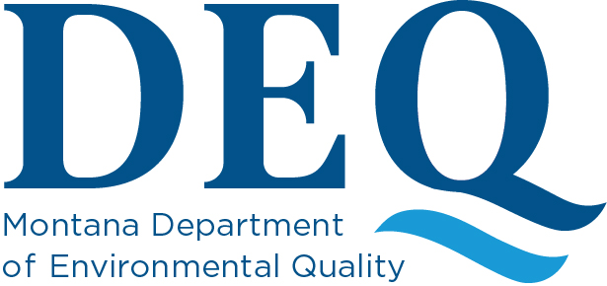

March 22, 2019

Re: 2020 303(d) and 305(b) Water Quality Call for Data

The department updates Montana’s list of “threatened and impaired waters” every 2 years. We are beginning work on the 2020 update. Our monitoring teams collect data during field seasons to update the water quality assessments of a number of waterbodies. We realize that many other organizations, both within and outside of state government, also collect water quality data and information, which could be very useful for our efforts at updating the list.

What kind of information is needed? Our staff seeks physical, chemical, and biological data relating to the current condition of streams, rivers, lakes, and reservoirs in the state acquired since 2012 not previously submitted. Data and information relating to the use and condition of riparian areas may also be relevant. Older data is likely to be of less value as it may not reflect current conditions. Specifically, Montana law requires DEQ to base its water quality assessments on data, which is "sufficient and credible" to allow for a determination of whether state water quality standards are being met.

How to get information to the Water Quality Planning Bureau? Directions on how to submit data are provided at http://deq.mt.gov/Water/SurfaceWater/SubmitData. Detailed directions are contained in the document titled
MT-eWQX Guidance Manual - Call for Data, which is found under Step 1: Prepare Your EDD. We would also appreciate being told of other sources of information (e.g., reports or water quality related documents) which you believe could assist us.

Please be aware that the deadline for submittal of water quality data and other materials has been set for June 14, 2019. All data and materials received on or before June 14, 2019 will be considered for review in developing the 2020 305(b)/303(d) Water Quality Integrated Report. Materials submitted after that date may not be used in the 2020 Report, but will be considered for subsequent list updates.

Please address any questions to Jane Madison, at jMadison@mt.gov, or phone (406) 444-3409. Any relevant data or information that you can provide will be appreciated.

If you would like to be included in future notifications please join the WQP Data Management Data Providers listserv at http://svc.mt.gov/deq/ListServe/ewqxStep1.asp.

Sincerely,

/Darrin Kron/

Darrin Kron, Supervisor
Water Quality Monitoring and Assessment Section
Water Quality Planning Bureau
Phone (406) 444-4765
dkron@mt.gov

